University of Macau

Faculty of Science and Technology



Your Project TitleScenario-Based Prediction of Student Performance using 2019 CISC1000 Course Data: A Python Summative Data Analysis

by

Vicky, Huang Liang Hui Gi, Student No: D-B62-661-3

Final Project Report submitted in partial fulfillment  
of the requirements of the Degree of   
Bachelor of Science in Computer Science

Project Supervisor

Dr. Kam Hou VAT

31 May 2020

# 

DECLARATION

I sincerely declare that:

1. I am the sole author of this report.
2. All the information contained in this report is certain and correct to the best of my knowledge.
3. I declare that the project report here submitted is original except for the source materials explicitly acknowledged and that this report or parts of this report have not been previously submitted for the same degree or for a different degree, and
4. I also acknowledge that I am aware of the Rules on Handling Student Academic Dishonesty and the Regulations of the Student Discipline of the University of Macau.

Signature : _________________________

Name : Huang Liang Hui Gi

Student No. : D-B6-2661-3

Date : 31 May 2020

ACKNOWLEDGEMENTS

First and foremost, I would like to express my utmost gratitude to UM for providing me with the opportunity to carry out this project as a partial fulfilment of the requirements for the degree of *Bachelor of Science in Computer Science*. The project has given me a good chance to experience the research process which will be helpful in my future study or career.

I am greatly indebted to my advisor Dr. Kam Hou Vat. He has indicated the main direction of the project and offered me many chances to improve my research skills including coding, analysis and professional storytelling. I have learned many valuable lessons in this project not only on how to conduct research but also on how to plan and manage my goals. I also owe thanks to my parents for their great support in our life and study.

**ABSTRACT**

This data science project *Scenario-Based Prediction of Student Performance using 2019 CISC1000 Course Data: A Python Summative Data Analysis* is a sequel to the 2018 FYP entitled *Python Data Analysis and Visualization using CISC1000 as Example Course Scenario*, which was about performing data analysis and data visualization using course data from *CISC1000 Information Technology Fundamentals and Practices*, in the first semester of the 2018-2019 academic years. This project builds on the 2018 FYP, with another set of scenarios for data wrangling and prediction, to deepen the analysis of student learning using performance data of the 2019-2020 related coursework, and to visualize the result for concise storytelling. My contributions in this project is to inform student performance of CISC1000 throughout the course evaluation period by answering the research question: “How did CISC1000 perform in terms of student summative assessment?” To answer this question, this project report has documented my use of different scenarios to elucidate the findings from the course delivery of CISC1000 after the first semester of the 2019-2020 academic year.

LIST OF TABLES

|  |  |
| --- | --- |
| **Table** | **Page** |
| Table 3.3.2‑1: CISC1000 Course Exam Sessions – 1st Semester Of AY2019-2020 By FST | 27 |
| Table 3.2‑2 CISC1000 Course Enrolment And Withdrawal By Section | 29 |
| Table 3.2‑3 CISC1000 Course Enrolment And Withdrawal By Major | 30 |
| Table 4.3‑1 Examination Results | 36 |
| Table 4.3‑2 Student Examination Trial Count | 36 |
| Table 4.5‑1 Student Scores By Section | 38 |
| Table 4.5‑2 Student Scores By Major | 39 |
| Table 4.5‑3 P Students Exam Trial Counts By RCs And Course Sections | 40 |
| Table 4.5‑4 NP Students Exam Trial Counts By RCs And Course Sections | 41 |
| Table 4.5‑5 P Students Exam Trial Counts By Major | 42 |
| Table 4.5‑6 NP Students Exam Trial Counts By Major | 44 |
| Table 4.5‑7 P Students Excellent, Good, Average Score By Course Section And RC | 46 |
| Table 4.5‑8np Students Exam Score Range By Course Section And RC | 46 |
| Table 4.5‑9 P Students Excellent, Good, Average Score By Major | 47 |
| Table 4.5‑10 NP Students Exam Score Range By Major | 48 |
| Table 5.4‑1example Of Confusion Matrix In Individual Student | 53 |
| Table 6.2‑1 Overview Of P, NP And ABS Students’ Distribution In Each Actual Exam Session | 56 |
| Table 6.2‑2 Overview Of P, NP And ABS Students’ Distribution In Each Exam Review For Each Exam Session | 57 |
| Table 6.3‑1 Table Of Overview Of Difference Between Predicted P Rate And NP Rate In Exam Review | 65 |
| Table 6.4‑1 Example Of Confusion Matrix | 66 |
| Table 6.6‑1 Example Of Overview Of Exam Review In Individual Level Part 4 | 77 |
| Table 6.6‑2 Example Of Table Of Summary Of Exam Session 01 | 77 |
| Table 7.2‑1 Example Of Summarized Dataframe Of Presenting The Percentage Of Score Obtained In Each Topic And Overall Average Passing Rate Of All Topics In Exam Review | 88 |
| Table 7.2‑2 Example Of Summarized Dataframe Of Presenting The Percentage Of Score Obtained In Each Topic And Overall Average Passing Rate Of All Topics In An Official Exam | 89 |
| Table 7.2‑3 Example Of Summarized Dataframe With Comparison Between Grading In Official Exam And Exam Review | 90 |
| Table 7.2‑4 Example Of A Confusion Matrix Of Accuracy Of Prediction | 91 |
| Table 7.2‑5 Example Of Number Of Correct Predictions | 91 |
| Table 7.3‑1 Comparison Of Number Of P And NP Student In Predicted And Actual Result With Difference Between Them In Topic 01 Of Exam Session 01 | 94 |
| Table 7.3‑2 Comparison Of Number Of P And Np Student In Predicted And Actual Result With Difference Between Them In Topic 02 Of Exam Session 01 | 94 |
| Table 7.4‑1 Data Table Contains The Number Of P And NP Student In Predicted Result And Actual Result. | 95 |
| Table 7.4‑2 Data Table Contains Confusion Matrix Of Exam Session 01 | 96 |
| Table 7.4‑3 Example Of Confusion Matrix In The Form Of Percentages | 97 |
| Table 7.5‑1 Example Of Student’s Information And RC With Indicator Of Participating In Mock Exam And Result Of Mock Exam | 98 |
| Table 7.5‑2 Example Of Number Of Students From RC Who Has Attempted Mock Exam And Number Of Students Who Has Not Attempted Mock Exam | 99 |
| Table 7.6‑1 Example Of A Slice Of Training Datasets For 22 Exam Sessions | 101 |

LIST OF FIGURES

|  |  |
| --- | --- |
| Figure | Page |
| Figure 5.5‑1 Example Of Overview Of Exam Review In Individual Level Part 1 | 55 |
| Figure 6.3‑1 Comparison Of Exam Review And Exam Session 01 | 63 |
| Figure 6.3‑2 Comparison Of Exam Review And Exam Session 02 | 64 |
| Figure 6.3‑3 Comparison Of Exam Review And Exam Session 03 | 65 |
| Figure 6.3‑4 Comparison Of Exam Review And Exam Session 04 | 66 |
| Figure 6.3‑5 Comparison Of Exam Review And Exam Session 05 | 67 |
| Figure 6.3‑6 Comparison Of Exam Review And Exam Session 06 | 68 |
| Figure 6.3‑7 Comparison Of Exam Review And Exam Session 07 | 69 |
| Figure 6.3‑8 Comparison Of Exam Review And Exam Session 08 | 70 |
| Figure 6.3‑9 Comparison Of Exam Review And Exam Session 09 | 71 |
| Figure 6.3‑10 Comparison Of Exam Review And Exam Session 10 | 72 |
| Figure 6.3‑11 Comparison Of Exam Review And Exam Session 11 | 73 |
| Figure 6.3‑12 Comparison Of Exam Review And Exam Session 12 | 74 |
| Figure 6.3‑13 Comparison Of Exam Review And Exam Session 13 | 75 |
| Figure 6.3‑14 Comparison Of Exam Review And Exam Session 14 | 76 |
| Figure 6.3‑15 Comparison Of Exam Review And Exam Session 15 | 77 |
| Figure 6.3‑16 Comparison Of Exam Review And Exam Session 16 | 77 |
| Figure 6.3‑17 Comparison Of Exam Review And Exam Session 17 | 79 |
| Figure 6.3‑18 Comparison Of Exam Review And Exam Session 18 | 80 |
| Figure 6.3‑19 Comparison Of Exam Review And Exam Session 19 | 81 |
| Figure 6.3‑20 Comparison Of Exam Review And Exam Session 20 | 82 |
| Figure 6.3‑21 Comparison Of Exam Review And Exam Session 21 | 83 |
| Figure 6.3‑22 Comparison Of Exam Review And Exam Session 22 | 84 |
| Figure 6.3‑23 Bar Graph Of Overview Of Difference Between Predicted P Rate And NP Rate In Exam Review And Official 22 Exam Sessions | 87 |
| Figure 6.4‑1 Confusion Matrix Of Exam Review And Exam Session 01 | 89 |
| Figure 6.4‑2 Confusion Matrix Of Exam Review And Exam Session 02 | 90 |
| Figure 6.4‑3 Confusion Matrix Of Exam Review And Exam Session 03 | 91 |
| Figure 6.4‑4 Confusion Matrix Of Exam Review And Exam Session 04 | 92 |
| Figure 6.4‑5 Confusion Matrix Of Exam Review And Exam Session 05 | 93 |
| Figure 6.4‑6 Confusion Matrix Of Exam Review And Exam Session 06 | 94 |
| Figure 6.4‑7 Confusion Matrix Of Exam Review And Exam Session 07 | 95 |
| Figure 6.4‑8 Confusion Matrix Of Exam Review And Exam Session 08 | 96 |
| Figure 6.4‑9 Confusion Matrix Of Exam Review And Exam Session 09 | 97 |
| Figure 6.4‑10 Confusion Matrix Of Exam Review And Exam Session 10 | 98 |
| Figure 6.4‑11 Confusion Matrix Of Exam Review And Exam Session 11 | 99 |
| Figure 6.4‑12 Confusion Matrix Of Exam Review And Exam Session 12 | 100 |
| Figure 6.4‑13 Confusion Matrix Of Exam Review And Exam Session 13 | 101 |
| Figure 6.4‑14 Confusion Matrix Of Exam Review And Exam Session 14 | 102 |
| Figure 6.4‑15 Confusion Matrix Of Exam Review And Exam Session 15 | 103 |
| Figure 6.4‑16 Confusion Matrix Of Exam Review And Exam Session 16 | 104 |
| Figure 6.4‑17 Confusion Matrix Of Exam Review And Exam Session 17 | 105 |
| Figure 6.4‑18 Confusion Matrix Of Exam Review And Exam Session 18 | 106 |
| Figure 6.4‑19 Confusion Matrix Of Exam Review And Exam Session 19 | 107 |
| Figure 6.4‑20 Confusion Matrix Of Exam Review And Exam Session 20 | 108 |
| Figure 6.4‑21 Confusion Matrix Of Exam Review And Exam Session 21 | 109 |
| Figure 6.4‑22 Confusion Matrix Of Exam Review And Exam Session 22 | 110 |
| Figure 6.5‑1 Confusion Matrix Of Topic 01 In Exam Session 01 | 112 |
| Figure 6.5‑2 Confusion Matrix Of Topic 02 In Exam Session 01 | 112 |
| Figure 6.5‑3 Confusion Matrix Of Topic 03 In Exam Session 01 | 112 |
| Figure 6.5‑4 Confusion Matrix Of Topic 04 In Exam Session 01 | 113 |
| Figure 6.5‑5 Confusion Matrix Of Topic 05 In Exam Session 01 | 113 |
| Figure 6.5‑6 Confusion Matrix Of Topic 06 In Exam Session 01 | 113 |
| Figure 6.5‑7 Confusion Matrix Of Topic 07 In Exam Session 01 | 113 |
| Figure 6.5‑8 Confusion Matrix Of Topic 08 In Exam Session 01 | 114 |
| Figure 6.5‑9 Confusion Matrix Of Topic 09 In Exam Session 01 | 114 |
| Figure 6.5‑10 Confusion Matrix Of Topic 10 In Exam Session 01 | 114 |
| Figure 6.5‑11 Confusion Matrix Of Topic 11 In Exam Session 01 | 114 |
| Figure 6.5‑12 Confusion Matrix Of Topic 12 In Exam Session 01 | 115 |
| Figure 6.6‑1 Example Of Overview Of Exam Review In Individual Level Part 1 | 117 |
| Figure 6.6‑2 Example Of Overview Of Exam Review In Individual Level Part 2 | 118 |
| Figure 6.6‑3 Example Of Overview Of Exam Review In Individual Level Part 3 | 119 |
| Figure 6.6‑4 Example Of Comparison Of Exam Review And Exam Session In Individual Level | 121 |
| Figure 6.7‑1 The Correlation Between Topics And Overall Grade Part 1 | 123 |
| Figure 6.7‑2 The Correlation Between Topics And Overall Grade Part 2 | 124 |
| Figure 7.2‑1 Additional Columns To The Original Data In Exam Review | 128 |
| Figure 7.2‑2 Example Of Overview Of Exam Review In Individual Level Part 1 | 131 |
| Figure 7.2‑3 Example Of Overview Of Exam Review In Individual Level Part 2 | 132 |
| Figure 7.2‑4 Example Of Overview Of Exam Review In Individual Level Part 3 | 133 |
| Figure 7.4‑1 List Of Output Excel Files Of An Individual Exam Session | 142 |
| Figure 7.7‑1 Example Of Result Of Multiple Linear Regression | 150 |
| Figure 7.8‑1 Example Of Visualizing Summative Analysis In Exam Session 01 In Web Page Part1 | 153 |
| Figure 7.8‑2 Example Of Visualizing Summative Analysis In Exam Session 01 In Web Page Part2 | 154 |
| Figure 7.8‑3 Example Of Visualizing Summative Analysis In Topic-Wise Level Of Exam Session 01 In Web Page Part1 | 156 |
| Figure 7.8‑4 Example Of Visualizing Summative Analysis In Individual Level Of Exam Session 01 In Web Page Part1 | 159 |
| Figure 7.8‑5 Example Of Visualizing Summative Analysis In Individual Level Of Exam Session 01 In Web Page Part2 | 160 |
| Figure 9.6‑1 Lowest Participation Of RC In Mock Exam In Exam Session 01 | 168 |
| Figure 9.6‑2 Highest Participation Of RC In Mock Exam In Exam Session 01 | 168 |
| Figure 9.8‑1 Example Of Listed Number Of Correct Questions In Each Topic In Official Exam And Ream Review | 172 |
| Figure 9.8‑2 Overview Of Exam Review In Sample Report Part 1 | 173 |
| Figure 9.8‑3 Overview Of Exam Review In Sample Report Part 2 | 174 |
| Figure 9.8‑4 Overview Of Exam Review In Sample Report Part 3 | 175 |
| Figure 9.8‑5 Overview Of Exam Review In Sample Report Part 4 | 176 |
| Figure 9.8‑6 Summary Of Exam Review In Exam Session 01 | 176 |
| Figure 9.8‑7 Summary Of Official Exam In Exam Session 01 | 177 |
| Figure 9.8‑8 Comparison Of Official Exam And Exam Review | 177 |
| Figure 9.8‑9 Line Graph Of Student Report In Exam Session 01 | 178 |
| Figure 9.8‑10 Confusion Matrix Of Predicted And Official Exam | 179 |
| Figure 9.9‑1 Menu Of Individual Exam Session | 181 |
| Figure 9.9‑2 Web Page Of Summary Of All Exam Session Part 1 | 182 |
| Figure 9.9‑3 Web Of Summary Of All Exam Session Part 2 | 183 |
| Figure 9.9‑4 Web Page Of Summary Of Exam Session 01 | 184 |
| Figure 9.9‑5 Confusion Matrix Of Exam Session 01 | 185 |
| Figure 9.9‑6 Percentage Of Confusion Matrix | 186 |
| Figure 9.9‑7 Summary Of Topics Of Exam Session | 187 |
| Figure 9.9‑8 Drop Down List Of Page Selection | 188 |
| Figure 9.9‑9 Web Page Of Search Student's Report | 189 |
| Figure 9.9‑10 Menu Of Mock-Up Exam | 190 |
| Figure 9.9‑11 Example Of Participation In Each RC | 191 |
| Figure 9.9‑12 Drop Down List Of Page Selection For Prediction Model | 192 |
| Figure 9.9‑13 Details Of Page Of Prediction Model | 193 |

LIST OF CODING

|  |  |  |
| --- | --- | --- |
| Code | Description | Page |
| 7.2 | Data Exploration and preparation of exam reviews | 127 |
| 7.3 | Summative analysis of overall performance on exam reviews in individual level | 137 |
| 7.4 | Summative analysis of overall performance on exam reviews in topic-wise level | 142 |
| 7.5 | Summative analysis of overall performance on exam reviews in overall exam session-wide level | 145 |
| 7.6 | Data Exploration and Data analysis of Mock Exams | 147 |
| 7.7 | Multiple linear regression for predicting student performance | 149 |
| 7.8 | Web based front-end for visualizing data analyzed in 7.3,7.4,7.5, 7.6 and 7.7 |  |

|  |  |
| --- | --- |
| Code | Page |
| Code 7.2‑1 Code Of Reading Exam Review Files Of Ay 2019-2020 First Semester | 127 |
| Code 7.2‑2 Code Of Reshaping Raw Data | 128 |
| Code 7.2‑3 Code Of Splitting Raw Data By Date | 128 |
| Code 7.2‑4 Code Of Analyzing Students Who Attempted Exam Review | 129 |
| Code 7.2‑5 Analyzing Students Who Did Not Attempt Exam Review | 129 |
| Code 7.2‑6 Data Unification | 135 |
| Code 7.2‑7 Split Data By Date | 136 |
| Code 7.3‑1 Code Of Pre-Defined Output Dataframe | 137 |
| Code 7.3‑2 Code Of Processing Result Of Topic 09 In Exam Review | 137 |
| Code 7.3‑3 Getting Overall Average Passing Rate Of An Exam Session Of Individual Student | 137 |
| Code 7.3‑4 Code Of Applying Rules Of Passing Rate In Exam Review | 138 |
| Code 7.3‑5 Code Of Defining A List Of Exam Result Files | 138 |
| Code 7.3‑6 Code Of Retrieving Data From Excel File And Convert It Into Dataframe | 138 |
| Code 7.3‑7 Code Of Removing Unwanted Values | 138 |
| Code 7.3‑8 Stored The Average Rate For Each Topic In The Resulted Dataframe | 139 |
| Code 7.3‑9 Code Of Summarizing Difference Between Performance Of Official Exam And Exam Review | 140 |
| Code 7.3‑10 Code Of Defining 'Inconclusive' Results | 140 |
| Code 7.3‑11 Code Of Confusion Matrix | 141 |
| Code 7.3‑12 Code Of Calculation Of Accuracy Of Predicted Result | 141 |
| Code 7.4‑1 Code Of Creation Of 12 Empty Dataframe For Storing Essential Data Of Analysed Data | 142 |
| Code 7.4‑2 Code Of Applying Regular Expression To Extract Essential Data | 142 |
| Code 7.4‑3 Code Of The Comparison Of Official Result And Predicted Result That We Analysed In Individual Level | 142 |
| Code 7.4‑4 Code Of Creating Confusion Matrix In Topic-Wise Level | 143 |
| Code 7.4‑5 Code Of Calculating Difference Of Predicted And Actual Result | 143 |
| Code 7.4‑6 Code Of Exporting Analyzed Result Into Excel File | 143 |
| Code 7.5‑1 Code Of Summarizing Analyzed Data In Exam Session Wide Level | 145 |
| Code 7.5‑2 Code Of Creating Confusion Matrix In Exam Session-Wide Level | 145 |
| Code 7.5‑3 Code Of Calculation Of Passing And No Passing Rate In Actual And Predicted Result | 146 |
| Code 7.5‑4 Code Of Summarizing Calculated Rate Of P And NP Rate In Exam Session-Wide Level | 146 |
| Code 7.6‑1 Code Of Retrieving Data From Roster.Xls | 147 |
| Code 7.6‑2 Code Of Finding Whether Student Participated In Mock-Up Exam | 147 |
| Code 7.6‑3 Code Of Analysis Of Participation Of Rc In Mock-Up Exam | 148 |
| Code 7.6‑4 Code Of Summary Of Participation Of Rc In Mock-Up Exam | 148 |
| Code 7.7‑1 Code Of Turning Analyzed Result Of Exam Review Into Training Data | 149 |
| Code 7.7‑2 Code Of Turning Analyzed Result Of Official Exam Into Training Data | 150 |
| Code 7.7‑3 Code Of Fitting Training Data Into Multiple Linear Regression | 151 |
| Code 7.8‑1 Code Of Splitting Data From Excel File Into Multiple Dataframe | 152 |
| Code 7.8‑2 Code Of Defining Triggered Function For Specific ‘Href’ From Html Files | 152 |
| Code 7.8‑3 Code Of Collecting Data From Html File | 153 |
| Code 7.8‑4 Code Of Plotting A Bar Graph | 153 |
| Code 7.8‑5 Code Of Visualization Of Data Generate In Python In Html File | 154 |
| Code 7.8‑6 Code Of Redirect To Other Pages Based On Input From Html | 155 |
| Code 7.8‑7 Code Of Processing Data Into A Graph | 156 |
| Code 7.8‑8 Code Of Transmitting Data From Python To Html | 156 |
| Code 7.8‑9 Code Of Redirecting To Url Of Student_Record | 158 |
| Code 7.8‑10 Code Of Generation Of Data Table To Visualize Gathered Data | 158 |
| Code 7.8‑11 Code Of Visualizing Data Table Of Summary Of Exam Review In 12 Topics | 158 |
| Code 7.8‑12 Code Of Visualizing Data Table Of Summary Of Actual Exam | 158 |
| Code 7.8‑13 Code Of Constructing Line Graph With Five Colors Of Lines | 159 |
| Code 7.8‑14 Code Of Creating Data Table And Bar Graph To Visualize Analyzed Data In Individual Level | 160 |

LIST OF ACRONYMS

|  |  |
| --- | --- |
| ACC | Accounting |
| APC | Applied Physics and Chemistry |
| BEC | Business Economics |
| BIA | Business Intelligence and Data Analytics |
| BIF | Bioinformatics |
| BIO | Biomedical Sciences |
| CHN | Chinese |
| CLL | Chinese Language and Literature |
| COM | Communication |
| CPS | Computer Science |
| CVE | Civil Engineering |
| ECE | Electrical and Computer Engineering |
| ECN | Economics |
| EME | Electromechanical Engineering |
| ENG | English |
| ENS | English Studies |
| FIC | Financial Controllership |
| FNC | Finance |
| GBM | Global Business Management |
| GBS | General Business Studies |
| GPA | Government and Public Administration |
| HGM | Hospitality and Gaming Management |
| HRM | Human Resources Management |
| HST | History |
| IIR | International Integrated Resort Management |
| INS | Integrated Science |
| JAP | Japanese Studies |
| MAS | Mathematics |
| MKG | Marketing |
| MTH | Mathematics |
| PPE | Pre-Primary Education |
| PSY | Psychology |
| PTS | Portuguese |
| PYE | Primary Education |
| SOC | Sociology |

TABLE OF CONTENT

ACKNOWLEDGEMENTS 3

ABSTRACT 4

LIST OF TABLES 5

LIST OF FIGURES 7

LIST OF CODING 11

LIST OF ACRONYMS 14

TABLE OF CONTENT 16

CHAPTER 1. INTRODUCTION 21

1.1 Motivation 21

1.2 Research Context 21

1.3 Research Problem 21

1.4 Research Methods 22

1.5 Andy’s Contributions 22

1.6 Vicky’s Contributions 22

1.7 Synopsis of the FYP Report 22

1.8 Summary 23

CHAPTER 2. LITERATURE REVIEW 24

2.1 Introduction 24

2.2 Literature Review in Data Science 24

2.3 Elements pertaining a Data Science Project 24

2.3.1 Exploratory Data Analysis (EDA) 24

2.3.2 Data Representation and Transformation 25

2.3.3 Data Analysis and Visualization 25

2.4 Machine Learning 25

2.4.1 Supervised Learning 25

2.4.2 Unsupervised Learning 26

2.4.3 Reinforcement Learning 26

2.4.4 Linking Data Science and Machine Learning 26

2.4.5 Literature review in Prediction Models 26

2.5 Literature Review in SPOC 27

2.6 CISC1000 - SPOC at UM 27

2.7 Summary 27

CHAPTER 3. DESIGN SCENARIOS 29

3.1 Introduction 29

3.2 CISC1000 Course Description 29

3.2.1 CISC1000 Course Requirements 30

3.2.2 CISC1000 Course Platforms 30

3.2.3 CISC1000 Course Examination Details 30

3.2.4 CISC1000 Course Records 30

3.2.5 CISC1000 Course Sections 33

3.2.6 CISC1000 Course Majors 34

3.3 Design of Scenarios in CISC1000 35

3.3.1 CISC1000 Scenarios on Course Completion 36

3.3.2 CISC1000 Scenarios on Measuring CILOs 36

3.3.3 CISC1000 Scenarios on Measuring Formative Performance 37

3.3.4 CISC1000 Scenarios on Predicting Summative Performance 37

3.4 Summary 38

CHAPTER 4. DATA ANALYSIS 39

4.1 Introduction 39

4.2 CISC1000 Scenarios For Data Analysis 39

4.3 Data Exploration And Preparation 39

4.4 Data Representation and Transformation 41

4.5 Data Analysis 41

4.5.1 Scenario 1: Analysing Course Completion 42

4.5.2 Scenario 2: Analysing Course Intended Learning Outcomes (CILO) 49

4.6 Summary 53

CHAPTER 5. Summative Data Analysis 54

5.1 Introduction 54

5.2 Data Exploration and Preparation 54

5.3 Data Transformation and Representation 54

5.4 Purpose of Summative Data Analysis 55

5.5 Summative Data Analysis 56

5.5.1 Scenario 4: Analysing Course Summative Performance 56

5.5.2 Summative Data Analysis in Individual Level 56

5.5.3 Summative Data Analysis in Exam Session Level 61

5.6 Summary 63

CHAPTER 6. DATA VISUALIZATION 64

6.1 Introduction 64

6.2 CISC1000 Essential Data for Each Exam Session 64

6.3 Comparison of Exam Review and Actual Exam In Each Session 65

6.3.1 Insight of Summary of Overall Exam Sessions 88

6.4 Confusion Matrix of Predicted Results And Actual Results 91

6.4.1 Introduction of Confusion Matrix 91

6.4.2 Confusion Matrix of Each Exam Session 91

6.5 Visualization of Exam Sessions at Topic-Wise Level 114

6.6 Visualization of Exam Result at Individual Level 119

6.6.1 Visualization of Results from Exam Review 119

6.6.2 Visualization of Results from Exam Session 123

6.6.3 Comparison of Exam Review and Exam Session 123

6.7 Visualization of Linearity between Grade of Single Topic and Overall Grade 125

6.8 Summary 128

CHAPTER 7. Implementation in Python Coding 129

7.1 Introduction 129

7.2 Data Exploration and Preparation of Exam Reviews 129

7.2.1 Important Imported libraries 129

7.2.2 Key Function of Python Programming in Data Wrangling of Exam Reviews 129

7.2.3 Involved Sub-functions for Data Handling 137

7.3 Summative Analysis of Overall Performance on Exam Reviews in Individual Level 138

7.3.1 Key Function of Python Programming in Data Analysis of Exam Reviews in Individual Level 138

7.4 Summative analysis of overall performance on exam reviews in topic-wise level 143

7.4.1 Key Function of Python Programming in Data Analysis in Topic-wise Level 144

7.5 Summative Analysis of Overall Performance on Exam Reviews in Overall Exam Session-wide Level 146

7.5.1 Key Function of Python Programming in Data Analysis of Exam Reviews in Overall Exam Session-wide Level 146

7.6 Data Exploration and Data analysis of Mock Exams 149

7.7 Multiple Linear Regression for Predicting Student Performance 151

7.7.1 Important Libraries and Modules for Data Visualization 153

7.8 Web Based Front-end for Visualizing Data Analyzed in 7.2, 7.3, 7.4, 7.5 and 7.6 154

7.8.1 Data Visualization of Summative Analysis of Exam Session-Wide Level 154

7.8.2 Data Visualization of Summative Analysis of Topic-wise Level 157

7.8.3 Data Visualization of Summative Analysis of Individual Level 159

7.9 Summary 163

CHAPTER 8. ETHICS & PROFESSIONAL CONDUCT 164

8.1 Introduction 164

8.2 General Ethical Principals 164

8.2.1 Be Honest and Trustworthy 164

8.2.2 Respect Privacy 165

8.2.3 Honor Confidentiality 166

8.3 Professional Responsibilities 166

8.3.1 Perform work only in areas of competence 166

8.4 Professional Leadership Principles 167

8.4.1 Create opportunities for members of the organization or group to grow as professionals 167

8.5 Compliance with the Code 167

8.5.1 Uphold, promote, and respect the principles of the Code 167

8.6 Summary 168

CHAPTER 9. PROJECT INSIGHT AND CONCLUSION 169

9.1 Introduction 169

9.2 Evaluation on Summative Analysis in Overall Exam Session Level 169

9.3 Evaluation on Summative Analysis in Topic-wise Level 169

9.4 Evaluation on Summative Analysis at Individual Level 170

9.5 Evaluation on Machine Learning Prediction Model 170

9.6 Limitation of Further Analysis of Data of Mock-Up Exams 171

9.7 Possible Improvement for Future Development 172

9.7.1 Improvement of Machine Learning Model 172

9.7.2 Improvement of Summative Analysis 172

9.7.3 Improvement on Data Visualization 172

9.8 Overall Evaluation in Summative Analysis of CISC1000 173

9.9 Overview of Result of Summative Analysis in Web Application 183

9.9.1 Access of Overall Exam Sessions 183

9.9.2 Access to Individual Student Report 191

9.9.3 Access to Summary of Mock Exams 191

9.9.4 Access to Machine Learning Prediction Model 195

9.10 Summary 197

CHAPTER 10. REFERENCES 198

APPENDIX I User guide of programming code 199

Appendix II: User guide – Web application 216

# INTRODUCTION

## Motivation

This report is written to fulfill the graduation requirements of *CISC4000 Final Year Project* (FYP) in the 4-year degree program of *Bachelor of Science in Computer Science*, offered by the Department of Computer and Information Science (DCIS), under the Faculty of Science and Technology (FST), at the University of Macau (UM). In particular, we have chosen the FYP context based on our interest in the work of a data scientist, acquired during our course learning of *CISC3015 Data and Information Visualization*, offered in the first semester of the 2019-2020 academic year.

## Research Context

The research and writing of this FYP report, represents our understanding of the online learning initiative currently installed at the University of Macau, via an online course entitled *CISC1000 Information Technology Fundamentals and Practices*. This course is offered as an example of a SPOC (Small Private Online Course) trial, to over 2000 undergraduate freshmen students in the respective first and second semesters of the 2018-2019 and the 2019-2020 academic years. As students following the steps of a data scientist in our FYP project, we have to perform an exploratory data analysis (EDA) of the course data, followed by doing related visualization of course result discovered. Moreover, we are keen on predicting individual students’ performance in summative course learning, based on different scenarios of interest, in an attempt to answer some essential question(s) of course analysis.

## Research Problem

The research goal in this FYP project is to study the student performance of CISC1000 through a data scientist’s perspective, by answering the research question: “How has CISC1000 performed in terms of student learning?” The answer to this question, according to the course data at the end of the first semester of the 2019-2020 academic year, includes the following:

Enrollment Count: 2043  
Total Pass Count: 1429  
Total No-Pass Count: 596  
Total Withdrawal Count: 18

(Source - <https://www.fst.um.edu.mo/en/courses/bsc/cisc1000/201920201/exam.html>)

Indeed, in order to produce a course analysis report from a data scientist’s perspective, this FYP requires our investigation of the course requirements, the assessment scheme and the examination results used to inform student performance of course learning at the end of the semester. In particular, we have to answer the essential question: How did individual CISC1000 students perform, in terms of formative and summative assessment, throughout the semester’s course exams?

## Research Methods

Our research in this project is to answer the research question: “How has CISC1000 performed in terms of student learning?” This is done by creating different scenarios of interest via design thinking in course assessment, to look into student performance based on such course activities as writing course examinations throughout the semester. In other words, we must first answer the essential question: How did individual CISC1000 students perform, in terms of formative assessment, throughout the semester’s attempts in individual course exams, each of which by itself is a summative assessment? The completion of this FYP project requires our knowledge and skills of both formative and summative data analysis, including the use of the Series and DataFrame data structures from Python Pandas library to analyse data, and the use of Python matplotlib library to visualize the extracted course information. In addition, we should also apply specific machine learning methods to support scenario-based prediction of student performance in the context of writing individual course exams, especially for those who have failed earlier attempts in the course exams.

## Andy’s Contributions

My contributions in this project is to inform the student performance of CISC1000 through a data scientist’s perspective, by presenting course data useful to answer the research question: “How has CISC1000 performed in terms of student formative learning?” Specifically, this FYP report has documented my learning in data cleaning, reshaping of data, basic data tabulations, aggregations and visual representation, in order to elucidate the findings from the course delivery of CISC1000 after the first semester of the 2019-2020 academic year.

## Vicky’s Contributions

My contributions in this project is to inform the student performance of CISC1000 through an analytic perspective close to machine learning formulation, by presenting course data useful to answer the research question: “How has CISC1000 performed in terms of student summative learning?” Specifically, this FYP report has documented my learning in summative analysis towards a machine learning problem formulation

, preparing data for problem exploration, model planning and construction, model evaluation and visual representation with web-based front-end system in order to elucidate the findings from the course delivery of CISC1000 during the first semester of the 2019-2020 academic year.

## Synopsis of the FYP Report

This FYP report is presented in a total of 10 chapters:

1. The first chapter is the Introduction, providing an overview of the research behind the Final Year Project.
2. The second chapter is the Literature Review, providing the background of the data science field, and thus of this data science project.
3. The third chapter is the Design of Scenarios for FYP, providing the investigation behind *CISC1000 Information Technology Fundamentals and Practices*, including the course learning objectives, course assessment scheme, the criteria to pass or fail a student. In particular, there are specific questions of interest rendered under the essential research question “How has CISC1000 performed in terms of student learning in the first semester of 2019-2020 academic year?”
4. The fourth chapter is Data Analysis, providing detailed analysis of related CISC1000 course enactment data.
5. The fifth chapter is Summative Data Analysis, providing detailed summative analysis of related data of exam review, mock exams and official exam result in exam-session level, topic-wise level and individual level.
6. The sixth chapter is Data Visualization, providing visualization of summative analysis of CISC1000.
7. The seventh chapter is the Python implementation on summative analysis on CISC1000, this chapter documented the coding we used to tackle raw data into data that we can used to answer the question we proposed in earlier chapter.
8. The eighth chapter is Ethics and Professional Conduct, providing the research practice followed to avoid revealing any information related to personal privacy.
9. The ninth chapter is the Project Insight and Conclusion, providing my reflective learning on completing the FYP, and evaluation on the analyzed result.
10. The tenth chapter is the list of all the references consulted during the project period.

## Summary

In this chapter, we have delineated our motivation behind doing this FYP along the line of a data science project. We have explained the context of our FYP research using a course scenario from *CISC1000 Information Technology Fundamentals and Practices*. We have also spelled out the core question of our FYP research as: “How has CISC1000 performed in terms of student formative and summative learning?” Besides, our perceived contributions in this FYP should include our perspectives offered to help understand student learning in the current offering of CISC1000, and to improve the subsequent offering of this course, using the results of data analysis acquired in the FYP.

***Statement of Integrity***

This chapter is written by the two members of Group V, including: Chan Chan Andy (D-B6-2543-5) and Huang Liang Hui Gi Vicky (D-B6-2661-3). So, the pronoun “We” instead of “I” and the possessive pronoun “our” instead of “my” have been used in the body of this chapter. The respective project titles of Andy and Vicky are as follows:

* Andy - *Scenario-Based Evaluation of Student Performance using 2019 CISC1000 Course Data: A Python Formative Data Analysis*
* Vicky - *Your Project TitleScenario-Based Prediction of Student Performance using 2019 CISC1000 Course Data: A Python Summative Data Analysis*

# LITERATURE REVIEW

## Introduction

The objective of this project is to analyze, visualize and predict student performance of the online course: *CISC1000 Information Technology Fundamentals and Practice* in the first semester of the 2019-2020 academic year. To achieve this goal, we researched the necessary knowledge on related literature items pertaining to the elements that entail a data science project and its definition, the elements that entails Machine Learning (ML) and prediction methods, and the nature and characteristics of a Small Private Online Course (SPOC).

## Literature Review in Data Science

The first literature item to gain the knowledge on the elements pertaining a data science project is the paper [1] “50 years of Data Science”. This paper goes through the evolution of *Data Science* as a newly emerged science and how it differs from statistics. The paper references four major key figures in the evolution of data science throughout the last 50 years and their contributions to data science in its contemporary form. These figures include John Tukey, Bill Cleveland, John Chambers and Leo Breiman. John Tukey, on his paper [2] “The Future of Data Analysis” acknowledged the existence of an “as-yet unrecognized science” whose objective is to learn from data, setting the precedence to data analysis.

On September 8 of 2015, the University of Michigan organized a “Data Science Initiative (DSI)” and defined data science as “The collection, management, processing, analysis, visualization and interpretation of vast amounts of heterogeneous data associated with a diverse array of scientific, translational, and interdisciplinary applications” [1]. This definition of data science will be used as the basis throughout this FYP project.

## Elements pertaining a Data Science Project

From the definition provided by the DSI in the paper [1] “50 years of Data Science” , a data science project involves the collection, management, processing, analysis, visualization and interpretation of heterogeneous data associated with a diverse array of scientific, translational, and interdisciplinary applications. In order to explore this FYP in a data scientist perspective, there are three important tasks that must be included. These are Exploratory Data Analysis (EDA), Data Representation and Transformation and Data Analysis and Visualization.

### Exploratory Data Analysis (EDA)

Exploratory Data Analysis refers to the strategy and philosophy of modifying the data in a way that it is more convenient and practical to use [4]. The prospect of EDA is to explore the data in as many ways as possible until a plausible story emerges from the data. [2] Tukey compared EDA to detective work, where a detective collects all clues related to a central question before finding an answer. EDA should also be approached in this manner, where the data collected is analyzed in different perspectives. This FYP approaches the data by cleaning and reformatting the raw data into meaningful data capable of telling a story.

### Data Representation and Transformation

The data that has been collected and used in this FYP project is represented by the form of csv (comma separated value) and excel files. These files are then subjected to transformations, also known as data wrangling, using Python libraries such as Pandas and NumPy, by taking the unfiltered raw data and preparing them for data analysis and visualization.

### Data Analysis and Visualization

Python is the programming language chosen to perform the needed data analysis and visualization for this FYP. Python provides extensive tools that facilitates data cleaning, data reshaping, visual representation and basic tabulations. Data analysis is performed by using Python Pandas library along with its in-built methods. The data is stored in Pandas in-built data structure called DataFrames, which allows us to perform analysis, cleaning and manipulation of the data using functions such as groupby, merge, concat, sum, append and drop. Another data structure used, although in a lesser extent, are Series, which are used to display individual columns of a DataFrame. Data Visualization is performed by using Python Matplotlib library to plot the data into meaningful charts, such as bar charts, line charts and histograms, for a more effective visualization.

## Machine Learning

The second research item requires knowledge of machine learning for prediction. Machine Learning is considered as an extension of Artificial Intelligence (AI) which can be considered as the discipline to teach machines to handle tasks such as object recognition, processing an amount of computation without explicit manual instructions. Machine Learning inherit the concept of AI and it is a subdivision of Artificial Intelligence which is capable of learning and achieving better result from its historical data [7]. According to Mohri, M.et al. [8], it is a computational method using the electronic data collected from the past in support of better data analysis. Collected electronic data could be images, information collected from the environments, or information retrieved from student’s test results. There are various categories for a machine to learn, for instance, supervised learning, unsupervised learning and reinforcement learning. Machine learning helps to predict students’ academic performance before their exam will be rewarding to long term facilitation in student’s success. Students will put more efforts in order to improve their studies.

### Supervised Learning

Supervised learning is associating input parameters and output parameters with learning the mapping function from input to output. For example, algorithms which uses supervised learning is Classification and Regression. Whereas classification is used to predict discrete value, regression is utilized for predicting continuous dependent variables from independent variables [7]. Classification includes algorithms such as K nearest neighbor, Bayesian network, Support Vector Machine (SVM), etc. Logistic Regression and Linear Regression are examples of Regression algorithm. Supervised learning can be applied in tackling real world problem such as weather forecasting, predict student performance, stock price prediction etc.

### Unsupervised Learning

Unsupervised learning infers patterns from a given dataset without knowing labels or any outcomes. It is different from supervised learning because the value of outcome would be unknown, learning methods cannot be applied directly. Unsupervised learning is largely grouped into two main methods: Clustering and Association. Clustering is non-trivial idea when introducing the topic of unsupervised learning, it is mainly used for identifying unknown features from uncategorized datasets. There are different types of clustering such as Hierarchical clustering, K-means, independent component analysis. Unsupervised learning is applied in discovering unusual data from a dataset such as finding abnormal security log and split given dataset into different groups based on similarities.

### Reinforcement Learning

Reinforcement learning is part of deep learning which has higher performance, it learns without supervisor, but it mainly works with hit and trial method [7]. There are two main learning models in reinforcement learning such as Markov Decision Process and Q learning. Reinforcement learning can be applied in automated robotics, robot motion control.

### Linking Data Science and Machine Learning

Data Science project is mainly exploring data in order to understand and attain deeper knowledge of data, while Machine Learning learns and makes prediction based on historical data. When data science and machine learning techniques combine, there will be more possibilities to answer related questions. Machine Learning can use extracted insight of data which are further processed through Data Science methods. It is because raw data are often in large volume, messy and cannot be used directly. Especially when our project is evaluating and predicting student’s performance, it is getting involved because the size of student’s academic performance data is large, and also because of the various attributes that would affect the ultimate outcome of course delivery – such as the overall success rate [10].

### Literature review in Prediction Models

Based on the nature of our project and data collected from the course CISC1000. There are various machine learning algorithms to be evaluated and we need to apply one suitable for our project to make prediction, such as linear regression, logistic regression, neural network and decision trees. Regression model is a type of evaluation that allows estimating the dependent variable by understanding independent variables and describing the relationship between dependent variables and independent variables through the analysis of regression [12]. Therefore, linear regression is considered appropriate for dependent variable affected by multiple independent variables such as historical data of exam reviews, result of mock tests [11]. This model describes the relationship of dependent variable Y and independent variable X with the equation of Y = aX + b. where b is considered as the regression coefficient and slope of the straight line, and a is the y-intersection of the line. The regression coefficient represents the contribution of X to Y [12].

## Literature Review in SPOC

In order to use the data from CISC1000 as our design scenario, it is important to understand the nature of a small private online course (SPOC). According to [3] Uijl et al., a SPOC is a small course where teaching is done online in a “flipped classroom” environment. Just like any other course, students are required to register and apply to enroll the course by paying a fee. Upon passing the course, students are awarded an official certificate and credits. The contents of the SPOC are provided by the teachers and the students are guided through the course by an E-moderator that serves as a first resource for all students. Students are provided with videos, online assessments such as practice quizzes with immediate feedback and/or discussion forums for communication and self-management.

## CISC1000 - SPOC at UM

CISC1000 is operationalized as a SPOC-like online course offered by the *Faculty of Science and Technology (FST)* at UM. The course follows the characteristics of a SPOC, which allow students to learn online at their own pace by studying the materials prepared for them in the UMMoodle website. Students are required to enroll into this course in the same way they are required to enroll in any other course. Students are awarded three credits and a grade of P (pass) in the end of the semester upon registering and passing the course exam, organized multiple times throughout the entire semester. Students are allowed to retake the exam until they pass before the end of the semester. The examination takes place in a designated computer room in UM. A student that could not pass the exam in the span of the semester gets a grade of NP (not pass) and is required to retake the course CISC1000 in the following semester. The examination schedule can be found in the FST website [6].

## Summary

In this chapter, we presented the literature items we used in our FYP. We used the definition provided in the paper [1] “50 years of Data Science” to define our FYP as a data science project and showed the major tasks related in a data science project, namely data exploration and preparation (EDA), data representation and transformation, and data analysis and visualization. We also presented our findings in Machine learning and prediction models in relation to our FYP. Moreover, we presented our understanding in SPOCs as a newly emerged learning method and introduced CISC1000 as the scenario of study for our FYP.

***Statement of Integrity***

This chapter is written by the two members of Group V, including: Chan Chan Andy (D-B6-2543-5) and Huang Liang Hui Gi Vicky (D-B6-2661-3). So, the pronoun “We” instead of “I” and the possessive pronoun “our” instead of “my” have been used in the body of this chapter. The respective project titles of Andy and Vicky are as follows:

* Andy - *Scenario-Based Evaluation of Student Performance using 2019 CISC1000 Course Data: A Python Formative Data Analysis*
* Vicky - *Your Project TitleScenario-Based Prediction of Student Performance using 2019 CISC1000 Course Data: A Python Summative Data Analysis*

# DESIGN SCENARIOS

## Introduction

Our contribution in the project is to inform, through a data scientist’s perspective, how *CISC1000 Information Technology Fundamentals and Practice* has performed at the end of the semester.To accomplish this task, we have documented in this chapter various design scenarios and subsequent data analysis on the data obtained after the conclusion of CISC1000 in the first semester of 2019-2020 academic year.

Specifically, Andy’s contribution lies mainly in the formative analysis of student performance, using the result of course exams organized throughout the semester. Vicky’s contribution is to predict student’s summative performance with the collected coursework data from CISC1000according to the individual student level, and the group levels regarding course sections, residential colleges, and related major areas of study.

## CISC1000 Course Description

The department of Computer and Information Science (DCIS) documents CISC1000 as [5] “a foundational course in Language and Skills that explores the impact of information technology in our modern society.” The first offering of this online course was in the first semester of the academic year 2018-2019. The course goal is to enable student learning, in a “flipped-classroom” environment, essential information technology (IT) related knowledge in the modern society. The course encompasses 12 different topics from three specific IT modules:

* Module 1: Fundamentals of Information Technology (IT)
  + Topic 01 Introduction to IT
  + Topic 02 The Internet, The Web, and Electronic Commerce
  + Topic 03 Privacy, Security, and Ethics
  + Topic 04 Information Technology and You
* Module 2: Software and Information Systems
  + Topic 05 Application Software
  + Topic 06 Systems Software
  + Topic 07 Information Systems
  + Topic 08 Systems Analysis and Design
  + Topic 12 Databases
* Module 3: Computer Hardware, Communication and Networking
  + Topic 09 Computer Hardware
  + Topic 10 Communication and Networking
  + Topic 11 Programming and Languages

The course intended learning outcomes (CILOs) is summarized in four specific competencies that students should acquire upon the successful completion of the course:

1. Students should be able to explain the fundamentals of information technology, including the Internet, the Web, connectivity and mobility;
2. Students should be able to compare the fundamentals of the basic components of computer hardware and software, mobile devices and apps;
3. Students should be able to identify security and privacy threats in digital environments;
4. Students should be able to analyze the social, legal and ethical impact of computing on society in the information age.

### CISC1000 Course Requirements

To successfully complete the course, students are required to take an examination during the semester. There are 22 scheduled examinations throughout the first semester of 2019-2020 academic year. The examination schedule can be found in the website (<https://www.fst.um.edu.mo/en/courses/bsc/cisc1000/201920201/exam.html>). Students are required to register for the examination through an UMMoodle site managed by Registry before being confirmed to attend the exam. The examination takes place in a designated UM computer facility. A maximum of 200 students can be accommodated in each exam session. If students pass the examination, a grade of P (Pass) will be recorded. If students do not pass the examination, they can register for another examination session and retake the exam. At the end of the semester, if students could not pass the examination, they are given a grade of NP (No Pass) and are required to retake the course CISC1000 in the following semester.

### CISC1000 Course Platforms

The course CISC1000 can be accessed by students through the UMMoodle website or UMMOOC website. Through these sites, students can access the course materials such as video lectures, PowerPoint slides, study notes, practice quizzes and mock-up exams. Students can access these online resources any time and as many times as they want, while the mock-up exam is available only 24 hours before each official examination session. More information on CISC1000 is available from FST website at (<https://www.fst.um.edu.mo/en/courses/bsc/cisc1000/>).

### CISC1000 Course Examination Details

The course examination is composed of 100 multiple choice questions. If students answer 70 or more questions correctly, they pass the examination. If students answer less than 70 questions correctly, they need to retake the examination. The examination questions consist of twelve different topics. Topics 01 to 11 each have 8 questions, while Topic 12 has 12 questions, making a total of 100 questions. Moreover, the questions can be classified into seen and unseen. Seen questions are the ones that appear in the practice quizzes that students can take to study before the exam in the UMMoodle website. Unseen questions are the ones that do not appear in the practice quizzes, hence students would not have seen them prior to the exam.

### CISC1000 Course Records

According to the FST website [6], there were 2043 students enrolled in the course CISC1000 in the first semester of academic year 2019/2020. However, there were 18 withdrawals from the course totalling 2025 active students. Out of the 2025 students, 1429 students achieved the P grade, while 596 students the NP grade. We can also find the number of attempts students took to pass the exam, as well the as the number of exam attempts students took before failing the course.

For the Pass (P) students:

* Number of students who passed the course by writing the exam ONCE (791)
* Number of students who passed the course by writing the exam TWICE (454)
* Number of students who passed the course by writing the exam THRICE (148)
* Number of students who passed the course by writing the exam four times or more (36)

For the No Pass (NP) students:

* Number of students who failed the course by writing the exam ZERO times (79)
* Number of students who failed the course by writing the exam only ONCE (168)
* Number of students who failed the course by writing the exam TWICE (115)
* Number of students who failed the course by writing the exam THRICE (59)
* Number of students who failed the course by writing the exam four times or more (22)
* Number of students who did not register any course exams, and failed the course (153)

The examination schedule, extracted from the website [6] can be found below:

Table 3.3.2‑1: CISC1000 Course Exam Sessions – 1st Semester of AY2019-2020 by FST

|  |  |  |
| --- | --- | --- |
| Date and Time | Exam Session | Exam Statistics |
| Date: 25th September 2019 (Wednesday)  Exam Time: 16:30-17:30 | Exam Session 01 for 2019SEP25 Course Exam (Finished) | Registration Count: 199 Attendance Count: 183 Absentee Count: 16 Pass Count: 88 NP Count: 111 |
| Date: 9th October 2019 (Wednesday)  Exam Time: 15:00-16:00 | Exam Session 02 for 2019OCT09 Course Exam (Finished) | Registration Count: 198 Attendance Count: 157 Absentee Count: 41 Pass Count: 56 NP Count: 142 |
| Date: 9th October 2019 (Wednesday)  Exam Time: 16:30-17:30 | Exam Session 03 for 2019OCT09 Course Exam (Finished) | Registration Count: 194 Attendance Count: 166 Absentee Count: 28 Pass Count: 57 NP Count: 137 |
| Date: 11th October 2019 (Friday)  Exam Time: 16:30-17:30 | Exam Session 04 for 2019OCT11 Course Exam (Finished) | Registration Count: 153 Attendance Count: 120 Absentee Count: 33 Pass Count: 34 NP Count: 119 |
| Date: 21st October 2019 (Monday)  Exam Time: 16:30-17:30 | Exam Session 05 for 2019OCT21 Course Exam (Finished) | Registration Count: 200 Attendance Count: 164 Absentee Count: 36 Pass Count: 77 NP Count: 123 |
| Date: 23rd October 2019 (Wednesday)  Exam Time: 15:00-16:00 | Exam Session 06 for 2019OCT23 Course Exam (Finished) | Registration Count: 200 Attendance Count: 178 Absentee Count: 22 Pass Count: 97 NP Count: 103 |
| Date: 23rd October 2019 (Wednesday)  Exam Time: 16:30-17:30 | Exam Session 07 for 2019OCT23 Course Exam (Finished) | Registration Count: 200 Attendance Count: 170 Absentee Count: 30 Pass Count: 98 NP Count: 102 |
| Date: 6th November 2019 (Wednesday)  Exam Time: 15:00-16:00 | Exam Session 08 for 2019NOV06 Course Exam (Finished) | Registration Count: 200 Attendance Count: 175 Absentee Count: 25 Pass Count: 95 NP Count: 105 |
| Date: 6th November 2019 (Wednesday)  Exam Time: 16:30-17:30 | Exam Session 09 for 2019NOV06 Course Exam (Finished) | Registration Count: 200 Attendance Count: 186 Absentee Count: 14 Pass Count: 99 NP Count: 101 |
| Date: 7th November 2019 (Thursday)  Exam Time: 16:30-17:30 | Exam Session 10 for 2019NOV07 Course Exam (Finished) | Registration Count: 200 Attendance Count: 172 Absentee Count: 28 Pass Count: 92 NP Count: 108 |
| Date: 18th November 2019 (Monday)  Exam Time: 16:30-17:30 | Exam Session 11 for 2019NOV18 Course Exam (Finished) | Registration Count: 200 Attendance Count: 183 Absentee Count: 17 Pass Count: 87 NP Count: 113 |
| Date: 20th November 2019 (Wednesday)  Exam Time: 15:00-16:00 | Exam Session 12 for 2019NOV20 Course Exam (Finished) | Registration Count: 200 Attendance Count: 173 Absentee Count: 27 Pass Count: 90 NP Count: 110 |
| Date: 20th November 2019 (Wednesday)  Exam Time: 16:30-17:30 | Exam Session 13 for 2019NOV20 Course Exam (Finished) | Registration Count: 200 Attendance Count: 169 Absentee Count: 31 Pass Count: 94 NP Count: 106 |
| Date: 3rd December 2019 (Tuesday)  Exam Time: 9:00-10:00 | Exam Session 14 for 2019DEC03 Course Exam (Finished) | Registration Count: 49 Attendance Count: 36 Absentee Count: 13 Pass Count: 21 NP Count: 28 |
| Date: 3rd December 2019 (Tuesday)  Exam Time: 10:30-11:30 | Exam Session 15 for 2019DEC03 Course Exam (Finished) | Registration Count: 114 Attendance Count: 89 Absentee Count: 25 Pass Count: 49 NP Count: 65 |
| Date: 3rd December 2019 (Tuesday)  Exam Time: 12:00-13:00 | Exam Session 16  for 2019DEC03 Course Exam (Finished) | Registration Count: 138 Attendance Count: 122 Absentee Count: 16 Pass Count: 44 NP Count: 94 |
| Date: 3rd December 2019 (Tuesday)  Exam Time: 15:00-16:00 | Exam Session 17 for 2019DEC03 Course Exam (Finished) | Registration Count: 198 Attendance Count: 178 Absentee Count: 20 Pass Count: 95 NP Count: 103 |
| Date: 3rd December 2019 (Tuesday)  Exam Time: 16:30-17:30 | Exam Session 18 for 2019DEC03 Course Exam (Finished) | Registration Count: 198 Attendance Count: 174 Absentee Count: 24 Pass Count: 89 NP Count: 109 |
| Date: 3rd January 2020 (Friday)  Exam Time: 10:30-11:30 | Exam Session 19 for 2020JAN03 Course Exam (Finished) | Registration Count: 26 Attendance Count: 20 Absentee Count: 6 Pass Count: 8 NP Count: 18 |
| Date: 3rd January 2020 (Friday)  Exam Time: 12:00-13:00 | Exam Session 20 for 2020JAN03 Course Exam (Finished) | Registration Count: 40 Attendance Count: 29 Absentee Count: 11 Pass Count: 14 NP Count: 26 |
| Date: 3rd January 2020 (Friday)  Exam Time: 15:00-16:00 | Exam Session 21 for 2020JAN03 Course Exam (Finished) | Registration Count: 70 Attendance Count: 54 Absentee Count: 16 Pass Count: 23 NP Count: 47 |
| Date: 3rd January 2020 (Friday)  Exam Time: 16:30-17:30 | Exam Session 22 for 2020JAN03 Course Exam (Finished) | Registration Count: 91 Attendance Count: 61 Absentee Count: 30 Pass Count: 22 NP Count: 69 |

### CISC1000 Course Sections

The Course CISC1000 consists of enrolled students from 20 course sections belonging to the 10 residential colleges (RC) at UM. Each RC has been allocated by Registry with 2 course sections. The student enrolment and withdrawal count per section is as follows:

Table 3.2‑2 CISC1000 Course Enrolment and Withdrawal by Section

|  |  |  |  |  |
| --- | --- | --- | --- | --- |
| **Residential College** | **Section** | **Enrolment Count (start)** | **Enrolment Count (end)** | **Withdrawal Count** |
| CKLC - Cheong Kun Lun College | 001 | 108 | 107 | 1 |
| 002 | 118 | 114 | 4 |
| CKPC - Chao Kuang Piu College | 101 | 82 | 82 | 0 |
| 102 | 86 | 85 | 1 |
| CYTC - Cheng Yu Tung College | 201 | 102 | 101 | 1 |
| 202 | 105 | 105 | 0 |
| CKYC - Choi Kai Yau College | 301 | 113 | 111 | 2 |
| 302 | 113 | 112 | 1 |
| FPJC - Henry Fok Pearl Jubilee College | 401 | 101 | 101 | 0 |
| 402 | 105 | 103 | 2 |
| LCWC - Lui Che Woo College | 501 | 111 | 110 | 1 |
| 502 | 110 | 110 | 0 |
| MCMC - Moon Chun Memorial College | 601 | 95 | 94 | 1 |
| 602 | 91 | 91 | 0 |
| SPC - Shiu Pong College | 701 | 100 | 99 | 1 |
| 702 | 108 | 108 | 0 |
| SEAC - Stanley Ho East Asia College | 801 | 95 | 95 | 0 |
| 802 | 87 | 87 | 0 |
| MLC - Ma Man Kei and Lo Pak Sam College | 901 | 111 | 108 | 3 |
| 902 | 102 | 102 | 0 |
| **Total Number of Students** | | **2043** | **2025** | **18** |

### 

### CISC1000 Course Majors

The Course CISC1000 consists of enrolled students from 35 different majors. The student enrolment and withdrawal count per major is as follows:

Table 3.2‑3 CISC1000 Course Enrolment and Withdrawal by Major

|  |  |  |  |
| --- | --- | --- | --- |
| Major | Enrolment Count (start) | Enrolment Count (end) | Withdrawal Count |
| ACC | 180 | 179 | 1 |
| APC | 15 | 15 | 0 |
| BEC | 4 | 4 | 0 |
| BIA | 63 | 63 | 0 |
| BIF | 11 | 11 | 0 |
| BIO | 44 | 43 | 1 |
| CHN | 36 | 35 | 1 |
| CLL | 86 | 85 | 1 |
| COM | 145 | 145 | 0 |
| CPS | 65 | 64 | 1 |
| CVE | 70 | 69 | 1 |
| ECE | 43 | 42 | 1 |
| ECN | 63 | 62 | 1 |
| EME | 55 | 55 | 0 |
| ENG | 52 | 52 | 0 |
| ENS | 58 | 55 | 3 |
| FIC | 2 | 2 | 0 |
| FNC | 93 | 92 | 1 |
| GBM | 2 | 2 | 0 |
| GBS | 299 | 295 | 4 |
| GPA | 104 | 104 | 0 |
| HGM | 13 | 13 | 0 |
| HRM | 15 | 15 | 0 |
| HST | 34 | 34 | 0 |
| IIR | 82 | 82 | 0 |
| INS | 20 | 20 | 0 |
| JAP | 57 | 57 | 0 |
| MAS | 18 | 18 | 0 |
| MKG | 9 | 9 | 0 |
| MTH | 62 | 61 | 1 |
| PPE | 50 | 50 | 0 |
| PSY | 90 | 89 | 1 |
| PTS | 7 | 7 | 0 |
| PYE | 41 | 41 | 0 |
| SOC | 55 | 55 | 0 |
| Total | 2043 | 2025 | 18 |

## Design of Scenarios in CISC1000

To study student’s performance in CISC1000, we designed several scenarios of interest based on the available data collected throughout the first semester of academic year 2019-2020, including the following:

* 12 Topics and 3 Modules included in the 22 examination sessions
* Question papers of the 22 examination sessions
* Student results of the 22 examination sessions
* Student results of each course section in the 22 examination sessions
* Student results of each major in the 22 examination sessions
* Student results of practice quizzes in the 22 examination sessions
* Student results of Mock-up exams in the 22 examination sessions

### CISC1000 Scenarios on Course Completion

The first scenario to inform student performance and learning in CISC1000 involves analysing the results of the examinations. From the published results available in the FST website [6], we found out that from the 2025 students who completed the course, only 1429 students scored higher or equal to 70, achieving a grade of P, while 596 students score below 70, achieving a score of NP. The website also presents the number of times a student has attempted the exam before achieving their respective score. Therefore, the first scenario of interest to analyse student’s performance involves answering the following questions:

* For each of the 20 sections, how many students achieved a score of P?
* For each of the 20 sections, how many students achieved a score of NP?
* For each of the 35 majors, how many students achieved a score of P?
* For each of the 35 majors, how many students achieved a score of NP?
* For each RC, Section and Major:
  + How many times did P students attempt the exam?
    - ONCE
    - TWICE
    - THIRCE
    - FOUR or MORE times
  + How many times did NP students attempt the exam?
    - ONCE
    - TWICE
    - THIRCE
    - FOUR or MORE times
  + How many students achieved a score of NP by registering in the exam but never showing up at the exam venue?
    - ONCE
    - TWICE
    - THIRCE
    - FOUR or MORE times
  + How many students achieved a score of NP by not registering in any exam?

### CISC1000 Scenarios on Measuring CILOs

The second scenario designed to study student’s performance in course CISC1000 is by analysing the course intended learning outcomes (CILO). As stated in Section 3.2 Course Description, the examination questions are composed of 12 topics under 3 modules. To find out how students performed relatively to the CILOs, we can track the 22 examination results to answer the following questions:

* From the students that achieved a score of P, how many scored:
  + Between 70 to 79 (AVERAGE)
  + Between 80 to 89 (GOOD)
  + Between 90 to 100 (EXCELLENT)
* From the students that achieved a score of NP, how many scored:
  + Between 60 to 69
  + Between 50 to 59
  + Between 40 to 49
  + Between 30 to 39
  + Between 20 to 29
  + Between 10 to 19
  + Between 0 to 9

This scenario can be further developed to study the performance of students by RC and major, giving us another perspective and point of reference.

### CISC1000 Scenarios on Measuring Formative Performance

The third scenario designed to study student’s performance in course CISC1000 through a formative perspective is by analysing each examination results and tracking the number of times each student has attempted the examination prior to the current examination session. Students are allowed to retake the examination until they pass, which means that from the second examination onwards, students partaking on the exam might have already taken it before. This information is collected by cumulatively adding new data as the exam sessions progresses. By the end of the 22nd exam, a list of all the students, with their respective number of attempts and scores will be available for analysis. Moreover, by tracking the attempts in an individual student level, we can group the data into RCs, Sections and Majors, creating another point of comparison and analysis. Therefore, the third scenario of interest to analyse student’s formative performance involves answering the following questions:

* For each of the 22 examination sessions organized:
  + How many students from each of the 10 RCs and 20 sections achieved a score of P?
  + How many students from each of the 10 RCs and 20 sections achieved a score of NP?
  + How many students from each of the 10 RCs and 20 sections were ABSENT?
  + How many students from each of the 35 majors achieved a score of P?
  + How many students from each of the 35 majors achieved a score of NP?
  + How many students from each of the 35 majors were ABSENT?
* For each RC, Section and Major:
  + How many students repeated the exam and got P for each examination?
  + How many students repeated the exam and got NP for each examination?
  + How many students are attempting the exam for the FIRST, SECOND, THIRD or FOUR or MORE times for each exam session?
  + What is the formative cumulative completion rate for each exam session?

### CISC1000 Scenarios on Predicting Summative Performance

In each semester offering of CISC1000, students who enrolled in the course can do exercise review after each topic learning. They can attempt review exercises as many times as needed. Exam questions taken from those review exercises are considered as ‘seen’ questions in the actual exam session. The history of their attempts will be collected as training data. Furthermore, there is a mock exam for student practice before each official exam. Students are encouraged to finish the mock exam before writing the actual exam. The result of mock exam can also be collected as our training data.

In this project, we are going to predict student’s performance at various levels which include individual level and exam session level. In individual level, we will predict student’s performance with given data of review exercises, mock exams and actual performance in student’s previous exam. In exam session level, the predicted result depends on outcomes of individual level.

However, with summative analysis of CISC1000, we mainly focus on students who achieved No Pass (NP), in order to answer the question ‘How to improve student’s performance’. With our summative analysis, we conclude the performance of student in their exam review and actual exam with deeper investigation in topic-wise level. Since we analyse the performance of student in each topic, we can especially inform those students who got No Pass ‘NP’ to put more efforts in specific topics that the student performed poorly in previous exam(s) and exam reviews.

## Summary

In this chapter, we have described the design scenarios used in our FYP. These scenarios will be explored later through data analysis in Chapter 4, summative data analysis in Chapter 5, data visualization in Chapter 6, and Python implementation in Chapter 7. We have also kept track of housekeeping data, including the number of students per RC, per course section and per major area of study in the first semester of academic year 2019-2020. The first two scenarios describe a formative analysis of student performance by answering the question: “How did CISC1000 perform in terms of student formative assessment?” The last scenario describes a summative analysis by answering the question: “How would individual CISC1000 students perform, in terms of summative assessment, throughout the semester’s course exams?”

***Statement of Integrity***

This chapter is written by the two members of Group V, including: Chan Chan Andy (D-B6-2543-5) and Huang Liang Hui Gi Vicky (D-B6-2661-3). So, the pronoun “We” instead of “I” and the possessive pronoun “our” instead of “my” have been used in the body of this chapter. The respective project titles of Andy and Vicky are as follows:

* Andy - *Scenario-Based Evaluation of Student Performance using 2019 CISC1000 Course Data: A Python Formative Data Analysis*
* Vicky - *Your Project TitleScenario-Based Prediction of Student Performance using 2019 CISC1000 Course Data: A Python Summative Data Analysis*

# DATA ANALYSIS

## Introduction

This chapter summarizes the results obtained through data exploration and preparation, data representation and transformation, and data analysis on the data collected through the course CISC1000 in the first semester of academic year 2019-2020. The scenarios used for this data analysis are described in Chapter 3, section 3.3.1 and 3.3.2 of this FYP report. The scenarios are designed to provide student performance data in order to answer the questions: “How has CISC1000 performed in terms of student learning?”

## CISC1000 Scenarios For Data Analysis

To answer the three fundamental questions of our FYP, four scenarios are singled out as follows:

* How has CISC1000 performed in terms of student learning?
  + Scenario in measuring Course Completion.
  + Scenario in measuring Course Intended Learning Outcomes (CILOs).
* How did CISC1000 perform in terms of student formative assessment?
  + Scenario in measuring formative exam results by exam session
* How would individual CISC1000 students perform, in terms of summative assessment, throughout the semester’s course exams?
  + Scenario in measuring summative exam results with practice quizzes and mock-up exams.

Chapter 4 explores the first two scenarios by using the data collected at the end of the semester, while Chapter 5 of this report explores the fourth scenario in measuring summative exam results with data from practice quizzes and mock-up exams. Andy’s report (Chapter 5) explores the third scenario by using the data given to us at the beginning of the semester. The data included are the enrolment file at the start of the semester with all the enrolled students, the enrolment file at the end of the semester with withdrawals, and examination result files collected for each of the 22 examinations.

## Data Exploration And Preparation

We performed exploratory data analysis (EDA) and data preparation first before moving into data analysis. The data prepared consist of the course enrolment file at the end of the semester, which shows all the students who enrolled in the course and their respective RC, Course Section and Major and the 22 exam result files that show the score of each student and how they individually performed in all 100 questions. Each examination session could accommodate a maximum of 200 students in registration. After the examination students are awarded a P if they score 70 or higher points and NP if they score lower than 70 points or were absent. The results from the 22 examinations is shown as follows:

Table 4.3‑1 Examination Results

|  |  |  |  |  |  |
| --- | --- | --- | --- | --- | --- |
| **Exam Session** | **Registration Count** | **Attendance Count** | **Absentee Count** | **Pass Count** | **NP Count (including Absent)** |
| **01** | 199 | 183 | 16 | 88 | 111 |
| **02** | 198 | 157 | 41 | 56 | 142 |
| **03** | 194 | 166 | 28 | 57 | 137 |
| **04** | 153 | 120 | 33 | 34 | 119 |
| **05** | 200 | 164 | 36 | 77 | 123 |
| **06** | 200 | 178 | 22 | 97 | 103 |
| **07** | 200 | 170 | 30 | 98 | 102 |
| **08** | 200 | 175 | 25 | 95 | 105 |
| **09** | 200 | 186 | 14 | 99 | 101 |
| **10** | 200 | 172 | 28 | 92 | 108 |
| **11** | 200 | 183 | 17 | 87 | 113 |
| **12** | 200 | 173 | 27 | 90 | 110 |
| **13** | 200 | 169 | 31 | 94 | 106 |
| **14** | 49 | 36 | 13 | 21 | 28 |
| **15** | 114 | 89 | 25 | 49 | 65 |
| **16** | 138 | 122 | 16 | 44 | 94 |
| **17** | 198 | 178 | 20 | 95 | 103 |
| **18** | 198 | 174 | 24 | 89 | 109 |
| **19** | 26 | 20 | 6 | 8 | 18 |
| **20** | 40 | 29 | 11 | 14 | 26 |
| **21** | 70 | 54 | 16 | 23 | 47 |
| **22** | 91 | 61 | 30 | 22 | 69 |

The essential statistics at semester end of academic year 2019-2020 includes:

* Enrollment Count: 2043
* Pass (P) Count: 1429
* No-Pass (NP) Count: 596
* Withdrawal Count: 18

Moreover, NP students can retake the examination multiple times until the end of the semester. The number of attempts for P and NP students at the end of the academic year is shown as follows:

Table 4.3‑2 Student Examination Trial Count

|  |  |  |  |
| --- | --- | --- | --- |
| **Number of Attempts** | **P** | **NP** | **Total** |
| **ZERO** | 0 | 79 | 79 |
| **ONCE** | 791 | 168 | 959 |
| **TWICE** | 454 | 115 | 569 |
| **THRICE** | 148 | 59 | 207 |
| **>FOUR** | 36 | 22 | 58 |
| **No Signup** | 0 | 153 | 153 |
| **Total** | 1429 | 596 | 2025 |

For the purpose of data exploration and preparation, the following findings were unearthed:

* There is a total of five computer rooms prepared for each examination to accommodate a maximum of 200 students during the examination.
* The result of the examination is collected from at most 5 sets of results, one from each of the 5 examination venues (computer rooms).
* The P and NP counts registered at the end of the semester are collated from the 22 examinations results, one for each examination session.
* The question paper consists of 100 multiple-choice questions (MCQs), worth one point each for a total of 100 points. The passing grade is at least 70 points out of 100.
* NP students are allowed to register for subsequent examinations until they pass or until no more examination sessions are available.

## Data Representation and Transformation

The data collected in this FYP are of two major file types: csv and excel. The data contained in these two types of files are transformed into Pandas DataFrames and Series for analysis. For the purpose of data representation and transformation, the following findings were unearthed:

* Each course examination is composed of students of any of the 20 sections and 10 RCs.
* The student performance on all examinations should be tracked and analyzed for each RC and course section.
* There is a total of 35 majors enrolled in the course, which makes the students registered for each examination a combination of any of these 35 majors.
* The student performance on all examinations should be track and analyzed for each major.

## Data Analysis

Data Analysis is performed in this FYP in the form of scenarios. The two scenarios to be explored in Chapter 4 with their respective questions to analyze are:

**Scenario 1: Analysing Course Completion**

* For each of the 20 sections, how many students achieved a score of P?
* For each of the 20 sections, how many students achieved a score of NP?
* For each of the 35 majors, how many students achieved a score of P?
* For each of the 35 majors, how many students achieved a score of NP?
* For each RC, Section and Major:
  + How many times did P students attempt the exam?
    - ONCE
    - TWICE
    - THIRCE
    - FOUR or MORE times
  + How many times did NP students attempt the exam?
    - ONCE
    - TWICE
    - THIRCE
    - FOUR or MORE times
  + How many students achieved a score of NP by registering in the exam but never showing up at the exam venue?
    - ONCE
    - TWICE
    - THIRCE
    - FOUR or MORE times
  + How many students achieved a score of NP by not registering in any exam?

**Scenario 2: Analysing Course Intended Learning Outcomes (CILOs)**

* From the students that achieved a score of P, how many scored:
  + Between 70 to 79 (AVERAGE)
  + Between 80 to 89 (GOOD)
  + Between 90 to 100 (EXCELLENT)
* From the students that achieved a score of NP, how many scored:
  + Between 60 to 69
  + Between 50 to 59
  + Between 40 to 49
  + Between 30 to 39
  + Between 20 to 29
  + Between 10 to 19
  + Between 0 to 9

### Scenario 1: Analysing Course Completion

The first scenario to inform student’s performance of CISC1000 is through measuring course completion by answering the following questions through data:

**For each of the 20 sections, how many students achieved a score of P and NP?**

Table 4.5‑1 Student Scores by Section

|  |  |  |  |  |
| --- | --- | --- | --- | --- |
| **Residential College** | **Section** | **P** | **NP** | **Total** |
| **CKLC** | 001 | 70 | 37 | 107 |
| 002 | 72 | 42 | 114 |
| **Total** | **142** | **79** | **221** |
| **CKPC** | 101 | 55 | 27 | 82 |
| 102 | 65 | 20 | 85 |
| **Total** | **120** | **47** | **167** |
| **CYTC** | 201 | 66 | 35 | 101 |
| 202 | 74 | 31 | 105 |
| **Total** | **140** | **66** | **206** |
| **CKYC** | 301 | 76 | 35 | 111 |
| 302 | 84 | 28 | 112 |
| **Total** | **160** | **63** | **223** |
| **FPJC** | 401 | 74 | 27 | 101 |
| 402 | 69 | 34 | 103 |
| **Total** | **143** | **61** | **204** |
| **LCWC** | 501 | 79 | 31 | 110 |
| 502 | 73 | 37 | 110 |
| **Total** | **152** | **68** | **220** |
| **MCMC** | 601 | 67 | 27 | 94 |
| 602 | 61 | 30 | 91 |
| **Total** | **128** | **57** | **185** |
| **SPC** | 701 | 68 | 31 | 99 |
| 702 | 75 | 33 | 108 |
| **Total** | **143** | **64** | **207** |
| **SEAC** | 801 | 76 | 19 | 95 |
| 802 | 64 | 23 | 87 |
| **Total** | **140** | **42** | **182** |
| **MLC** | 901 | 84 | 24 | 108 |
| 902 | 77 | 25 | 102 |
| **Total** | **161** | **49** | **210** |
| **Grand Total** | | **1429** | **596** | **2025** |

**For each of the 35 majors, how many students achieved a score of P and NP?**

Table 4.5‑2 Student Scores by Major

|  |  |  |  |
| --- | --- | --- | --- |
| **Major** | **P** | **NP** | **Total** |
| **ACC** | 154 | 25 | 179 |
| **APC** | 11 | 4 | 15 |
| **BEC** | 3 | 1 | 4 |
| **BIA** | 48 | 15 | 63 |
| **BIF** | 9 | 2 | 11 |
| **BIO** | 31 | 12 | 43 |
| **CHN** | 31 | 4 | 35 |
| **CLL** | 33 | 52 | 85 |
| **COM** | 96 | 49 | 145 |
| **CPS** | 47 | 17 | 64 |
| **CVE** | 57 | 12 | 69 |
| **ECE** | 26 | 16 | 42 |
| **ECN** | 34 | 28 | 62 |
| **EME** | 42 | 13 | 55 |
| **ENG** | 46 | 6 | 52 |
| **ENS** | 36 | 19 | 55 |
| **FIC** | 2 | 0 | 2 |
| **FNC** | 73 | 19 | 92 |
| **GBM** | 2 | 0 | 2 |
| **GBS** | 183 | 112 | 295 |
| **GPA** | 81 | 23 | 104 |
| **HGM** | 13 | 0 | 13 |
| **HRM** | 15 | 0 | 15 |
| **HST** | 15 | 19 | 34 |
| **IIR** | 62 | 20 | 82 |
| **INS** | 17 | 3 | 20 |
| **JAP** | 26 | 31 | 57 |
| **MAS** | 17 | 1 | 18 |
| **MKG** | 9 | 0 | 9 |
| **MTH** | 48 | 13 | 61 |
| **PPE** | 37 | 13 | 50 |
| **PSY** | 52 | 37 | 89 |
| **PTS** | 6 | 1 | 7 |
| **PYE** | 39 | 2 | 41 |
| **SOC** | 28 | 27 | 55 |
| **Total** | **1429** | **596** | **2025** |

**For each Course Section:**

* **How many times did P students attempt the exam? ONCE, TWICE, THRICE, FOUR or MORE times**

Table 4.5‑3 P Students Exam Trial Counts by RCs and Course Sections

|  |  |  |  |  |  |  |  |
| --- | --- | --- | --- | --- | --- | --- | --- |
| **RC** | **Course Section** | **Enrolment Count** | **P Count** | **Pass by 1 Trial** | **Pass by 2 Trials** | **Pass by 3 Trials** | **Pass by 4 or more Trials** |
| CKLC | 001 | 107 | 70 | 42 | 17 | 11 | 0 |
| 002 | 114 | 72 | 40 | 23 | 5 | 4 |
| **Total** | **221** | **142** | **82** | **40** | **16** | **0** |
| CKPC | 101 | 82 | 55 | 37 | 14 | 4 | 0 |
| 102 | 85 | 65 | 38 | 25 | 2 | 0 |
| **Total** | **167** | **120** | **75** | **39** | **6** | **0** |
| CYTC | 201 | 101 | 66 | 30 | 25 | 10 | 1 |
| 202 | 105 | 74 | 36 | 25 | 9 | 4 |
| **Total** | **206** | **140** | **66** | **50** | **19** | **5** |
| CKYC | 301 | 111 | 76 | 43 | 26 | 6 | 1 |
| 302 | 112 | 84 | 50 | 20 | 10 | 4 |
| **Total** | **223** | **160** | **93** | **46** | **16** | **5** |
| FPJC | 401 | 101 | 74 | 36 | 22 | 11 | 5 |
| 402 | 103 | 69 | 39 | 23 | 5 | 2 |
| **Total** | **204** | **143** | **75** | **45** | **16** | **7** |
| LCWC | 501 | 110 | 79 | 50 | 20 | 9 | 0 |
| 502 | 110 | 73 | 39 | 26 | 7 | 1 |
| **Total** | **220** | **152** | **89** | **46** | **16** | **1** |
| MCMC | 601 | 94 | 67 | 36 | 23 | 7 | 1 |
| 602 | 91 | 61 | 33 | 23 | 3 | 2 |
| **Total** | 185 | 128 | **70** | **46** | **10** | **3** |
| SPC | 701 | 99 | 68 | 35 | 21 | 8 | 4 |
| 702 | 108 | 75 | 37 | 22 | 15 | 1 |
| **Total** | **207** | **143** | **72** | **43** | **23** | **5** |
| SEAC | 801 | 95 | 76 | 50 | 21 | 5 | 0 |
| 802 | 87 | 64 | 40 | 17 | 6 | 1 |
| **Total** | **182** | **140** | **90** | **38** | **11** | **1** |
| MLC | 901 | 108 | 84 | 41 | 17 | 5 | 1 |
| 902 | 102 | 77 | 39 | 37 | 10 | 4 |
| **Total** | **210** | **161** | **80** | **24** | **15** | **5** |
| **Grand Total** | | **2025** | **1429** | **791** | **454** | **148** | **36** |

* **How many times did NP students attempt the exam? ONCE, TWICE, THRICE, FOUR or MORE times and NO Signup**

Table 4.5‑4 NP Students Exam Trial Counts by RCs and Course Sections

|  |  |  |  |  |  |  |  |  |  |
| --- | --- | --- | --- | --- | --- | --- | --- | --- | --- |
| **RC** | **Course Section** | **Enrolment Count** | **NP Count** | **Fail by 0 Trial** | **Fail by 1 Trial** | **Fail by 2 Trials** | **Fail by 3 Trials** | **Fail by 4 or more Trials** | **Fail by**  **No Signup** |
| CKLC | 001 | 107 | 37 | 3 | 9 | 8 | 3 | 2 | 12 |
| 002 | 114 | 42 | 4 | 11 | 7 | 6 | 6 | 8 |
| **Total** | **221** | **79** | **7** | **20** | **15** | **9** | **8** | **20** |
| CKPC | 101 | 82 | 27 | 3 | 6 | 8 | 4 | 0 | 6 |
| 102 | 85 | 20 | 2 | 5 | 6 | 0 | 2 | 5 |
| **Total** | **167** | **47** | **5** | **11** | **14** | **4** | **2** | **11** |
| CYTC | 201 | 101 | 35 | 3 | 7 | 9 | 6 | 0 | 10 |
| 202 | 105 | 31 | 2 | 9 | 6 | 3 | 1 | 10 |
| **Total** | **206** | **66** | **5** | **16** | **15** | **9** | **1** | **20** |
| CKYC | 301 | 111 | 35 | 3 | 14 | 3 | 2 | 2 | 11 |
| 302 | 112 | 28 | 4 | 11 | 6 | 1 | 1 | 5 |
| **Total** | **223** | **63** | **7** | **25** | **9** | **3** | **3** | **16** |
| FPJC | 401 | 101 | 27 | 6 | 7 | 6 | 1 | 0 | 7 |
| 402 | 103 | 34 | 6 | 5 | 9 | 3 | 1 | 10 |
| **Total** | **204** | **61** | **12** | **12** | **15** | **4** | **1** | **17** |
| LCWC | 501 | 110 | 31 | 5 | 9 | 6 | 3 | 1 | 7 |
| 502 | 110 | 37 | 4 | 6 | 8 | 3 | 2 | 14 |
| **Total** | **220** | **68** | **9** | **15** | **14** | **6** | **3** | **21** |
| MCMC | 601 | 94 | 27 | 5 | 9 | 4 | 3 | 1 | 5 |
| 602 | 91 | 30 | 6 | 9 | 8 | 1 | 1 | 5 |
| **Total** | 185 | 57 | **11** | **18** | **12** | **4** | **2** | **10** |
| SPC | 701 | 99 | 31 | 7 | 6 | 5 | 7 | 0 | 6 |
| 702 | 108 | 33 | 1 | 12 | 7 | 3 | 0 | 10 |
| **Total** | **207** | **64** | **8** | **18** | **12** | **10** | **0** | **16** |
| SEAC | 801 | 95 | 19 | 6 | 6 | 2 | 1 | 0 | 4 |
| 802 | 87 | 23 | 3 | 12 | 3 | 3 | 0 | 2 |
| **Total** | **182** | **42** | **9** | **18** | **5** | **4** | **0** | **6** |
| MLC | 901 | 108 | 24 | 3 | 7 | 1 | 2 | 1 | 10 |
| 902 | 102 | 25 | 3 | 8 | 3 | 4 | 1 | 6 |
| **Total** | **210** | **49** | **6** | **15** | **4** | **6** | **2** | **16** |
| **Grand Total** | | **2025** | **596** | **79** | **168** | **115** | **59** | **22** | **153** |

**For each Major:**

* **How many times did P students attempt the exam? ONCE, TWICE, THRICE, FOUR or MORE times**

Table 4.5‑5 P Students Exam Trial Counts by Major

|  |  |  |  |  |  |  |
| --- | --- | --- | --- | --- | --- | --- |
| **Major** | **Enrolment Count** | **P Count** | **Pass by 1 Trial** | **Pass by 2 Trial** | **Pass by 3 Trial** | **Pass by 4 Trial** |
| **ACC** | 179 | 154 | 97 | 42 | 14 | 1 |
| **APC** | 15 | 11 | 5 | 5 | 1 | 0 |
| **BEC** | 4 | 3 | 0 | 2 | 1 | 0 |
| **BIA** | 63 | 48 | 29 | 17 | 2 | 0 |
| **BIF** | 11 | 9 | 3 | 4 | 2 | 0 |
| **BIO** | 43 | 31 | 19 | 10 | 1 | 1 |
| **CHN** | 35 | 31 | 12 | 9 | 8 | 2 |
| **CLL** | 85 | 33 | 18 | 12 | 2 | 1 |
| **COM** | 145 | 96 | 41 | 37 | 14 | 4 |
| **CPS** | 64 | 47 | 28 | 15 | 3 | 1 |
| **CVE** | 69 | 57 | 33 | 14 | 8 | 2 |
| **ECE** | 42 | 26 | 14 | 8 | 4 | 0 |
| **ECN** | 62 | 34 | 22 | 7 | 4 | 1 |
| **EME** | 55 | 42 | 24 | 14 | 4 | 0 |
| **ENG** | 52 | 46 | 25 | 19 | 1 | 1 |
| **ENS** | 55 | 36 | 22 | 12 | 1 | 1 |
| **FIC** | 2 | 2 | 2 | 0 | 0 | 0 |
| **FNC** | 92 | 73 | 39 | 22 | 11 | 1 |
| **GBM** | 2 | 2 | 1 | 1 | 0 | 0 |
| **GBS** | 295 | 183 | 98 | 61 | 20 | 4 |
| **GPA** | 104 | 81 | 45 | 27 | 4 | 5 |
| **HGM** | 13 | 13 | 10 | 2 | 1 | 0 |
| **HRM** | 15 | 15 | 10 | 0 | 5 | 0 |
| **HST** | 34 | 15 | 9 | 6 | 0 | 0 |
| **IIR** | 82 | 62 | 32 | 19 | 9 | 2 |
| **INS** | 20 | 17 | 7 | 9 | 0 | 1 |
| **JAP** | 57 | 26 | 16 | 8 | 1 | 1 |
| **MAS** | 18 | 17 | 13 | 1 | 1 | 2 |
| **MKG** | 9 | 9 | 7 | 2 | 0 | 0 |
| **MTH** | 61 | 48 | 28 | 18 | 2 | 0 |
| **PPE** | 50 | 37 | 10 | 16 | 8 | 3 |
| **PSY** | 89 | 52 | 29 | 16 | 5 | 2 |
| **PTS** | 7 | 6 | 5 | 1 | 0 | 0 |
| **PYE** | 41 | 39 | 23 | 8 | 8 | 0 |
| **SOC** | 55 | 28 | 15 | 10 | 3 | 0 |
| **Total** | **2025** | **1429** | **791** | **454** | **148** | **36** |

* **How many times did NP students attempt the exam? ONCE, TWICE, THRICE, FOUR or MORE times, No Signup**

Table 4.5‑6 NP Students Exam Trial Counts by Major

|  |  |  |  |  |  |  |  |  |
| --- | --- | --- | --- | --- | --- | --- | --- | --- |
| **Major** | **Enrolment Count** | **NP Count** | **NP by 0 Trials** | **NP by 1 Trial** | **NP by 2 Trial** | **NP by 3 Trial** | **NP by 4 Trial** | **NP by No Signup** |
| **ACC** | 179 | 25 | 2 | 9 | 4 | 2 | 0 | 8 |
| **APC** | 15 | 4 | 1 | 1 | 1 | 0 | 0 | 1 |
| **BEC** | 4 | 1 | 0 | 1 | 0 | 0 | 0 | 0 |
| **BIA** | 63 | 15 | 1 | 5 | 4 | 3 | 1 | 1 |
| **BIF** | 11 | 2 | 1 | 0 | 0 | 0 | 0 | 1 |
| **BIO** | 43 | 12 | 2 | 0 | 6 | 2 | 0 | 2 |
| **CHN** | 35 | 4 | 2 | 0 | 1 | 1 | 0 | 0 |
| **CLL** | 85 | 52 | 4 | 8 | 11 | 9 | 3 | 17 |
| **COM** | 145 | 49 | 8 | 10 | 6 | 3 | 2 | 20 |
| **CPS** | 64 | 17 | 3 | 4 | 3 | 1 | 0 | 6 |
| **CVE** | 69 | 12 | 1 | 0 | 2 | 3 | 1 | 5 |
| **ECE** | 42 | 16 | 2 | 5 | 3 | 2 | 3 | 1 |
| **ECN** | 62 | 28 | 6 | 7 | 7 | 2 | 0 | 6 |
| **EME** | 55 | 13 | 2 | 6 | 1 | 3 | 0 | 1 |
| **ENG** | 52 | 6 | 0 | 2 | 4 | 0 | 0 | 0 |
| **ENS** | 55 | 19 | 3 | 3 | 6 | 2 | 0 | 5 |
| **FIC** | 2 | 0 | 1 | 8 | 1 | 0 | 1 | 8 |
| **FNC** | 92 | 19 | 15 | 42 | 19 | 11 | 3 | 22 |
| **GBM** | 2 | 0 | 2 | 6 | 6 | 4 | 0 | 5 |
| **GBS** | 295 | 112 | 3 | 6 | 2 | 0 | 0 | 8 |
| **GPA** | 104 | 23 | 1 | 8 | 4 | 0 | 1 | 6 |
| **HGM** | 13 | 0 | 1 | 0 | 0 | 0 | 1 | 1 |
| **HRM** | 15 | 0 | 3 | 11 | 6 | 0 | 0 | 11 |
| **HST** | 34 | 19 | 0 | 1 | 0 | 0 | 0 | 0 |
| **IIR** | 82 | 20 | 1 | 2 | 3 | 1 | 0 | 6 |
| **INS** | 20 | 3 | 0 | 5 | 5 | 1 | 1 | 1 |
| **JAP** | 57 | 31 | 7 | 11 | 3 | 6 | 4 | 6 |
| **MAS** | 18 | 1 | 1 | 0 | 0 | 0 | 0 | 0 |
| **MKG** | 9 | 0 | 0 | 0 | 1 | 1 | 0 | 0 |
| **MTH** | 61 | 13 | 6 | 7 | 6 | 2 | 1 | 5 |
| **PPE** | 50 | 13 | 2 | 9 | 4 | 2 | 0 | 8 |
| **PSY** | 89 | 37 | 1 | 1 | 1 | 0 | 0 | 1 |
| **PTS** | 7 | 1 | 0 | 1 | 0 | 0 | 0 | 0 |
| **PYE** | 41 | 2 | 1 | 5 | 4 | 3 | 1 | 1 |
| **SOC** | 55 | 27 | 1 | 0 | 0 | 0 | 0 | 1 |
| **Total** | **2025** | **596** | **79** | **168** | **115** | **59** | **22** | **153** |

### Scenario 2: Analysing Course Intended Learning Outcomes (CILO)

At the end of the semester students are divided into two groups: P if their examination score is higher than 70 and NP if their examination score is lower than 70. In order to measure the course intended learning outcomes, each student group is further divided into multiple ranges as follows:

For P Students:

* Average: 70 ≤ score < 80
* Good: 80 ≤ score < 90
* Excellent: 90 ≤ score ≤ 100

For NP Students:

* Range 01: 0 ≤ score < 10
* Range 02: 10 ≤ score < 20
* Range 03: 20 ≤ score < 30
* Range 04: 30 ≤ score < 40
* Range 05: 40 ≤ score < 50
* Range 06: 50 ≤ score < 60
* Range 07: 60 ≤ score < 70

For NP students, since they are allowed to register and attempt the examination multiple times until the end of the semester, their highest recorded scores amongst all their exam attempts are taken for the study of this scenario.

The second scenario to inform student’s performance of CISC1000 is done through measuring CILOs by answering the following questions:

**For each Course Section:**

* **How many students scored EXCELLENT, GOOD, and AVERAGE?**

Table 4.5‑7 P Students EXCELLENT, GOOD, AVERAGE score by Course Section and RC

|  |  |  |  |  |  |  |
| --- | --- | --- | --- | --- | --- | --- |
| **RC** | **Course Section** | **Enrolment Count** | **P Count** | **Pass with Excellent Score** | **Pass with Good Score** | **Pass with Average Score** |
| CKLC | 001 | 107 | 70 | 13 | 31 | 26 |
| 002 | 114 | 72 | 9 | 31 | 32 |
| **Total** | **221** | **142** | **22** | **62** | **58** |
| CKPC | 101 | 82 | 55 | 8 | 25 | 22 |
| 102 | 85 | 65 | 6 | 30 | 29 |
| **Total** | **167** | **120** | **14** | **55** | **51** |
| CYTC | 201 | 101 | 66 | 7 | 29 | 30 |
| 202 | 105 | 74 | 7 | 44 | 23 |
| **Total** | **206** | **140** | **14** | **73** | **53** |
| CKYC | 301 | 111 | 76 | 8 | 29 | 39 |
| 302 | 112 | 84 | 5 | 35 | 44 |
| **Total** | **223** | **160** | **13** | **64** | **83** |
| FPJC | 401 | 101 | 74 | 11 | 33 | 30 |
| 402 | 103 | 69 | 12 | 28 | 29 |
| **Total** | **204** | **143** | **23** | **61** | **59** |
| LCWC | 501 | 110 | 79 | 10 | 32 | 37 |
| 502 | 110 | 73 | 9 | 30 | 34 |
| **Total** | **220** | **152** | **19** | **62** | **71** |
| MCMC | 601 | 94 | 67 | 6 | 25 | 36 |
| 602 | 91 | 61 | 7 | 27 | 27 |
| **Total** | **185** | **128** | **13** | **52** | **63** |
| SPC | 701 | 99 | 68 | 6 | 32 | 30 |
| 702 | 108 | 75 | 10 | 31 | 34 |
| **Total** | **207** | **143** | **16** | **63** | **64** |
| SEAC | 801 | 95 | 76 | 7 | 28 | 41 |
| 802 | 87 | 64 | 9 | 34 | 21 |
| **Total** | **182** | **140** | **16** | **63** | **64** |
| MLC | 901 | 108 | 84 | 7 | 42 | 35 |
| 902 | 102 | 77 | 8 | 30 | 39 |
| **Total** | **210** | **161** | **15** | **72** | **74** |
| **Grand Total** | | **2025** | **1429** | **165** | **626** | **638** |

* **How many students scored from Range 01-07?**

Table 4.5‑8NP Students Exam Score Range by Course Section and RC

|  |  |  |  |  |  |  |  |  |  |  |  |
| --- | --- | --- | --- | --- | --- | --- | --- | --- | --- | --- | --- |
| **RC** | **Course Section** | **Enrolment Count** | **NP Count** | **Fail in 01 Range** | **Fail in 02 Range** | **Fail in 03 Range** | **Fail in 04 Range** | **Fail in 05 Range** | **Fail in 06 Range** | **Fail in 07 Range** | **Fail with no signups** |
| **CKLC** | 001 | 107 | 37 | 3 | 0 | 1 | 6 | 7 | 4 | 4 | 12 |
| 002 | 114 | 42 | 4 | 0 | 1 | 4 | 8 | 10 | 7 | 8 |
| **Total** | **221** | **79** | **7** | **0** | **2** | **10** | **15** | **14** | **11** | **20** |
| **CKPC** | 101 | 82 | 27 | 3 | 0 | 0 | 0 | 3 | 3 | 3 | 9 |
| 102 | 85 | 20 | 2 | 0 | 0 | 0 | 4 | 1 | 5 | 3 |
| **Total** | **167** | **47** | **5** | **0** | **0** | **7** | **4** | **8** | **12** | **11** |
| **CYTC** | 201 | 101 | 35 | 3 | 0 | 0 | 4 | 4 | 6 | 8 | 10 |
| 202 | 105 | 31 | 2 | 0 | 0 | 5 | 5 | 3 | 6 | 10 |
| **Total** | **206** | **66** | **5** | **0** | **0** | **9** | **9** | **9** | **14** | **20** |
| **CKYC** | 301 | 111 | 35 | 3 | 0 | 1 | 11 | 5 | 2 | 2 | 11 |
| 302 | 112 | 28 | 4 | 0 | 2 | 4 | 3 | 5 | 5 | 5 |
| **Total** | **223** | **63** | **7** | **0** | **3** | **15** | **8** | **7** | **7** | **16** |
| **FPJC** | 401 | 101 | 27 | 6 | 0 | 2 | 2 | 2 | 3 | 5 | 7 |
| 402 | 103 | 34 | 6 | 0 | 0 | 3 | 4 | 7 | 4 | 10 |
| **Total** | **204** | **61** | **12** | **0** | **2** | **5** | **6** | **10** | **9** | **17** |
| **LCWC** | 501 | 110 | 31 | 5 | 0 | 0 | 2 | 2 | 4 | 11 | 7 |
| 502 | 110 | 37 | 4 | 0 | 2 | 6 | 1 | 2 | 8 | 14 |
| **Total** | **220** | **68** | **9** | **0** | **2** | **8** | **3** | **6** | **19** | **21** |
| **MCMC** | 601 | 94 | 27 | 5 | 0 | 0 | 2 | 5 | 3 | 7 | 5 |
| 602 | 91 | 30 | 6 | 0 | 1 | 7 | 4 | 5 | 2 | 5 |
| **Total** | **185** | **57** | **11** | **0** | **1** | **9** | **9** | **8** | **9** | **10** |
| **SPC** | 701 | 99 | 31 | 7 | 0 | 1 | 3 | 5 | 5 | 4 | 6 |
| 702 | 108 | 33 | 1 | 0 | 0 | 4 | 4 | 5 | 9 | 10 |
| **Total** | **207** | **64** | **8** | **0** | **1** | **7** | **9** | **10** | **13** | **16** |
| **SEAC** | 801 | 95 | 19 | 6 | 0 | 0 | 3 | 3 | 0 | 3 | 4 |
| 802 | 87 | 23 | 3 | 0 | 1 | 5 | 3 | 5 | 4 | 2 |
| **Total** | **182** | **42** | **9** | **0** | **1** | **8** | **6** | **5** | **7** | **6** |
| **MLC** | 901 | 108 | 24 | 3 | 0 | 1 | 1 | 3 | 2 | 4 | 10 |
| 902 | 102 | 25 | 3 | 0 | 0 | 3 | 3 | 1 | 9 | 6 |
| **Total** | **210** | **49** | **6** | **0** | **1** | **4** | **6** | **3** | **13** | **16** |
| **Grand Total** | | **2025** | **596** | **76** | **0** | **13** | **82** | **75** | **80** | **114** | **153** |

**For each Major:**

* **How many students scored EXCELLENT, GOOD, and AVERAGE?**

Table 4.5‑9 P Students EXCELLENT, GOOD, AVERAGE score by Major

|  |  |  |  |  |  |
| --- | --- | --- | --- | --- | --- |
| **Major** | **Enrolment Count** | **P Count** | **Pass with Excellent Score** | **Pass with Good Score** | **Pass with Average Score** |
| **ACC** | 179 | 154 | 31 | 67 | 56 |
| **APC** | 15 | 11 | 0 | 5 | 6 |
| **BEC** | 4 | 3 | 1 | 1 | 1 |
| **BIA** | 63 | 48 | 4 | 24 | 20 |
| **BIF** | 11 | 9 | 0 | 8 | 1 |
| **BIO** | 43 | 31 | 1 | 13 | 17 |
| **CHN** | 35 | 31 | 2 | 12 | 17 |
| **CLL** | 85 | 33 | 5 | 15 | 13 |
| **COM** | 145 | 96 | 11 | 40 | 45 |
| **CPS** | 64 | 47 | 10 | 26 | 11 |
| **CVE** | 69 | 57 | 4 | 18 | 35 |
| **ECE** | 42 | 26 | 0 | 9 | 17 |
| **ECN** | 62 | 34 | 3 | 14 | 17 |
| **EME** | 55 | 42 | 4 | 18 | 20 |
| **ENG** | 52 | 46 | 4 | 23 | 19 |
| **ENS** | 55 | 36 | 4 | 13 | 19 |
| **FIC** | 2 | 2 | 2 | 0 | 0 |
| **FNC** | 92 | 73 | 8 | 40 | 25 |
| **GBM** | 2 | 2 | 0 | 1 | 1 |
| **GBS** | 295 | 183 | 20 | 79 | 84 |
| **GPA** | 104 | 81 | 8 | 32 | 41 |
| **HGM** | 13 | 13 | 2 | 4 | 7 |
| **HRM** | 15 | 15 | 4 | 7 | 4 |
| **HST** | 34 | 15 | 1 | 8 | 6 |
| **IIR** | 82 | 62 | 4 | 31 | 27 |
| **INS** | 20 | 17 | 2 | 5 | 10 |
| **JAP** | 57 | 26 | 2 | 12 | 12 |
| **MAS** | 18 | 17 | 3 | 6 | 8 |
| **MKG** | 9 | 9 | 2 | 4 | 3 |
| **MTH** | 61 | 48 | 9 | 22 | 17 |
| **PPE** | 50 | 37 | 4 | 14 | 19 |
| **PSY** | 89 | 52 | 5 | 23 | 24 |
| **PTS** | 7 | 6 | 0 | 2 | 4 |
| **PYE** | 41 | 39 | 2 | 20 | 17 |
| **SOC** | 55 | 28 | 3 | 10 | 15 |
| **Total** | **2025** | **1429** | **165** | **626** | **638** |

* **How many students scored from Range 01-07?**

Table 4.5‑10 NP Students Exam Score Range by Major

|  |  |  |  |  |  |  |  |  |  |  |
| --- | --- | --- | --- | --- | --- | --- | --- | --- | --- | --- |
| **Major** | **Enrolment Count** | **NP Count** | **Fail in 01 Range** | **Fail in 02 Range** | **Fail in 03 Range** | **Fail in 04 Range** | **Fail in 05 Range** | **Fail in 06 Range** | **Fail in 07 Range** | **Fail with no signups** |
| **ACC** | 179 | 25 | 2 | 0 | 0 | 3 | 3 | 6 | 3 | 8 |
| **APC** | 15 | 4 | 1 | 0 | 0 | 0 | 0 | 1 | 1 | 1 |
| **BEC** | 4 | 1 | 0 | 0 | 0 | 0 | 0 | 0 | 1 | 0 |
| **BIA** | 63 | 15 | 1 | 0 | 1 | 2 | 2 | 1 | 7 | 1 |
| **BIF** | 11 | 2 | 1 | 0 | 0 | 0 | 0 | 0 | 0 | 1 |
| **BIO** | 43 | 12 | 2 | 0 | 0 | 0 | 1 | 2 | 5 | 2 |
| **CHN** | 35 | 4 | 2 | 0 | 0 | 0 | 2 | 0 | 0 | 0 |
| **CLL** | 85 | 52 | 4 | 0 | 1 | 9 | 4 | 5 | 12 | 17 |
| **COM** | 145 | 49 | 8 | 0 | 0 | 4 | 5 | 4 | 8 | 20 |
| **CPS** | 64 | 17 | 3 | 0 | 1 | 0 | 0 | 3 | 4 | 6 |
| **CVE** | 69 | 12 | 1 | 0 | 0 | 3 | 0 | 3 | 0 | 5 |
| **ECE** | 42 | 16 | 2 | 0 | 0 | 1 | 3 | 4 | 5 | 1 |
| **ECN** | 62 | 28 | 6 | 0 | 0 | 2 | 3 | 2 | 9 | 6 |
| **EME** | 55 | 13 | 2 | 0 | 0 | 3 | 2 | 4 | 1 | 1 |
| **ENG** | 52 | 6 | 0 | 0 | 0 | 1 | 1 | 2 | 2 | 0 |
| **ENS** | 55 | 19 | 3 | 0 | 0 | 1 | 3 | 3 | 4 | 5 |
| **FIC** | 2 | 0 | 0 | 0 | 0 | 0 | 0 | 0 | 0 | 0 |
| **FNC** | 92 | 19 | 1 | 0 | 0 | 4 | 4 | 1 | 1 | 8 |
| **GBM** | 2 | 0 | 0 | 0 | 0 | 0 | 0 | 0 | 0 | 0 |
| **GBS** | 295 | 112 | 15 | 0 | 4 | 18 | 17 | 17 | 19 | 22 |
| **GPA** | 104 | 23 | 2 | 0 | 1 | 5 | 4 | 2 | 4 | 5 |
| **HGM** | 13 | 0 | 0 | 0 | 0 | 0 | 0 | 0 | 0 | 0 |
| **HRM** | 15 | 0 | 0 | 0 | 0 | 0 | 0 | 0 | 0 | 0 |
| **HST** | 34 | 19 | 3 | 0 | 0 | 2 | 3 | 2 | 1 | 8 |
| **IIR** | 82 | 20 | 1 | 0 | 1 | 2 | 2 | 5 | 3 | 6 |
| **INS** | 20 | 3 | 1 | 0 | 0 | 0 | 0 | 1 | 0 | 1 |
| **JAP** | 57 | 31 | 3 | 0 | 3 | 7 | 2 | 1 | 4 | 11 |
| **MAS** | 18 | 1 | 0 | 0 | 0 | 1 | 0 | 0 | 0 | 0 |
| **MKG** | 9 | 0 | 0 | 0 | 0 | 0 | 0 | 0 | 0 | 0 |
| **MTH** | 61 | 13 | 1 | 0 | 0 | 1 | 3 | 0 | 2 | 6 |
| **PPE** | 50 | 13 | 0 | 0 | 0 | 5 | 1 | 1 | 5 | 1 |
| **PSY** | 89 | 37 | 7 | 0 | 1 | 5 | 7 | 5 | 6 | 6 |
| **PTS** | 7 | 1 | 1 | 0 | 0 | 0 | 0 | 0 | 0 | 0 |
| **PYE** | 41 | 2 | 0 | 0 | 0 | 0 | 0 | 2 | 0 | 0 |
| **SOC** | 55 | 27 | 6 | 0 | 0 | 3 | 3 | 3 | 7 | 5 |
| **Total** | **2025** | **596** | **79** | **0** | **13** | **82** | **75** | **80** | **114** | **153** |

## Summary

In this chapter, scenario 1 and 2 described in chapter 3 has been tabulated. The tables obtained in this chapter show the overall performance of each RC, Course Section and Major in the course CISC1000. The number of P and NP students and the number of times it took for each student to achieve their respective score. The score range of each RC, Course Section and Major by creating three groups for P students are also shown with three categories: EXCELLENT, GOOD, AVERAGE and eight categories for NP students: range from 01 to 07 described in section 4.5.2 and no sign-up.

***Statement of Integrity***

This chapter is written by the two members of Group V, including: Chan Chan Andy (D-B6-2543-5) and Huang Liang Hui Gi Vicky (D-B6-2661-3). So, the pronoun “We” instead of “I” and the possessive pronoun “our” instead of “my” have been used in the body of this chapter. The respective project titles of Andy and Vicky are as follows:

* Andy - *Scenario-Based Evaluation of Student Performance using 2019 CISC1000 Course Data: A Python Formative Data Analysis*
* Vicky - *Your Project TitleScenario-Based Prediction of Student Performance using 2019 CISC1000 Course Data: A Python Summative Data Analysis*

# Summative Data Analysis

## Introduction

This chapter helps document the results of data analysis from the scenarios designed to predict the performance of student learning according to related data of student preparation on course topics from online review quizzes and mock exams conducted throughout the semester. This chapter provides a summative analysis of performance data from students who enrolled in CISC1000 in the first semester of 2019/2020. The data include results of exam reviews and actual exams. Indeed, data of exam reviews indicate how much effort students put into their exam preparation. Such data should also help students who have yet obtained a ‘Pass (P)’ after each exam session to improve their performances in their next attempt. To further understand the logic behind this data analysis, illustration from one of the exam sessions is provided.

## Data Exploration and Preparation

Data exploration and preparation has been performed on student review files (online quizzes data) collected at the end of the semester. There are fourteen files in total which included Topics 1 to 8, Topics 9-1 to 9-2 and Topic 10 to Topic 12. Those files contain every record of student quiz attempt throughout the first semester of the academic year 2019/2020. Since not all students completed their practice of the 12 related topics, we decide to process those data with a Pandas Data Frame in order to render any prediction methods.

Thereby, we first input result data from all exam sessions to get the list of students per exam session. Then we use each student number to trace student records in exam review results for each of the 12 topics and merge the topic-wise results into a single student record. Every student must have at least one set of exam review data for each of the 12 topics even if they did not complete any topic attempts.

After we obtain individual student’s review records, we calculate the student’s passing rate in each of the 12 review topics and work out the accumulative passing rate for all the topics. The average passing rate will be used as our prediction of whether he/she will pass in the actual exam. Since data is collected at the end of each exam session in the first semester of 2019/2020, we can use student’s result in actual exam(s) to compare with our predicted result in order to find out the accuracy of our analytic approach and draw conclusion to the performance of student learning and be able to suggest to those students who failed in the exam where to do better (which particular topics to review more for better result) in the next exam attempt.

## Data Transformation and Representation

Exam reviews are exercises for students to practice after they studied each course topic of CISC1000. The purpose of exam reviews (in the form of online topic-wise quizzes) is allowing students to check if they have grasped the topic in terms of score achieved in the topic-wise review quizzes. The quiz data of exam reviews prepared through EDA and stored in Python Pandas DataFrame are then transformed into excel files. The excel files created are used for data analysis. This way of transforming the data from DataFrame into excel files makes data analysis more convenient since we need to keep track of the previous data while performing summative data analysis per each student. Each of the student’s exam review files for each exam session is represented as individual excel files, identified by the UM student number.

## Purpose of Summative Data Analysis

The output of summative data analysis is to help NP student to improve their performance in their next enrolled exam. In CISC1000 course exam, questions in official exam are separated in two types which is ‘seen’ and ‘unseen’ question respectively. The definition of ‘seen’ question is questions are presented in exam review. And the ‘unseen’ question has never appeared in any exam reviews. However, we do not encourage student to memorize answers of questions presented in exam reviews. Practising with exam reviews helps student to obtain certain score in CISC1000 course exam, as long as student put efforts in studying course materials and attempted exam reviews in 12 topics, the opportunity for them to pass this exam will be much higher.

Since students are not allowed to revise their performance of an actual exam after they completed. In this case, our essential data generated by summative analysis played a significant role. We organize summative analysed data into a report for student to revise and learn which specific area of exam they performed relatively weak compared to other topics by showing their performance on 12 topics of official exam. Moreover, we used summative analysed exam review data in 12 topics as a comparison to analysed official exam in 12 topics and presented in a table form as shown in Table 5.4-1. Then, we able to advise NP student to study harder against specific topic which score relatively lower to other topics based on data we collected and analysed from their record of exam review and official exam.

For example, the following table we can interpret in this way. In topic 1 of exam review, the passing rate of student is 25% and 75% is obtained in official exam. The student has higher chance to pass in topic 1 in his/her next exam. And we look for the lower score obtained in other topics. We have discovered student performed particularly weak in topic 3 and topic 12, which scored 37.5% and 33.3% respectively. As far as we learned from the table 5.4-1, the student did not attempt exam review in topic 12 so we would recommend this student to revise the questions in topic 12 of exam review and course material of topic 12. On the other hand, student did attempt topic 3 of exam review but this student only obtained 40%. We would also suggest this student to redo more questions in topic 3 of exam review. With this strategy, this student would have greater chances to pass in his/her next enrolled official exam session.

Table 5.4‑1 Comparison of summative analyzed data of exam review and actual exam of a NP student in exam session 01



## Summative Data Analysis

### Scenario 4: Analysing Course Summative Performance

After the data has been explored and transformed, we come to perform summative data analysis. Summative data analysis is performed by using the exam review files for each student prepared through EDA and data wrangling on the data set of exam review quizzes provided after the first semester of 2019/2020. During this step, each excel file is subject to a “split, apply, and combine” working sequence. In order to answer the question ‘How well would the student perform in actual exam?’ and ‘How to improve NP student’s performance?’ which we proposed in Chapter 3 section 3.3.4, we perform summative analysis at two levels - the individual student level and the exam session level respectively. Our work of summative analysis is applied to every student enrolled in CISC1000: any student who scored 70 or above will be considered as Pass ‘P’ and any student who scored from 0 to 69 will be considered as No Pass (NP). For any topics attempted in the exam review and actual exam session, the criterion grade of 70 or above will be considered as Pass ‘P’ and any grade below 70 will be considered as No Pass ‘NP’. In exam review, if student attempt any of topics more than once, the predicted grade of that topic will be the accumulation of grade in that topic divided by number of attempts. And the result will be evaluated as Pass or No Pass. With 12 results from 12 topics, we should count the number of Pass (P) and number of No Pass (NP) to evaluate the performance of student in the exam review.

### Summative Data Analysis in Individual Level

In CISC1000, students are encouraged to complete review session (online quiz) for each topic before entering any exam session. There are fourteen review online quizzes for twelve topics. Topic 1 to Topic 8, Topic 10 and Topic 12 contains 20 questions. Topic 9 are separated into three reviews which are Topic 9-1, Topic 9-2 and Topic 9-3 respectively. Topic 9-1, Topic 9-2, Topic 9-3 and Topic 11 consist of 10 questions. Results of exam review for each topic are recorded after the student attempted any review quizzes. In order to track the performance (or learning) of student in every topic before entering exam session, we collected all records from the beginning of semester to the date (just one day) before the date of student’s actual exam session if it were the student’s first attempt to write the exam of CISC1000. On the other hand, if the student did attempt the exam session before, we selectively collect data from the date of the student’s last exam attempt to the date (just one day) before the student’s scheduled actual exam session.

After collection of data related to exam review of an individual student, we summarized in two scenarios for each topic of exam review:

* 1. The student does not attempt the exam review of specific topic
  2. The student completed the exam review of specific topic.

In order to make a full exam review report for each individual student during certain period, all topics must be included even if student did not attempt any. Firstly, we retrieve a list of student numbers from an exam session. We read student number one by one and use the same to search for the student’s exam review data in the form of excel files for all the topics ever reviewed. If we found the student’s record in a data file of specific topic, we save that the student record and keep searching in next topic until the last of the 12 topics. In order to make data of whole report available for each student we also saved any topic (with no review attempt) and filled it with null if we cannot find any student’s review record of that topic. Since we need to show the whole content of review record clearly in this report, the whole record has been divided into three figures and named as Part1, Part2 and Part3 in order to show a student’s review record neatly. The following figures shown a student’s review record with only some (but not all) topics attempted.

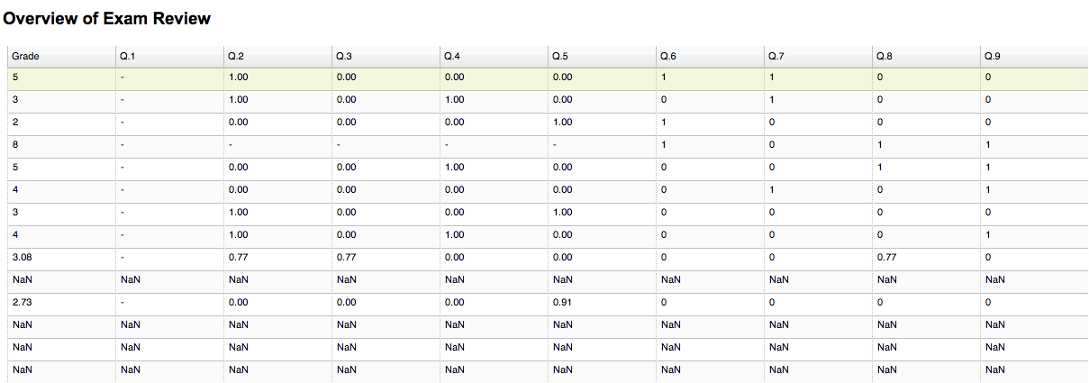

Figure 5.5‑1 Example of overview of exam review in individual level Part 1

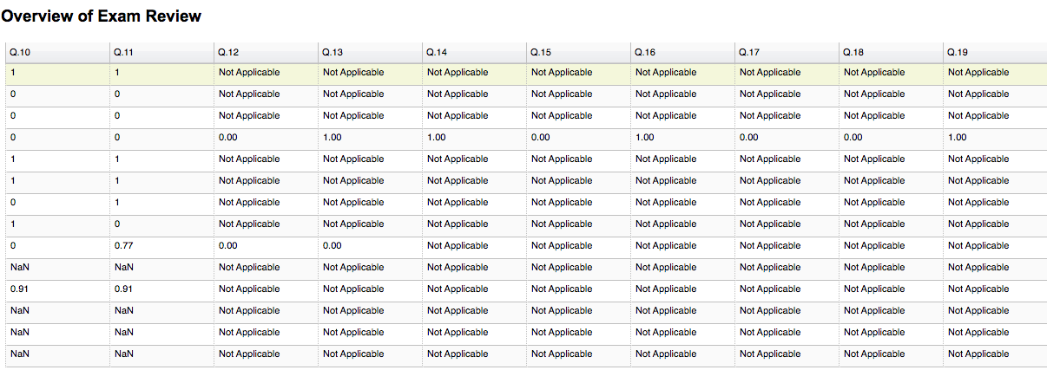

Figure 5.5‑2 Example of overview of exam review in individual level Part 2

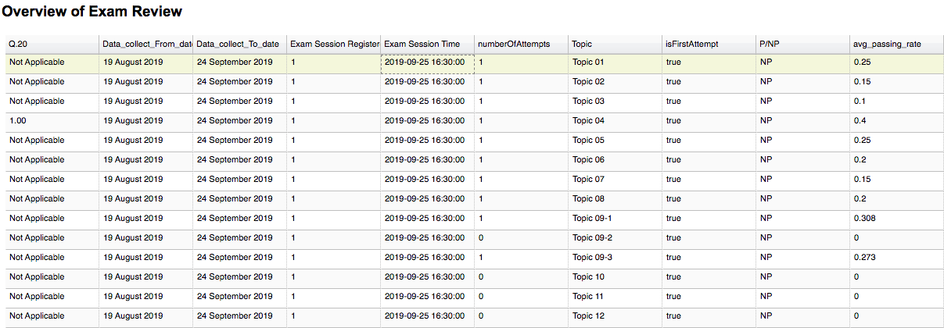

Figure 5.5‑3 Example of overview of exam review in individual level Part 3

We start to analyse individual student data after we collected all exam review records of a student. From results of exam review of each topic, we can also find how well the student performed in each question, and the score of each question will contribute to the overall grade of a topic. For each correct answer, student gains 1 point. If the answer is incorrect or omitted, score for that question will be zero. Pass ‘P’ or No Pass ‘NP’ of a topic will be determined by the overall grade of a specific topic. The rule set to determine whether the student pass in certain topic in exam reviews is this: Student must answer correctly over 70 percent of all the questions in the topic, otherwise, we consider it as No Pass ‘NP’. The average passing rate of a topic is worked out by dividing the total number of correct answers by the total number of questions of a topic.

Average passing rate will be calculated for every topic as many times as student attempted, after we determined ‘P’ or ‘NP’ of each topic and calculated average passing rate. We start to draw conclusion of student performance in exam review during the period from the start of semester to the day before the student’s first attempt of actual exam or period from the date of student’s last attempt to the day before the student’s next (scheduled) attempt of the exam. If student attempted more than once in certain topic in exam review, we accumulate the average passing rate of that topic and divided by number of times the student attempted the exam. The result of division will be represented as total average passing rate of student for that topic. And we will evaluate the result of division whether it is Pass ‘P’ or No Pass ‘NP’.

The result of exam review will be compared with results collected from actual exam. In this case, we are able to evaluate the differences between results from exam review and actual exam. Especially for student obtained ‘NP’ from his/her actual exam. We can use our findings to encourage students to study harder in specific topics which they did not perform well in exam review and actual exam. Since we analysed student performance topic by topic, and we can also focus on student’s weak areas of performance in certain topics, the summative analysis should help inform and improve their performance by with our analytic personalized report.

We summarized the predicted result and actual result from each topic for the purpose of counting value of correct and incorrect predictions. Confusion matrix allows us to measure performance of our prediction method. With counted value of true positive, true negative, false positive and false negative, we can retrieve the accuracy of our prediction model. The following Table 5.5-1 illustrates the confusion matrix of predicted performance and actual performance of an individual student. For example, accuracy of correct prediction would be 4/(8+4) = 0.333 and accuracy of incorrect prediction would be 8/(8+4) = 0.667.

Table 5.5‑1 Example of confusion matrix in individual student

|  |  |  |
| --- | --- | --- |
|  | **Predicted Pass** | **Predicted No Pass** |
| Actual Pass | 0 | 0 |
| Actual No Pass | 8 | 4 |
|  |  |  |

### Summative Data Analysis in Exam Session Level

In the first semester of 2019/2020, there are 22 exam sessions of CISC1000. For each exam session, we are able to obtain a list of students registered for exam in that session. After we finished summative analysis in individual level, we classify students into two groups for Exam Review: namely, the ‘P’ and ‘NP’ respectively. On the other hand, students are split into three categories in actual exam result, which are ‘P’, ‘NP’ and ‘Absent’ respectively. Hence, we have the number of students who achieve ‘P’, ‘NP’ in exam review and students who obtain ‘P’, ‘NP’ and ‘Absent’ in their actual exam. Since we collected those numbers, we are able to make a comparison between predicted number of students and actual number of students in the following six scenarios

* Predicted number of students obtained ‘P’ and actual number of students obtained ‘P’
* Predicted number of students obtained ‘P’ and actual number of students obtained ‘NP’
* Predicted number of students obtained ‘P’ and actual number of students obtained ‘Absent’
* Predicted number of students obtained ‘NP’ and actual number of students obtained ‘P’
* Predicted number of students obtained ‘NP’ and actual number of students obtained ‘NP’
* Predicted number of students obtained ‘NP’ and actual number of students obtained ‘Absent’

Based on six groups listed above, we are able to obtain four sets of values, which are true positive, true negative, false positive and false negative. These four sets of values are important elements for a confusion matrix to evaluate the accuracy between predicted result from exam reviews and actual result from exam session. We managed to discover the differences between predicted result and actual result. After our observation for 22 exam sessions, we have found that the majority of registered students in a single exam session results in No Pass (NP), minority of registered students are absent. The remaining proportion of registered student results in Pass (P).

In our deeper investigation of student exam results, the overall performance of an exam session is based on 12 topics. We also looked into student’s performance at the topic level. The distribution of ‘Predicted Pass’ students, ‘Predicted No Pass’ students, ‘Actual Pass’ students and ‘Actual No Pass’ students, varies with different topics. After we sum up the respective numbers of ‘Predicted Pass’ students, ‘Predicted No Pass’ students, ‘Actual Pass’ students and ‘Actual No Pass’ students, we find the difference between ‘Predicted Pass’ students and ‘Actual Pass’ students, and difference between ‘Actual Pass’ students and ‘Predicted No Pass’ students.  
Subsequently, we can work out the percentages of the difference between predicted result and actual result. Afterwards, we collected percentages of difference in Passing Rate, No Passing Rate for each of the 12 topics. Then we accumulated the percentage of difference in Passing Rate for all the 12 topics and divided the same by 12 in order to get the average percentage of difference in Passing Rate. Hence, we are able to find out the maximum and minimum percentages of difference in Passing Rate and using such percentages of difference in Passing Rate for each topic to compare with average percentage of difference in Passing Rate in order to find out whether the percentage is below, above or equal to average percentages. The result of comparison can be used to evaluate the accuracy of our prediction method (quite heuristic but logical). On the other hand, the method can also be applied to calculate average percentage of difference in No Passing rate.

## Summary

Based on the outcome of our summative analysis, we have discovered that our predicted method for number of NP students are much higher than number of P students. However, the number of P students in official exams (as far as each topic is concerned) is normally higher than the number of P students predicted based on exam review and the number of NP students are slightly lower than the number of predicted NP students. For some of topics, there tended to be more NP students than P students. To conclude, students who attempted exam reviews and obtained Pass for NINE topics or above has highest probability to pass in their actual exam.

In some exceptional cases, there were students who did not attempt any of exam reviews and since we did not have any records of their exam reviews, we considered those students to receive a No Pass grade for exam review in each of the 12 topics, but some of them still passed the actual exams. However, the main focus of summative analysis is on what to inform those NP students so as to improve their performance in their next exam attempts. We encourage NP students with no records of exam reviews to practise more the suggested topics based on our analytic advice before they enter the next exam.

For students who obtained P in 6 to 9 topics in exam review and still results in No Pass in actual exams, we suggest them to enhance their review based on our report of summative analysis for their actual exam performance (identifying their relatively weak topics with low scores achieved) and try to improve their performances for their next registered exam. We also suggest students obtained No Pass and collected 0 to 5 topics with Pass in exam reviews, strengthen knowledge of each topics by taking a thorough revision from study materials and re-attempt all topics of exam reviews. On the other hand, for students who scored No Pass or absent in last exam session of the semester, we advise them to re-take the course and study all the materials given from the course and strongly advise them to practise with all topics of exam reviews.

# DATA VISUALIZATION

## Introduction

This chapter is written to illustrate essential result from Chapter 5 Summative Data Analysis, in order to answer questions raised in the scenarios from Chapter 3 and explain our discovery towards *Section 5.4.1 Summative Data Analysis in Individual Level and 5.4.2 Summative Data Analysis in Exam Session Level*. This is a vital step for my storytelling on the course performance of student learning for *CISC1000 Information Technology and Practise,* delivered in the first semester of 2019/2020 academic year.

## CISC1000 Essential Data for Each Exam Session

The essential data gathered for CISC1000 at the end of the semester including the number of Pass (P) students, number of No Pass (NP) students and number of Absent (ABS) students in actual exam session and exam reviews include the following:

Table 6.2‑1 Overview of P, NP and ABS students’ distribution in each actual Exam Session

|  |  |  |  |  |
| --- | --- | --- | --- | --- |
| Exam Session No | Number of Pass  (P) students | Number of No Pass (NP) students | Number of Absent (ABS) students | Total Number of Student Registered |
| 1 | 85 | 94 | 20 | 199 |
| 2 | 51 | 97 | 50 | 198 |
| 3 | 52 | 109 | 33 | 194 |
| 4 | 33 | 81 | 39 | 153 |
| 5 | 75 | 84 | 41 | 200 |
| 6 | 93 | 78 | 29 | 200 |
| 7 | 94 | 67 | 39 | 200 |
| 8 | 90 | 79 | 31 | 200 |
| 9 | 95 | 84 | 21 | 200 |
| 10 | 88 | 78 | 34 | 200 |
| 11 | 77 | 100 | 23 | 200 |
| 12 | 84 | 83 | 33 | 200 |
| 13 | 90 | 70 | 40 | 200 |
| 14 | 17 | 15 | 17 | 49 |
| 15 | 46 | 38 | 30 | 114 |
| 16 | 37 | 74 | 27 | 138 |
| 17 | 86 | 81 | 31 | 198 |
| 18 | 84 | 82 | 32 | 198 |
| 19 | 5 | 11 | 10 | 26 |
| 20 | 13 | 12 | 15 | 40 |
| 21 | 21 | 28 | 21 | 70 |
| 22 | 20 | 36 | 35 | 91 |

Table 6.2‑2 Overview of P, NP and ABS students’ distribution in each Exam Review for each exam session

|  |  |  |  |  |
| --- | --- | --- | --- | --- |
| Exam Session No | Number of Predicted  Pass (P) students | Number of Predicted No Pass (NP) students | Number of Absent (ABS) students | Total Number of Student Registered |
| 1 | 25 | 174 | 0 | 199 |
| 2 | 14 | 184 | 0 | 198 |
| 3 | 19 | 175 | 0 | 194 |
| 4 | 10 | 143 | 0 | 153 |
| 5 | 11 | 189 | 0 | 200 |
| 6 | 9 | 191 | 0 | 200 |
| 7 | 10 | 190 | 0 | 200 |
| 8 | 5 | 195 | 0 | 200 |
| 9 | 3 | 197 | 0 | 200 |
| 10 | 5 | 195 | 0 | 200 |
| 11 | 6 | 194 | 0 | 200 |
| 12 | 5 | 195 | 0 | 200 |
| 13 | 6 | 194 | 0 | 200 |
| 14 | 0 | 49 | 0 | 49 |
| 15 | 1 | 113 | 0 | 114 |
| 16 | 0 | 138 | 0 | 138 |
| 17 | 3 | 195 | 0 | 198 |
| 18 | 1 | 197 | 0 | 198 |
| 19 | 0 | 26 | 0 | 26 |
| 20 | 0 | 40 | 0 | 40 |
| 21 | 1 | 69 | 0 | 70 |
| 22 | 1 | 90 | 0 | 91 |

## Comparison of Exam Review and Actual Exam In Each Session

There were 22 examinations scheduled throughout the semester. For every exam review for each exam session, the majority of students were predicted with grade of No Pass. Minority of students predicted with grade of Pass. Our grading principle is student who achieved score greater than or equals to 70 will be considered as Pass, student who achieved score below 70 will be considered as No Pass. We applied bar chart to illustrate our compared data, the bar chart of all exam session mainly is divided into two parts which is Predicted Result and Actual Result respectively. For each part of bar chart, it contains three categories which is P, NP and Absent respectively, and measured value represents the number of students. Overall, bar chart can be interpreted as the number of P students, number of NP students and number of Absent students in predicted result category. On the other hand, it can also be interpreted as the number of P student, number of NP student and number of Absent students in actual exam result category. The figures below show the statistics of student’s performance in exam review and actual exams.

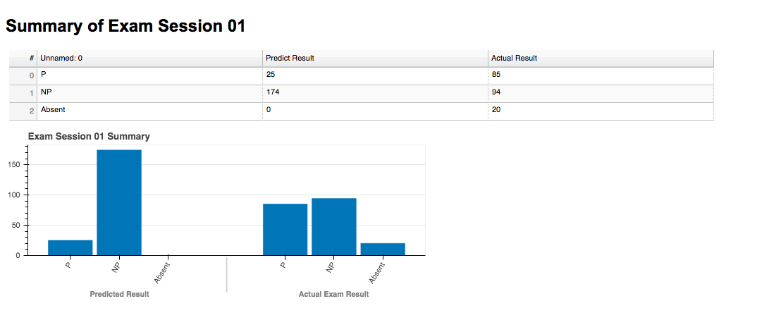

Figure 6.3‑1 Comparison of Exam Review and Exam Session 01

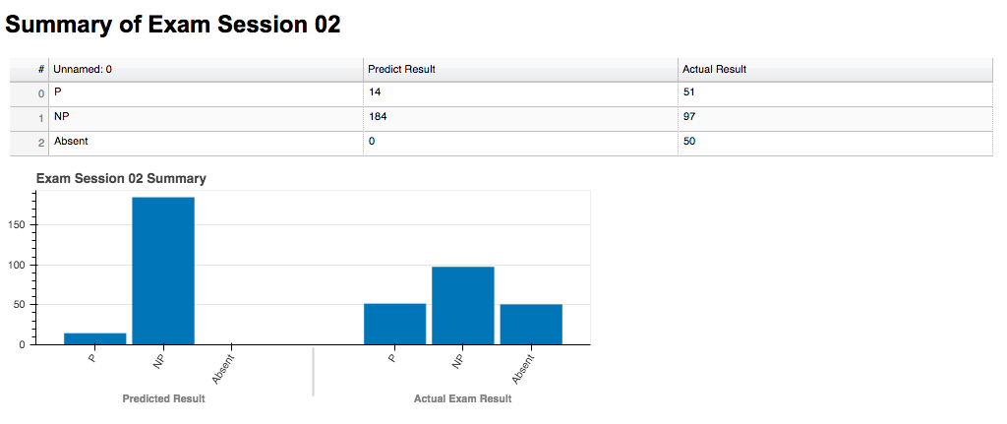

Figure 6.3‑2 Comparison of Exam Review and Exam Session 02

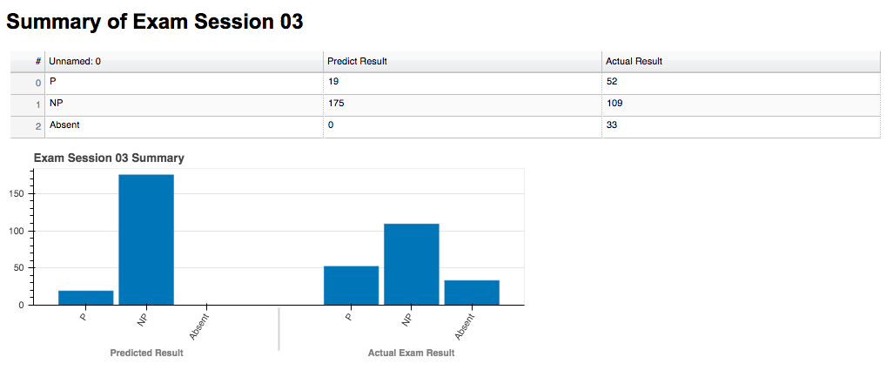

Figure 6.3‑3 Comparison of Exam Review and Exam Session 03

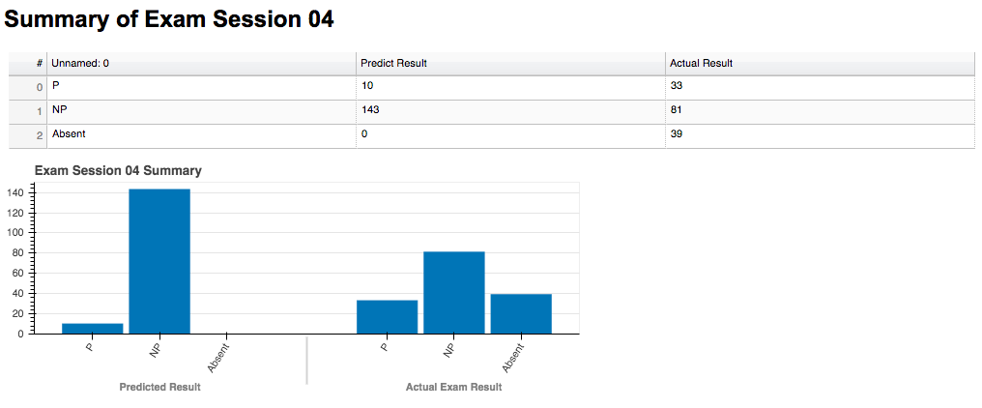

Figure 6.3‑4 Comparison of Exam Review and Exam Session 04

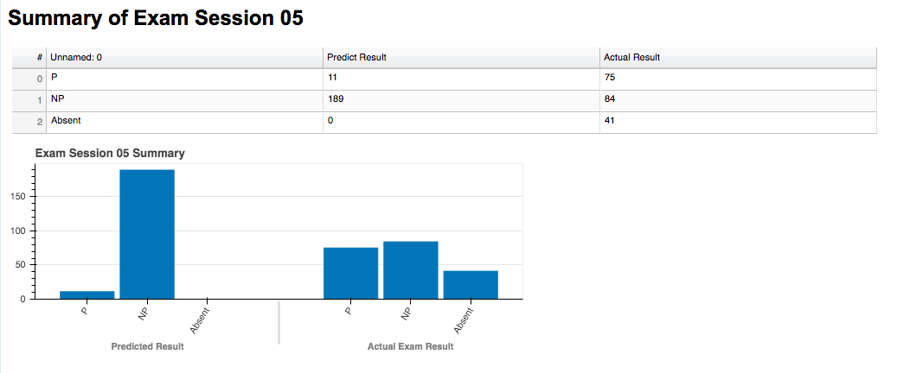

Figure 6.3‑5 Comparison of Exam Review and Exam Session 05

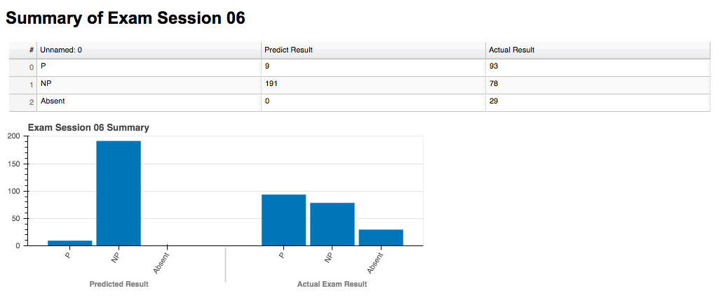

Figure 6.3‑6 Comparison of Exam Review and Exam Session 06

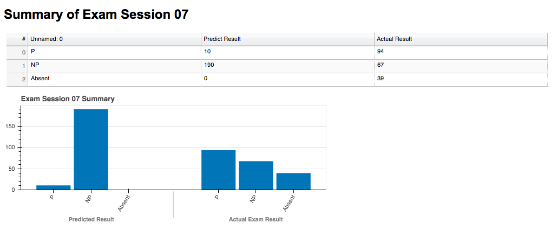

Figure 6.3‑7 Comparison of Exam Review and Exam Session 07

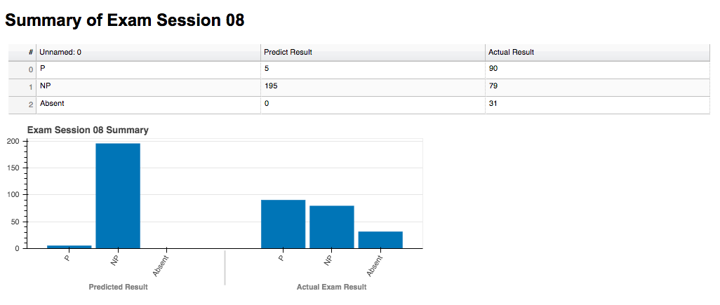

Figure 6.3‑8 Comparison of Exam Review and Exam Session 08

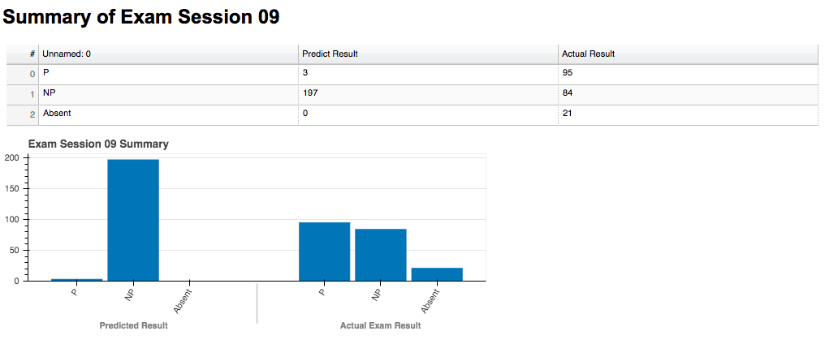

Figure 6.3‑9 Comparison of Exam Review and Exam Session 09

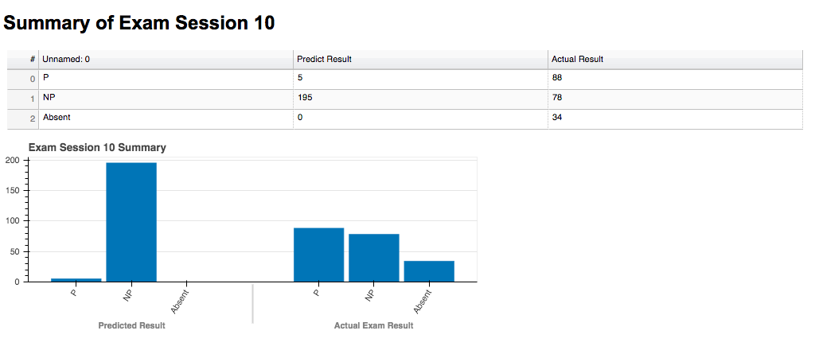

Figure 6.3‑10 Comparison of Exam Review and Exam Session 10

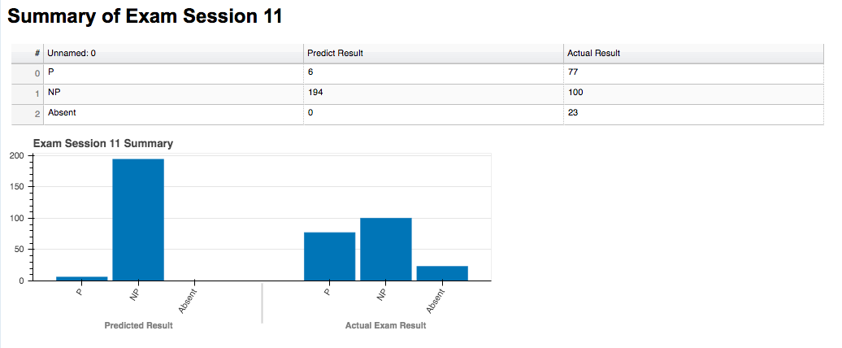

Figure 6.3‑11 Comparison of Exam Review and Exam Session 11

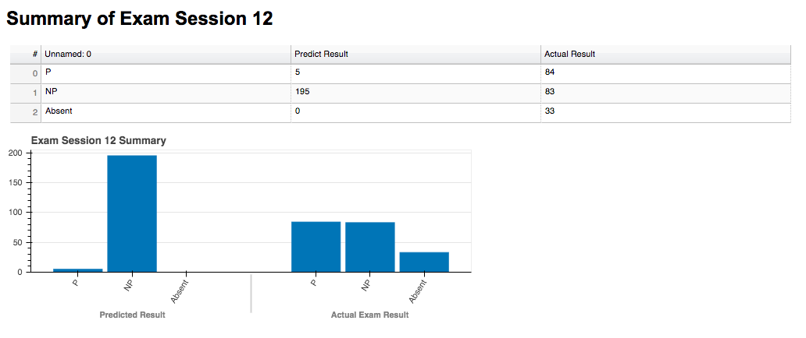

Figure 6.3‑12 Comparison of Exam Review and Exam Session 12

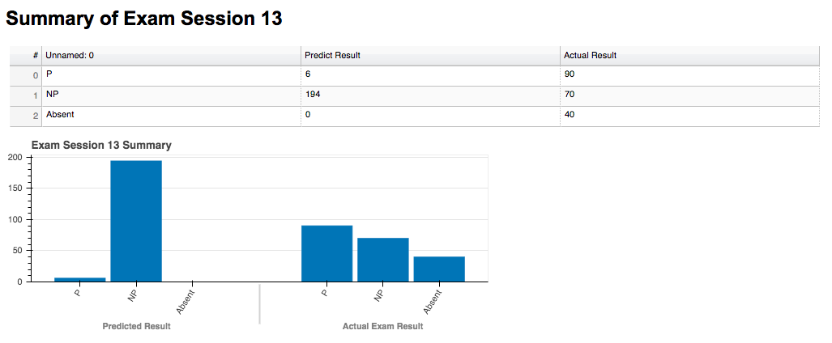

Figure 6.3‑13 Comparison of Exam Review and Exam Session 13

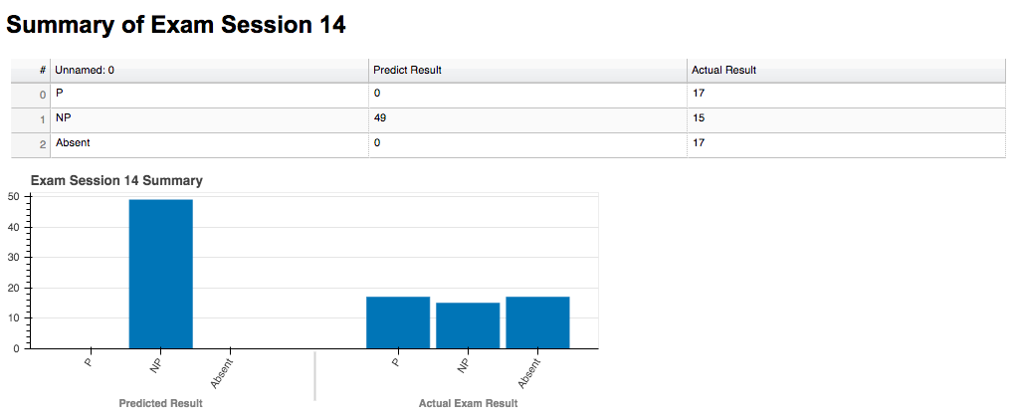

Figure 6.3‑14 Comparison of Exam Review and Exam Session 14

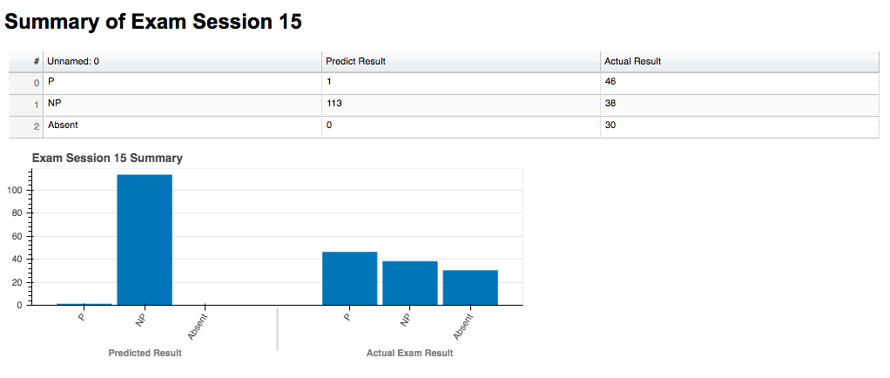

Figure 6.3‑15 Comparison of Exam Review and Exam Session 15

Figure 6.3‑16 Comparison of Exam Review and Exam Session 16

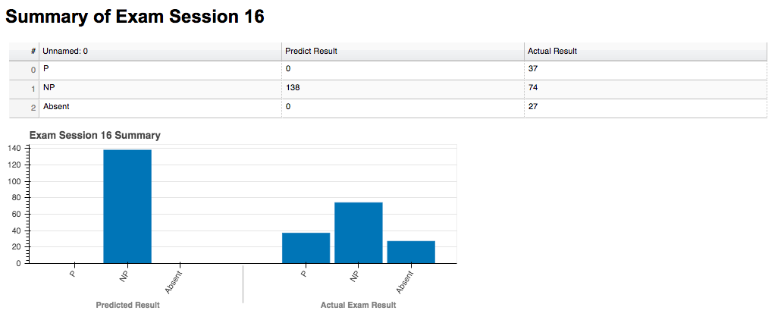

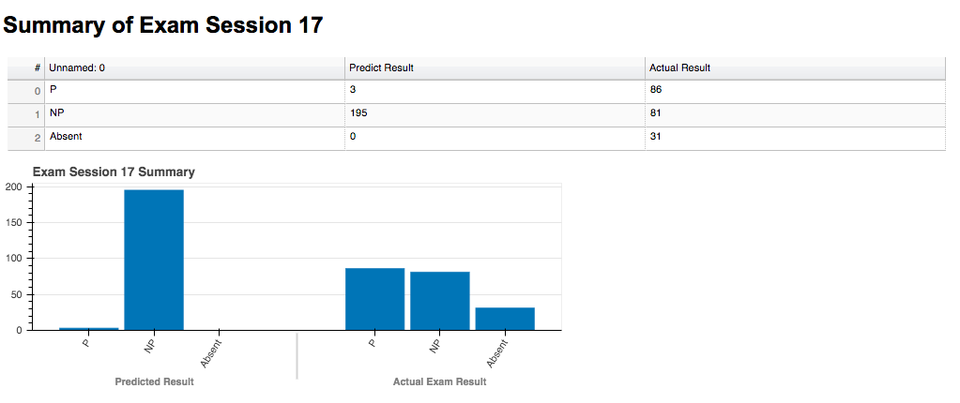

Figure 6.3‑17 Comparison of Exam Review and Exam Session 17

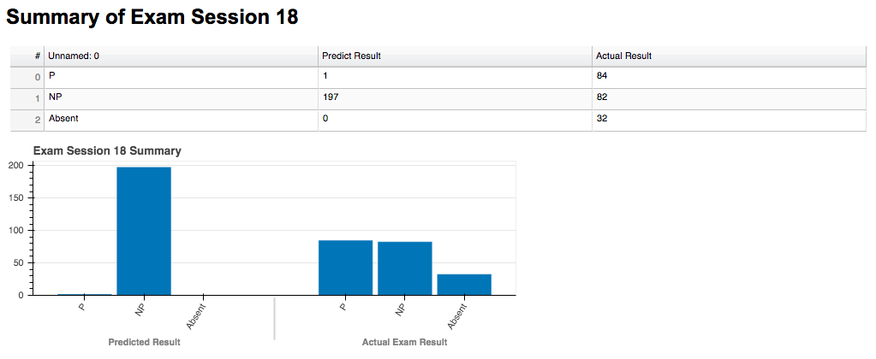

Figure 6.3‑18 Comparison of Exam Review and Exam Session 18

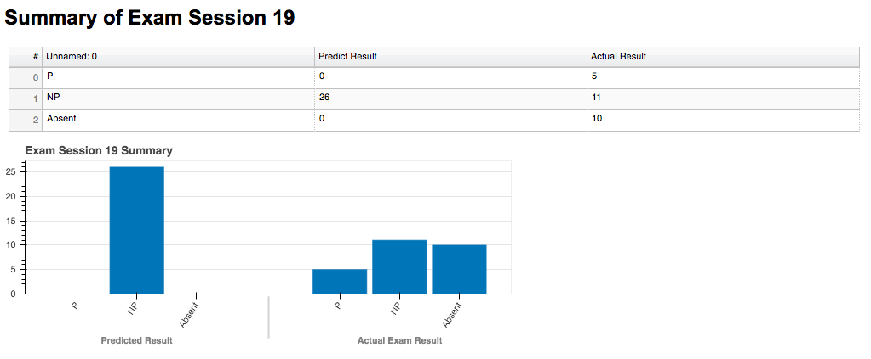

Figure 6.3‑19 Comparison of Exam Review and Exam Session 19

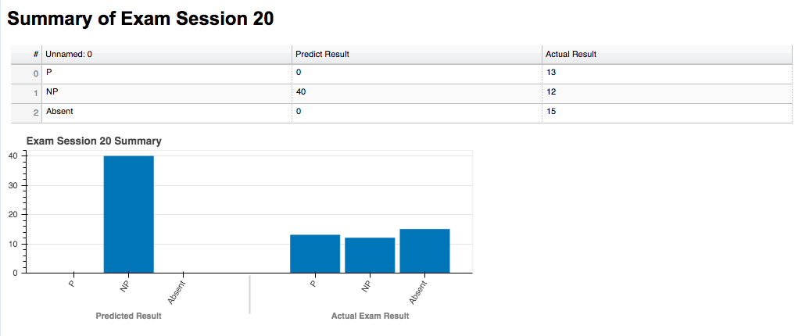

Figure 6.3‑20 Comparison of Exam Review and Exam Session 20

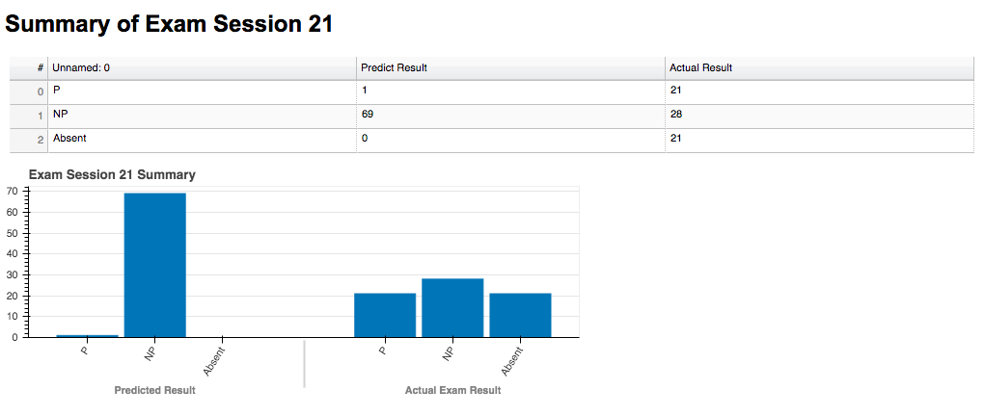

Figure 6.3‑21 Comparison of Exam Review and Exam Session 21

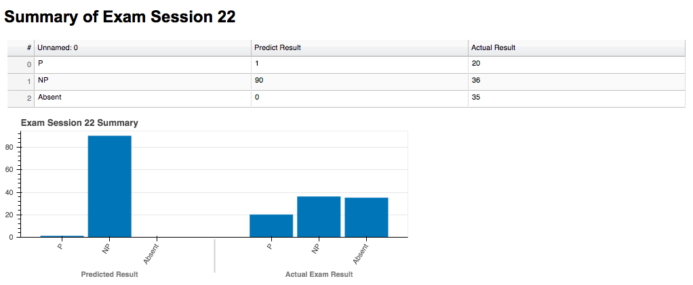

Figure 6.3‑22 Comparison of Exam Review and Exam Session 22

To conclude, the overall prediction for NP students are much higher than number of P students. In official exams, number of NP student reduced significantly compared with predicted number retrieved from exam reviews. In contrast, number of P students in official exams increase sharply compared with predicted number of P students in exam reviews.

### Insight of Summary of Overall Exam Sessions

Table of Overview of difference between predicted P rate and NP rate in exam review and official 22 exam sessions (Fig 6.3.1.1) has shown the percentage of difference between predicted P rate and NP rate in exam review and actual exam. We calculate the average difference of each result from every exam session. Based on our findings, the average difference of P rate is about 20 percent lower than average difference of NP rate. There are 10 exam sessions with P rate below average and 8 exam session with NP rate below average.

Table 6.3‑1 Table of Overview of difference between predicted P rate and NP rate in exam review

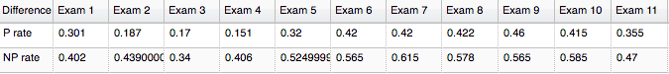

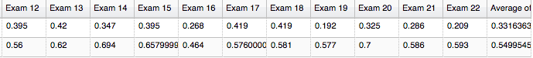

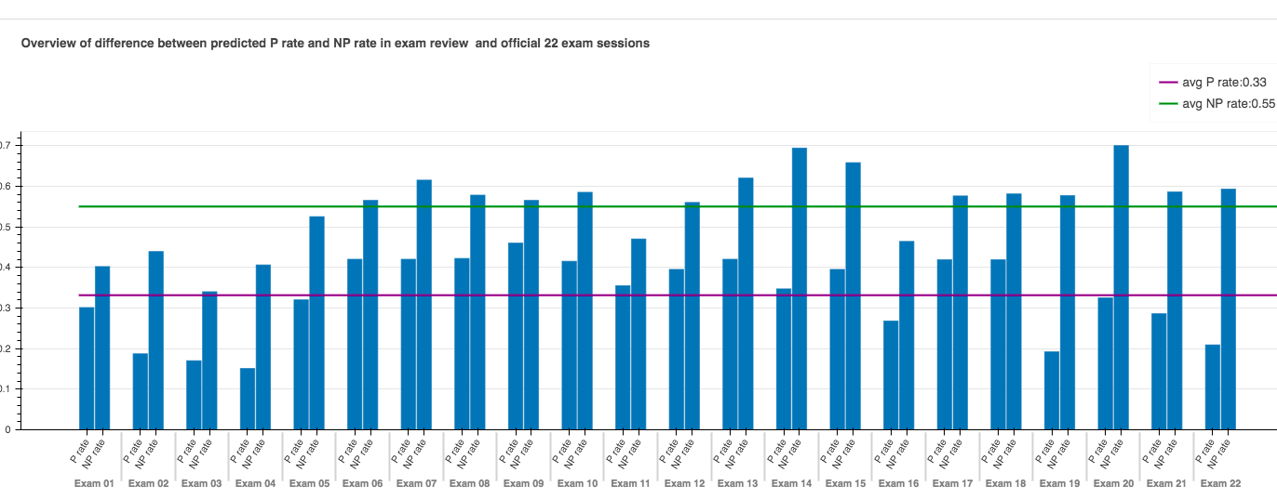

Figure 6.3‑23 Bar Graph of Overview of difference between predicted P rate and NP rate in exam review and official 22 exam sessions

## Confusion Matrix of Predicted Results And Actual Results

### Introduction of Confusion Matrix

To evaluate the accuracy of our predicted grade of student in their actual exam. We used our findings in section 6.3 to summarize the number of correct and incorrect predictions with count values and divided by each class such as Pass and No Pass. In particular, class of Pass defined as our observation of student’s grade is Pass and class of No Pass defined as our observation of student’s grade results in No Pass. Since we need to count the number of True Positive where student’s actual grade is Pass and our predicted grade for student is also Pass, the number of False Negative where student’s actual grade is Positive (Pass) but our predicted grade for student is negative (No Pass), the counted value of True Negative where student’s actual grade is negative (No Pass) and our predicted score for student is negative (No Pass), and the counted value of False Positive where student’s grade is negative (No Pass) and our predicted grade is positive (Pass). In this way, we summarized data in a confusion matrix (table) as followed.

Table 6.4‑1 Example of Confusion Matrix

|  |  |  |
| --- | --- | --- |
|  | Predicted Pass | Predicted No Pass |
| Actual Pass | True Positive | False Negative |
| Actual No Pass | False Positive | True Negative |

### Confusion Matrix of Each Exam Session

In our confusion matrix, we also included the number of absent students in actual exam session in order to make the data consistent, but we only focus on the number of Pass (P) and No Pass (NP) students in exam review and actual exam sessions. To illustrate the data from confusion matrix of every exam session, we choose bar graph to visualize the numbers of P, NP and absent student of actual exams in both predicted P and NP categories. From the bar graph of confusion matrix, we can compare the counted value of True Positive, True Negative, False Positive and False Negative. The following

figures shows confusion matrix of 22 exam sessions in data table and bar chart.

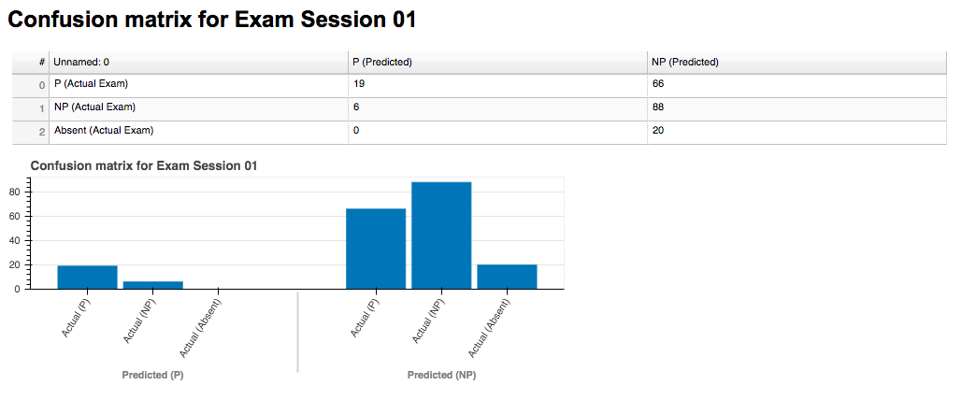

Figure 6.4‑1 Confusion matrix of Exam Review and Exam Session 01

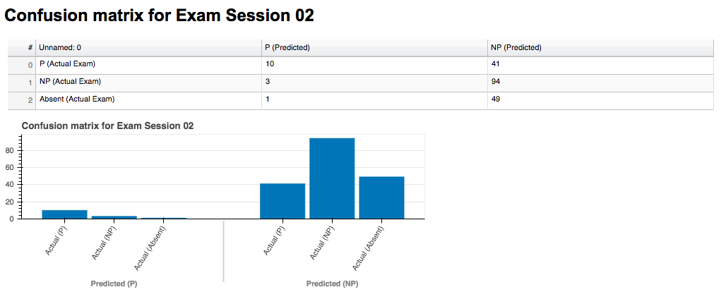

Figure 6.4‑2 Confusion matrix of Exam Review and Exam Session 02

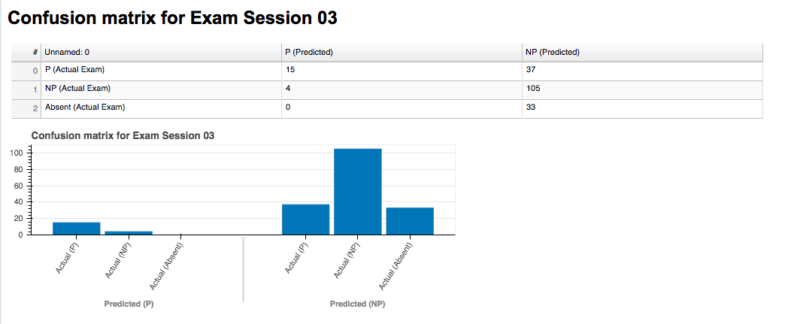

Figure 6.4‑3 Confusion matrix of Exam Review and Exam Session 03

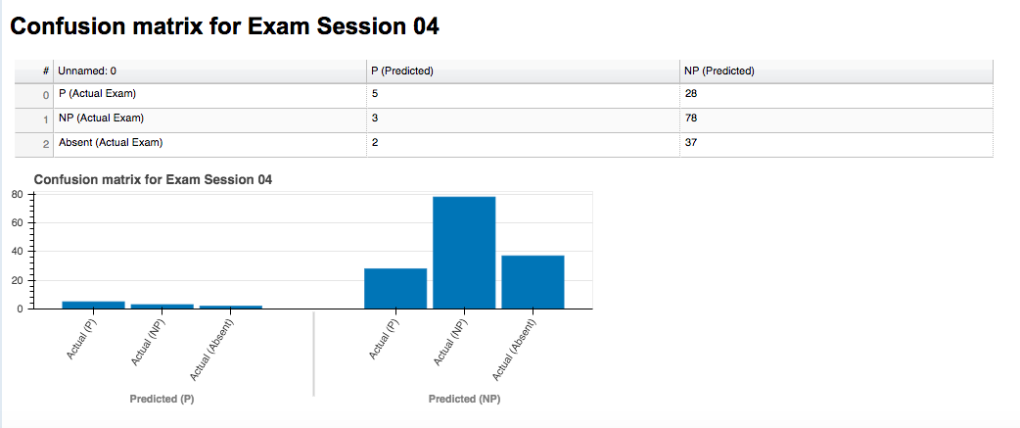

Figure 6.4‑4 Confusion matrix of Exam Review and Exam Session 04

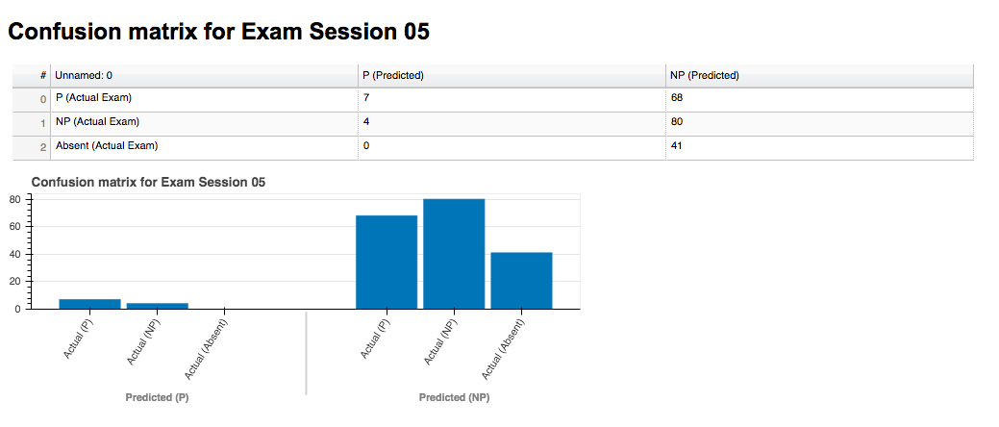

Figure 6.4‑5 Confusion matrix of Exam Review and Exam Session 05

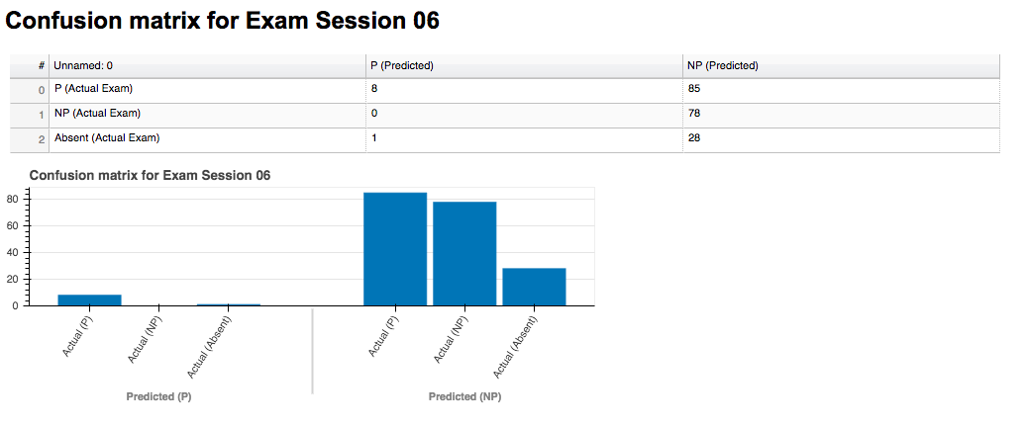

Figure 6.4‑6 Confusion matrix of Exam Review and Exam Session 06

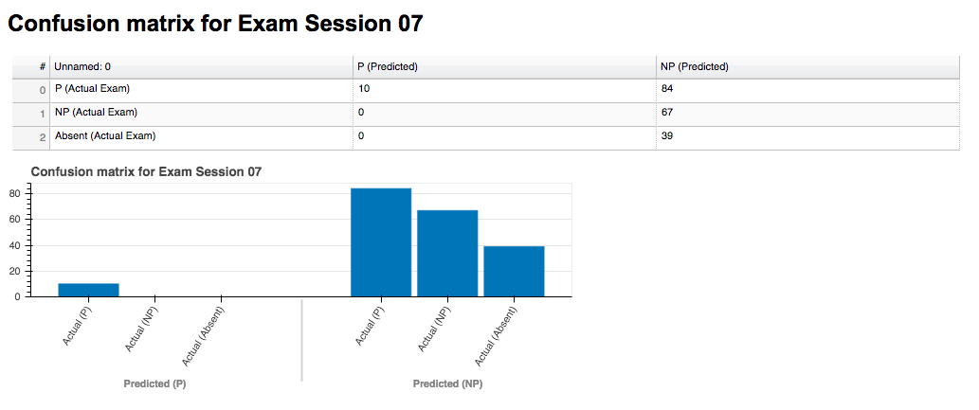

Figure 6.4‑7 Confusion matrix of Exam Review and Exam Session 07

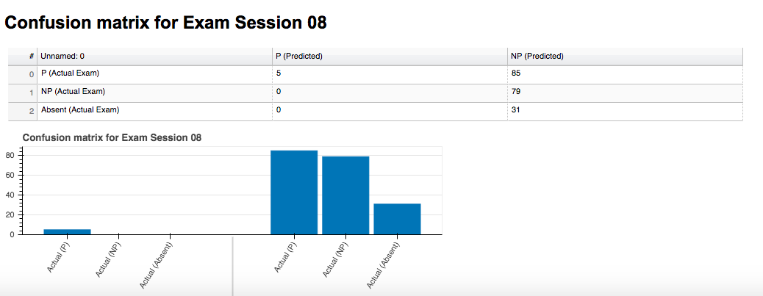

Figure 6.4‑8 Confusion matrix of Exam Review and Exam Session 08

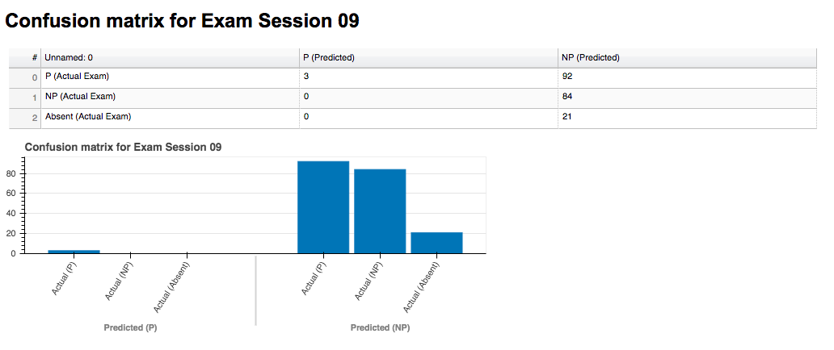

Figure 6.4‑9 Confusion matrix of Exam Review and Exam Session 09

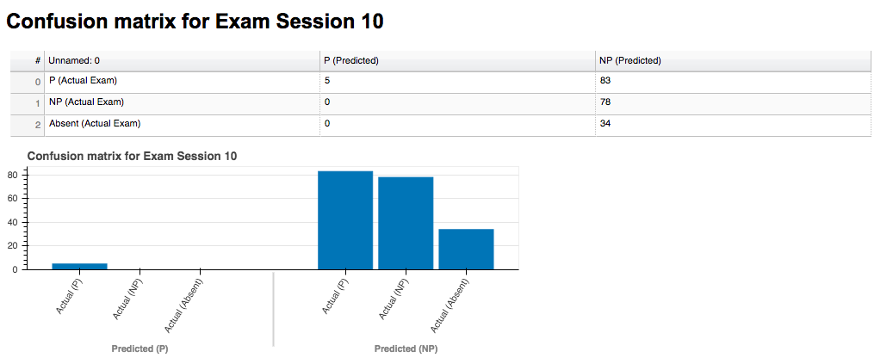

Figure 6.4‑10 Confusion matrix of Exam Review and Exam Session 10

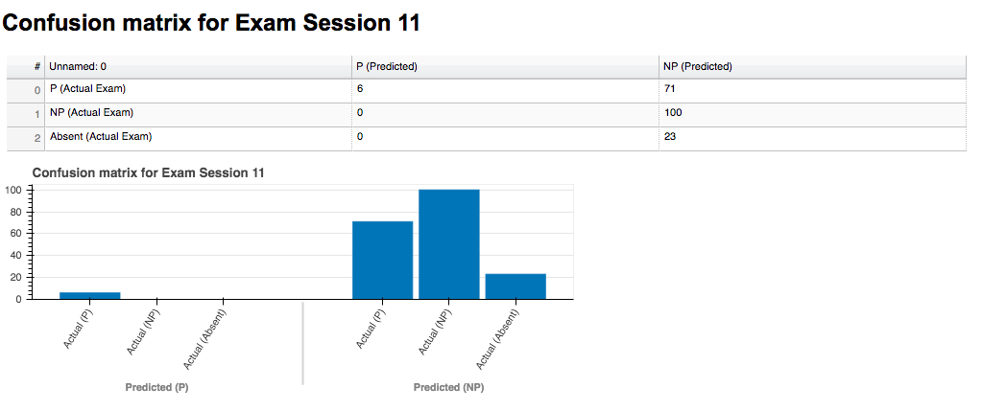

Figure 6.4‑11 Confusion matrix of Exam Review and Exam Session 11

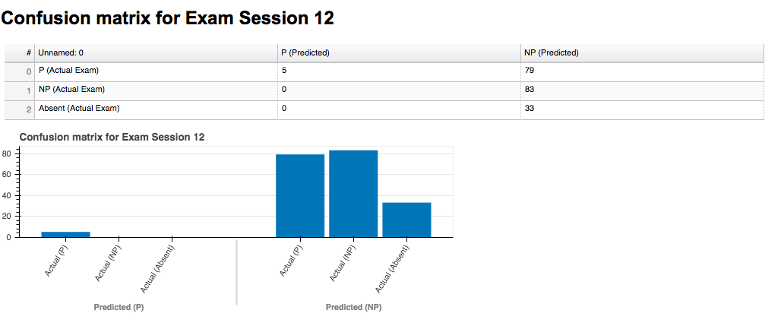

Figure 6.4‑12 Confusion matrix of Exam Review and Exam Session 12

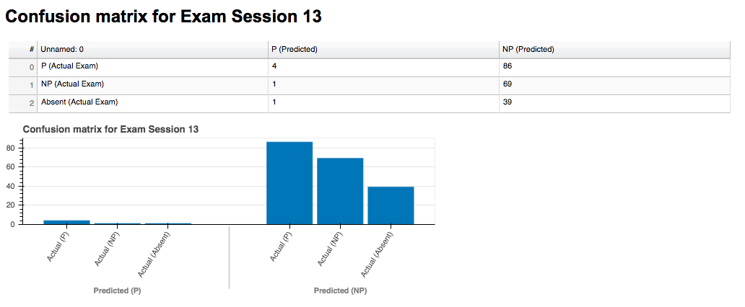

Figure 6.4‑13 Confusion matrix of Exam Review and Exam Session 13

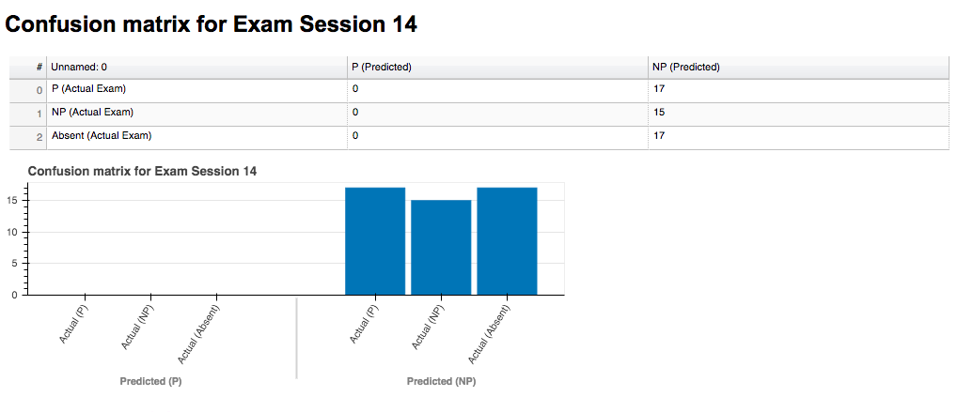

Figure 6.4‑14 Confusion matrix of Exam Review and Exam Session 14

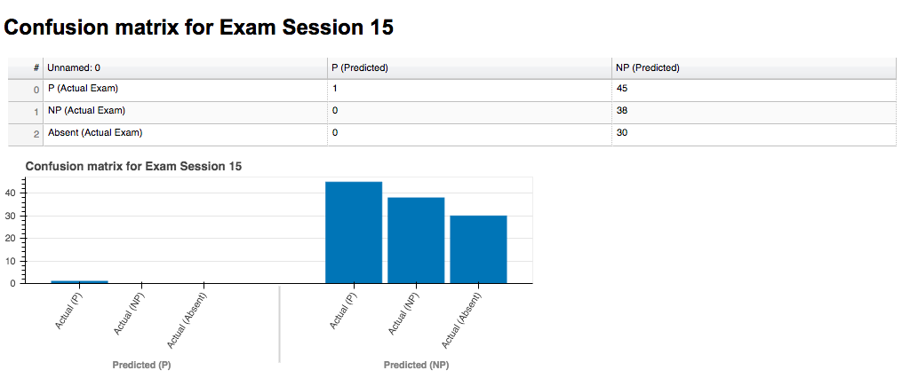

Figure 6.4‑15 Confusion matrix of Exam Review and Exam Session 15

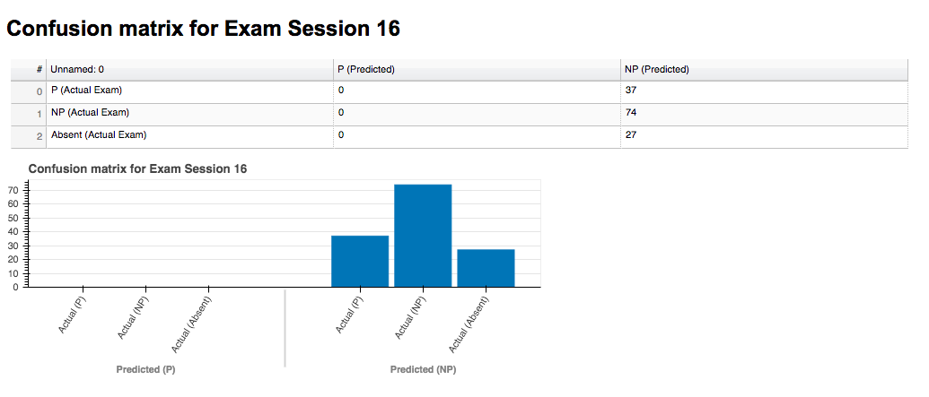

Figure 6.4‑16 Confusion matrix of Exam Review and Exam Session 16

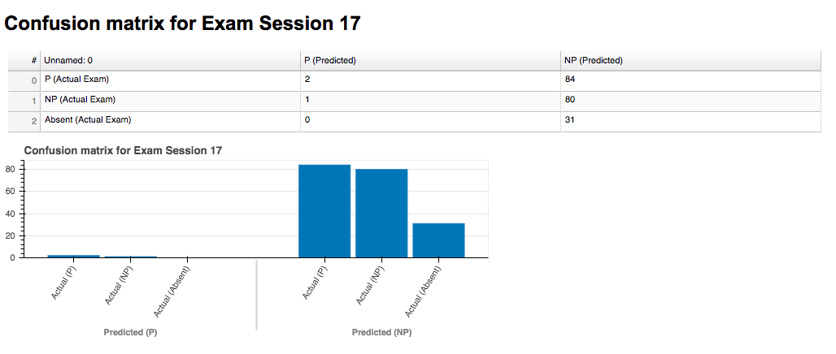

Figure 6.4‑17 Confusion matrix of Exam Review and Exam Session 17

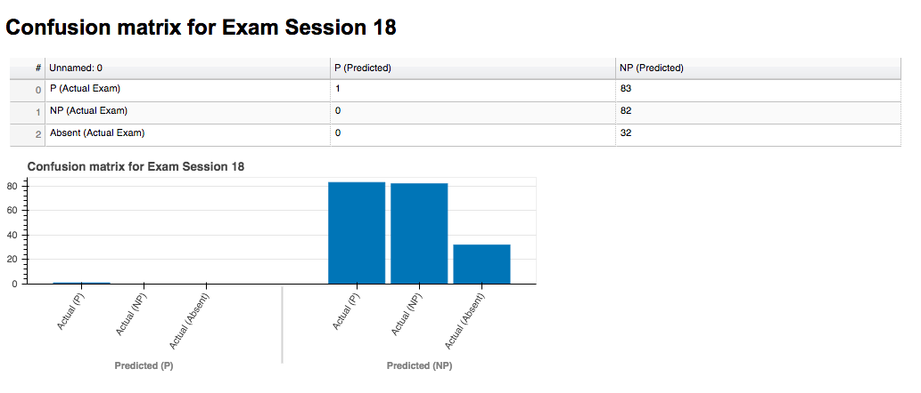

Figure 6.4‑18 Confusion matrix of Exam Review and Exam Session 18

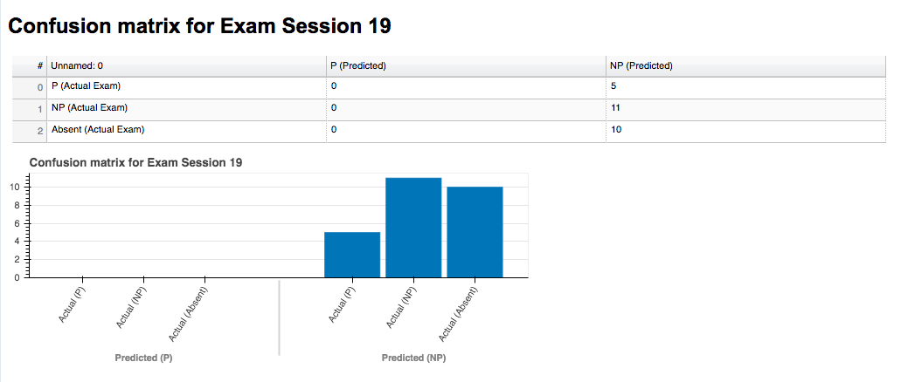

Figure 6.4‑19 Confusion matrix of Exam Review and Exam Session 19

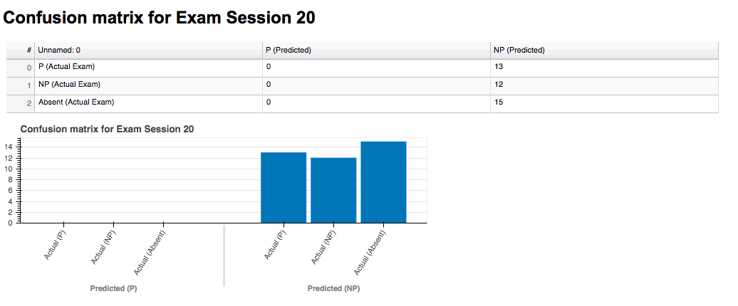

Figure 6.4‑20 Confusion matrix of Exam Review and Exam Session 20

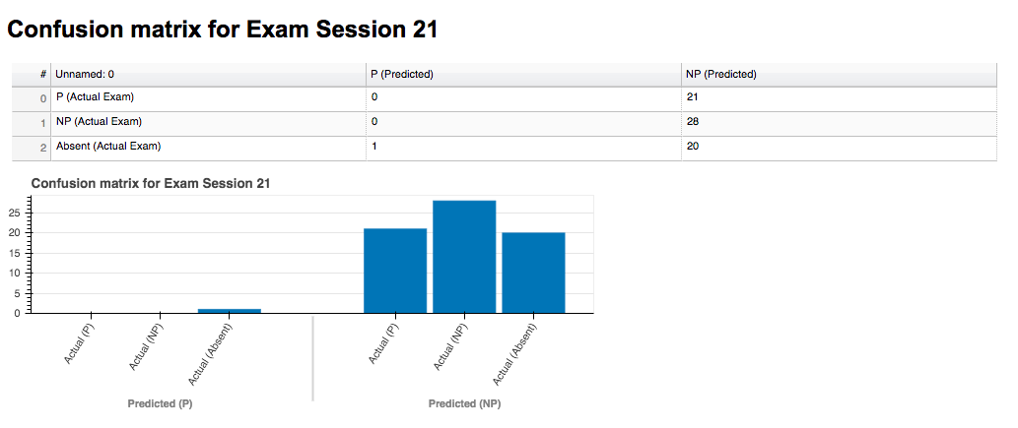

Figure 6.4‑21 Confusion matrix of Exam Review and Exam Session 21

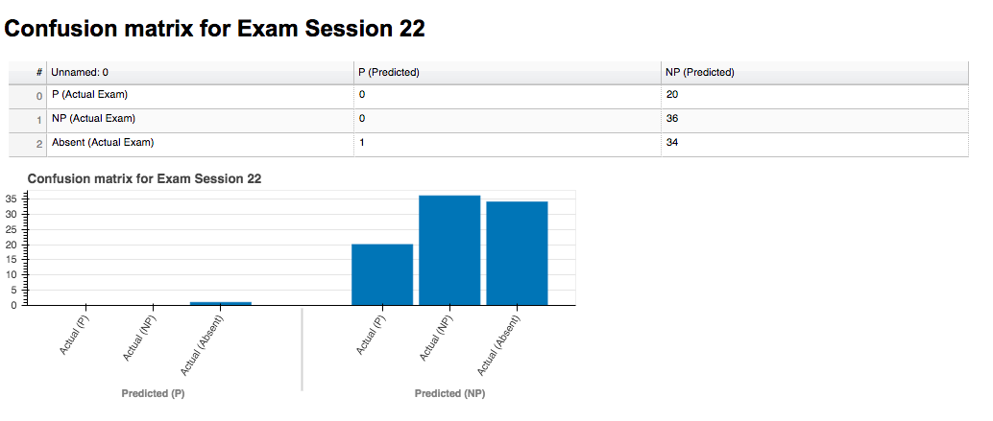

Figure 6.4‑22 Confusion matrix of Exam Review and Exam Session 22

## Visualization of Exam Sessions at Topic-Wise Level

At this point, we have discovered the distribution of P and NP students in every exam session. Since the student grade of any exam is made up of the grades from each of the 12 topics, we focus on a higher level to investigate the spread of P and NP students in each topic. In order to visualize what we have gathered with data analysis; we used the form of bar chart to illustrate the distribution of P and NP students and use Exam Session 1 as an example.

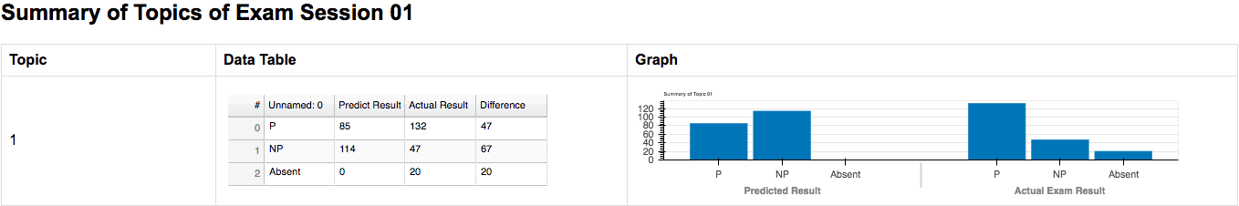

Figure 6.5‑1 Confusion matrix of Topic 01 in Exam Session 01

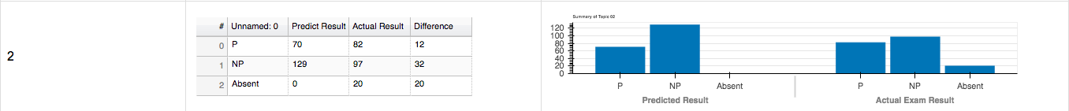

Figure 6.5‑2 Confusion matrix of Topic 02 in Exam Session 01

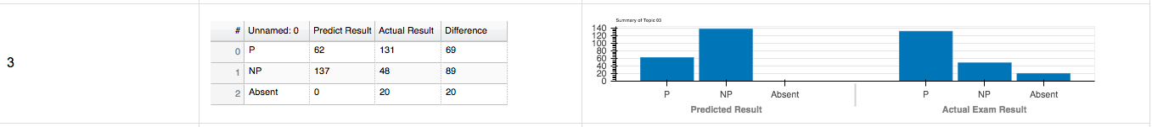

Figure 6.5‑3 Confusion matrix of Topic 03 in Exam Session 01

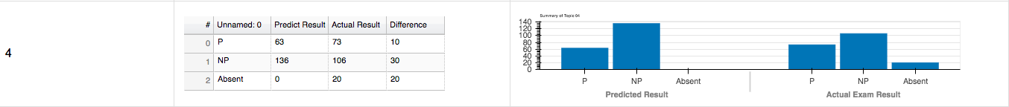

Figure 6.5‑4 Confusion matrix of Topic 04 in Exam Session 01

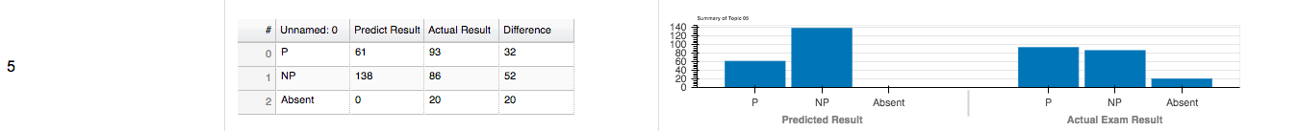

Figure 6.5‑5 Confusion matrix of Topic 05 in Exam Session 01

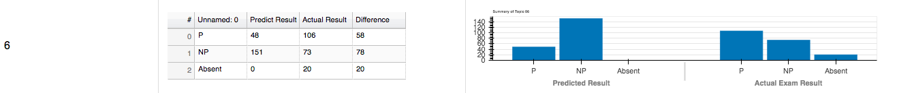

Figure 6.5‑6 Confusion matrix of Topic 06 in Exam Session 01

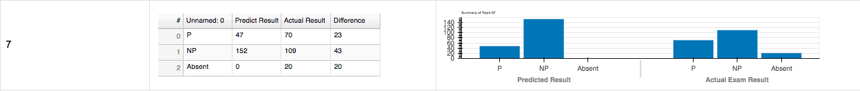

Figure 6.5‑7 Confusion matrix of Topic 07 in Exam Session 01

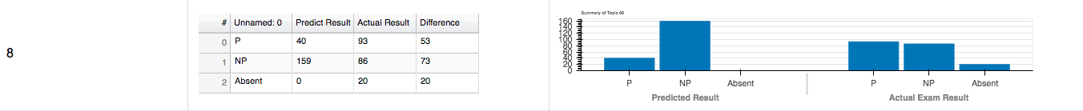

Figure 6.5‑8 Confusion matrix of Topic 08 in Exam Session 01

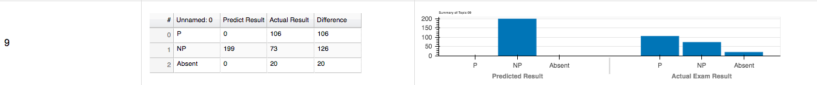

Figure 6.5‑9 Confusion matrix of Topic 09 in Exam Session 01

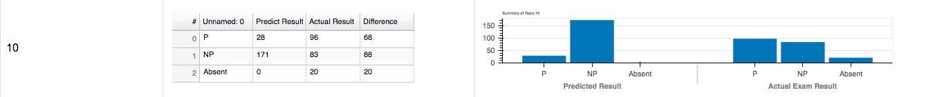

Figure 6.5‑10 Confusion matrix of Topic 10 in Exam Session 01

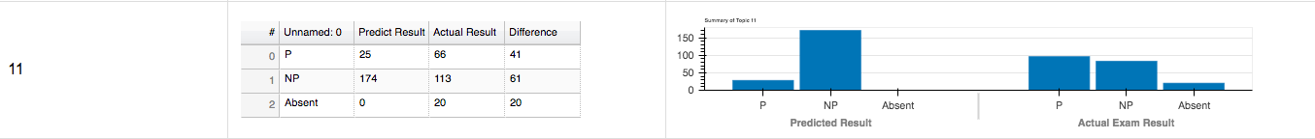

Figure 6.5‑11 Confusion matrix of Topic 11 in Exam Session 01

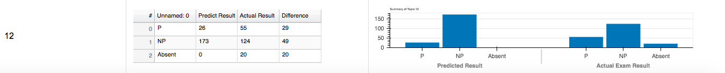

Figure 6.5‑12 Confusion matrix of Topic 12 in Exam Session 01

The bar charts of exam session 01 has shown that the number of predicted NP students has a greater proportion to number of predicted P students in every topic. On the other hand, the number of P students and the number of NP students distributed differently with different topics in actual exam session 01. There are more P students than NP students in Topic 1, 3, 5, 6, 8, 9, 10 and 11. For Topic 2, 4, 7 and 12, it has greater number of NP student than number of P students. As a result, the difference between predicted grade and actual grade can be found in each topic for both P and NP students. With the difference of P student and NP student, we are able to calculate the average percentage of the difference of all 12 topic by accumulating the differences of 12 topics and divided by 12. The average of difference can be used to make a comparison with each topic and decide which one is equal, above or below the average.

## Visualization of Exam Result at Individual Level

There are two main parts in an individual student exam report. The first is Exam Review result and the other is Actual Exam Result. After summative analysis in Exam Review, we able to visualize the overview summary of Exam Review and summary of each topic in an exam review. And we can draw summary of each topic in an actual exam, altogether we generate a line graph for a clear comparison of student’s performances in both exam review and actual result. We picked one student from exam session 01 as an illustration.

### Visualization of Results from Exam Review

With usage of Data Table to visualize student’s overall result in an exam review, it includes the following essential data:

* Student’s personal information
* Exam Session Date and Time
* Duration of exam review of each topic, including start time and end time
* Indication of correct or incorrect for questions answered in each topic
* Number of Attempts for each topic
* Grade of each topic in an exam review

Since the content in overview of exam review cannot be shown all at once, and therefore we split it into 3 figures and assigned three figures as part 1, part 2 and part 3.



Figure 6.6‑1 Example of overview of exam review in individual level Part 1



Figure 6.6‑2 Example of overview of exam review in individual level Part 2



Figure 6.6‑3 Example of overview of exam review in individual level Part 3

We generate table for summary of exam review in each topic from the table of overview of exam review. Table 6.6-1 summarized the performance of a student in every topic in an exam review, the first row shows data of student’s average passing in 12 topics in numeric form and the second row represents the grading of topics. It depends on first row’s result, if value in first row is lower than 0.7, value in second row would be ‘NP’. In contrast, if value of first row is equal to or above 0.7, value in second row would be ‘P’. Overall passing rate at the last column is represented as predicted passing rate of a student in his/her future actual exam.

Table 6.6‑1 Example of overview of exam review in individual level Part 4



### Visualization of Results from Exam Session

We applied form of table to visualize the summary of student performance in actual exam which data is gathered from formative analysis, however, we need to use actual exam data to compare with our predicted result. In order to make the student report complete, we must include a set of result from actual exam. The following table summarized the performance of a student in every topic in an exam session, the first row shows data of student’s average passing in 12 topics in numeric form and the second row represents the grading of topics. It depends on first row’s result, if value in first row is lower than 0.7, value in second row would be ‘NP’. In contrast, if value of first row is equal to or above 0.7, value in second row would be ‘P’. Overall passing rate at the last column is represented as overall passing rate of a student in his/her actual exam.

Table 6.6‑2 Example of table of summary of exam session 01



### Comparison of Exam Review and Exam Session

Based on the table listed in section 6.6.1 and 6.6.2, we are able to plot a line graph to illustrate the comparison between predicted grade from exam review and actual exam. The x-axis of this graph represents the topic of exam review and exam session, for instance, topic = 1, it means Topic 01. Furthermore, the starting point for x-axis is 1, it is because we do not have Topic 0. On the other hand, the y-axis of graph represents the percentage of student achieved in each topic. Moreover, the starting point for y-axis is from 0, since our range of percentage of grade for each topic between from 0.0 to 1.0. For example, this graph contains five lines in five different colours. The green line represents predicted grade of an individual student and each node in the green line represents a specific topic. Line in yellow colour shows the actual grade of student obtained in official exam session, dots along the line represents grade obtained in each topic. The purple line illustrates the official pass rate of 70 percent. The blue line shows overall passing rate of a student achieved in his/her official exam session. And the red line illustrates predicted overall passing rate based on summative analysis on exam review.

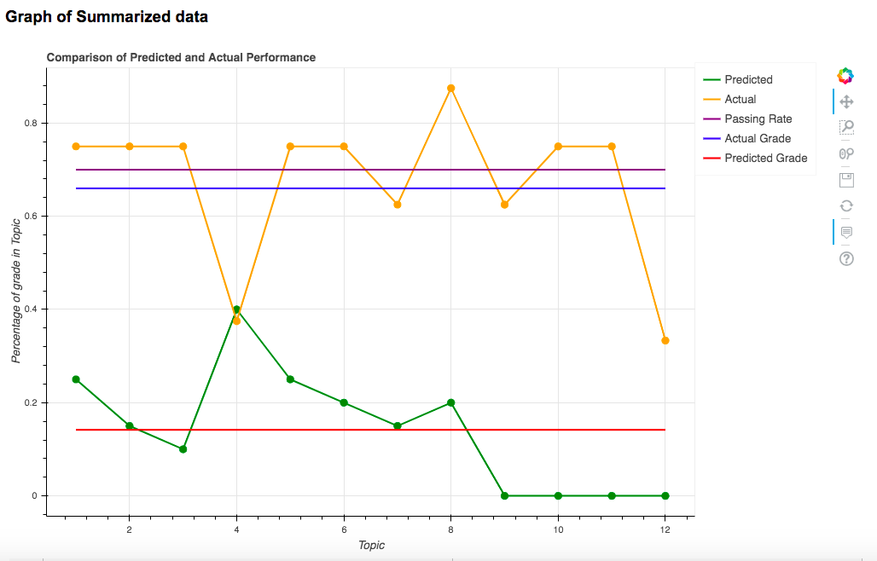

Figure 6.6‑4 Example of comparison of exam review and exam session in individual level

Figure 6.6-4 has shown us the comparison of predicted performance and actual performance of students. With the purple line of official passing rate, percentage of grade in each topic in both predicted and actual performance can be seen clearly whether it is below official passing rate or above official passing rate. The difference between predicted performance and actual performance can also be interpreted from this graph.

Especially for student who obtained NP in their last exam, if they receive a report with the sample graph: They will certainly be aware of which topics they performed weakly and they can put more effort with a clearer goal in some specific topics. Hence, the possibility of improving their grade in their exam will be boosted.

## Visualization of Linearity between Grade of Single Topic and Overall Grade

Before we applied our processed training data to linear regression model, we have to understand the relationship of our dependent variable and independent variables. By plotting 12 scatter graphs with Matplotlib to elucidate Overall Grade against Topics.

We discovered there has positive correlation between Overall Grade and grades obtained in each topic. To summarize, if the student scored higher in each topic, there will be a higher possibility for a student to pass the exam. The usage of scattered graph is suitable for presenting the correlation of dependent variables and independent variable because our variables are very diverse, the spread of data can be shown clearly in a scatter graph.

From the result of 12 scattered graph, we aware there has some outliners when the score is 0 percent and scored over 70 percent in overall grade. It indicates some students who did not attempt the exam review(quizzes) and still passed with flying colors. In topic 1 and 2, there are tended to be more students obtained high score while they score below 40 percent in overall grade. It can be interpreted as students are performed better in these two topics than the other topics. However, excelling in a single topic does not enough for a student to pass in an exam with 12 topics. In certain cases, we have found that starting from topic 7, the number of outliers which score in topic is 0 but the overall grade in official exam score more than 70 percent. Reasons for this scenario could be caused by the participation rate from topic 7 to topic 12 is relatively low compared with topic 01 to topic 07. The psychological state of student has been changed after finished 6 topics’ questions. Or the level of difficulty of topic 7 to topic 12 is a little higher than the first 6 topics.

In contrast, if the student answers the number of questions correctly decreases, the overall score they obtain would be relatively lower. With the characteristic of dependent and independent variables, we can apply our data into multiple linear regression model.

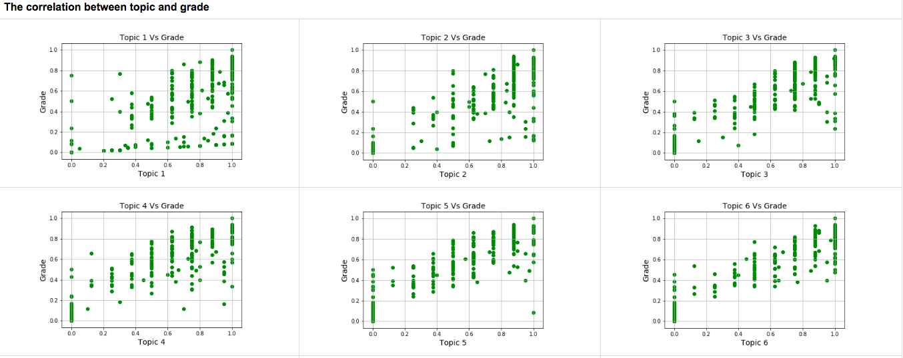

Figure 6.7‑1 The correlation between topics and overall grade part 1

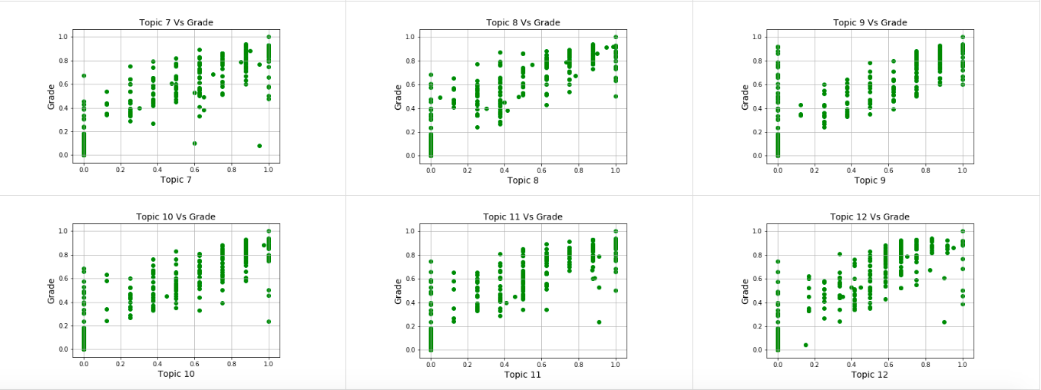

Figure 6.7‑2 The correlation between topics and overall grade part 2

## Summary

From the visualization of summative analysis in exam session level in section 6.3, the bar represents number of NP students in predicted result is usually higher than the bar represents number of NP students in official exam. And the bar represents number of P students in predicted result is relatively lower than the bar represents the number of P students in official result. And this phenomenon not only applied to a single exam session but to all of exam sessions. This finding leads to the conclusion of students performs better in actual exam rather than in exam review(quizzes). The graphs show the summative analysis of topic-wise level illustrates the similar phenomenon as the result in exam session level. With visualizing summative analysis in exam result in individual level, there has a number of exceptional cases which our predicted result supposed to be below 50 percent or lower. But the actual grade obtained by student could be 70 percent or above. However, in most of the exceptional cases, students are never attempted once in exam review(quizzes).

With the scattered graph of overall grade against grade of each topic. We are able to find the positive correlation between overall grade and grade of a topic. It shows the linearity which allow us to perform multiple linear regression on it. As the topic number went up, the number of outliners increases. This could be caused by various types of reasons. For example, the psychological state of student has changed due to continuously completed a series number of questions. The difficulty of questions in certain topics are relatively higher than the other topics. Or the student has not enough understandings in certain topic before they entered the exam.

# Implementation in Python Coding

## Introduction

This chapter provides essential Python Coding Segments used to generate results presented in the tables of Chapter 5 and in the figures of Chapter 5. All of Python coding segments have been test-run using Anaconda 3 Jupyter Notebook with Python 3 Environment. In particular, the coding segments are divided into two streams: Codes in support of summative data analysis, codes in support of data visualization

## Data Exploration and Preparation of Exam Reviews

This section is intended to deliberate the detail of using python code to explore raw data of exam review (quizzes) and preparation of data for further analysis.

### Important Imported libraries

1. **import** pandas as pd
2. **import** numpy as np
3. **import** re
4. **import** os
5. **import** operator
6. **from** os **import** listdir
7. **from** datetime **import** datetime
8. **from** os.path **import** isdir, isfile, join

### Key Function of Python Programming in Data Wrangling of Exam Reviews

The following in pre-defined data list contains every raw data filename for result of each topics in all exam reviews throughout the whole semester of academic year of 2019/2020.

1. filename_list = [ '2019-1-CISC1000-ALL-META-CISC1000 Review Quiz for Topic 01 of Module 01-grades.csv'
2. , …, '2019-1-CISC1000-ALL-META-CISC1000 Review Quiz for Topic 12 of Module 02-grades.csv'   ]

**Code 7.2 Data Exploration and Preparation of Exam Reviews**

In the following coding, we read csv files of raw data of result of each topics in all exam reviews throughout the whole semester of academic year of 2019/2020. We reshaped student number into a format without ‘-’ and used regular expression to find the topic name from the string of filename from the list.

1. result_frame = pd.DataFrame()
2. **for** i **in** filename_list:
3. topic_df = pd.read_csv('CISC1000 Data on Review Quizzes 2019/'+ i)
4. topic_df['Student No.'] = topic_df['Student No.'].str.replace('-','')
5. topic_name = re.findall(r'(Topic\s[0-9\W]+)\s', i)

Code 7.2‑1 code of reading exam review files of AY 2019-2020 first semester

The first approach for processing basic data of topics in every exam session is unifying and cleaning data of each topic, we created sub-function topic_rename() which listed in section 7.1.3. Since different topic has different number of questions and grading of topics differs, the purpose of sub-function topic_rename() uniforms the column name of question no. and filled non-existent questions in certain topic with ‘Not Applicable’ in order to make data complete and unified.

For some students who did not attempt or incomplete any exam review in certain topic. Column ‘Grade’ will be assigned by a character ‘-’, since data type in each column must be the name, we have to replace ‘-’ with numeric data ‘0’. For columns ‘Start on’ and ‘Completed’, data of both columns is in DateTime type, and therefore we need to replace ‘-’ with ‘’.

1. topic_df = topic_rename(topic_df, topic_name[0])
2. topic_df['Grade'] = topic_df['Grade'].str.replace('-','0')
3. topic_df['Completed'] = topic_df['Completed'].str.replace('-', '')
4. topic_df['Started on'] = topic_df['Started on'].str.replace('-', '')

Code 7.2‑2 Code of reshaping raw data

The second approach of reshaping data of each topic is splitting data throughout the whole semester into 22 set of data by date of student’s registered exam session. Our principle of splitting data by a period from the date of last exam attempted to the date (1 day) before the date of official registered exam. It depends on individual student’s exam registration. We created sub-function split_review_by_date() for further handling which documented in section 7.1.3. and the function split_review_by_date() will return a processed dataframe. With processed dataframe split by date, we have all records of student’s result within such period and we can locate all record of a student with input student number.

1. topic_df = split_review_by_date(topic_df, previous_session_no, exam_session_no, isFirstAttempt)
2. topic_df = topic_df[topic_df['Full Name'] != 'Overall average']
3. data_collect_from_date = topic_df['Data_collect_From_date'].iloc[0]
4. data_collect_to_date = topic_df['Data_collect_To_date'].iloc[0]
5. temp = topic_df.loc[topic_df['Student No.'] == student_no]

Code 7.2‑3 Code of splitting raw data by date

The third approach of reshaping data for a single student is finding all trace of student’s attempt in every topic within a period. There are two possible situations for record of topic.

1) There are no record of student trying to attempt the topic of exam review.   
2) Student attempted more than once in topics of exam review.

For student who has attempted exam review (quizzes), in order to make a complete set of data, we need to add the exam session number, isFirstAttempt, grading of P or NP for certain record of topics and counted number of attempts to certain topic, we calculated average passing rate for the single attempt of that topic. The additional columns to original data shown in the figure below. We applied certain technique from topic 01 to 12. The following code is applied to situation 1.

1. temp.at[index, 'Exam Session Registered'] = exam_session_no
2. time = find_Session_time(exam_session_no)
3. temp.at[index, 'Exam Session Time'] = time[0]
4. temp['numberOfAttempts'] = temp.groupby('Student No.')['Student No.'].transform('count')
5. temp.at[index, 'Topic'] = topic_name[0]
6. temp['isFirstAttempt'] = isFirstAttempt
7. temp.at[index, 'P/NP'] = PassOrFail(topic_name[0], temp['Grade'][index])
8. temp.at[index,'avg_passing_rate']=avg_rate(topic_name[0], temp['Grade'][index])
9. temp['isFirstAttempt'] = temp['isFirstAttempt'].astype('bool')
10. result_frame = pd.concat([result_frame, temp], sort=False)

Code 7.2‑4 Code of analyzing students who attempted exam review

The following code is applied to situation 2.

1. empty = topic_df.loc[topic_df['Student No.'] == student_no]
2. full_name = session_df.loc[session_df['Student No.'] == student_no, 'Full Name']
3. chin_name = session_df.loc[session_df['Student No.'] == student_no, 'Chinese Name']
4. shor_name = session_df.loc[session_df['Student No.'] == student_no, 'Short Name']
5. time = find_Session_time(exam_session_no)
6. test = {'Full Name': full_name.iloc[0], 'Chinese Name': chin_name.iloc[0], 'Short Name': shor_name.iloc[0], 'Exam Session Registered': exam_session_no, 'Exam Session Time': time[0],'numberOfAttempts': 0, 'Topic': topic_name[0], 'Student No.': student_no, 'P/NP': 'NP', 'Data_collect_From_date': data_collect_from_date, 'Data_collect_To_date': data_collect_to_date, 'isFirstAttempt': isFirstAttempt, 'avg_passing_rate': 0}
7. empty = empty.append(test, ignore_index=True)
8. empty = topic_rename(empty, topic_name[0])
9. empty['isFirstAttempt'] = empty['isFirstAttempt'].astype('bool')
10. result_frame = pd.concat([result_frame, empty], sort=False)

Code 7.2‑5 analyzing students who did not attempt exam review

For who student who did not attempt topic of exam review(quizzes), since we do not have any records, we can assign ‘number of attempts’ with ‘0’ directly, column ‘P/NP’ with ‘NP’ and ‘avg_passing rate’ as ‘0’. Value for column ‘isFirstAttempt’ describes whether the student enters the official exam in the very first time.

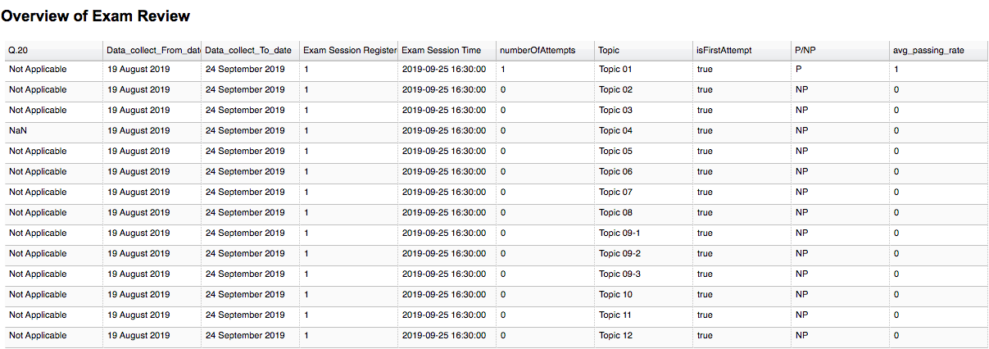

Figure 7.2‑1 Additional columns to the original data in exam review

**Required Input**

* Dataframe contain raw data of result of exam session
* Individual student number from a list of registered students in an exam session,
* Student’s previous registered exam session number
* Current registered exam session number
* An indicator checks student’s first attempt to the exam.

**Expected Output**

**A full set of student’s records in 12 topics of exam review**



Figure 7.2‑2 Example of overview of exam review in individual level Part 1



Figure 7.2‑3 Example of overview of exam review in individual level Part 2



Figure 7.2‑4 Example of overview of exam review in individual level Part 3

### Involved Sub-functions for Data Handling

topic_rename() uniforms the column name of question no. and filled non-existent questions in certain topic with ‘Not Applicable’ in order to make data complete and unified.

1. **def** topic_rename(topic_df, topic_name):
2. type_1 = ['Topic 01', 'Topic 02', 'Topic 03', 'Topic 05', 'Topic 06', 'Topic 07', 'Topic 08', 'Topic 10', 'Topic 12']
3. type_1_question_list = ['Q.12','Q.13','Q.14','Q.15','Q.16','Q.17','Q.18','Q.19','Q.20']
4. type_2 = ['Topic 04']
5. type_3 = ['Topic 09-1']
6. type_3_question_list = ['Q.14','Q.15','Q.16','Q.17','Q.18','Q.19','Q.20']
7. type_4 = ['Topic 11', 'Topic 09-2', 'Topic 09-3']
8. type_4_question_list = ['Q.12','Q.13','Q.14','Q.15','Q.16','Q.17','Q.18','Q.19','Q.20']
9. **if** (topic_name **in** type_1):
10. topic_df = topic_df.rename(columns={'Q. 1 /10.00': 'Q.1','Q. 2 /1.00':'Q.2','Q. 3 /1.00':'Q.3','Q. 4 /1.00':'Q.4','Q. 5 /1.00':'Q.5','Q. 6 /1.00':'Q.6','Q. 7 /1.00':'Q.7','Q. 8 /1.00':'Q.8','Q. 9 /1.00':'Q.9','Q. 10 /1.00':'Q.10','Q. 11 /1.00':'Q.11'})
11. topic_df = topic_df.rename(columns={'Grade/20.00': 'Grade'})
12. **for** i **in** type_1_question_list:
13. topic_df[i] = 'Not Applicable’
14. **elif**(topic_name **in** type_2):
15. topic_df = topic_df.rename(columns={'Q. 1 /1.00': 'Q.1','Q. 2 /1.00':'Q.2','Q. 3 /1.00':'Q.3','Q. 4 /1.00':'Q.4','Q. 5 /1.00':'Q.5','Q. 6 /1.00':'Q.6','Q. 7 /1.00':'Q.7','Q. 8 /1.00':'Q.8','Q. 9 /1.00':'Q.9','Q. 10 /1.00':'Q.10','Q. 11 /1.00':'Q.11','Q. 12 /1.00':'Q.12','Q. 13 /1.00':'Q.13','Q. 14 /1.00':'Q.14','Q. 15 /1.00':'Q.15','Q. 16 /1.00':'Q.16','Q. 17 /1.00':'Q.17','Q. 18 /1.00':'Q.18','Q. 19 /1.00':'Q.19','Q. 20 /1.00':'Q.20'})
16. topic_df = topic_df.rename(columns={'Grade/20.00': 'Grade'})
18. **elif**(topic_name **in** type_3):
19. topic_df = topic_df.rename(columns={'Q. 1 /0.77': 'Q.1','Q. 2 /0.77':'Q.2','Q. 3 /0.77':'Q.3','Q. 4 /0.77':'Q.4','Q. 5 /0.77':'Q.5','Q. 6 /0.77':'Q.6','Q. 7 /0.77':'Q.7','Q. 8 /0.77':'Q.8','Q. 9 /0.77':'Q.9','Q. 10 /0.77':'Q.10','Q. 11 /0.77':'Q.11', 'Q. 12 /0.77':'Q.12', 'Q. 13 /0.77':'Q.13'})
20. topic_df = topic_df.rename(columns={'Grade/10.00': 'Grade'})
21. **for** i **in** type_3_question_list:
22. topic_df[i] = 'Not Applicable'
23. **elif**(topic_name **in** type_4):
24. topic_df = topic_df.rename(columns={'Q. 1 /0.91': 'Q.1','Q. 2 /0.91':'Q.2','Q. 3 /0.91':'Q.3','Q. 4 /0.91':'Q.4','Q. 5 /0.91':'Q.5','Q. 6 /0.91':'Q.6','Q. 7 /0.91':'Q.7','Q. 8 /0.91':'Q.8','Q. 9 /0.91':'Q.9','Q. 10 /0.91':'Q.10','Q. 11 /0.91':'Q.11'})
25. topic_df = topic_df.rename(columns={'Grade/10.00': 'Grade'})
26. **for** i **in** type_4_question_list:
27. topic_df[i] = 'Not Applicable'
28. **return** topic_df
29. former_exam_datetime = str(former_exam_datetime.day)+' '+str(former_exam_datetime.month)+' '+str(former_exam_datetime.year)
30. former_exam_date = datetime.strptime(former_exam_datetime, '%d %m %Y')
31. former_exam_date = datetime.strftime(former_exam_date, '%d %B %Y')
33. new_df = df[operator.and_(df['Started on'] > str(former_exam_date),df['Started on'] <= str(current_exam_date))]
34. new_df['Data_collect_From_date'] = former_exam_date
35. new_df['Data_collect_To_date'] = current_exam_date
36. **return** new_df

Code 7.2‑6 Data Unification

split_review_by_date() handles data of students with splitting data by a period from the date of last exam attempted to the date (1 day) before the date of official registered exam. split_review_by_date() will return a processed dataframe.

1. **def** split_review_by_date(df, previous_session_no, exam_session_no, isFirstAttempt):
2. #22 September 2019 8:09 PM
3. new_df = pd.DataFrame()
4. exam_session_ref_df = pd.DataFrame(pd.read_excel('CISC1000 Data on Review Quizzes 2019/exam_session.xlsx'))
5. exam_session_ref_df['Time'] = pd.to_datetime(exam_session_ref_df['Time'], errors='ignore')
6. exam_session_ref_df['Time'] = exam_session_ref_df['Time']
7. exam_session_ref_df['Exam_Session'] = exam_session_ref_df['Exam_Session'].astype(str)
8. #19 August 2019  10:37 AM
9. df['Completed'] = pd.to_datetime(df['Completed'], format='%d %B %Y %I:%M %p', errors='coerce')
10. df['Started on'] = pd.to_datetime(df['Started on'], format='%d %B %Y  %I:%M %p', errors='coerce')
12. **if** isFirstAttempt == True:
13. exam_datetime = exam_session_ref_df.loc[exam_session_ref_df['Exam_Session'] == str(exam_session_no), 'Time']
14. exam_datetime = exam_datetime.iloc[0]+pd.DateOffset(-1)
15. exam_datetime = str(exam_datetime.day)+' '+str(exam_datetime.month)+' '+ str(exam_datetime.year)
16. exam_date = datetime.strptime(exam_datetime, '%d %m %Y')
17. exam_date = datetime.strftime(exam_date, '%d %B %Y')
18. new_df = df[(df['Started on'] <= exam_date)]
19. new_df['Data_collect_From_date'] = '19 August 2019'
20. new_df['Data_collect_To_date'] = exam_date
21. **else**:
22. current_exam_datetime=exam_session_ref_df.loc[exam_session_ref_df['Exam_Session'] == str(exam_session_no), 'Time']
23. current_exam_datetime = current_exam_datetime.iloc[0]+pd.DateOffset(-1)
24. current_exam_datetime = str(current_exam_datetime.day)+' '+str(current_exam_datetime.month)+' '+str(current_exam_datetime.year)
25. current_exam_date = datetime.strptime(current_exam_datetime, '%d %m %Y')
26. current_exam_date = datetime.strftime(current_exam_date, '%d %B %Y')
27. former_exam_session = int(previous_session_no)
28. former_exam_datetime = exam_session_ref_df.loc[exam_session_ref_df['Exam_Session'] == str(former_exam_session), 'Time']
29. former_exam_datetime = former_exam_datetime.iloc[0]
30. former_exam_datetime = str(former_exam_datetime.day)+' '+str(former_exam_datetime.month)+' '+str(former_exam_datetime.year)
31. former_exam_date = datetime.strptime(former_exam_datetime, '%d %m %Y')
32. former_exam_date = datetime.strftime(former_exam_date, '%d %B %Y')
34. new_df = df[operator.and_(df['Started on'] > str(former_exam_date),df['Started on'] <= str(current_exam_date))]
35. new_df['Data_collect_From_date'] = former_exam_date
36. new_df['Data_collect_To_date'] = current_exam_date
37. **return** new_df

Code 7.2‑7 Split Data By Date

## Summative Analysis of Overall Performance on Exam Reviews in Individual Level

### Key Function of Python Programming in Data Analysis of Exam Reviews in Individual Level

**Code 7.3: Summative Analysis of Overall Performance on Exam Reviews in Individual Level**

In this code section, there are two main parts, the major part is summative analysis of exam review. we inherited the output dataframe form code 7.1 and perform summative analysis on data based on results from code 7.1 with **def** summarize_exam**()**.

The other part is summative analysis of official exam, we collect data from official exam files and summarized data topic by topic. We set up an empty dataframe with fixed columns name of ['Topic 01', 'Topic 02', 'Topic 03', 'Topic 04', 'Topic 05', 'Topic 06', 'Topic 07', 'Topic 08', 'Topic 09', 'Topic 10', 'Topic 11', 'Topic 12', 'Overall Passing Rate For Exam (All topic Grades/12)'] in order to store the data we summarize along the function. And this pre-defined dataframe will be our output of this function.

1. topic = ['Topic 01', 'Topic 02', 'Topic 03', 'Topic 04', 'Topic 05', 'Topic 06', 'Topic 07', 'Topic 08', 'Topic 09','Topic 10', 'Topic 11', 'Topic 12']
2. topic_avg_passing_rate = 0
3. s_df = pd.DataFrame(columns=['Topic 01', 'Topic 02', 'Topic 03', 'Topic 04', 'Topic 05', 'Topic 06', 'Topic 07', 'Topic 08', 'Topic 09', 'Topic 10', 'Topic 11', 'Topic 12', 'Overall Passing Rate For Exam (All topic Grades/12)'])

Code 7.3‑1 code of pre-defined output dataframe

In our exam review, Topic 09 is separated into three sections which are 'Topic 09-1', 'Topic 09-2', 'Topic 09-3', and we accumulate the score from 3 sub-section of Topic 09 and divide them by 3, the division of result will be the average percentage of Topic 09.

1. **if**(t == 'Topic 09'):
2. topic9_list = ['Topic 09-1', 'Topic 09-2', 'Topic 09-3']
3. overall_topic9 = 0
4. **for** j **in** topic9_list:
5. result = result_frame.loc[result_frame['Topic']== j, 'avg_passing_rate']
6. **for** k **in** result:
7. topic_avg_passing_rate += k
8. overall_topic9 += topic_avg_passing_rate/len(result)
9. topic_avg_passing_rate = 0
10. topic_avg_passing_rate = topic_avg_passing_rate/3

Code 7.3‑2 Code of processing result of Topic 09 in exam review

We accumulate the percentage of score in twelve topics and divided the accumulated result by 12 results in getting overall average passing rate of an exam session of individual student.

1. **for** i **in** topic:
2. total += s_df[i][0]
4. avg = total/12
5. s_df.at[0, 'Overall Passing Rate For Exam (All topic Grades/12)'] = avg

Code 7.3‑3 getting overall average passing rate of an exam session of individual student

After we collected the overall average passing rate of an exam session of individual student, we have to distinguish percentage of score obtain in each topic whether it is ‘P’ or ‘NP’. Based on our principle of distinguish ‘P’ or ‘NP’, student has to achieve equal or more than 70 percent to be considered as ‘P’, below 70 percent will be considered as ‘NP’.

1. **if**(avg >= 0.7):
2. s_df.at[1, 'Overall Passing Rate For Exam (All topic Grades/12)'] = 'P'
3. **else**:
4. s_df.at[1, 'Overall Passing Rate For Exam (All topic Grades/12)'] = 'NP'
5. **return** s_df

Code 7.3‑4 Code of applying rules of passing rate in exam review

**Required Input:**

* A dataframe contains full set of performance of an individual student in 12 topics

**Expected output:**

**A summarized dataframe of presenting the percentage of score obtained in each topic and overall average passing rate of all topics in exam review.**

Table 7.3‑1 Example of summarized dataframe of presenting the percentage of score obtained in each topic and overall average passing rate of all topics in exam review



We declared the actual_exam_list in public in case other function can use it as well. The usage of actual_exam_list is not limited to a single function.

1. actual_exam_list = ['CISC1000 Exam Result for Session 01 on 25-SEP-2019 (WEDNESDAY 1630-1730)-grades',
2. …,
3. 'CISC1000 Exam Result for Session 22 on 03-JAN-2020 (FRIDAY 1630-1730)-grades']

Code 7.3‑5 Code of defining a list of exam result files

In **def** actual_exam_retrival(exam_session_no, student_no), we read the file based on exam session number, and assign it into a dataframe.

1. filename = actual_exam_list[int(exam_session_no)-1]
2. path = 'CISC1000 Exam Results/Exam Results/'+filename+'.xlsx'
3. actual_exam_data = pd.read_excel(path)
4. actual_exam_df = pd.DataFrame(actual_exam_data)

Code 7.3‑6 Code of retrieving data from excel file and convert it into dataframe

We replaced all the cells with character ‘-’ by ‘’. And we reformat student no into a string without any character ‘-’.

1. actual_exam_df.replace('-', np.NaN, inplace = True)
2. actual_exam_df['Student No.'] = actual_exam_df['Student No.'].str.replace('-','')

Code 7.3‑7 Code of removing unwanted values

In record of official exam, it does not clarify which questions belongs to which topic, so we need to handle it in our code. From topic 01 to topic 11, there are 8 questions per topic, and there are 12 questions for topic 12. We stored the average rate for each topic in the resulted dataframe.

1. topic_df = topic_df.drop(['State','Completed','Started on'],axis = 1
2. start = 0
3. end = 8
4. #topics 1-11 (8 questions each)
5. **for** x **in** range(11):
6. **if**(x < 9):
7. topic_df['Topic0'+str(x+1)]=copy_df[copy_df.columns[start:end]].apply(**lambda** x: x.mean(),axis=1)
8. **else**:
9. topic_df['Topic'+str(x+1)]=copy_df[copy_df.columns[start:end]].apply(**lambda** x: x.mean(),axis=1)
10. start = start + 8
11. end = end + 8
12. #topic 12 (12 questions)
13. topic_df['Topic 12'] = copy_df[copy_df.columns[88:100]].apply(**lambda** x: x.mean(),axis=1)
14. topic_df = topic_df.loc[topic_df['Student No.'] == student_no]
15. **return** topic_df

Code 7.3‑8 stored the average rate for each topic in the resulted dataframe

**Required input of function** actual_exam_retrival**():**

* Number of exam session
* Student number
* List of official exam filenames

**Expected output:**

**A summarized dataframe of presenting the percentage of score obtained in each topic and overall average passing rate of all topics in an official exam.**

Table 7.3‑2 Example of summarized dataframe of presenting the percentage of score obtained in each topic and overall average passing rate of all topics in an official exam



This code section mainly concluded the difference between performance of official exam and exam review.

1. s_df = s_df.append({'Data Collection' : 'Exam Review' , 'Topic 01': er_t1, 'Topic 02': er_t2, 'Topic 03': er_t3, 'Topic 04': er_t4, 'Topic 05': er_t5, 'Topic 06': er_t6, 'Topic 07': er_t7, 'Topic 08': er_t8, 'Topic 09': er_t9, 'Topic 10': er_t10, 'Topic 11': er_t11, 'Topic 12': er_t12, 'Overall grade': er_overall_grade} , ignore_index=True)
2. s_df = s_df.append({'Data Collection' : 'Actual Exam' , 'Topic 01': actual_t1, 'Topic 02': actual_t2, 'Topic 03': actual_t3, 'Topic 04': actual_t4, 'Topic 05': actual_t5, 'Topic 06': actual_t6, 'Topic 07': actual_t7, 'Topic 08': actual_t8, 'Topic 09': actual_t9, 'Topic 10': actual_t10, 'Topic 11': actual_t11, 'Topic 12': actual_t12, 'Overall grade': overall_grade} , ignore_index=True)
3. s_df['No. of P'] = (s_df[['Topic 01', 'Topic 02', 'Topic 03', 'Topic 04', 'Topic 05', 'Topic 06', 'Topic 07', 'Topic 08', 'Topic 09', 'Topic 10', 'Topic 11', 'Topic 12']] == 'P').sum(axis=1)
4. s_df['No. of NP'] = (s_df[['Topic 01', 'Topic 02', 'Topic 03', 'Topic 04', 'Topic 05', 'Topic 06', 'Topic 07', 'Topic 08', 'Topic 09', 'Topic 10', 'Topic 11', 'Topic 12']] == 'NP').sum(axis=1)
5. topics = ['Topic 01', 'Topic 02', 'Topic 03', 'Topic 04', 'Topic 05', 'Topic 06', 'Topic 07', 'Topic 08', 'Topic 09','Topic 10', 'Topic 11', 'Topic 12']
6. s_df.at[2, 'Data Collection'] = 'Comparison’
7. **return** s_df

Code 7.3‑9 code of summarizing difference between performance of official exam and exam review

For student who absent from the official exam session, our program defined the comparison as ‘inconclusive’.

1. **for** topic **in** topics:
2. predict = s_df[topic][0]
3. actual = s_df[topic][1]
4. **if**(predict == actual):
5. s_df.at[2, topic] = True
6. **elif**(actual == 'N/A'):
7. s_df.at[2, topic] = 'Inconclusive'
8. **else**:
9. s_df.at[2, topic] = False

Code 7.3‑10 Code of defining 'inconclusive' results

**Required Input:**

* DataFrame of summarized official exam data
* DataFrame of summarized exam review data

**Expected Output:**

**Dataframe with comparison between grading in official exam and exam review.**

Table 7.3‑3 Example of summarized dataframe with comparison between grading in official exam and exam review



After we completed the comparison between result of official exams and predicted result based on exam reviews. We are going to investigate how well does our prediction performed with brute-force method. With counting number of true positive, true negative, false positive and false negative, we are able to obtain the accuracy of correct prediction and incorrect ones.

1. **def** confusion_matrix(df):
2. topic = ['Topic 01', 'Topic 02', 'Topic 03', 'Topic 04', 'Topic 05', 'Topic 06', 'Topic 07', 'Topic 08', 'Topic 09','Topic 10', 'Topic 11', 'Topic 12']
3. accuracy_df = pd.DataFrame(columns=['Positive', 'Negative'], index=['Positive', 'Negative'])
4. #accuracy_df.at[0, "Positive"] =
5. tp = 0
6. tn = 0
7. fp = 0
8. fn = 0
9. **for** i **in** topic:
10. **if** df.at[0, i] == 'P' **and** df.at[1, i] == 'P':
11. tp+=1
12. **elif** df.at[0, i] == 'P' **and** df.at[1, i] == 'NP':
13. tn+=1
14. **elif** df.at[0, i] == 'NP' **and** df.at[1, i] == 'P':
15. fp+=1
16. **elif** df.at[0, i] == 'NP' **and** df.at[1, i] == 'NP':
17. fn+=1
18. accuracy_df.at["Positive", "Positive"] = tp
19. accuracy_df.at["Positive", "Negative"] = tn
20. accuracy_df.at["Negative", "Positive"] = fp
21. accuracy_df.at["Negative", "Negative"] = fn
22. **return** accuracy_df

Code 7.3‑11 Code of Confusion Matrix

**Required input of function** confusion_matrix**():**

* **Dataframe of Comparison of official exam results and predicted result based on exam review**

**Expected Output**

**A confusion matrix of accuracy of prediction**

Table 7.3‑4 Example of A confusion matrix of accuracy of prediction

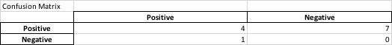

With the confusion matrix we obtained from confusion_matrix(df), we can calculate the number of correct prediction by counting true positive and false negative.

1. **def** prediction_correctness(accuracy_df):
2. correctness_df = pd.DataFrame(columns=['Predicted postive matches', 'Predicted Negative matches'])
3. correctness_df.at[0, 'Predicted postive matches'] = accuracy_df.at["Positive", "Positive"]
4. correctness_df.at[0, 'Predicted Negative matches'] = accuracy_df.at["Negative", "Negative"]
6. correctness = accuracy_df.at["Positive", "Positive"] + accuracy_df.at["Negative", "Negative"]
7. Remark = ['Remark: Number of predicted correctly in 12 topics: ' , correctness]
8. correctness_df.loc[len(correctness_df)] = Remark
9. **return** correctness_df

Code 7.3‑12 Code of Calculation of Accuracy of Predicted Result

**Required Input:**

* **Dataframe of Confusion matrix of official exam results and predicted result based on exam review**

**Expected Output**

Table 7.3‑5 Example of number of correct predictions

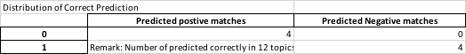

## Summative analysis of overall performance on exam reviews in topic-wise level

### Key Function of Python Programming in Data Analysis in Topic-wise Level

**Code 7.4 Summative Analysis of Overall Performance on Exam Reviews in Topic-wise Level**

This code section illustrates the summative analysis on topic-wise level in a exam session.

In function Topic(), first of all, We created 12 empty dataframe for storing essential data of analysed data of topics in each exam session.

1. topic1 = pd.DataFrame(columns=['Predict Result', 'Actual Result', 'Difference'], index=['P', 'NP', 'Absent'])
2. topic1 = topic1.fillna(0)

Code 7.4‑1 Code of creation of 12 empty dataframe for storing essential data of analysed data

Secondly, we collect a list of student from official exam result, and we read student number one by one from the student list in official exam. We collected the exam session number from input filename with regular expression.

1. code = re.findall(r'Session ([0-9]+)', filename)
2. code = code[0]

Code 7.4‑2 Code of applying regular expression to extract essential data

With using information of student number and exam session number, we can find the filename of excel file which contains the comparison of official result and predicted result that we analysed in individual level.

1. **for** student_no **in** student_list:
2. topic_data = pd.read_excel('Exam_Review/Exam_Sec_'+code+'/Comparison/'+student_no+'_'+code+'.xlsx')
3. topic_df = pd.DataFrame(topic_data)
4. topic_df = topic_df.fillna('N/A')

Code 7.4‑3 Code of the comparison of official result and predicted result that we analysed in individual level

This action allows us to count the number of predicted ‘P’ student, predicted ‘NP’ student, officially obtained ‘P’ student, officially obtained ‘NP’ student and number of students who absent from the registered exam session.

1. topic_list = ['Topic 01', 'Topic 02', 'Topic 03', 'Topic 04', 'Topic 05', 'Topic 06', 'Topic 07', 'Topic 08', 'Topic 09', 'Topic 10', 'Topic 11', 'Topic 12']
2. **for** topic **in** topic_list:
3. **if**(topic_df.iloc[0][topic] == 'P' **and** topic_df.iloc[1][topic] == 'P'):
4. **if**(topic == 'Topic 01'):
5. topic1.at['P', 'Predict Result'] += 1
6. topic1.at['P', 'Actual Result'] += 1

9. **elif**(topic_df.iloc[0][topic] == 'P' **and** topic_df.iloc[1][topic] == 'NP'):
10. **if**(topic == 'Topic 01'):
11. topic1.at['P', 'Predict Result'] += 1
12. topic1.at['NP', 'Actual Result'] += 1
14. **elif**(topic_df.iloc[0][topic] == 'P' **and** topic_df.iloc[1][topic] == 'N/A'):
15. **if**(topic == 'Topic 01'):
16. topic1.at['P', 'Predict Result'] += 1
17. topic1.at['Absent', 'Actual Result'] += 1
18. **elif**(topic_df.iloc[0][topic] == 'NP' **and** topic_df.iloc[1][topic] == 'P'):
19. **if**(topic == 'Topic 01'):
20. topic1.at['NP', 'Predict Result'] += 1
21. topic1.at['P', 'Actual Result'] += 1
23. **elif**(topic_df.iloc[0][topic] == 'NP' **and** topic_df.iloc[1][topic] == 'NP'):
24. **if**(topic == 'Topic 01'):
25. topic1.at['NP', 'Predict Result'] += 1
26. topic1.at['NP', 'Actual Result'] += 1
27. **elif**(topic_df.iloc[0][topic] == 'NP' **and** topic_df.iloc[1][topic] == 'N/A'):
28. **if**(topic == 'Topic 01'):
29. topic1.at['NP', 'Predict Result'] += 1
30. topic1.at['Absent', 'Actual Result'] += 1

Code 7.4‑4 Code of Creating Confusion Matrix in Topic-wise Level

From the obtained number of students mentioned, the difference between student achieved ‘P’ or ‘NP’ in official exam and predicted result can be found. With the value of difference, the performance of prediction using brute force method can be told from the value of difference.

1. topic1.at['P', 'Difference'] = abs(topic1.iloc[0]['Predict Result']- topic1.iloc[0]['Actual Result'])
2. topic1.at['NP', 'Difference'] = abs(topic1.iloc[1]['Predict Result']- topic1.iloc[1]['Actual Result'])
3. topic1.at['Absent', 'Difference'] = abs(topic1.iloc[2]['Predict Result']- topic1.iloc[2]['Actual Result'])

Code 7.4‑5 Code of calculating difference of predicted and actual result

Eventually, we exported the dataframe of each topic into excel files.

1. topic1.to_excel('Exam_Review/Topic/Exam Sec_'+code+'/Topic01_'+code+'.xlsx')

Code 7.4‑6 Code of exporting analyzed result into excel file

**Required input:**

* A list of file names of result of exam session
* Excel file of comparison of official and predicted result in individual level

**Expected Output:**

12 Excel files for a single exam session

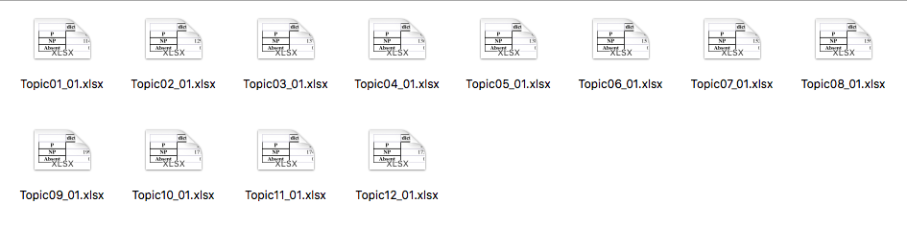

Figure 7.4‑1 List of output excel files of an individual exam session

Each excel file contains data as below, we provided topic 01 and topic 02 as an example.

**Topic01_01.xlsx**

Table 7.4‑1 Comparison of number of P and NP student in predicted and actual result with difference between them in Topic 01 of exam session 01



**Topic02_01.xlsx**

Table 7.4‑2 Comparison of number of P and NP student in predicted and actual result with difference between them in Topic 02 of exam session 01



## Summative Analysis of Overall Performance on Exam Reviews in Overall Exam Session-wide Level

### Key Function of Python Programming in Data Analysis of Exam Reviews in Overall Exam Session-wide Level

**Code 7.5 Summative Analysis of Overall Performance on Exam Reviews in Overall Exam Session-wide Level**

In this code section, we defined two dataframe for storing overall result of exam session. One of the dataframe stored number of students scored ‘P’ and ‘NP’ in both official exam and prediction based on exam review with the difference between results of official exam and predicted result.

In function session_summary(), first of all, we collected overall grade of exam review and actual result which is represented by ‘P’ and ‘NP’. If student scored ‘P’ in actual exam, the column ‘P’ at index ‘Actual Result’ will be added 1. If student scored ‘P’ in exam review, the column ‘P’ at index ‘Predicted Result’ will be added 1. The situation for ‘NP’ will be the same.

1. **def** session_summary(output, actual, exam_review):
2. predict = exam_review.iloc[1]['Overall Passing Rate For Exam (All topic Grades/12)']
3. actual_res = actual.iloc[1]['Overall grade']
4. **if**(predict == 'P'):
5. output.at['P','Predict Result'] += 1
6. **elif**(predict == 'NP'):
7. output.at['NP','Predict Result'] += 1
8. **if**(actual_res == 'P'):
9. output.at['P','Actual Result'] += 1
10. **elif**(actual_res == 'NP'):
11. output.at['NP','Actual Result'] += 1
12. **elif**(actual_res == 'N/A'):
13. output.at['Absent','Actual Result'] += 1
14. **return** output

Code 7.5‑1 Code of summarizing analyzed data in exam session wide level

**Required Input:**

* Dataframe of summative analysed exam review of an individual student
* Dataframe of summative analysed official exam of an individual student

**Expected Output:**

**A dataframe contains the number of P and NP student in Predicted Result and Actual Result.**

Table 7.5‑1 Data Table contains the number of P and NP student in Predicted Result and Actual Result.

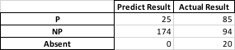

The other one is showing the confusion matrix of predicted and official result.

* **def** session_cm_summary(output, actual, exam_review):
* predict = exam_review.iloc[1]['Overall Passing Rate For Exam (All topic Grades/12)']
* actual_res = actual.iloc[1]['Overall grade']
* **if**(predict == 'P' **and** actual_res == 'P'):
* output.at['P (Actual Exam)', 'P (Predicted)'] += 1
* **elif**(predict == 'NP' **and** actual_res == 'P'):
* output.at['P (Actual Exam)', 'NP (Predicted)'] += 1
* **if**(predict == 'P' **and** actual_res == 'NP'):
* output.at['NP (Actual Exam)', 'P (Predicted)'] += 1
* **elif**(predict == 'NP'**and** actual_res == 'NP'):
* output.at['NP (Actual Exam)', 'NP (Predicted)'] += 1
* **elif**(predict == 'NP'**and** actual_res == 'N/A'):
* output.at['Absent (Actual Exam)', 'NP (Predicted)'] += 1
* **elif**(predict == 'P'**and** actual_res == 'N/A'):
* output.at['Absent (Actual Exam)', 'P (Predicted)'] += 1
* **return** output

Code 7.5‑2 Code of Creating Confusion Matrix in Exam Session-wide Level

**Required Input:**

* Dataframe of summative analysed exam review of an individual student
* Dataframe of summative analysed official exam of an individual student

**Expected Output**

**A dataframe contains the confusion matrix between predicted and actual number of P and NP students.**

Table 7.5‑2 Data Table contains confusion matrix of exam session 01



Based on output of session_summary(), we need to convert the number in the confusion matrix into the form of percentage in terms of P rate, NP rate. The following coding shows how to convert numbers into percentage for each exam session.

First of all, we generate a list of filenames based on the format of files we obtained data in session_summary(). Secondly, we read files one by one and split the data in the excel files into two dataframes. However, we only need the data in the first dataframe. We defined formulas for calculating predicted passing rate, actual passing rate by   
“Predicted P / Predicted P + Predicted NP” and “Actual P / Actual P + Actual NP”. On the other hand, formulas for predicted no passing rate and actual passing rate would be   
“Predicted NP / Predicted P + Predicted NP” and “Actual NP / Actual P + Actual NP”.

1. **for** summary **in** summary_list:
2. xl = pd.ExcelFile('Exam_Review/'+summary)
3. nrows = xl.book.sheet_by_index(0).nrows
4. df1 = xl.parse(0, skipfooter= nrows-(3+1)).dropna(axis=1, how='all')
5. df2 = xl.parse(0, skiprows=6).dropna(axis=1, how='all')
6. '''''ppr = prediction passing rate
7. apr = actual passing rate'''
8. ppr = df1.iloc[0]['Predict Result']/(df1.iloc[0]['Predict Result']+df1.iloc[1]['Predict Result'])
9. apr = df1.iloc[0]['Actual Result']/(df1.iloc[0]['Actual Result']+df1.iloc[1]['Actual Result']+df1.iloc[2]['Actual Result'])
10. '''''pnpr = prediction no passing rate
11. anpr = actual no passing rate'''
12. pnpr = df1.iloc[1]['Predict Result']/(df1.iloc[0]['Predict Result']+df1.iloc[1]['Predict Result'])
13. anpr = df1.iloc[1]['Actual Result']/(df1.iloc[0]['Actual Result']+df1.iloc[1]['Actual Result']+df1.iloc[2]['Actual Result'])
14. '''''pabsr = predicted absent rate'''
15. pabsr = df1.iloc[2]['Predict Result']/(df1.iloc[0]['Predict Result']+df1.iloc[1]['Predict Result'])
16. aabsr = df1.iloc[2]['Actual Result']/(df1.iloc[0]['Actual Result']+df1.iloc[1]['Actual Result']+df1.iloc[2]['Actual Result'])

Code 7.5‑3 Code of calculation of Passing and No Passing rate in actual and predicted result

After we calculated four important result, we stored results in the dataframe we declared by the name ‘sess_summary’ and export it as an excel file.

1. sess_summary.at['P rate', 'Predict'] = round(ppr,3)
2. sess_summary.at['P rate', 'Actual'] = round(apr,3)
3. sess_summary.at['NP rate', 'Predict'] = round(pnpr,3)
4. sess_summary.at['NP rate', 'Actual'] = round(anpr,3)
5. sess_summary.at['Absent rate', 'Predict'] = round(pabsr,3)
6. sess_summary.at['Absent rate', 'Actual'] = round(aabsr,3)
7. sess_summary.at['P rate', 'Difference'] = abs(round(ppr,3) - round(apr,3))
8. sess_summary.at['NP rate', 'Difference'] = abs(round(pnpr,3) - round(anpr,3))
9. sess_summary.at['Absent rate', 'Difference'] = abs(round(pabsr,3) - round(aabsr,3))
10. sess_summary.to_excel('Exam_Review/Session_Summary/percentage_'+summary)

Code 7.5‑4 Code of Summarizing calculated rate of P and NP rate in Exam Session-wide Level

**Required Input:**

* **Output dataframe from session_cm_summary()**

**Expected Output:**

**22 Excel Files contains result as Table 7.4-3**

Table 7.5‑3 Example of Confusion matrix in the form of percentages

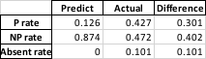

## Data Exploration and Data analysis of Mock Exams

**Code 7.6 Data Exploration and Data Analysis of Mock Exams**

In this section, we present data of participation of RCs in Mock Exams. We collected a list of students who registered in exam session and information of which RC do they belong to.

1. roster_data = pd.read_excel('CISC1000 Roster/2019_Roster.xls')
2. roster_df = pd.DataFrame(roster_data)

Code 7.6‑1 Code of retrieving data from roster.xls

From data of mock exam result files, we can find whether the student registered exam session participated in mock exam.

1. **for** student_no **in** student_list:
2. temp_df = pd.DataFrame(columns=['Student No.', 'Section Code', 'RC', 'hasAttemptMock'])
3. temp_df = roster_df.loc[roster_df['Student No.'] == student_no]
4. temp_df['Course Section Code'] = temp_df['Course Section Code'].astype(str)
5. **if**(len(temp_df) != 0):
6. sec_code = temp_df.iloc[0]['Course Section Code']
7. **if**(sec_code == '1' **or** sec_code == '2'):
8. sec_code = '00'+str(sec_code)
9. RC = temp_df.iloc[0]['RC']

Code 7.6‑2 Code of finding whether student participated in mock-up exam

We defined a variable named ‘has Attempt’ to indicate whether student practise with mock exam and if the student did the mock exam, we can find the grade they obtain in mock exam. Otherwise, the grade of mock exam will be set with ‘N/A’.

1. **if** os.path.isfile('CISC1000-2019 Mocked Exam Data/'+mockfolder_name[0]+'/'+RC+'-'+sec_code+'/'+'2019-1-CISC1000-'+sec_code+'-'+RC+'-'+RC+'-'+sec_code+' CISC1000 Mocked Exam Practice for Exam Session 01-grades.csv'):
2. mock_data = pd.read_csv('CISC1000-2019 Mocked Exam Data/'+mockfolder_name[0]+'/'+RC+'-'+sec_code+'/'+'2019-1-CISC1000-'+sec_code+'-'+RC+'-'+RC+'-'+sec_code+' CISC1000 Mocked Exam Practice for Exam Session 01-grades.csv')
3. tmp_mock_df = pd.DataFrame(mock_data)
4. tmp_mock_df['Student No.'] = tmp_mock_df['Student No.'].str.replace('-','')
5. tmp_mock_df = tmp_mock_df.loc[tmp_mock_df['Student No.'] == student_no]
6. **if**(len(tmp_mock_df) != 0):
7. grade = tmp_mock_df.iloc[0]['Grade/100.00']
8. mock_df = mock_df.append(pd.DataFrame({"Student No.":[student_no], "Section Code":[sec_code], "RC":[RC], "hasAttemptMock": [True], "Grade":[grade]}))
9. **else**:
10. mock_df = mock_df.append(pd.DataFrame({"Student No.":[student_no], "Section Code":[sec_code], "RC":[RC], "hasAttemptMock": [False], "Grade":["N/A"]}))
11. **else**:
12. mock_df = mock_df.append(pd.DataFrame({"Student No.":[student_no], "Section Code":[sec_code], "RC":[RC], "hasAttemptMock": [False], "Grade":["N/A"]}))
14. mock_df['Section Code'] = mock_df['Section Code'].astype(str)
15. mock_df.to_excel('CISC1000-2019 Mocked Exam Data/Exam Sec_01/Mock_Summary_01.xlsx', index=False)

Code 7.6‑3 Code of Analysis of participation of RC in mock-up exam

**Required Inputs**

* **A list of exam result filename**
* **A list of Mock Exam filename**

**Expected Output:**

**A dataframe filled with student’s information and RC with indicator of participating in Mock Exam and result of Mock Exam**

Table 7.6‑1 Example of student’s information and RC with indicator of participating in Mock Exam and result of Mock Exam

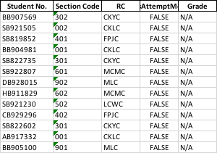

After we obtained the dataframe filled with information of RC, section code, indicator of participating in Mock Exam and result of Mock Exam. We further analysed the detail of participation of RC in Mock Exam. The following code has shown how we collected data of participation of CKLC section 002.

1. mock_exam_data = pd.read_excel('CISC1000-2019 Mocked Exam Data/Exam Sec_01/Mock_Summary_01.xlsx')
2. mock_df = pd.DataFrame(mock_exam_data)
3. RC_df = mock_df.loc[(mock_df['RC'] == 'CKLC')& (mock_df['Section Code'] == 2)]
4. df_value_counts = RC_df['hasAttemptMock'].value_counts()
5. df_value_counts = df_value_counts.reset_index()
6. df_value_counts.columns = ['hasAttemptMock', 'NumberOfStudents']
7. df_value_counts

Code 7.6‑4 Code of Summary of participation of RC in mock-up exam

**Required Input:**

* **Processed Excel files of Summary of Mock Exam**

**Expected Output:**

**A Table of number of students from RC who has attempted Mock Exam and number of students who has not attempted Mock Exam**

Table 7.6‑2 Example of number of students from RC who has attempted Mock Exam and number of students who has not attempted Mock Exam

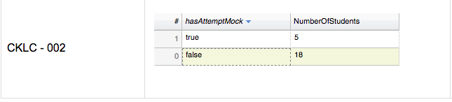

## Multiple Linear Regression for Predicting Student Performance

**Code 7.7 Multiple Linear Regression for Predicting Student Performance**

Function ml_dataset() has two input parameters which is dataframe of summative analysed result of exam review and summative analysed result of official review. We also declared the output dataframe with desired column names in advance.

1. **def** ml_dataset(actual_df, exam_review_df):    
   s_df = pd.DataFrame(columns=['Data Collection', 'Grade','Topic 01', 'Topic 02', 'Topic 03', 'Topic 04', 'Topic 05', 'Topic 06', 'Topic 07', 'Topic 08', 'Topic 09', 'Topic 10', 'Topic 11', 'Topic 12'])

We collected score from each topic in dataframe of exam reviews and append each record to the output dataframe

1. er_t1 = exam_review_df['Topic 01'][0]
2. er_t2 = exam_review_df['Topic 02'][0]
3. er_t3 = exam_review_df['Topic 03'][0]
4. er_t4 = exam_review_df['Topic 04'][0]
5. er_t5 = exam_review_df['Topic 05'][0]
6. er_t6 = exam_review_df['Topic 06'][0]
7. er_t7 = exam_review_df['Topic 07'][0]
8. er_t8 = exam_review_df['Topic 08'][0]
9. er_t9 = exam_review_df['Topic 09'][0]
10. er_t10 = exam_review_df['Topic 10'][0]
11. er_t11 = exam_review_df['Topic 11'][0]
12. er_t12 = exam_review_df['Topic 12'][0]
13. er_overall_grade = exam_review_df['Overall Passing Rate For Exam (All topic Grades/12)'][0]

s_df = s_df.append({'Data Collection' : 'Exam Review' , 'Grade': er_overall_grade,'Topic 01': er_t1, 'Topic 02': er_t2, 'Topic 03': er_t3, 'Topic 04': er_t4, 'Topic 05': er_t5, 'Topic 06': er_t6, 'Topic 07': er_t7, 'Topic 08': er_t8, 'Topic 09': er_t9, 'Topic 10': er_t10, 'Topic 11': er_t11, 'Topic 12': er_t12} , ignore_index=True)

Code 7.7‑1 Code of turning analyzed result of exam review into training data

We collected score from each topic in dataframe of official exam and append each record to the output dataframe.

1. **if**(len(actual_df['Topic 01'])!= 0):
2. actual_t1 = actual_df.iloc[0]['Topic 01']
3. **else**:
4. actual_t1 = 0
5. **if**(len(actual_df['Topic 02'])!= 0):
6. actual_t2 = actual_df.iloc[0]['Topic 02']
7. **else**:
8. actual_t2 = 0
9. **if**(len(actual_df['Topic 03'])!= 0):
10. actual_t3 = actual_df.iloc[0]['Topic 03']
11. **else**:
12. actual_t3 = 0
13. **if**(len(actual_df['Topic 04'])!= 0):
14. actual_t4 = actual_df.iloc[0]['Topic 04']
15. **else**:
16. actual_t4 = 0
17. **if**(len(actual_df['Topic 05'])!= 0):
18. actual_t5 = actual_df.iloc[0]['Topic 05']
19. **else**:
20. actual_t5 = 0
21. **if**(len(actual_df['Topic 06'])!= 0):
22. actual_t6 = actual_df.iloc[0]['Topic 06']
23. **else**:
24. actual_t6 = 0
25. **if**(len(actual_df['Topic 07'])!= 0):
26. actual_t7 = actual_df.iloc[0]['Topic 07']
27. **else**:
28. actual_t7 = 0
29. **if**(len(actual_df['Topic 08'])!= 0):
30. actual_t8 = actual_df.iloc[0]['Topic 08']
31. **else**:
32. actual_t8 = 0
33. **if**(len(actual_df['Topic 09'])!= 0):
34. actual_t9 = actual_df.iloc[0]['Topic 09']
35. **else**:
36. actual_t9 = 0
37. **if**(len(actual_df['Topic 10'])!= 0):
38. actual_t10 = actual_df.iloc[0]['Topic 10']
39. **else**:
40. actual_t10 = 0
41. **if**(len(actual_df['Topic 11'])!= 0):
42. actual_t11 = actual_df.iloc[0]['Topic 11']
43. **else**:
44. actual_t11 = 0
45. **if**(len(actual_df['Topic 12'])!= 0):
46. actual_t12 = actual_df.iloc[0]['Topic 12']
47. **else**:
48. actual_t12 = 0
49. **if**(len(actual_df['Grade/100.00'])!= 0):
50. overall_grade = float(actual_df.iloc[0]['Grade/100.00'])/100
51. **else**:
52. overall_grade = 0
53. s_df = s_df.append({'Data Collection' : 'Actual Exam' , 'Grade': overall_grade, 'Topic 01': actual_t1, 'Topic 02': actual_t2, 'Topic 03': actual_t3, 'Topic 04': actual_t4, 'Topic 05': actual_t5, 'Topic 06': actual_t6, 'Topic 07': actual_t7, 'Topic 08': actual_t8, 'Topic 09': actual_t9, 'Topic 10': actual_t10, 'Topic 11': actual_t11, 'Topic 12': actual_t12} , ignore_index=True)
54. **return** s_df

Code 7.7‑2 Code of turning analyzed result of official exam into training data

The output dataframe would be the training data of our multiple regression model. The reason of using actual exam and exam review is accumulating various student’s performance.

**Required input:**

* **DataFrame of summative analysed result of exam review**
* **DataFrame of summative analysed result of official review**

**Expected Output:**

**22 Excel files of training datasets for 22 exam sessions**

Table 7.7‑1 Example of a slice of training datasets for 22 exam sessions



The next step is using training data we obtained in function ml_dataset() and fit data into multiple linear regression model. Our result from Topic 01 to Topic 12 is dependent variables and grade as independent variable. And we fit data into regression model and use predict() to predict student’s grade based on input of twelve topics.

1. data = pd.read_excel('Exam_Review/training_data_01.xlsx')
2. df = pd.DataFrame(data)
3. X = df[['Topic 01','Topic 02','Topic 03','Topic 04', 'Topic 05', 'Topic 06', 'Topic 07', 'Topic 08', 'Topic 09', 'Topic 10', 'Topic 11', 'Topic 12']]
4. Y = df['Grade']
5. regr = linear_model.LinearRegression()
6. regr.fit(X, Y)
7. Predicted_grade = regr.predict([[Topic_1 ,Topic_2, Topic_3, Topic_4, Topic_5, Topic_6, Topic_7, Topic_8, Topic_9, Topic_10, Topic_11, Topic_12]])
8. Predicted_grade = Predicted_grade[0]
9. **if** Predicted_grade >= 0.7:
10. Grade_Classifiation = 'P'
11. **else**:
12. Grade_Classifiation = 'NP'

Code 7.7‑3 Code of fitting training data into multiple linear regression

**Required input:**

* **Training dataset collected from exam sessions**

**Expected Output:**

**Value of predicted grade and score of regression model**

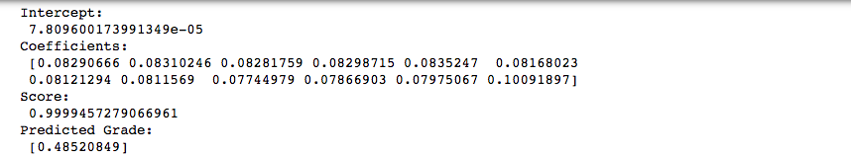

Figure 7.7‑1 Example of Result of multiple linear regression

### Important Libraries and Modules for Data Visualization

1. **from** flask **import** Flask, request, jsonify, render_template, redirect, url_for
2. **import** numpy
3. **from** bokeh.plotting **import** figure
4. **from** bokeh.models.widgets **import** DataTable, DateFormatter, TableColumn
5. **from** bokeh.layouts **import** row
6. **from** bokeh.plotting **import** figure, output_file, show
7. **from** bokeh.models **import** ColumnDataSource, FactorRange
8. **from** bokeh.models **import** HoverTool
9. **from** bokeh.embed **import** components
10. **from** bokeh.resources **import** INLINE
11. **import** re
12. **import** pandas as pd
13. **from** sklearn **import** linear_model
14. **import** statsmodels.api as sm
15. **import** matplotlib.pyplot as plt
16. **from** matplotlib.backends.backend_tkagg **import** FigureCanvasTkAgg
17. **from** bokeh.models **import** Legend

## Web Based Front-end for Visualizing Data Analyzed in 7.2, 7.3, 7.4, 7.5 and 7.6

**Code 7.8 Web Based Front-end for Visualizing Data Analyzed in 7.3, 7.4, 7.5, 7.6 and 7.7**

### Data Visualization of Summative Analysis of Exam Session-Wide Level

This section of coding shows how to read analysed excel files and import data from excel file into a dataframe.

1. session_code = request.args['session_code']
2. header = '''''<h2>Summary of Exam Session '''+session_code+'''''</h2>'''
3. summary_data = pd.ExcelFile('Exam_Review/Exam_Session_'+session_code+'_Summary.xlsx')
4. nrows = summary_data.book.sheet_by_index(0).nrows
5. sum_df = summary_data.parse(0, skipfooter= nrows-(3+1)).dropna(axis=1, how='all')
6. cm_df = summary_data.parse(0, skiprows=6).dropna(axis=1, how='all')

Code 7.8‑1 Code of splitting data from excel file into multiple dataframe

Secondly, we need to add @app.route before defining a function in the purpose of connecting with html page interaction. If we clicked a button which value contains ‘Exam_Session’, it will call the function Exam_Session.

1. @app.route('/Exam_Session',methods = ['POST', 'GET'])
2. **def** Exam_Session():

Code 7.8‑2 Code of defining triggered function for specific ‘href’ from HTML files

If we clicked button on the button set, those buttons will transfer the value of a button to Python and codes in Python distinguish which web page to be shown based on our design of coding. We also applied regular expression to extract important data from the value assigned to a button. For example, a button contains value ‘topic_01’, after applying regular expression of ‘split’, we obtained a list of [‘topic’, ‘01’]. The first element decides which function to be called and html pages to be redirected, the second element in the list is an exam session code to be carried between functions.

1. **if** request.method == 'POST':
2. input_val = request.form['submit']
3. input_val = re.split(r'_', input_val)
4. **if**(input_val[0] == 'topic'):
5. code = input_val[1]
6. **return** redirect(url_for('Topic', code=code))
7. **elif**(input_val[0] == 'studentSearch'):
8. session_code = input_val[1]
9. **return** redirect(url_for('Student_Search', session_code=session_code))
10. **elif**(input_val[0] == 'mock'):
11. session_code = input_val[1]
12. **return** redirect(url_for('Mock', session_code=session_code))

Code 7.8‑3 Code of collecting data from HTML file

With using of library Bokeh, we can visualize data in table and bar graph form directly by using dataframe as an input. In order to make bar graph interative, we applied HoverTool from Bokeh and assigned it to bar graph.

1. data = {'category' : category,
2. 'P Rate': [cm_100_df.iloc[0]['Predict'], cm_100_df.iloc[1]['Predict'], cm_100_df.iloc[2]['Predict']],
3. 'NP Rate': [cm_100_df.iloc[0]['Actual'], cm_100_df.iloc[1]['Actual'], cm_100_df.iloc[2]['Actual']],
4. 'Absent Rate': [cm_100_df.iloc[0]['Difference'], cm_100_df.iloc[1]['Difference'], cm_100_df.iloc[2]['Difference']]}
6. x = [ (cate, stat) **for** cate **in** category **for** stat **in** status ]
7. counts = sum(zip(data['P Rate'], data['NP Rate'], data['Absent Rate']), ()) # like an hstack
9. source = ColumnDataSource(data=dict(x=x, counts=counts))
11. cm_p_100 = figure(x_range=FactorRange(*x), plot_height=250, title='''''Percentage of Confusion Matrix for Exam Session '''+session_code+'''''''', toolbar_location=None, tools="")
13. cm_p_100.vbar(x='x', top='counts', width=0.9, source=source)
15. cm_p_100.y_range.start = 0
16. cm_p_100.x_range.range_padding = 0.1
17. cm_p_100.xaxis.major_label_orientation = 1
18. cm_p_100.xgrid.grid_line_color = None
20. cm_p_100.add_tools(HoverTool(tooltips=[("Category", "@x"), ("Percentage", "@counts")]))

Code 7.8‑4 Code of plotting a bar graph

At the end of this function, we will return render_template() from web framework Flask and filled with css and js generated by INLINE.render_js() and INLINE.render_js() from Bokeh, html source code we created in exam session() and html source code we made with component() from Bokeh.

1. script6, div6 = components(cm_p_100)
3. js_resources = INLINE.render_js()
4. css_resources = INLINE.render_css()
5. **return** render_template('exam_session.html', header=header, header2=header2, header3=header3,script=script, div=div, script2=script2, div2=div2, script3=script3, div3=div3, script4=script4, div4=div4, script5=script5, div5=div5, script6=script6, div6=div6, js_resources=js_resources, css_resources=css_resources, button_menu=button_menu)

Code 7.8‑5 Code of visualization of data generate in Python in HTML file

**Required input:**

* **Excel Files of summative analysis of exam session**
* **Excel Files of confusion matrix of summative analysis of exam session**

**Expected Output:**

A html page visualizing three tables with corresponding bar graph. Tables are summative analysis of exam session, confusion matrix of summative analysis of exam session and confusion matrix of P and NP rate in terms of percentage respectively. With pre-defined button set which generated in Python.

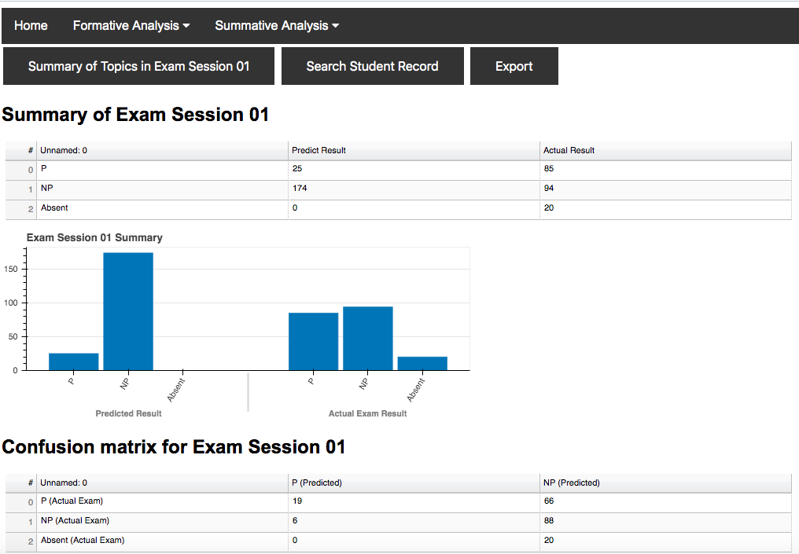

Figure 7.8‑1 Example of visualizing summative analysis in exam session 01 in web page Part1

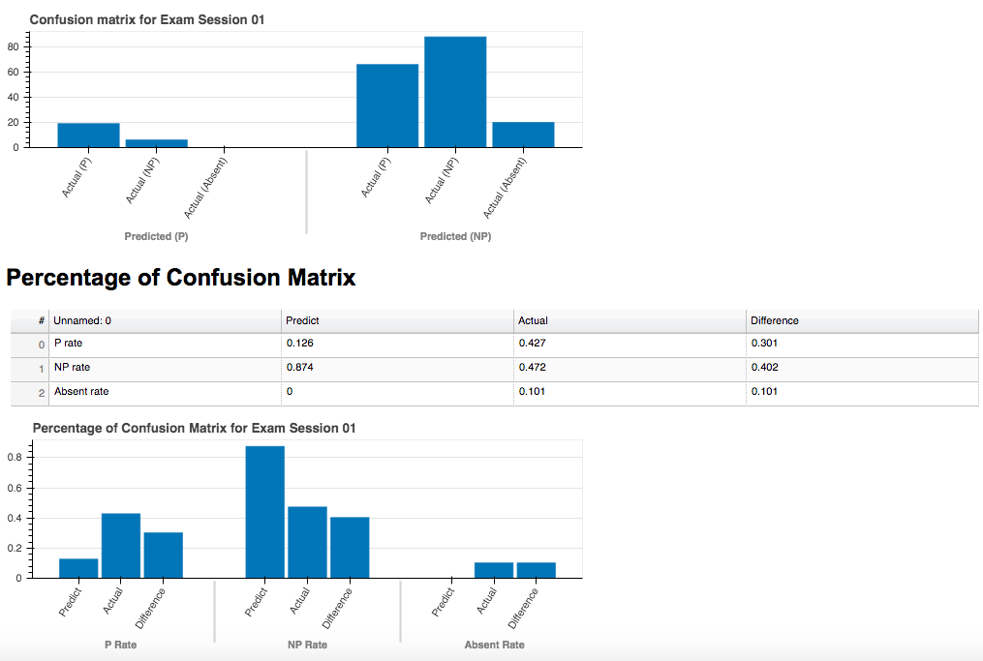

Figure 7.8‑2 Example of visualizing summative analysis in exam session 01 in web page Part2

### Data Visualization of Summative Analysis of Topic-wise Level

This section of coding illustrates how to read analysed topic excel files and import data from excel file into a dataframe. With using of library Bokeh, we can visualize data in table and bar graph form directly by using dataframe as an input. In order to make bar graph interative, we applied HoverTool from Bokeh and assigned it to bar graph.

Secondly, we added ('/Topic',methods = ['POST', 'GET']) before defining function **Topic()** in the purpose of connecting with html page ‘topic-wise.html’ that we created beforehand so we can make the interaction and transfer data between html and Python. If we clicked a button which href is ‘Topic’, it will call the function Topic. And start to read 12 excel files for each topic and generate data tables and bar graphs corresponded to each topic.

1. @app.route('/Topic',methods = ['POST', 'GET'])
2. **def** Topic():

In the function Topic(), it can redirect to page of searching student and page of summary of exam session.

1. **if** request.method == 'POST':
2. input_val = request.form['submit']
3. input_val = re.split(r'_', input_val)
4. **if**(input_val[0] == 'studentSearch'):
5. session_code = input_val[1]
6. **return** redirect(url_for('Student_Search', session_code=session_code))
7. **elif**(input_val[0] == 'es'):
8. session_code = input_val[1]
9. **return** redirect(url_for('Exam_Session', session_code=session_code))

Code 7.8‑6 Code of redirect to other pages based on input from HTML

In order to visualize bar graph with Bokeh, we used data from t2_df as input and assigned processed input data to figure(). Inside of figure(), we declared the x_range of bar graph, the height of plot and the title of graph.

1. data = {'category' : category,
2. 'P': [t2_df.iloc[0]['Predict Result'], t2_df.iloc[0]['Actual Result']],
3. 'NP': [t2_df.iloc[1]['Predict Result'], t2_df.iloc[1]['Actual Result']],
4. 'Absent': [t2_df.iloc[2]['Predict Result'], t2_df.iloc[2]['Actual Result']]}
6. x = [ (cate, stat) **for** cate **in** category **for** stat **in** status ]
7. counts = sum(zip(data['P'], data['NP'], data['Absent']), ()) # like an hstack
8. source = ColumnDataSource(data=dict(x=x, counts=counts))
9. t2_p = figure(x_range=FactorRange(*x), plot_height=125, title='''''Summary of Topic 02''', toolbar_location=None, tools="")
10. t2_p.vbar(x='x', top='counts', width=0.9, source=source)

Code 7.8‑7 Code of processing data into a graph

It visualizes 12 excel files of summative analysis of topics. At the end of this function, we will return render_template() from web framework Flask and filled with css and js generated by INLINE.render_js() and INLINE.render_js() from Bokeh, html source code we created in exam session() and html source code we made with component() from Bokeh.

1. js_resources = INLINE.render_js()    
   css_resources = INLINE.render_css()
2. **return** render_template('topic-wise.html'
3. ,button_menu=button_menu
4. ,header=header
5. ,js_resources=js_resources
6. ,css_resources=css_resources,
7. ,t2_script=t2_script,t2_div=t2_div

Code 7.8‑8 Code of transmitting data from Python to HTML

**Required input:**

* **Excel Files of summative analysis in Topic-wise level**
* **Value of exam session number from a button which redirect to Topic-wise.html**

**Expected Output:**

**A web page illustrates 12 sets of Data Table and Bar Chart for each topic**

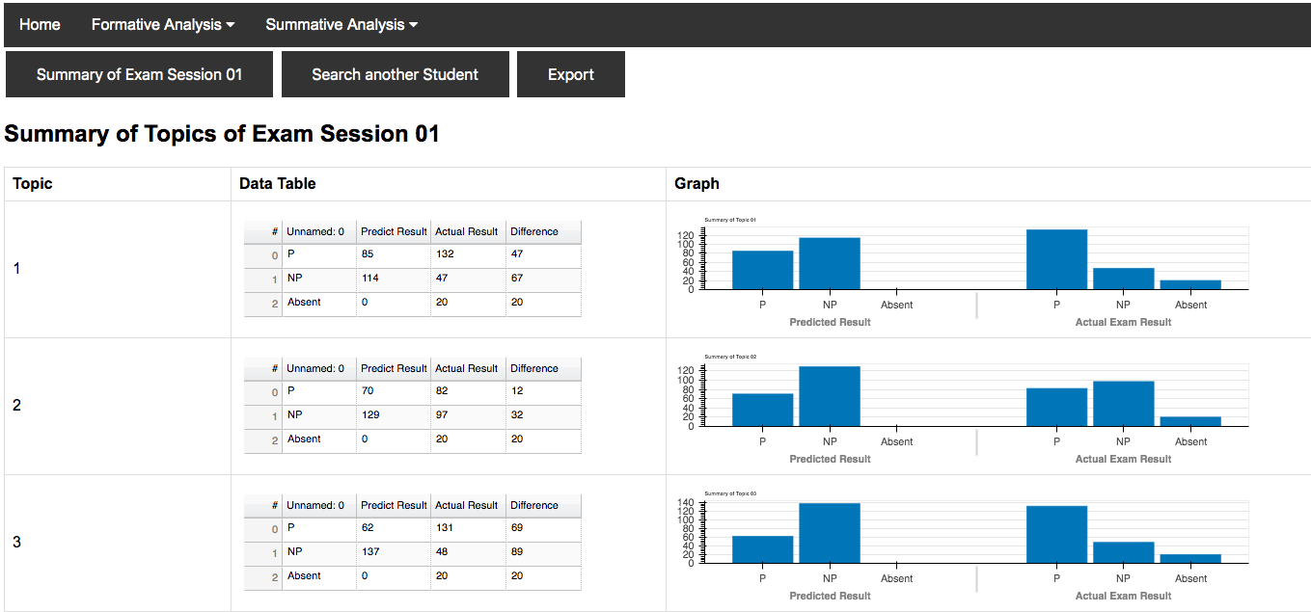

Figure 7.8‑3 Example of visualizing summative analysis in Topic-wise level of exam session 01 in web page Part1

### Data Visualization of Summative Analysis of Individual Level

This section of coding illustrates how to read excel file of summative analysis and import data from excel file into a dataframe. With using of library Bokeh, we can visualize data in table, bar graph and line graph form directly by using dataframe as an input. In order to make bar graph interative, we applied HoverTool from Bokeh and assigned it to bar graph.

Secondly, we added @app.route('/Student_Record',methods = ['POST', 'GET']) before defining function **Student_Record()** in the purpose of connecting with html page ‘student_record.html’ that we created before so we can make the interaction and transfer data between html and Python.

1. @app.route('/Student_Record',methods = ['POST', 'GET'])
2. **def** Student_Record():

If we clicked a button which value contains ‘Student_Record’, it will call the function Student_Record. The most important information for this function is student number, we collected such information from another function named student_search().

1. @app.route('/Student_Search',methods = ['POST', 'GET'])
2. **def** Student_Search():

The purpose of student_search() is for user to pick a student number based on categories of ‘P’, ‘NP’ and ‘Absent’. The drop-down list of student no will change accordingly based on categories. And student search() redirects to page of student record after submit button is pressed. It will transfer the student number and session number to the page of student record and called the function Student_Record().

1. **if** request.method == 'POST':
2. student_no = request.form['student_no']
3. code = request.form['submit']
4. **return** redirect(url_for('Student_Record', student_no=student_no, code=code))

Code 7.8‑9 Code of redirecting to url of student_record

In the function of Student_Record(), the program will fetch the excel file of student in certain exam session. With using analysed result to visualize with a data table of overview of exam reviews.

1. student_no = request.args['student_no']
2. code = request.args['code']
3. header = '''''<h2>Summary of Student No. '''+student_no+''''' in Exam Session '''+code+'''''</h2>'''
4. summary_data = pd.read_excel('Exam_Review/Exam_Sec_'+code+'/Exam_Review_Overview/'+student_no+'_'+code+'.xlsx')
5. sum_df = pd.DataFrame(summary_data)
6. sum_df['Completed'] = sum_df['Completed'].astype(str)
7. sum_df['Started on'] = sum_df['Started on'].astype(str)
9. Columns = [TableColumn(field=Ci, title=Ci, width=120) **for** Ci **in** sum_df.columns] # bokeh columns
10. data_table = DataTable(columns=Columns, source=ColumnDataSource(sum_df), height=400, width=1200, sortable=True, fit_columns=False)

Code 7.8‑10 Code of Generation of Data Table to visualize gathered data

And visualize with a data table of summary of exam review in 12 topics.

1. header3 = '''''<h3>Summary of Student No. '''+student_no+''''' in Actual Exam Session '''+code+'''''</h3>'''
2. actual_sum_data = pd.read_excel('Exam_Review/Exam_Sec_'+code+'/Actual_Exam_Summary/'+student_no+'_'+code+'.xlsx')
3. actual_sum_df = pd.DataFrame(actual_sum_data)
4. Columns = [TableColumn(field=Ci, title=Ci, width=90) **for** Ci **in** actual_sum_df.columns] # bokeh columns
5. actual_sum_data_table = DataTable(columns=Columns, source=ColumnDataSource(actual_sum_df), height=100, width=1200, sortable=True, fit_columns=False)
6. **if**(str(actual_sum_df['Overall grade'][0]) != 'nan'):
7. overall_grade = float(actual_sum_df['Overall grade'][0])/100.0
8. **else**:
9. overall_grade = 0

Code 7.8‑11 Code of visualizing data table of summary of exam review in 12 topics

And visualize with a data table of summary of actual exam.

1. header4 = '''''<h3>Summary of Student No. '''+student_no+''''' in Exam Review '''+code+'''''</h3>'''
2. summary_data = pd.read_excel('Exam_Review/Exam_Sec_'+code+'/Exam_Review_Summary/'+student_no+'_'+code+'.xlsx')
3. sum_df = pd.DataFrame(summary_data)
4. Columns = [TableColumn(field=Ci, title=Ci, width=90) **for** Ci **in** sum_df.columns] # bokeh columns
5. er_data_table = DataTable(columns=Columns, source=ColumnDataSource(sum_df), height=100, width=1200, sortable=True, fit_columns=False)
6. **if**(str(sum_df['Overall Passing Rate For Exam (All topic Grades/12)'][0]) != 'nan'):
7. overall_rate = float(sum_df['Overall Passing Rate For Exam (All topic Grades/12)'][0])
8. **else**:
9. overall_rate = 0

Code 7.8‑12 Code of visualizing data table of summary of actual exam

Next, we used a line graph with 5 different colors of lines to visualize data from the datatable.

1. header2 = '''''<h3>Graph of Summarized data</h3>'''
2. plot_data = pd.read_excel('Exam_Review/Exam_Sec_'+code+'/Plot/'+student_no+'_'+code+'.xlsx')
3. plot_df = pd.DataFrame(plot_data)
4. plot_df = plot_df.fillna('')
5. topics = ['Topic 01', 'Topic 02', 'Topic 03', 'Topic 04', 'Topic 05', 'Topic 06', 'Topic 07', 'Topic 08', 'Topic 09','Topic 10', 'Topic 11', 'Topic 12']
6. predicted = []
7. actual = []
8. topic = [1, 2, 3, 4, 5, 6, 7, 8, 9, 10, 11, 12]
9. legend_it = []
10. **for** i **in** topics:
11. predicted.append(plot_df[i][0])
12. actual.append(plot_df[i][1])
13. source_pk = ColumnDataSource(data=dict(topic=topic,grade=predicted,))
14. source_in = ColumnDataSource(data=dict(topic=topic,grade=actual,))
15. plot = figure(title='Comparison of Predicted and Actual Performance', x_axis_label='Topic', y_axis_label='Percentage of grade in Topic', width=1000)
16. c = plot.line('topic', 'grade', line_width=2, line_color='green', source=source_pk)
17. plot.circle('topic', 'grade', fill_color="green",line_color='green', size=8, source=source_pk)
18. legend_it.append(('Predicted', [c]))
19. c = plot.line('topic', 'grade', line_width=2, line_color='orange', source=source_in)
20. legend_it.append(('Actual', [c]))
21. plot.circle('topic', 'grade', fill_color="orange", line_color='orange', size=8, source=source_in)
22. c = plot.line([1, 12], [0.7, 0.7], line_width=2, line_color="purple")
23. legend_it.append(('Passing Rate', [c]))
24. c = plot.line([1, 12], [overall_grade, overall_grade], line_width=2, line_color="blue")
25. legend_it.append(('Actual Grade', [c]))
26. c = plot.line([1, 12], [overall_rate, overall_rate], line_width=2, line_color="red")
27. legend_it.append(('Predicted Grade', [c]))
28. legend = Legend(items=legend_it, location=(0, 400))
29. plot.add_layout(legend, 'right')
30. plot.legend.click_policy="hide"

Code 7.8‑13 Code of constructing line graph with five colors of lines

Since we also have confusion matrix for individual student, we present it with a bar chart and data table.

1. header_cm = '''''<h3>Confusion Matrix of Predict and Actual Result</h3>'''
2. cm_data = pd.read_excel('Exam_Review/Exam_Sec_'+code+'/'+'/Confusion_matrix/'+student_no+'_'+code+'.xlsx')
3. cm_df = pd.DataFrame(cm_data)
4. Columns = [TableColumn(field=Ci, title=Ci) **for** Ci **in** cm_df.columns] # bokeh columns
5. data_table_cm = DataTable(columns=Columns, source=ColumnDataSource(cm_df), height=100, width=1000)
7. category = ['Predict P', 'Predict NP']
8. status = ['Actual P', 'Actual NP']
9. data = {'category' : category,
10. 'P Rate': [cm_df.iloc[0]['Positive'], cm_df.iloc[1]['Positive']],
11. 'NP Rate': [cm_df.iloc[0]['Negative'], cm_df.iloc[1]['Negative']]}
12. x = [(cate, stat) **for** cate **in** category **for** stat **in** status]
13. counts = sum(zip(data['P Rate'], data['NP Rate']), ()) # like an hstack
14. source = ColumnDataSource(data=dict(x=x, counts=counts))
15. cm_plot = figure(x_range=FactorRange(*x), plot_height=250, title='''''Percentage of Confusion Matrix for Exam Session '''+code+'''''''', toolbar_location=None, tools="")
17. cm_plot.vbar(x='x', top='counts', width=0.9, source=source)
18. cm_plot.y_range.start = 0
19. cm_plot.x_range.range_padding = 0.1
20. cm_plot.xaxis.major_label_orientation = 1
21. cm_plot.xgrid.grid_line_color = None
22. cm_plot.add_tools(HoverTool(tooltips=[("Category", "@x"), ("Percentage", "@counts")]))

Code 7.8‑14 Code of creating data table and bar graph to visualize analyzed data in individual level

**Required input:**

* **Excel File of summative analysis in individual level**
* **Value of student number and exam session number from Student_Search()**

**Expected Output:**

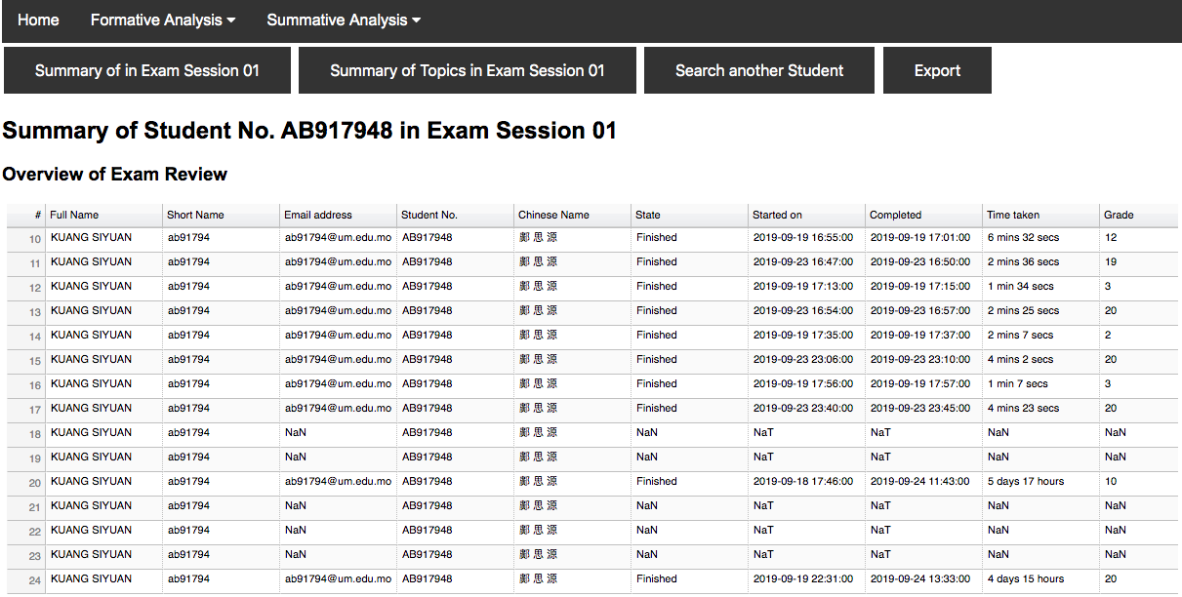

Figure 7.8‑4 Example of visualizing summative analysis in Individual level of exam session 01 in web page Part1

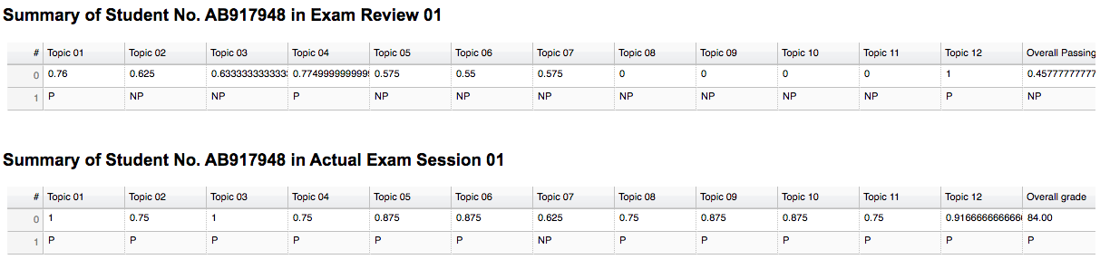

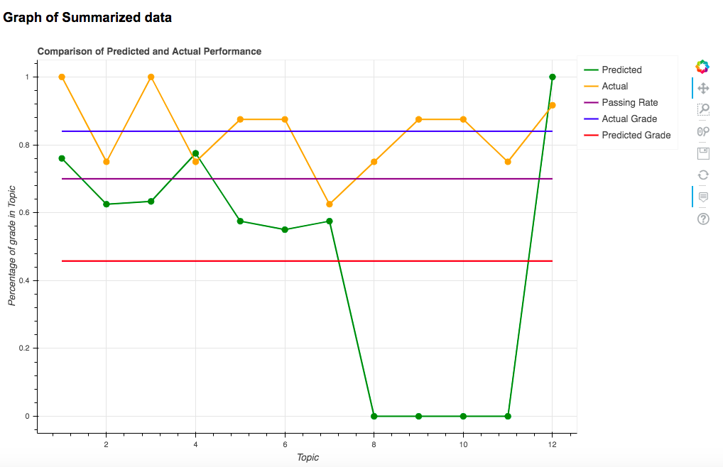

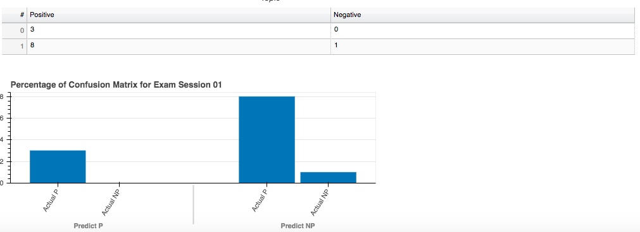

Figure 7.8‑5 Example of visualizing summative analysis in Individual level of exam session 01 in web page Part2

## Summary

In this chapter, we have documented our efforts in Python coding in order to generate results documented in Chapter 5 and 6. We have learned how to present data with different visualizing techniques and how to transfer data between different platforms for further handling of data in Python. And how to analyse data from different sources so we can perform ‘split-apply-combine’ on our data with Python and used analysed result to answer the question we proposed in Chapter 3. Moreover, we also learned how to train a multiple linear regression model with data we analysed.

# ETHICS & PROFESSIONAL CONDUCT

## Introduction

In this chapter we have provided our personal declaration to follow the ACM Code of Conduct and Ethics (<https://www.acm.org/code-of-ethics>) in the development and research of our FYP. The ACM Code of Ethics and Professional Conduct is a collection of principles and guidelines designed to help computing professionals make ethically responsible decisions. The code is divided into four sections:

1. General Ethical Principals
2. Professional Responsibilities
3. Professional Leadership Principles
4. Compliance with the Code

In the context of this data science project, we have followed through the following items of interest in the Code of Ethics:

* Code 1.3: Be honest and trustworthy
* Code 1.6: Respect privacy
* Code 1.7: Honor confidentiality
* Code 2.6: Perform work only in areas of competence
* Code 3.5: Create opportunities for members of the organization or group to grow as professionals
* Code 4.1 Uphold, promote, and respect the principles of the Code

## General Ethical Principals

As a data science computer professional we should abide to the following general ethical principles:

### Be Honest and Trustworthy

According to Item 1.3 in ACM Code of Ethics and Professional Conduct, reproduced below:

*“Honesty is an essential component of trustworthiness. A computing professional should be transparent and provide full disclosure of all pertinent system capabilities, limitations, and potential problems to the appropriate parties. Making deliberately false or misleading claims, fabricating or falsifying data, offering or accepting bribes, and other dishonest conduct are violations of the Code.*

*Computing professionals should be honest about their qualifications, and about any limitations in their competence to complete a task. Computing professionals should be forthright about any circumstances that might lead to either real or perceived conflicts of interest or otherwise tend to undermine the independence of their judgment. Furthermore, commitments should be honored.*

*Computing professionals should not misrepresent an organization's policies or procedures, and should not speak on behalf of an organization unless authorized to do so.”*

(Source: <https://www.acm.org/code-of-ethics#h-1.3-be-honest-and-trustworthy.>)

A data science project involves manipulation and transformation of large amounts of data. The developed program code in this project is designed to redistribute the data by reshaping and regrouping it in a way that it is more accessible for analysis and visualization and further process with machine learning model. Processing with large amounts of numbers requires specific amount of organization and verification. In this FYP we have taken time and effort to verify the numbers of the tabulated data so that all information could be consistent and truth to the source. We have also taken time to verify the data given to me at the end of the semester in order to check for inconsistencies before starting the summative analysis.

### Respect Privacy

According to Item 1.6 in ACM Code of Ethics and Professional Conduct, reproduced below:

*“The responsibility of respecting privacy applies to computing professionals in a particularly profound way. Technology enables the collection, monitoring, and exchange of personal information quickly, inexpensively, and often without the knowledge of the people affected. Therefore, a computing professional should become conversant in the various definitions and forms of privacy and should understand the rights and responsibilities associated with the collection and use of personal information.*

*Computing professionals should only use personal information for legitimate ends and without violating the rights of individuals and groups. This requires taking precautions to prevent re-identification of anonymized data or unauthorized data collection, ensuring the accuracy of data, understanding the provenance of the data, and protecting it from unauthorized access and accidental disclosure. Computing professionals should establish transparent policies and procedures that allow individuals to understand what data is being collected and how it is being used, to give informed consent for automatic data collection, and to review, obtain, correct inaccuracies in, and delete their personal data.*

*Only the minimum amount of personal information necessary should be collected in a system. The retention and disposal periods for that information should be clearly defined, enforced, and communicated to data subjects. Personal information gathered for a specific purpose should not be used for other purposes without the person's consent. Merged data collections can compromise privacy features present in the original collections. Therefore, computing professionals should take special care for privacy when merging data collections.”*

(Source: <https://www.acm.org/code-of-ethics#h-1.6-respect-privacy.>)

The data collected for this FYP contains private information about the students enrolled in the course CISC1000. Throughout the year long project, we have kept the sensitive data hidden and only accessible to the people involved in the project. The minimum amount of personal data has been collected and shown for the development of this FYP report. I have also taken measures to secure the trading of data among the involved member through secure platforms by exclusively using UMMoodle to communicate with my supervisor and a private Github repository to exchange data with my groupmate and FYP representatives.

### Honor Confidentiality

According to Item 1.7 in ACM Code of Ethics and Professional Conduct, reproduced below:

*“Computing professionals are often entrusted with confidential information such as trade secrets, client data, nonpublic business strategies, financial information, research data, pre-publication scholarly articles, and patent applications. Computing professionals should protect confidentiality except in cases where it is evidence of the violation of law, of organizational regulations, or of the Code. In these cases, the nature or contents of that information should not be disclosed except to appropriate authorities. A computing professional should consider thoughtfully whether such disclosures are consistent with the Code.”*

(Source: <https://www.acm.org/code-of-ethics#h-1.7-honor-confidentiality.>).

The data collected for this FYP is used for research only. The data has been kept confidential and within the margins of the project. We have also been notified that the data included in this FYP should be available to the intended audience only.

## Professional Responsibilities

As a data science computer professional we should abide to the following professional responsibilities:

### Perform work only in areas of competence

According to Item 2.6 in ACM Code of Ethics and Professional Conduct, reproduced below:

*“A computing professional is responsible for evaluating potential work assignments. This includes evaluating the work's feasibility and advisability, and making a judgment about whether the work assignment is within the professional's areas of competence. If at any time before or during the work assignment the professional identifies a lack of a necessary expertise, they must disclose this to the employer or client. The client or employer may decide to pursue the assignment with the professional after additional time to acquire the necessary competencies, to pursue the assignment with someone else who has the required expertise, or to forgo the assignment. A computing professional's ethical judgment should be the final guide in deciding whether to work on the assignment.*”

(Source: <https://www.acm.org/code-of-ethics#h-2.6-perform-work-only-in-areas-of-competence.>)

This FYP requires knowledge in programming with Python and HTML, data science with formulation towards machine learning and visualization in a web-based system. As a member of a group, we are responsible to voice my opinion and concern towards skills or requirements that I have difficulty in performing. Throughout this FYP, we have regularly communicated with my supervisor about the extent of our knowledge, programming skills, feasibility on the deliverables of the FYP, and time availability. We have also communicated about our common knowledge in Data Science and respective skills that we can contribute to this FYP. We have properly divided the work among ourselves relative to our own respective skills.

## Professional Leadership Principles

As a data science computer professional we should abide to the following Professional Leadership principles:

### Create opportunities for members of the organization or group to grow as professionals

According to Item 3.5 in ACM Code of Ethics and Professional Conduct, reproduced below:

*“Educational opportunities are essential for all organization and group members. Leaders should ensure that opportunities are available to computing professionals to help them improve their knowledge and skills in professionalism, in the practice of ethics, and in their technical specialties. These opportunities should include experiences that familiarize computing professionals with the consequences and limitations of particular types of systems. Computing professionals should be fully aware of the dangers of oversimplified approaches, the improbability of anticipating every possible operating condition, the inevitability of software errors, the interactions of systems and their contexts, and other issues related to the complexity of their profession—and thus be confident in taking on responsibilities for the work that they do.”*

(Source: <https://www.acm.org/code-of-ethics#h-3.5-create-opportunities-for-members-of-the-organization-or-group-to-grow-as-professionals.>)

We have considered that every member of the group could contribute to the development of this FYP. We divided the work in a way that our contributions could complement each other by separating the data analysis into a formative approach and a summative approach. In this approach, both members of the group could grow as computer professionals while simultaneously approach the topic of the FYP in two different perspectives.

## Compliance with the Code

As a data science computer professional we should comply with the Code to:

### Uphold, promote, and respect the principles of the Code

According to Item 4.1 in ACM Code of Ethics and Professional Conduct, reproduced below:

*“The future of computing depends on both technical and ethical excellence. Computing professionals should adhere to the principles of the Code and contribute to improving them. Computing professionals who recognize breaches of the Code should take actions to resolve the ethical issues they recognize, including, when reasonable, expressing their concern to the person or persons thought to be violating the Code.”*

(Source: <https://www.acm.org/code-of-ethics#h-4.1-uphold,-promote,-and-respect-the-principles-of-the-code.>)

At the start of this FYP, before we were given the data to work with, our supervisor communicated to us the importance of confidentiality and privacy when dealing with sensitive data. We recognized the importance of keeping our Github repository private despite it being easier to maintain it public.

## Summary

In this chapter, we have described the pertinent items on the ACM Code of Ethics that were abided in the development of this FYP. As a growing computer professional, learning about the code of Ethics was especially useful for developing an ethical decision-making mindset for future works.

***Statement of Integrity***

This chapter is written by the two members of Group V, including: Chan Chan Andy (D-B6-2543-5) and Huang Liang Hui Gi Vicky (D-B6-2661-3). So, the pronoun “We” instead of “I” and the possessive pronoun “our” instead of “my” have been used in the body of this chapter. The respective project titles of Andy and Vicky are as follows:

* Andy - *Scenario-Based Evaluation of Student Performance using 2019 CISC1000 Course Data: A Python Formative Data Analysis*
* Vicky - *Your Project TitleScenario-Based Prediction of Student Performance using 2019 CISC1000 Course Data: A Python Summative Data Analysis*

# PROJECT INSIGHT AND CONCLUSION

## Introduction

This chapter written to summarize the results and discovery of our FYP regarding the overall performance of summative analysis of the course CISC1000 in academic year 2019-2020 by answering the research question: “How did CISC1000 perform in terms of student summative assessment?”. After presenting our findings, we will provide our insights and suggestions for possible improvements of the course for future development.

## Evaluation on Summative Analysis in Overall Exam Session Level

From the result of our summative analysis in overall exam session level. We have discovered our predicted method for number of NP students are much higher than number of P students. However, the number of P students in official exams is normally higher than the number of P students predicted based on exam review and the number of NP students are slightly lower than the number of predicted NP students. The reason caused this phenomenon is there are certain number of exceptional cases of student who did not attempt any topic in exam review (quizzes) and still pass in the official exam. Since student who does not attempted any exam review (quizzes) we predicted their grade as ‘NP’, and therefore, these exceptional cases also made the difference between number of predicted NP and actual NP higher.

Another possible cause of greater difference between prediction and actual result is students who absent from the enrolled exam, these absent students could be part of number of students who attempted exam review(quizzes) and obtained ‘P’ or ‘NP’ of the overall predicted grade.

To improve the accuracy of prediction, we would suggest students tried to practise with exam review (quizzes) before entering official exam and attend the official exam as they scheduled. In this way, our data would be more intact. The difference between prediction and official exam result would be lowered.

## Evaluation on Summative Analysis in Topic-wise Level

In topic-wise level, we found the similar pattern as the result from overall exam session level. Our predicted number of NP students are significantly higher than number of P students. But the number of P students in official exams is slightly higher than the number of P students predicted based on exam review and the number of NP students are merely lower than the number of predicted NP students. Even outcome between topic-wise level and exam session level is similar, but the cause is very different. There are three categories of students in participating exam review(quizzes):

* 1. Students completed all topics in exam review at least once
  2. Students completed some of topics in an exam review
  3. Students did not complete any of topics in an exam review

This contributes to prediction of more NP students than P students. For students who completed all topics in exam review at least once has lower chances to be predicted ‘NP’ compared to other two categories because it is depends on student’s performances. For students in second category, certain topics have not been attempted must result in ‘NP’ which leads to higher number of ‘NP’ student. Students in third category, all of 12 topics will be predicted with ‘NP’ because none of topics has been attempted by students. To conclude, if number of students practises with exam review (quizzes) increases, the number of predicted ‘NP’ student for each topic has possibility to be lowered.

## Evaluation on Summative Analysis at Individual Level

The key of summative analysis is using analysed result to inform those NP students so as to improve their performance in their next exam attempts. We encourage NP students with no records of exam reviews to practise more the suggested topics based on our analytic advice before they enter the next exam.

From what we have observed summative analysis in individual level, the score of official exam fluctuates with various topics. In most of cases regardless of ‘P’ or ‘NP’ student, grade of topic 9 to topic 12 scored relatively lower compared to other topics in an exam session. In this matter, we encourage student who is going to take an exam should practise more online quizzes of topic 9 to topic 12.

On the other hand, student who achieve ‘P’ in more than nine topics in exam review(quizzes) tended to pass in an official exam. For students who obtained ‘P’ in 6 to 9 topics in exam review and still results in No Pass in actual exams, we recommend them to improve their review based on our report of summative analysis for their actual exam performance (identifying their relatively weak topics with low scores achieved) and try to improve their performances for their next registered exam. For NP students with no records of exam reviews to practise more the suggested topics based on our analytic advice before they enter the next exam. Lastly, we also encourage students obtained No Pass and collected 0 to 5 topics with Pass in exam reviews, strengthen knowledge of each topics by taking a thorough revision from study materials and re-attempt all topics of exam reviews.

All in all, students are highly recommended to complete each topic in exam review at least once to enhance their understanding of knowledge to 12 different area of CISC1000 exams.

## Evaluation on Machine Learning Prediction Model

From the beginning of this FYP, our approach is choosing one of the most suitable machine learning models and fitted with our collected data in order to answer the question we proposed in Chapter 3. However, our approach is different compared to our original idea of applying machine learning technique. We started with an analytic data science problem. In order to understand better of our defined question, we applied data wrangling, data analysis and data visualization. However, we found that our problem is related to prediction during the process of data analysis, we need to find a way to redirect our problem towards a problem related to machine learning. And reshape our analysed data into training data in order to fit into a machine learning model. And this model will provide the prediction result for us to interpret as positive or negative based on particular data as inputs to answer our analytic question.

In our case, we have a set of data after summative analysis. Those data contain student’s performance from topic 1 to topic 12, and each set of data of a student has an overall grade of official exam and exam review. For our machine learning model, we reshaped the analytic data into training data to fit our multiple linear regression model. The main purpose of this model is predicting how well will the student perform in their official exam. After we provide 12 individual inputs for our model, it will return the predicted score for us to interpret whether the student pass or no pass in their official exam.

## Limitation of Further Analysis of Data of Mock-Up Exams

Mock-up exams is newly added in this year, it is not compulsory for students to attempt the mock-up exam before they entered official exam. The purpose of mock-up exam is for student to practise in order to enhance their understanding of materials of CISC1000, so student who attempted mock exam and obtained score with ‘P’ has higher chances to pass in official exam. However, we have discovered the rate participation of mock-up exams is relatively low compared to exam review (quizzes). This results in the data of mock-up exams is not enough to be represented as part of features in our prediction model. We used mock-up exam in exam session 1 as an example. In exam session 01, there are 10 RC and each RC has two class sections. There are 20 sections in total. We provided the participation rate in RC sections to illustrate the proportion of student attempted mock-up exam. The lowest participation rate is RC: MCMC- 602, there are 10 students enrolled the exam session 01 but 0 students attempted the mock-up exam, therefore, the participation rate is 0 percent.

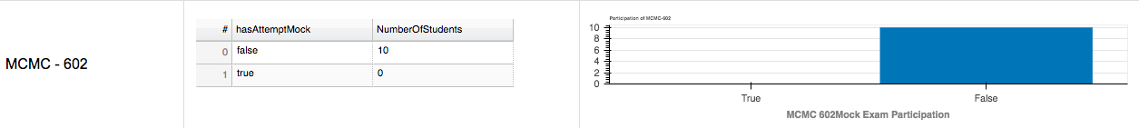

Figure 9.6‑1 Lowest participation of RC in Mock Exam in Exam session 01

On the other hand, the highest participation rate is RC: CKLC- 001, there are 14 students enrolled the exam session 01 and 10 students attempted the mock-up exam, therefore, the participation rate is about 71 percent.

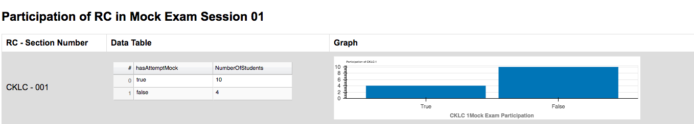

Figure 9.6‑2 Highest participation of RC in Mock Exam in Exam session 01

In order to obtain the overall participation rate in mock-up exam in exam session 01, we accumulate the number of students in each RC who enrolled exam session 01 and the number of students who attempted the mock-up exam. There are 179 students enrolled in exam session 01 and only 36 percent of students participated in mock-up exams. We would suggest that data of mock exam can be very representative if participation rate of student in mock exam is higher so that we have more data to be analyzed.

## Possible Improvement for Future Development

In this section, we are going to discuss possible improvement of our project in future development.

### Improvement of Machine Learning Model

Even though students are allowed to re-attempt exams as many times as they needed but the number of exam session is limited within one semester. This makes our data is limited for a machine learning training model. We would suggest that more exam session can be scheduled in next academic year. However, we still tried to use our limited data to fit in a multiple linear regression model. This model helps student to predict their possible score obtained in an official exam based on 12 inputs of grade of each topic. We recommend more features can be added into our training data such as RC, gender or major instead of only percentage of score of twelve topics. We believe that non-numeric elements of a student could affect the result of predictions. On the other hand, we utilize the regression model from framework Sklearn this year and fitted with our data. We would develop our defined multiple linear regression model if time is not limited.

### Improvement of Summative Analysis

In this FYP, we have sorted out major summative analysis on three different levels, which is exam-session level, topic-wise level and individual level. We can perform more deliberate analysis on top of what we have produce this year. What we are going to do is using retrospective approach to analysis in topic-wise level. We can find how many mutual ‘P’ students in number of predicted ‘P’ of each topic and vice versa. Since we already collected the number of predicted ‘P’ in every topic, the number of predicted ‘P’ belonged to a single student can also be found after we performed the retrospective analysis.

### Improvement on Data Visualization

We created a web-based system to visualize data we analysed throughout the whole academic year. At this point, we can only run the web application via running the script written in Juypter Notebook on a localhost. However, we could deploy it as independent web application with specific domain and connected to a server which student can log in with their student account. We could also use LDAP by binding student to an LDAP server, and verify student login credentials. This action can help student only allowed to check the report of their own instead of others and the overall performance of exam session. On the other hand, teachers can have higher authority of web application which allow them to view the category of P, NP and absent student.

On the other hand, some of our data visualization in web application is not interactive. We believe that if our time schedule is not so tight, we can turn every graph into an interactive graph, so the data can be shown more clearly.

## Overall Evaluation in Summative Analysis of CISC1000

This section mainly focused on how to make good use of our summative analysed data from exam review and official exam. Our purpose for result of summative analysis is helping NP student to pass CISC1000 course exam by providing the report which can be generated by our developed web application in order to advice student to study harder on some of topic they perform relatively poor. Since CISC1000 course exam contains a combination of ‘seen’ and ‘unseen’ questions. And the ‘seen’ questions are those question appeared in exam review. In other words, if student did attempt exam review of all topics, those ‘seen’ questions in official exam would be familiar to student. This would be a huge advantage for student who attempt the actual exam. At least they would obtain certain points even though it is not enough for them to pass because there has a proportion of ‘unseen’ questions. However, if the student acquired knowledge of 12 topics of official exam. We believe that ‘unseen’ question would not be a disadvantage to them.

Since the nature of our data represents the efforts of student in course CISC1000 and the report we generated are mainly focused on NP student. In the report, we will provide a clear contrast in percentage of topics obtained in exam review and actual exam. The report will be sent within 24 hours after the last attempted exam has finished. We used the following report extracted from our application as an example. This case is a student who scored ‘NP’ in exam session 01. The report composed of seven parts. The first part is showing (Figure 9.8-1) number of answering question correctly in an official exam with a table and using a table to illustrate number of correct answers in a topic in exam review. This part of content is very essential to our report for every individual student because they can revise how many questions they answer incorrectly in each topic and able to revise certain materials related the that specific topic.

The second part is overview of exam review. We split the whole overview into four figures in order to illustrate the full content of overview of exam review. For protection of student’s personal information, we are not included the name of student in this sample report. Figure 9.8-2 contains the performance of each question in every topic and the duration of student completed in topics of exam review Figure 9.8-3 has shown the performance of Q.6 to Q.15, as we can see some of question has been filled with ‘Not Applicable’. It is because the number of questions in every topic might be different. In order to make the whole data consistent so we filled some of non-existent question with ‘Not Applicable’. Figure 9.8-4 has shown the period of data collection, the value of data_collect_from_date and data_collect_to_date illustrate which period does this slice of data extracted from. Column ‘Exam Session Registered’ indicates which exam session does the studet enrolled and ‘numberOfAttempts’ shows the number of times did the student tried to complete corresponding area of exam before entering official exam. Figure 9.8‑5 mainly illustrates average passing rate of a topic and whether the student attempt the registered exam in the first time. This figure also presents the interactive function of data table. The table column and be clicked to sort ascendingly or descending. In this case, the avg_passing rate is sorted ascendingly.

The third part of the report is summary of exam review, Figure 9.8‑6 extracted average passing rate of each topic and assigned ‘P’ or ‘NP’ based on the rule we introduced in Chapter 5.

The fourth part is report is summary of official exam, Figure 9.8‑7 shows extracted average passing rate of each topic in an official exam. Student cannot check this part of data in UMMoodle after they finished the actual exam. This part of data is essential to ‘NP’ student to improve their performance in their next exam.

The fifth part is comparison of result extracted from summary of exam review and summary of official exam which illustrates as Figure 9.8‑8. NP students would aware which topic they performed poorly in official exam and how much efforts did they put into corresponding topics in exam review. With this kind of information, we can suggest them to revisit the corresponding topic in exam review and hope them would take the advice and perform better in their next exam.

The sixth part is a line graph (Figure 9.8‑9) which shows the data from the previous four parts. This allow students to revise their effort in exam clearly.

The last part of our report is confusion matrix of predicted and official exam which displayed as Figure 9.8-10, to illustrate the accuracy of our predicted outcome compared with student’s result from official exam.

Lastly, we would continually investigate those students who attempted course exam multiple times and still results in ‘NP’. We could gather all records of official exam and exam review into a report and provide advices to them about the strategy to study specifically.

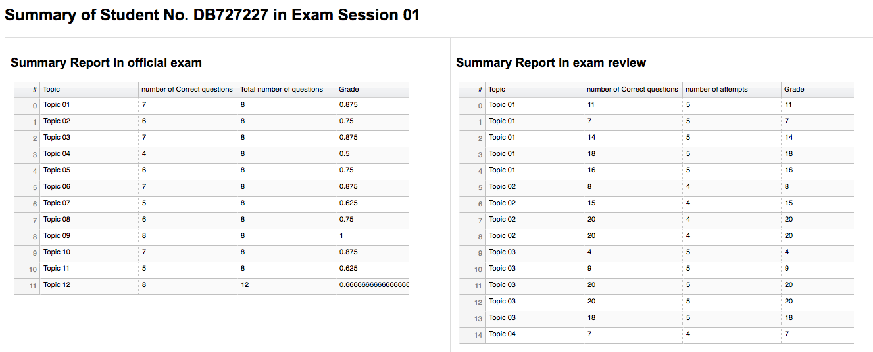

Figure 9.8‑1 Example of listed number of correct questions in each topic in official exam and ream review

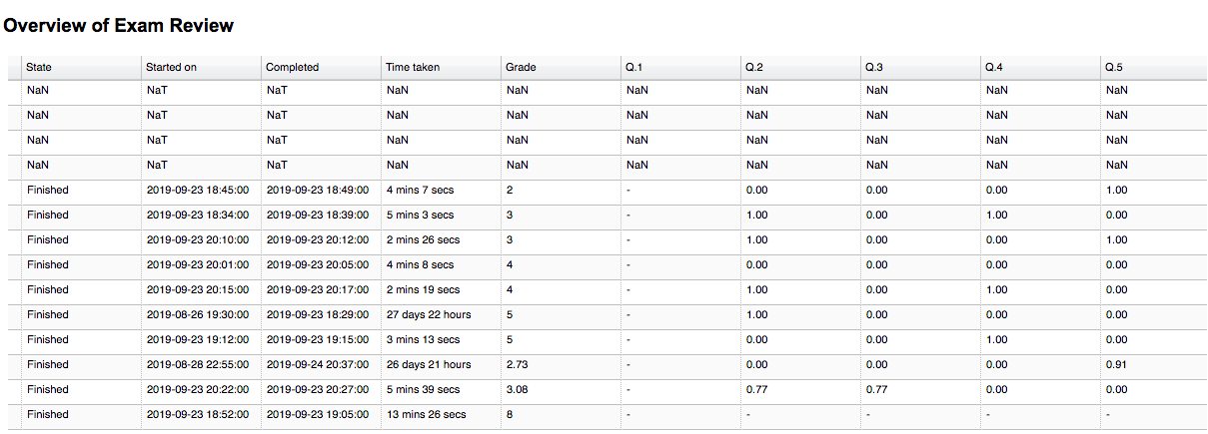

Figure 9.8‑2 Overview of exam review in sample report part 1

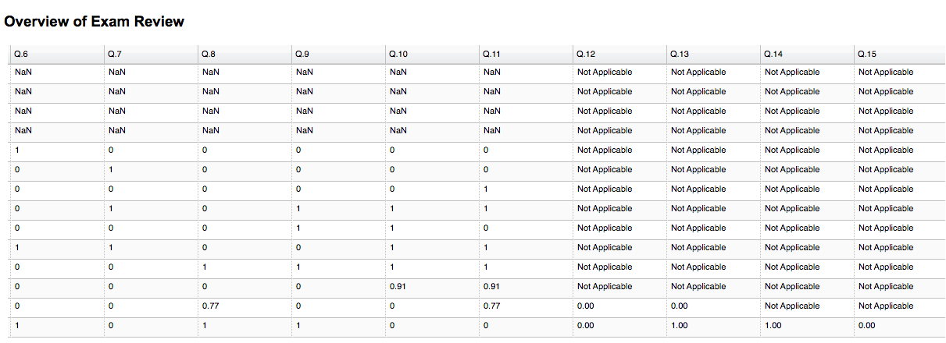

Figure 9.8‑3 Overview of exam review in sample report part 2

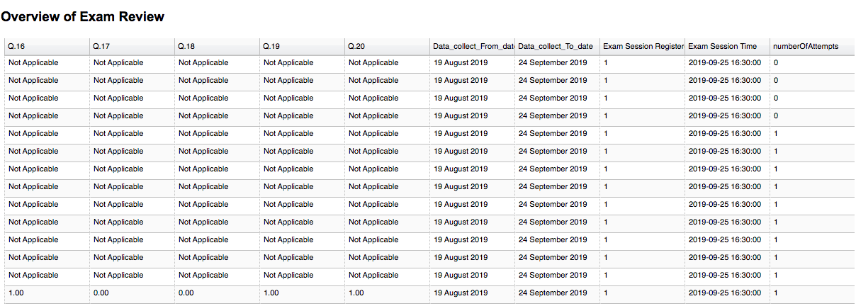

Figure 9.8‑4 Overview of exam review in sample report part 3

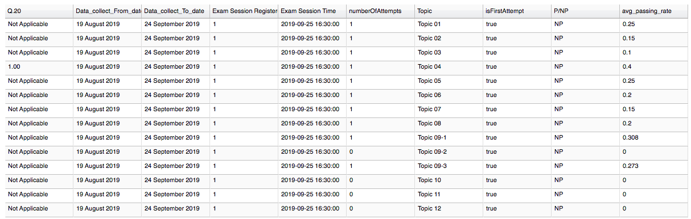

Figure 9.8‑5 Overview of exam review in sample report part 4

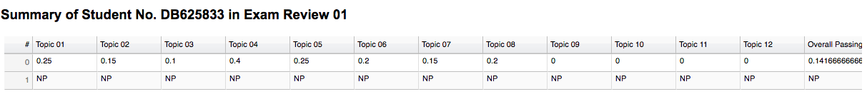

Figure 9.8‑6 Summary of exam review in exam session 01

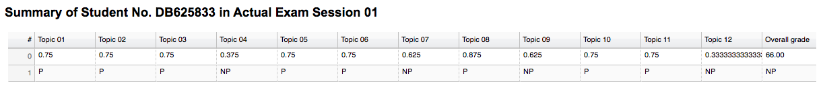

Figure 9.8‑7 Summary of official exam in exam session 01

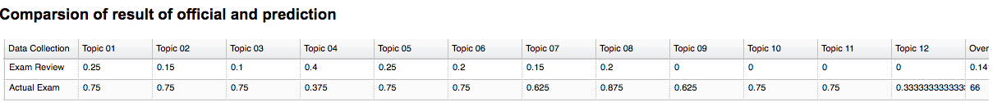

Figure 9.8‑8 Comparison of official exam and exam review

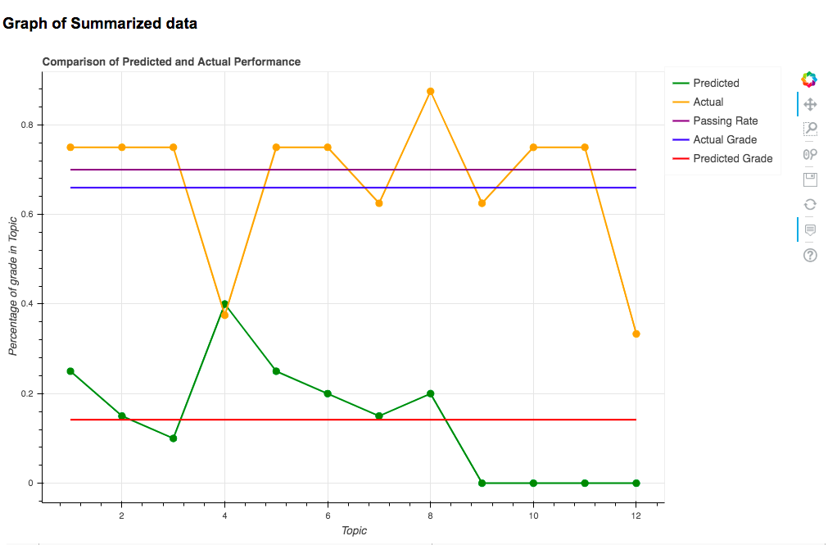

Figure 9.8‑9 Line graph of student report in exam session 01

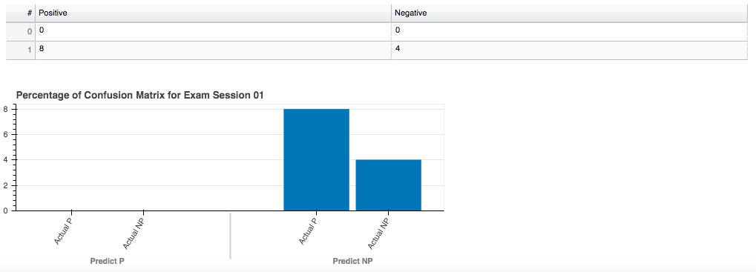

Figure 9.8‑10 Confusion matrix of predicted and official exam

## Overview of Result of Summative Analysis in Web Application

In this section, we conclude the usage of our designed web application for teachers and student to access in order to retrieve reports of course exams. We introduce our structure of web application deliberately in the following sub-section. Our web application can access both formative analysis and summative analysis There are various types of report listed as below.

* SUMMARY OF ALL EXAM SESSIONS
* SUMMARY OF INDIVIDUAL EXAM SESSION
* SUMMARY OF TOPICS IN AN INDIVIDUAL EXAM SESSION
* SUMMARY OF MOCK EXAMS
* EXAM PERFORMANCE OF INDIVIDUAL STUDENT

### Access of Overall Exam Sessions

Figure 9.7-1 has displayed the essential menu of our summative analysis session in web application. It contains 22 buttons in the menu and each button represents the corresponding exam session listed in left side of table. On top of the menu, there is a button named “Summary of all exam sessions”. This button triggers the action of generating a full report of SUMMARY OF ALL EXAM SESSIONS in CISC1000. After we clicked “Summary of all exam sessions”, the web application redirects us to the report as shown in Figure 9.9-2 and 9.9-3. Figure 9.9-2 illustrates the minimum and maximum difference of predicted and actual result in a table follows by a bar graph of P and NP rate in all 22 exam sessions with 22 tables of each summarized exam sessions.

Secondly, if we clicked one of 22 buttons in the menu, there will be a page contains two buttons which can redirect to “Summary of Topics in Exam Session 1” and a page can search students’ record. And this mainly illustrates a list of summative analysed data of corresponding exam sessions. Figure 9.9-4, Figure 9-9.5 and Figure 9-9.6 has shown the completed summative analysed data of exam session 01. It contains data table of number of P, NP and absent student in official exam and exam review with a bar graph to represent those data in data table. The confusion matrix to show how many matches between predicted and actual result of P and NP student and a table presents percentage of predicted and actual P and NP rate with calculated difference between predicted and actual result.

After revision of summary of exam session, we are going to click the button of ‘Summary of Topics in Exam Session 01’. The report consist of bar graph and tables in 12 topics will be shown as Figure 9-9.7

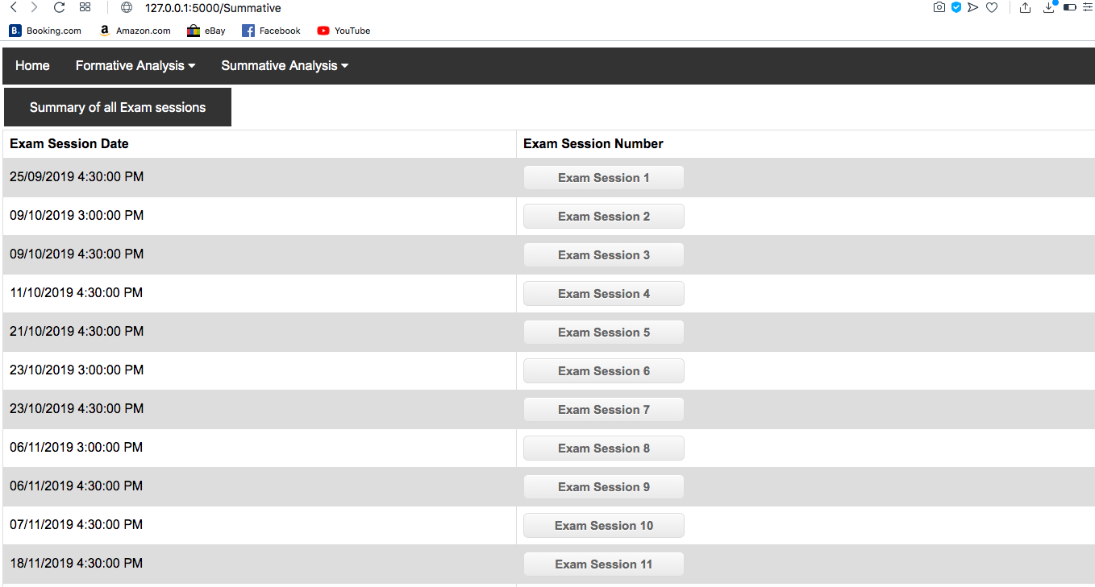

Figure 9.9‑1 Menu of individual exam session

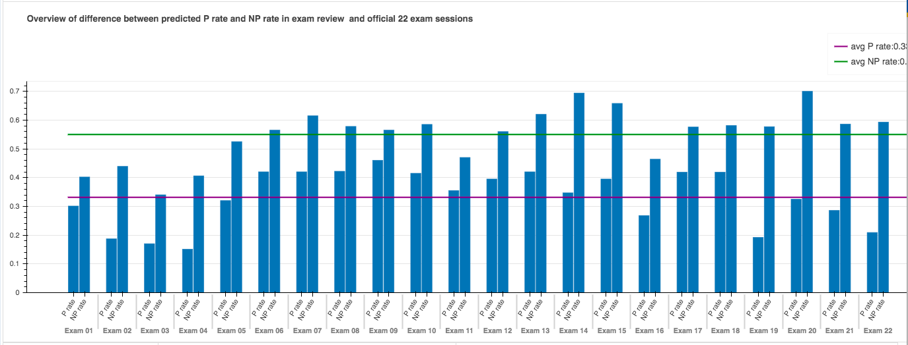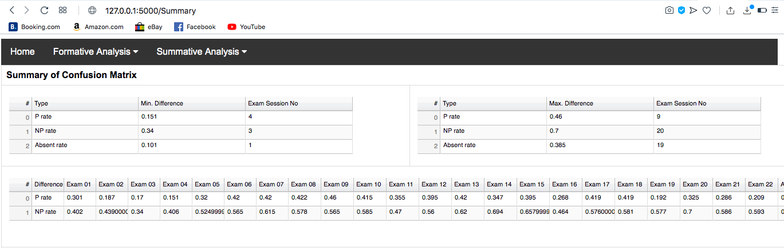

Figure ‑ Web page of summary of all exam session part 1

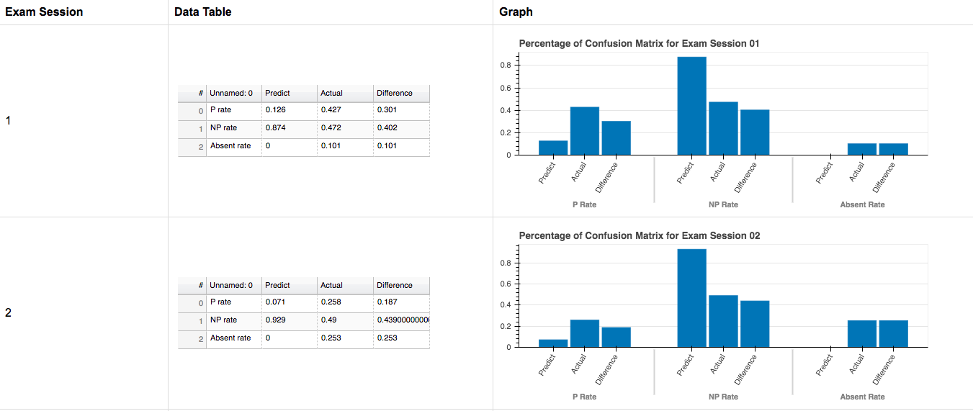

Figure 9.9‑3 Web of summary of all exam session part 2

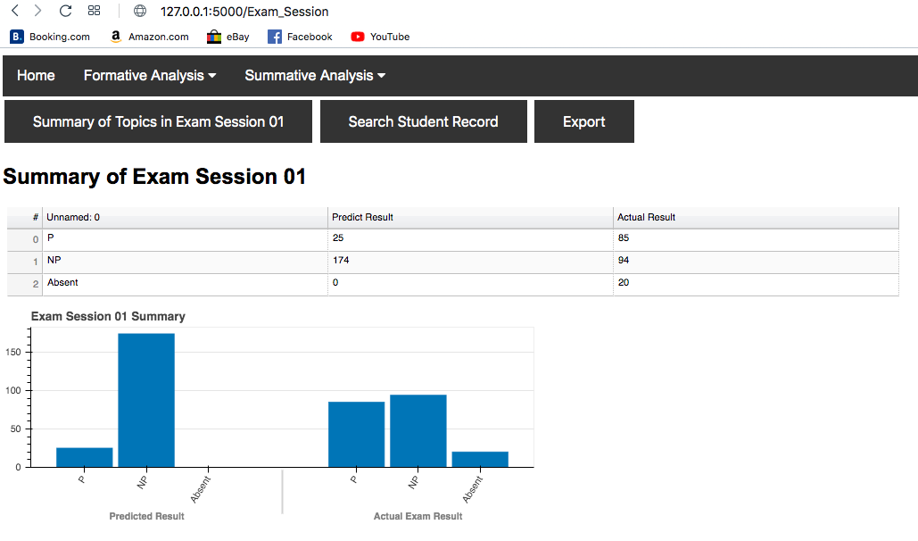

Figure 9.9‑4 Web page of summary of exam session 01

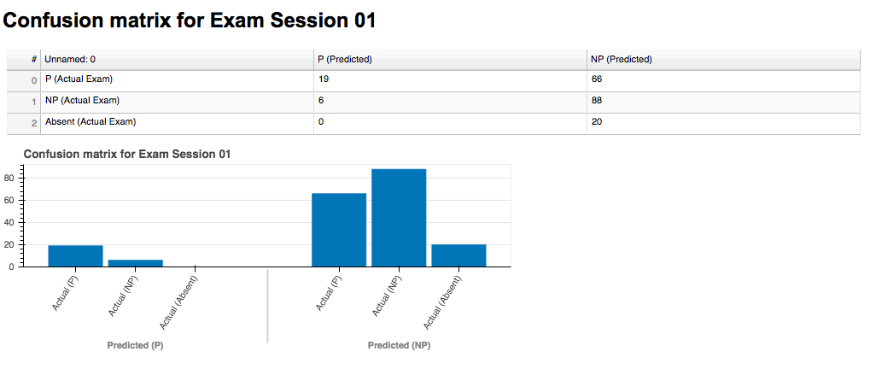

Figure 9.9‑5 Confusion matrix of Exam session 01

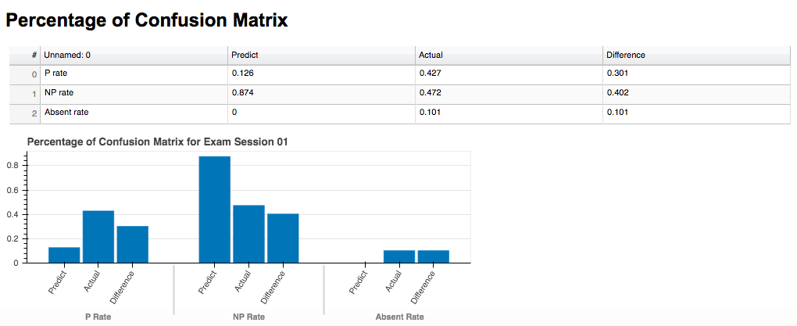

Figure 9.9‑6 Percentage of Confusion matrix

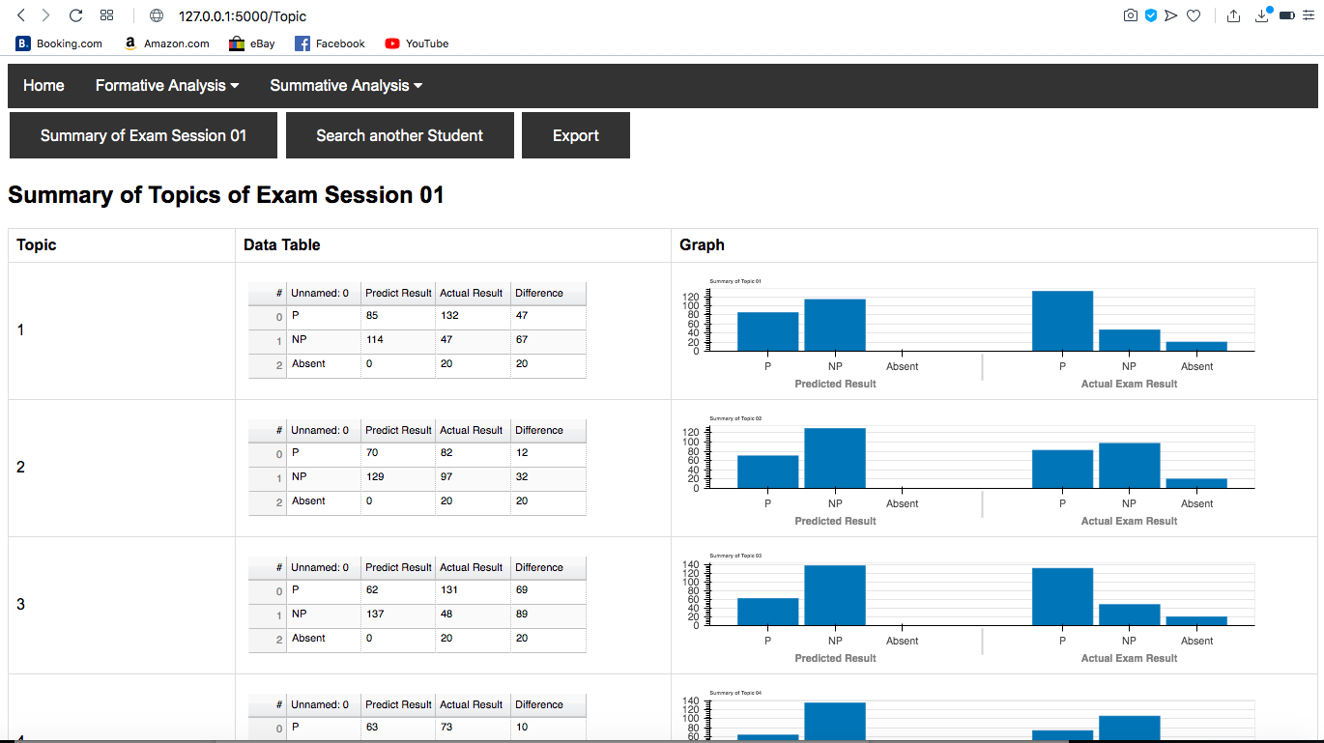

Figure 9.9‑7 Summary of Topics of Exam Session

### Access to Individual Student Report

From the menu of button listed in web page of ‘Summary of exam session’ and page of ‘Summary of Topic in exam session’. There is a button named ‘Search student’. After we clicked it, a form will be generated and allow users to search student number in three categories which are ‘P’, ‘NP’ and ‘Absent’ respectively (Figure 9.9-9). When we selected category ‘P’, the list of student number will be changed accordingly, and it will suggest the student number based on input on the text field.

Supposed we will continue to develop a way of verifying the role of user in order to gain access to student’s individual report, due to time limitation we are not able to finish it and we have already discussed in section 9.7.

With pressing the submit button, the page of individual student report will be redirected.

The content of this page based on the input student number and exam session number.

The details of student individual report have been described in section 9.7.

### Access to Summary of Mock Exams

As shown in figure 9.9-8, we can click the ‘Summary of Mock Exam’ in order to access the web page designed for illustrating the mock-up exam summary.

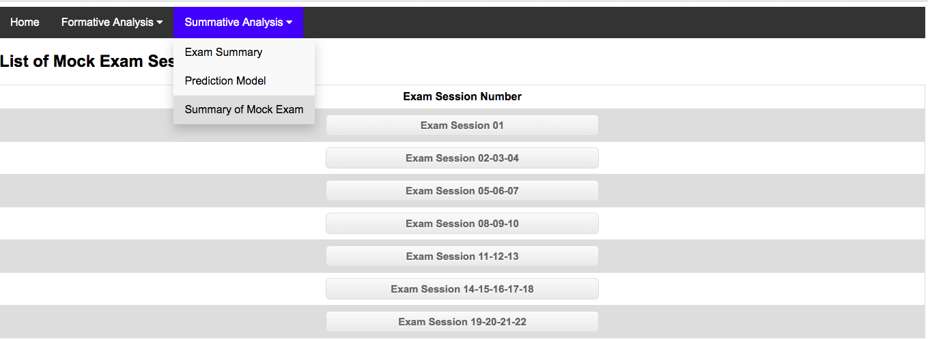

Figure 9.9‑8 Drop down list of page selection

After we clicked the button, we will see the directory of mock-up exams for which exam sessions. As long as we clicked the button shown in the table as Figure 9.9‑10. For example, we clicked ‘Exam session 02-03-04’ then we will be redirected the web page designed to show 10 RCs with 2 sections’ participation rate in the related mock exam session. In the web page, we will see 20 tables with corresponding 20 bar graphs as shown in Figure 9.9-11.

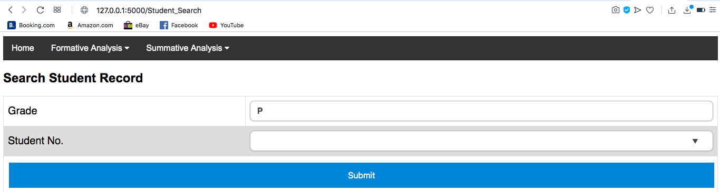

Figure 9.9‑9 Web page of search student's report

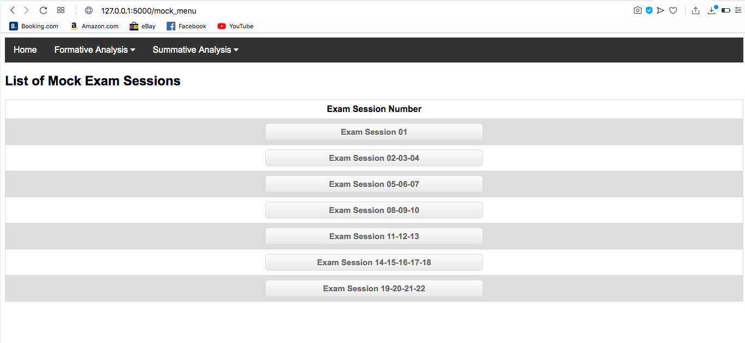

Figure 9.9‑10 Menu of mock-up exam

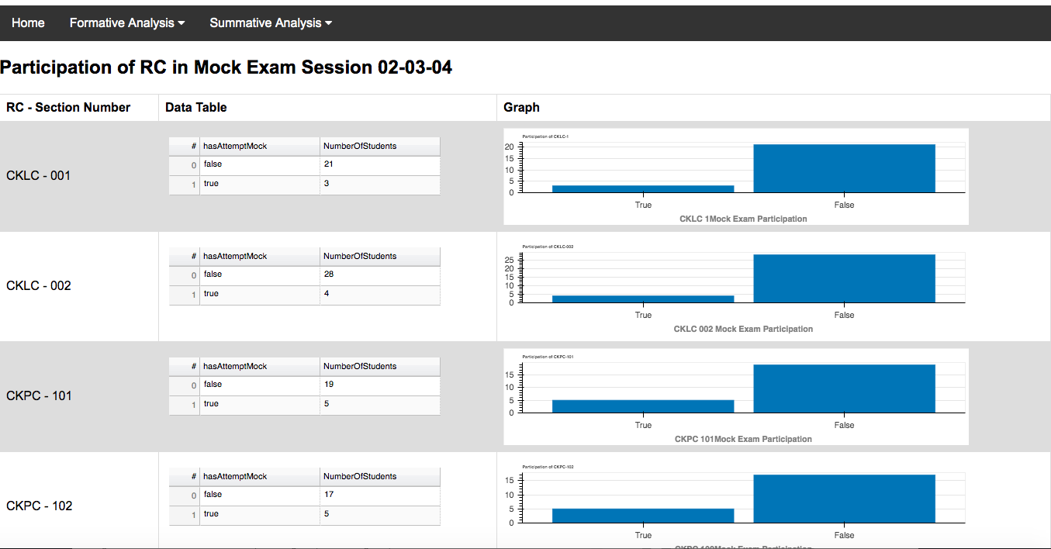

Figure 9.9‑11 Example of Participation in each RC

### Access to Machine Learning Prediction Model

As shown in figure 9.9-12, we can click the ‘Prediction Model’ in order to access the web page designed for predicting student’s result with multiple linear regression. There are 12 input text boxes are provided for user to input their score for each topic in numeric form and press the button ‘submit’. Our model will output the predicted result based on the input from 12 text boxes. The result will be shown below all input boxes as shown in Figure 9.9-13. In this model, student can use their immediate result from exam review and apply it into this model to predict their score in official exam. If they found it lower than passing rate, they can still study harder before entering any enrolled exams

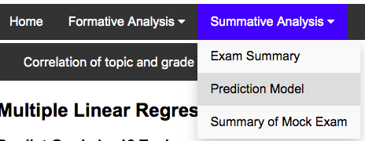

Figure 9.9‑12 Drop down list of page selection for prediction model

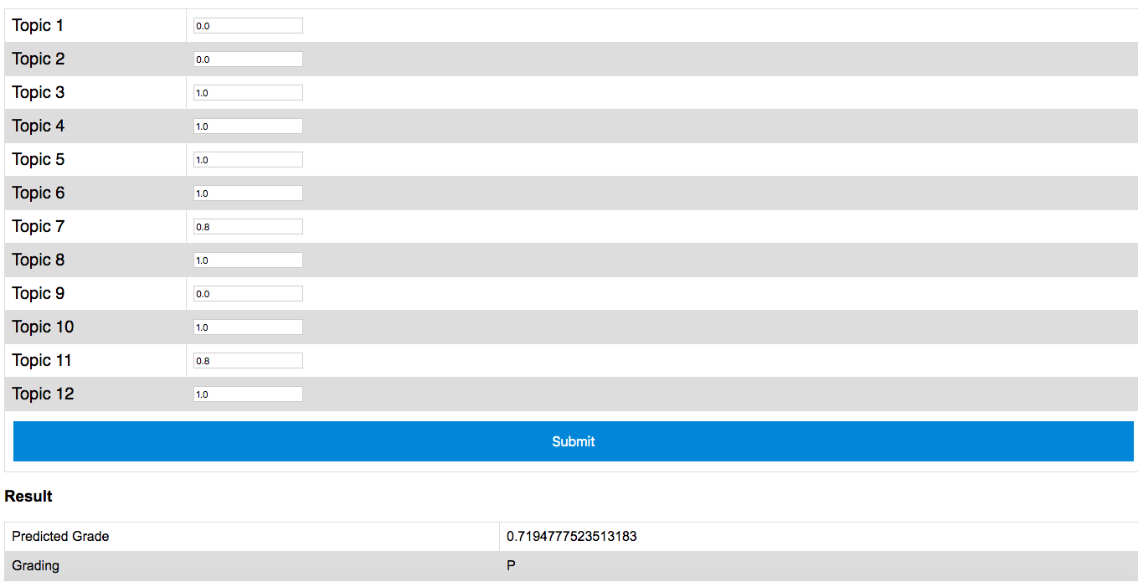

Figure 9.9‑13 Details of page of prediction model

## Summary

In this chapter, we have summarized our major findings, acquired through following the steps of summative data analysis, data visualization and formulation towards machine learning. We have attempted to provide our results on summative analysis to answer the question ‘How would individual CISC1000 students perform, in terms of summative assessment, throughout the semester’s course exams’ based on data collected from the first semester of academic year 2019/2020. Altogether with our perceived list of possible improvement for future development, hopefully to be instrumental to the ongoing improvement of this online course, especially in her next offering.

Throughout this FYP project, we have learned how a data science project is designed to gather data, to clean up data, to reshape data, before the steps of data analysis could be performed, followed by visualizing the data acquired after analysis, with machine learning prediction model as a tool in order to gain a deeper insights from the tabulation of summarized data. Even though we only focus on course CISC1000 and tried to help student who performed relatively weak. However, this project can also be applied to any other object as long as it develops continually along the stream of our work this year. It has potential to help students to perform better in any other subjects by receiving a report acknowledge them which part of the subject they perform weakly.

# REFERENCES

[1] D. Donoho, “50 years of Data Science,” *Journal of Computational and Graphical Statistics*, Vol. 26, No.4, pp.745-766, 2017. [Online]. Available: <https://courses.csail.mit.edu/18.337/2015/docs/50YearsDataScience.pdf>

[2] J.W. Tukey, “The future of data analysis,” *The Annals of Mathematical Statistics*, pp. 1-67, 1962. [Online]. Available: <https://pdfs.semanticscholar.org/192e/08be6c4dc6b9b2ed09fddcb6b67920ba7c7c.pdf>

[3] Uijl, S., Filius, R., & Ten Cate, O. (2017). Student interaction in small private online courses. *Medical Science Educator*, *27*(2), 237-242. [Online]. Available: <https://link.springer.com/article/10.1007/s40670-017-0380-x>

[4] Yu, Chong Ho. "Exploratory data analysis." *Methods* 2 (1977): 131-160. [Online]. Available: <https://uilt.pw/exploratory_data_analysis.pdf>

[5] University of Macau, FST, CISC1000 – Information Technology Fundamentals and Practices. [Online]. Available: <https://www.fst.um.edu.mo/en/courses/bsc/cisc1000/>

[6] University of Macau, FST, CISC1000 Information Technology Fundamentals and Practices (First semester, Academic Year 2019/2020). [Online]. Available: <https://www.fst.um.edu.mo/en/courses/bsc/cisc1000/201920201/exam.html>

[7] S. Mittal and O. P. Sangwan, "Big Data Analytics using Machine Learning Techniques," 2019 9th International Conference on Cloud Computing, Data Science & Engineering (Confluence), Noida, India, 2019, pp. 203-207.

[8] Mohri, M., Rostamizadeh, A. and Talwalkar, A., 2012. Foundations of machine learning. MIT press.

[9] Dtsch Arztebl Int. 2010 Nov; 107(44): 776–782. Last retrieved on 2019 December 8 from <https://www.ncbi.nlm.nih.gov/pmc/articles/PMC2992018/>

[10] N.A. Yassein, R.G.M Helali, S.B. Mohomad, "Predicting Student Academic Performance in KSA using Data Mining Techniques", J. Inf. Technol. Softw. Eng., vol. 7, no. 5, pp. 187-191, 2017.

[11] F. Widyahastuti and V. U. Tjhin, "Predicting students performance in final examination using linear regression and multilayer perceptron," 2017 10th International Conference on Human System Interactions (HSI), Ulsan, 2017, pp. 188-192.

[12] Schneider A, Hommel G, Blettner M: Linear regression analysis—part 14 of a series on evaluation of scientific publications. Dtsch Arztebl Int 2010; 107(44): 776–82. DOI: 10.3238/arztebl.2010.0776

[13] V.O. Oladokun, Ph.D., A.T. Adebanjo, B.Sc., and O.E. Charles-Owaba, Ph.D. “Predicting Students’ Academic Performance using Artificial Neural Network: A Case Study of an Engineering Course.”

APPENDIX I User guide of programming code

**Guide to using the programming codes:**

Prerequisites:

* Python 3.8
* Anaconda
* Jupyter Notebook

Required Python libraries:

* Pandas
* Numpy
* Os
* Matplotlib
* Re
* Ast
* Xlsxwriter
* Flask
* Bokeh == 1.4.8
* pickle

**Running Order:**

1. Exam_review_analysis.ipynb
2. Mock_exam_analysis.ipynb
3. MultipleLinearRegression.ipynb
4. Data_visualization.ipynb

**Code 1:**

|  |  |
| --- | --- |
| **File Name:** | Exam_review_analysis.ipynb |
| **File Location:** | Jupyter Notebook/src/ |
| **Required Inputs:** | **Exam Result files:**  1. CISC1000 Exam Result for Session 01 on 25-SEP-2019 (WEDNESDAY 1630-1730)-grades.xlsx  2. CISC1000 Exam Result for Session 02 on 09-OCT-2019 (WEDNESDAY 1500-1600)-grades.xlsx  3. CISC1000 Exam Result for Session 03 on 09-OCT-2019 (WEDNESDAY 1630-1730)-grades.xlsx  4. CISC1000 Exam Result for Session 04 on 11-OCT-2019 (FRIDAY 1630-1730)-grades.xlsx  5. CISC1000 Exam Result for Session 05 on 21-OCT-2019 (MONDAY 1630-1730)-grades.xlsx  6. CISC1000 Exam Result for Session 06 on 23-OCT-2019 (WEDNESDAY 1500-1600)-grades.xlsx  7. CISC1000 Exam Result for Session 07 on 23-OCT-2019 (WEDNESDAY 1630-1730)-grades.xlsx  8. CISC1000 Exam Result for Session 08 on 06-NOV-2019 (WEDNESDAY 1500-1600)-grades.xlsx  9. CISC1000 Exam Result for Session 09 on 06-NOV-2019 (WEDNESDAY 1630-1730)-grades.xlsx  10. CISC1000 Exam Result for Session 10 on 07-NOV-2019 (THURSDAY 1630-1730)-grades.xlsx  11. CISC1000 Exam Result for Session 11 on 18-NOV-2019 (MONDAY 1630-1730)-grades.xlsx  12. CISC1000 Exam Result for Session 12 on 20-NOV-2019 (WEDNESDAY 1500-1600)-grades.xlsx  13. CISC1000 Exam Result for Session 13 on 20-NOV-2019 (WEDNESDAY 1630-1730)-grades.xlsx  14. CISC1000 Exam Result for Session 14 on 03-DEC-2019 (TUESDAY 0900-1000)-grades.xlsx  15. CISC1000 Exam Result for Session 15 on 03-DEC-2019 (TUESDAY 1030-1130)-grades.xlsx  16. CISC1000 Exam Result for Session 16 on 03-DEC-2019 (TUESDAY 1200-1300)-grades.xlsx  17. CISC1000 Exam Result for Session 17 on 03-DEC-2019 (TUESDAY 1500-1600)-grades.xlsx  18. CISC1000 Exam Result for Session 18 on 03-DEC-2019 (TUESDAY 1630-1730)-grades.xlsx  19. CISC1000 Exam Result for Session 19 on 03-JAN-2020 (FRIDAY 1030-1130)-grades.xlsx  20. CISC1000 Exam Result for Session 20 on 03-JAN-2020 (FRIDAY 1200-1300)-grades.xlsx  21. CISC1000 Exam Result for Session 21 on 03-JAN-2020 (FRIDAY 1500-1600)-grades.xlsx  22. CISC1000 Exam Result for Session 22 on 03-JAN-2020 (FRIDAY 1630-1730)-grades.xlsx  **Exam Review files:**  1. 2019-1-CISC1000-ALL-META-CISC1000 Review Quiz for Topic 01 of Module 01-grades.csv  2. 2019-1-CISC1000-ALL-META-CISC1000 Review Quiz for Topic 02 of Module 01-grades.csv  3. 2019-1-CISC1000-ALL-META-CISC1000 Review Quiz for Topic 03 of Module 01-grades.csv  4. 2019-1-CISC1000-ALL-META-CISC1000 Review Quiz for Topic 04 of Module 01-grades.csv  5. 2019-1-CISC1000-ALL-META-CISC1000 Review Quiz for Topic 05 of Module 02-grades.csv  6. 2019-1-CISC1000-ALL-META-CISC1000 Review Quiz for Topic 06 of Module 02-grades.csv  7. 2019-1-CISC1000-ALL-META-CISC1000 Review Quiz for Topic 07 of Module 02-grades.csv  8. 2019-1-CISC1000-ALL-META-CISC1000 Review Quiz for Topic 08 of Module 02-grades.csv  9. 2019-1-CISC1000-ALL-META-CISC1000 Review Quiz for Topic 09-1 of Module 03-grades.csv  10. 2019-1-CISC1000-ALL-META-CISC1000 Review Quiz for Topic 09-2 of Module 03-grades.csv  11. 2019-1-CISC1000-ALL-META-CISC1000 Review Quiz for Topic 09-3 of Module 03-grades.csv  12. 2019-1-CISC1000-ALL-META-CISC1000 Review Quiz for Topic 10 of Module 03-grades.csv  13. 2019-1-CISC1000-ALL-META-CISC1000 Review Quiz for Topic 11 of Module 03-grades.csv  14. 2019-1-CISC1000-ALL-META-CISC1000 Review Quiz for Topic 12 of Module 02-grades.csv |
| **Input Location:** | Jupyter Notebook/ CISC1000 Exam Results/Exam Results/ |
| **Output:** | Jupyter Notebook/ Exam_Review/:  1. Exam_Session_01_Summary.xlsx  2. Exam_Session_02_Summary.xlsx  3. Exam_Session_03_Summary.xlsx  4. Exam_Session_04_Summary.xlsx  5. Exam_Session_05_Summary.xlsx  6. Exam_Session_06_Summary.xlsx  7. Exam_Session_07_Summary.xlsx  8. Exam_Session_08_Summary.xlsx  9. Exam_Session_09_Summary.xlsx  10. Exam_Session_10_Summary.xlsx  11. Exam_Session_11_Summary.xlsx  12. Exam_Session_12_Summary.xlsx  13. Exam_Session_13_Summary.xlsx  14. Exam_Session_14_Summary.xlsx  15. Exam_Session_15_Summary.xlsx  16. Exam_Session_16_Summary.xlsx  17. Exam_Session_17_Summary.xlsx  18. Exam_Session_18_Summary.xlsx  19. Exam_Session_19_Summary.xlsx  20. Exam_Session_20_Summary.xlsx  21. Exam_Session_21_Summary.xlsx  22. Exam_Session_22_Summary.xlsx  For Exam_Sec_’session_number’ folder:  It contains each individual analyzed files with the following format:  BBxxxxxx_sessionNum.xlsx  (e.g. DB123456_01.xlsx)  **It also contains five folders:**  Jupyter Notebook/ Exam_Review/Exam_Sec_’sessionNum’/Actual_Exam_Summary  Jupyter Notebook/ Exam_Review/Exam_Sec_’sessionNum’/Comparison  Jupyter Notebook/ Exam_Review/Exam_Sec_’sessionNum’/Confusion_matrix  Jupyter Notebook/ Exam_Review/Exam_Sec_’sessionNum’/Exam_Review_Overview  Jupyter Notebook/ Exam_Review/Exam_Sec_’sessionNum’/Exam_Review_Summary  Jupyter Notebook/ Exam_Review/Exam_Sec_’sessionNum’/Plot  **And each folder also contains each individual**  **files with the following format:**  BBxxxxxx_sessionNum.xlsx  (e.g. DB123456_01.xlsx)  **Jupyter Notebook/ Exam_Review/Topic/Exam_Sec_’sessionNum’:**  **(e.g.** Topic_01_01.xlsx**)**  1. Topic_01_sessionNum.xlsx  2. Topic_02_sessionNum.xlsx  3. Topic_03_sessionNum.xlsx  4. Topic_04_sessionNum.xlsx  5. Topic_05_sessionNum.xlsx  6. Topic_06_sessionNum.xlsx  7. Topic_07_sessionNum.xlsx  8. Topic_08_sessionNum.xlsx  9. Topic_09_sessionNum.xlsx  10. Topic_10_sessionNum.xlsx  11. Topic_11_sessionNum.xlsx  12. Topic_12_sessionNum.xlsx  **Training Data:**  Exam_Review/Training_data/training_data_sessionNumber.xlsx |
| **How to Run:** | Press ‘cell’ > ‘run all’ in jyupter notebook |
| **Notes:** | This set of programming code needs to run about 6 hours in order to generate about 22000 excel files in total.  It covers analytic result from individual level, topic-wise level and exam session level |

**Code 2:**

|  |  |
| --- | --- |
| **File Name:** | Mock_exam_analysis.ipynb |
| **File Location:** | Jupyter Notebook/src/ |
| **Required Inputs:** | **Exam Roster:**   1. 2019_Roster.xls   **Exam Result files:**   * 1. CISC1000 Exam Result for Session 01 on 25-SEP-2019 (WEDNESDAY 1630-1730)-grades.xlsx   2. CISC1000 Exam Result for Session 02 on 09-OCT-2019 (WEDNESDAY 1500-1600)-grades.xlsx   3. CISC1000 Exam Result for Session 03 on 09-OCT-2019 (WEDNESDAY 1630-1730)-grades.xlsx   4. CISC1000 Exam Result for Session 04 on 11-OCT-2019 (FRIDAY 1630-1730)-grades.xlsx   5. CISC1000 Exam Result for Session 05 on 21-OCT-2019 (MONDAY 1630-1730)-grades.xlsx   6. CISC1000 Exam Result for Session 06 on 23-OCT-2019 (WEDNESDAY 1500-1600)-grades.xlsx   7. CISC1000 Exam Result for Session 07 on 23-OCT-2019 (WEDNESDAY 1630-1730)-grades.xlsx   8. CISC1000 Exam Result for Session 08 on 06-NOV-2019 (WEDNESDAY 1500-1600)-grades.xlsx   9. CISC1000 Exam Result for Session 09 on 06-NOV-2019 (WEDNESDAY 1630-1730)-grades.xlsx   10. CISC1000 Exam Result for Session 10 on 07-NOV-2019 (THURSDAY 1630-1730)-grades.xlsx   11. CISC1000 Exam Result for Session 11 on 18-NOV-2019 (MONDAY 1630-1730)-grades.xlsx   12. CISC1000 Exam Result for Session 12 on 20-NOV-2019 (WEDNESDAY 1500-1600)-grades.xlsx   13. CISC1000 Exam Result for Session 13 on 20-NOV-2019 (WEDNESDAY 1630-1730)-grades.xlsx   14. CISC1000 Exam Result for Session 14 on 03-DEC-2019 (TUESDAY 0900-1000)-grades.xlsx   15. CISC1000 Exam Result for Session 15 on 03-DEC-2019 (TUESDAY 1030-1130)-grades.xlsx   16. CISC1000 Exam Result for Session 16 on 03-DEC-2019 (TUESDAY 1200-1300)-grades.xlsx   17. CISC1000 Exam Result for Session 17 on 03-DEC-2019 (TUESDAY 1500-1600)-grades.xlsx   18. CISC1000 Exam Result for Session 18 on 03-DEC-2019 (TUESDAY 1630-1730)-grades.xlsx   19. CISC1000 Exam Result for Session 19 on 03-JAN-2020 (FRIDAY 1030-1130)-grades.xlsx   20. CISC1000 Exam Result for Session 20 on 03-JAN-2020 (FRIDAY 1200-1300)-grades.xlsx   21. CISC1000 Exam Result for Session 21 on 03-JAN-2020 (FRIDAY 1500-1600)-grades.xlsx   22. CISC1000 Exam Result for Session 22 on 03-JAN-2020 (FRIDAY 1630-1730)-grades.xlsx   **Mock Exam result:**  **Exam Session 01:**   * 1. 2019-1-CISC1000-01-CKPC-CKPC-01 CISC1000 Mocked Exam Practice for Exam Session 01-grades.csv   2. 2019-1-CISC1000-01-MCMC-MCMC-01 CISC1000 Mocked Exam Practice for Exam Session 01-grades.csv   3. 2019-1-CISC1000-01-CKYC-CKYC-01 CISC1000 Mocked Exam Practice for Exam Session 01-grades.csv   4. 2019-1-CISC1000-01-FPJC-FPJC-01 CISC1000 Mocked Exam Practice for Exam Session 01-grades.csv   5. 2019-1-CISC1000-01-CKLC-CKLC-01 CISC1000 Mocked Exam Practice for Exam Session 01-grades.csv   6. 2019-1-CISC1000-01-SEAC-SEAC-01 CISC1000 Mocked Exam Practice for Exam Session 01-grades.csv   7. 2019-1-CISC1000-01-LCWC-LCWC-01 CISC1000 Mocked Exam Practice for Exam Session 01-grades.csv   8. 2019-1-CISC1000-01-CYTC-CYTC-01 CISC1000 Mocked Exam Practice for Exam Session 01-grades.csv   9. 2019-1-CISC1000-01-SPC-SPC-01 CISC1000 Mocked Exam Practice for Exam Session 01-grades.csv   10. 2019-1-CISC1000-01-MLC-MLC-01 CISC1000 Mocked Exam Practice for Exam Session 01-grades.csv   **Exam Session 02-03-04:**   * 1. 2019-1-CISC1000-01-CKPC-CKPC-01 CISC1000 Mocked Exam Practice for Exam Session 02-03-04-grades.csv   2. 2019-1-CISC1000-01-MCMC-MCMC-01 CISC1000 Mocked Exam Practice for Exam Session 02-03-04-grades.csv   3. 2019-1-CISC1000-01-CKYC-CKYC-01 CISC1000 Mocked Exam Practice for Exam Session 02-03-04-grades.csv   4. 2019-1-CISC1000-01-FPJC-FPJC-01 CISC1000 Mocked Exam Practice for Exam Session 02-03-04-grades.csv   5. 2019-1-CISC1000-01-CKLC-CKLC-01 CISC1000 Mocked Exam Practice for Exam Session 02-03-04-grades.csv   6. 2019-1-CISC1000-01-SEAC-SEAC-01 CISC1000 Mocked Exam Practice for Exam Session 02-03-04-grades.csv   7. 2019-1-CISC1000-01-LCWC-LCWC-01 CISC1000 Mocked Exam Practice for Exam Session 02-03-04-grades.csv   8. 2019-1-CISC1000-01-CYTC-CYTC-01 CISC1000 Mocked Exam Practice for Exam Session 02-03-04-grades.csv   9. 2019-1-CISC1000-01-SPC-SPC-01 CISC1000 Mocked Exam Practice for Exam Session 02-03-04-grades.csv   10. 2019-1-CISC1000-01-MLC-MLC-01 CISC1000 Mocked Exam Practice for Exam Session 02-03-04-grades.csv   ​**Exam Session 05-06-07:**   * 1. 2019-1-CISC1000-01-CKPC-CKPC-01 CISC1000 Mocked Exam Practice for Exam Session 05-06-07-grades.csv   2. 2019-1-CISC1000-01-MCMC-MCMC-01 CISC1000 Mocked Exam Practice for Exam Session 05-06-07-grades.csv   3. 2019-1-CISC1000-01-CKYC-CKYC-01 CISC1000 Mocked Exam Practice for Exam Session 05-06-07-grades.csv   4. 2019-1-CISC1000-01-FPJC-FPJC-01 CISC1000 Mocked Exam Practice for Exam Session 05-06-07-grades.csv   5. 2019-1-CISC1000-01-CKLC-CKLC-01 CISC1000 Mocked Exam Practice for Exam Session 05-06-07-grades.csv   6. 2019-1-CISC1000-01-SEAC-SEAC-01 CISC1000 Mocked Exam Practice for Exam Session 05-06-07-grades.csv   7. 2019-1-CISC1000-01-LCWC-LCWC-01 CISC1000 Mocked Exam Practice for Exam Session 05-06-07-grades.csv   8. 2019-1-CISC1000-01-CYTC-CYTC-01 CISC1000 Mocked Exam Practice for Exam Session 05-06-07-grades.csv   9. 2019-1-CISC1000-01-SPC-SPC-01 CISC1000 Mocked Exam Practice for Exam Session 05-06-07-grades.csv   10. 2019-1-CISC1000-01-MLC-MLC-01 CISC1000 Mocked Exam Practice for Exam Session 05-06-07-grades.csv   ​**Exam Session 08-09-10:**   * 1. 2019-1-CISC1000-01-CKPC-CKPC-01 CISC1000 Mocked Exam Practice for Exam Session 08-09-10-grades.csv   2. 2019-1-CISC1000-01-MCMC-MCMC-01 CISC1000 Mocked Exam Practice for Exam Session 08-09-10-grades.csv   3. 2019-1-CISC1000-01-CKYC-CKYC-01 CISC1000 Mocked Exam Practice for Exam Session 08-09-10-grades.csv   4. 2019-1-CISC1000-01-FPJC-FPJC-01 CISC1000 Mocked Exam Practice for Exam Session 08-09-10-grades.csv   5. 2019-1-CISC1000-01-CKLC-CKLC-01 CISC1000 Mocked Exam Practice for Exam Session 08-09-10-grades.csv   6. 2019-1-CISC1000-01-SEAC-SEAC-01 CISC1000 Mocked Exam Practice for Exam Session 08-09-10-grades.csv   7. 2019-1-CISC1000-01-LCWC-LCWC-01 CISC1000 Mocked Exam Practice for Exam Session 08-09-10-grades.csv   8. 2019-1-CISC1000-01-CYTC-CYTC-01 CISC1000 Mocked Exam Practice for Exam Session 08-09-10-grades.csv   9. 2019-1-CISC1000-01-SPC-SPC-01 CISC1000 Mocked Exam Practice for Exam Session 08-09-10-grades.csv   10. 2019-1-CISC1000-01-MLC-MLC-01 CISC1000 Mocked Exam Practice for Exam Session 08-09-10-grades.csv   **Exam Session 11-12-13:**   * 1. 2019-1-CISC1000-01-CKPC-CKPC-01 CISC1000 Mocked Exam Practice for Exam Session 11-12-13-grades.csv   2. 2019-1-CISC1000-01-MCMC-MCMC-01 CISC1000 Mocked Exam Practice for Exam Session 11-12-13-grades.csv   3. 2019-1-CISC1000-01-CKYC-CKYC-01 CISC1000 Mocked Exam Practice for Exam Session 11-12-13-grades.csv   4. 2019-1-CISC1000-01-FPJC-FPJC-01 CISC1000 Mocked Exam Practice for Exam Session 11-12-13-grades.csv   5. 2019-1-CISC1000-01-CKLC-CKLC-01 CISC1000 Mocked Exam Practice for Exam Session 11-12-13-grades.csv   6. 2019-1-CISC1000-01-SEAC-SEAC-01 CISC1000 Mocked Exam Practice for Exam Session 11-12-13-grades.csv   7. 2019-1-CISC1000-01-LCWC-LCWC-01 CISC1000 Mocked Exam Practice for Exam Session 11-12-13-grades.csv   8. 2019-1-CISC1000-01-CYTC-CYTC-01 CISC1000 Mocked Exam Practice for Exam Session 11-12-13-grades.csv   9. 2019-1-CISC1000-01-SPC-SPC-01 CISC1000 Mocked Exam Practice for Exam Session 11-12-13-grades.csv   10. 2019-1-CISC1000-01-MLC-MLC-01 CISC1000 Mocked Exam Practice for Exam Session 11-12-13-grades.csv   **Exam Session 14-15-16-17-18:**   * 1. 2019-1-CISC1000-01-CKPC-CKPC-01 CISC1000 Mocked Exam Practice for Exam Session 14-15-16-17-18-grades.csv   2. 2019-1-CISC1000-01-MCMC-MCMC-01 CISC1000 Mocked Exam Practice for Exam Session 14-15-16-17-18-grades.csv   3. 2019-1-CISC1000-01-CKYC-CKYC-01 CISC1000 Mocked Exam Practice for Exam Session 14-15-16-17-18-grades.csv   4. 2019-1-CISC1000-01-FPJC-FPJC-01 CISC1000 Mocked Exam Practice for Exam Session 14-15-16-17-18-grades.csv   5. 2019-1-CISC1000-01-CKLC-CKLC-01 CISC1000 Mocked Exam Practice for Exam Session 14-15-16-17-18-grades.csv   6. 2019-1-CISC1000-01-SEAC-SEAC-01 CISC1000 Mocked Exam Practice for Exam Session 14-15-16-17-18-grades.csv   7. 2019-1-CISC1000-01-LCWC-LCWC-01 CISC1000 Mocked Exam Practice for Exam Session 14-15-16-17-18-grades.csv   8. 2019-1-CISC1000-01-CYTC-CYTC-01 CISC1000 Mocked Exam Practice for Exam Session 14-15-16-17-18-grades.csv   9. 2019-1-CISC1000-01-SPC-SPC-01 CISC1000 Mocked Exam Practice for Exam Session 14-15-16-17-18-grades.csv   10. 2019-1-CISC1000-01-MLC-MLC-01 CISC1000 Mocked Exam Practice for Exam Session 14-15-16-17-18-grades.csv   **Exam Session 19-20-21-22:**   * 1. 2019-1-CISC1000-01-CKPC-CKPC-01 CISC1000 Mocked Exam Practice for Exam Session 19-20-21-22-grades.csv   2. 2019-1-CISC1000-01-MCMC-MCMC-01 CISC1000 Mocked Exam Practice for Exam Session 19-20-21-22-grades.csv   3. 2019-1-CISC1000-01-CKYC-CKYC-01 CISC1000 Mocked Exam Practice for Exam Session 19-20-21-22-grades.csv   4. 2019-1-CISC1000-01-FPJC-FPJC-01 CISC1000 Mocked Exam Practice for Exam Session 19-20-21-22-grades.csv   5. 2019-1-CISC1000-01-CKLC-CKLC-01 CISC1000 Mocked Exam Practice for Exam Session 19-20-21-22-grades.csv   6. 2019-1-CISC1000-01-SEAC-SEAC-01 CISC1000 Mocked Exam Practice for Exam Session 19-20-21-22-grades.csv   7. 2019-1-CISC1000-01-LCWC-LCWC-01 CISC1000 Mocked Exam Practice for Exam Session 19-20-21-22-grades.csv   8. 2019-1-CISC1000-01-CYTC-CYTC-01 CISC1000 Mocked Exam Practice for Exam Session 19-20-21-22-grades.csv   9. 2019-1-CISC1000-01-SPC-SPC-01 CISC1000 Mocked Exam Practice for Exam Session 19-20-21-22-grades.csv   10. 2019-1-CISC1000-01-MLC-MLC-01 CISC1000 Mocked Exam Practice for Exam Session 19-20-21-22-grades.csv   ​ |
| **Input Location:** | 1. Jupyter Notebook/CISC1000 Exam Results/Exam Results/ CISC1000-2019 Mocked Exam Data/Mocked Exam for Exam Session 01 - 2019SEP24 2. Jupyter Notebook/CISC1000 Exam Results/Exam Results/ CISC1000-2019 Mocked Exam Data/ Mocked Exam for Exam Session 02-03-04 - 2019OCT08 3. Jupyter Notebook/CISC1000 Exam Results/Exam Results/ CISC1000-2019 Mocked Exam Data/ Mocked Exam for Exam Session 05-06-07 - 2019OCT20 4. Jupyter Notebook/CISC1000 Exam Results/Exam Results/ CISC1000-2019 Mocked Exam Data/ Mocked Exam for Exam Session 08-09-10 - 2019NOV05 5. Jupyter Notebook/CISC1000 Exam Results/Exam Results/ CISC1000-2019 Mocked Exam Data/ Mocked Exam for Exam Session 11-12-13 - 2019NOV17 6. Jupyter Notebook/CISC1000 Exam Results/Exam Results/ CISC1000-2019 Mocked Exam Data/ Mocked Exam for Exam Session 14-15-16-17-18 - 2019DEC02 7. Jupyter Notebook/CISC1000 Exam Results/Exam Results/ CISC1000-2019 Mocked Exam Data/ Mocked Exam for Exam Session 19-20-21-22 - 2020JAN02 8. Jupyter Notebook/CISC1000 Roster/ |
| **Output:** | Jupyter Notebook/CISC1000-2019 Mocked Exam Data/Exam Sec_xxxxxx/:  1.Mock_Summary_xx.xlsx |
| **How to Run:** | 1. In Jupyter Notebook, click Kernel 🡪 *Restart & Run All* |
| **Notes:** | N/A |

**Code 3：**

|  |  |
| --- | --- |
| **File Name:** | MultipleLinearRegression.ipynb |
| **File Location:** | Jupyter Notebook/src/ |
| **Required Inputs:** | 1. training_data_1.xlsx  2. training_data_2.xlsx  3. training_data_3.xlsx  4. training_data_4.xlsx  5. training_data_5.xlsx  6. training_data_6.xlsx  7. training_data_7.xlsx  8. training_data_8.xlsx  9. training_data_9.xlsx  10. training_data_10.xlsx  11. training_data_11.xlsx  12. training_data_12.xlsx  13. training_data_13.xlsx  14. training_data_14.xlsx  15. training_data_15.xlsx  16. training_data_16.xlsx  17. training_data_17.xlsx  18. training_data_18.xlsx  19. training_data_19.xlsx  20. training_data_20.xlsx  21. training_data_21.xlsx  22. training_data_22.xlsx |
| **Input Location:** | 1. Jupyter Notebook/ Exam_Review/ Training_data |
| **Output:** | 1. Multiple linear regression model file : model_mlr.pkl |
| **How to Run:** | 1. In Jupyter Notebook, click Kernel 🡪 *Restart & Run All* |
| **Notes:** |  |

**Code 4:**

|  |  |
| --- | --- |
| **File Name:** | data_visualization.ipynb |
| **File Location:** | Jupyter Notebook/src/ |
| **Required Inputs:** | **Output of Code 1:**  Jupyter Notebook/ Exam_Review/:  1. Exam_Session_01_Summary.xlsx  2. Exam_Session_02_Summary.xlsx  3. Exam_Session_03_Summary.xlsx  4. Exam_Session_04_Summary.xlsx  5. Exam_Session_05_Summary.xlsx  6. Exam_Session_06_Summary.xlsx  7. Exam_Session_07_Summary.xlsx  8. Exam_Session_08_Summary.xlsx  9. Exam_Session_09_Summary.xlsx  10. Exam_Session_10_Summary.xlsx  11. Exam_Session_11_Summary.xlsx  12. Exam_Session_12_Summary.xlsx  13. Exam_Session_13_Summary.xlsx  14. Exam_Session_14_Summary.xlsx  15. Exam_Session_15_Summary.xlsx  16. Exam_Session_16_Summary.xlsx  17. Exam_Session_17_Summary.xlsx  18. Exam_Session_18_Summary.xlsx  19. Exam_Session_19_Summary.xlsx  20. Exam_Session_20_Summary.xlsx  21. Exam_Session_21_Summary.xlsx  22. Exam_Session_22_Summary.xlsx  For Exam_Sec_’session_number’ folder:  It contains each individual analyzed files with the following format:  BBxxxxxx_sessionNum.xlsx  (e.g. DB123456_01.xlsx)  **It also contains five folders:**  Jupyter Notebook/ Exam_Review/Exam_Sec_’sessionNum’/Actual_Exam_Summary  Jupyter Notebook/ Exam_Review/Exam_Sec_’sessionNum’/Comparison  Jupyter Notebook/ Exam_Review/Exam_Sec_’sessionNum’/Confusion_matrix  Jupyter Notebook/ Exam_Review/Exam_Sec_’sessionNum’/Exam_Review_Overview  Jupyter Notebook/ Exam_Review/Exam_Sec_’sessionNum’/Exam_Review_Summary  Jupyter Notebook/ Exam_Review/Exam_Sec_’sessionNum’/Plot  **And each folder also contains each individual**  **files with the following format:**  BBxxxxxx_sessionNum.xlsx  (e.g. DB123456_01.xlsx)  **Jupyter Notebook/ Exam_Review/Topic/Exam_Sec_’sessionNum’:**  **(e.g.** Topic_01_01.xlsx**)**  1. Topic_01_sessionNum.xlsx  2. Topic_02_sessionNum.xlsx  3. Topic_03_sessionNum.xlsx  4. Topic_04_sessionNum.xlsx  5. Topic_05_sessionNum.xlsx  6. Topic_06_sessionNum.xlsx  7. Topic_07_sessionNum.xlsx  8. Topic_08_sessionNum.xlsx  9. Topic_09_sessionNum.xlsx  10. Topic_10_sessionNum.xlsx  11. Topic_11_sessionNum.xlsx  12. Topic_12_sessionNum.xlsx  **Output of Code 2**  Jupyter Notebook/CISC1000-2019 Mocked Exam Data/Exam Sec_xxxxxx/:  1.Mock_Summary_xx.xlsx |
| **Input Location:** | 1. Jupyter Notebook/ Exam_Review/Topic/Exam_Sec_’sessionNum’ 2. Jupyter Notebook/ Exam_Review/Exam_Sec_’sessionNum’/Actual_Exam_Summary 3. Jupyter Notebook/ Exam_Review/Exam_Sec_’sessionNum’/Comparison 4. Jupyter Notebook/ Exam_Review/Exam_Sec_’sessionNum’/Confusion_matrix 5. Jupyter Notebook/ Exam_Review/Exam_Sec_’sessionNum’/Exam_Review_Overview 6. Jupyter Notebook/ Exam_Review/Exam_Sec_’sessionNum’/Exam_Review_Summary 7. Jupyter Notebook/ Exam_Review/Exam_Sec_’sessionNum’/Plot 8. Jupyter Notebook/CISC1000-2019 Mocked Exam Data/Exam Sec_xxxxxx/   **Output of Code 3:**   * 1. Model file: model_mlr.pkl   **Prepared html files:**   * 1. Jupyter Notebook/ templates/ xx.html   **Prepared input images files:**   * + 1. Jupyter Notebook/ static/images   1. Jupyter Notebook/ static/ Visualization Figures |
| **Output:** | Web Application for presenting our analytic data  <http://127.0.0.1:5001/Home> |
| **How to Run:** | 1. In Jupyter Notebook, click Kernel 🡪 *Restart & Run All* 2. If run successfully, the following will appear 3. If it is not successful, please change the port number into 5002,5003,.. etc in order to run again. 4. Click the link and redirected to our front-end system |
| **Notes:** | * In order to produce our interactive graph successfully, we **must** install **Bokeh 1.4.8** version. * All of our data in this web application is from code 1, 2 and 3. Please ensure to run those before code 4 * All path of data file must match with those used in code 4, otherwise, error would occur * We run our front-end in local host, and therefore, files must be stored locally in order to make it work successfully * Any input images for our front-end must be placed in folder ‘static’ * All HTML file must be placed in folder ‘template’ * Filename of HTML file must be the same as name used in rendered_template() * Front – end system can only worked when data_visualization.ipynb is running in development mode * It should be deployed as production mode if we can collect all consent from student that allow us to deploy it third platform such as ‘Heroku’. Since all data file we used in this front-end contains sensitive information of students. * We prefer to use HTTPS instead of HTTP. However, we need to create server.crt and server.key file as self-signed certificate for web browser to validate a server certificate. |

Appendix II: User guide – Web application

Home page:

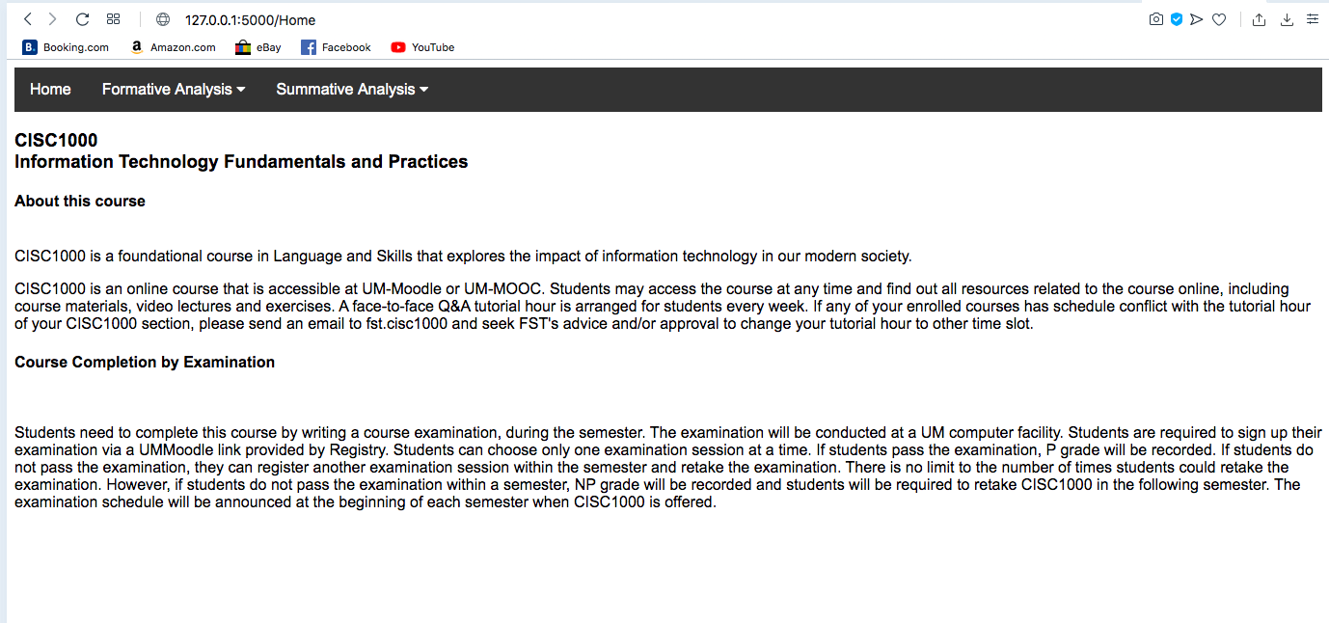

Menu of Summative analysis

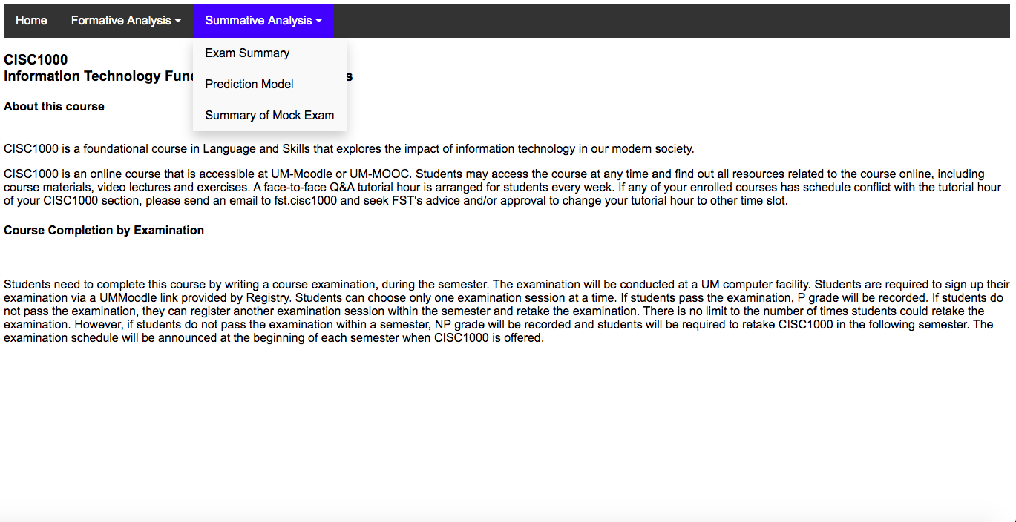

Directory of Summative analysis

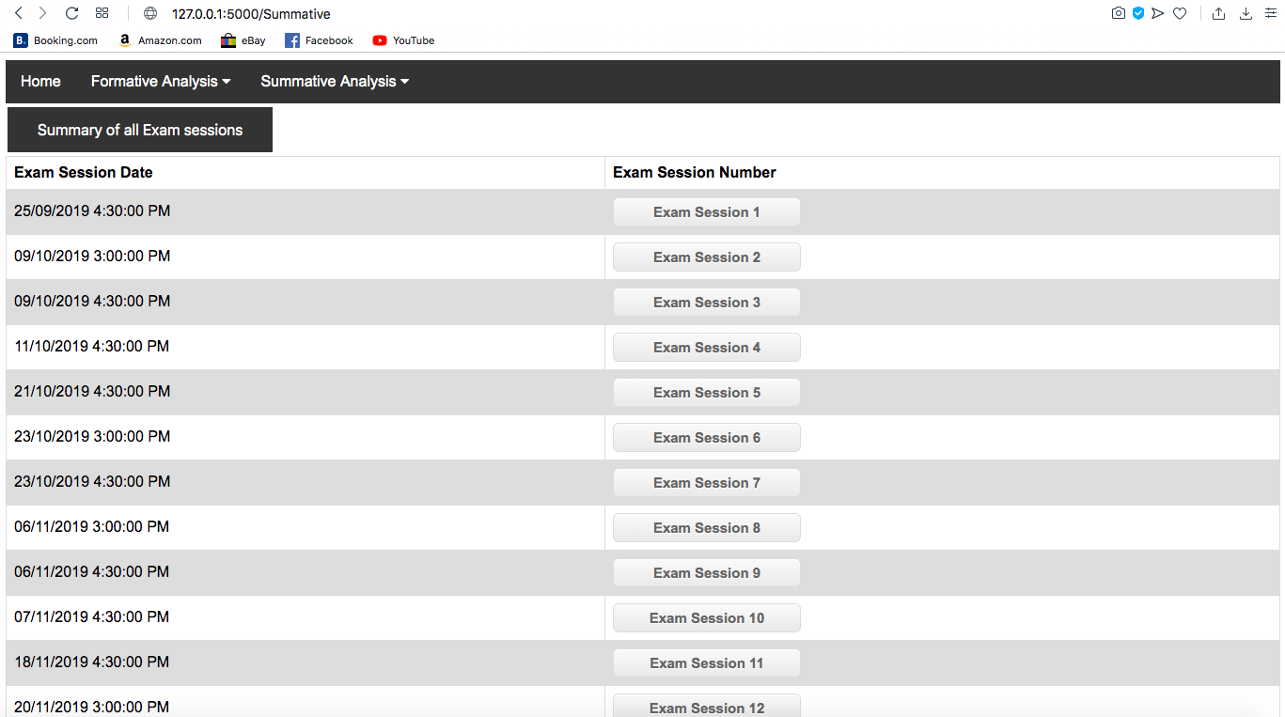

Page of summary of all exam sessions

This page contains table of minimum and maximum difference of P and NP rate and a bar graph for illustration

Part 1 of page

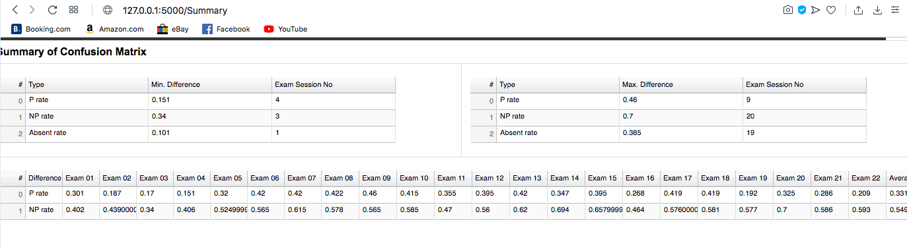

Part 2 of page

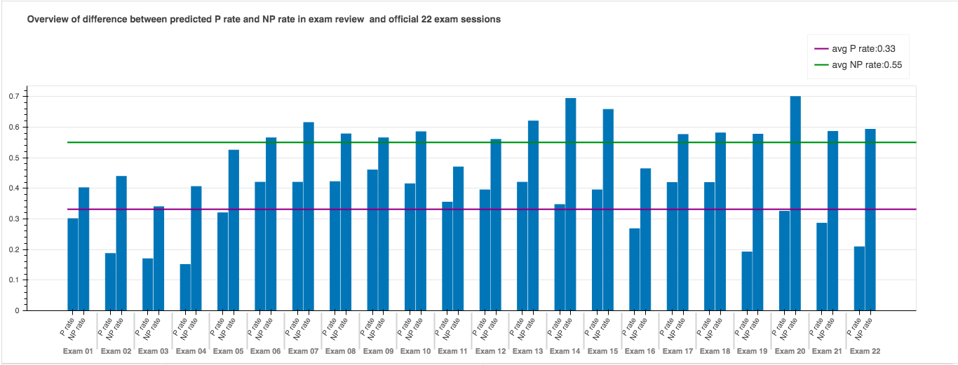

Part 3 of page

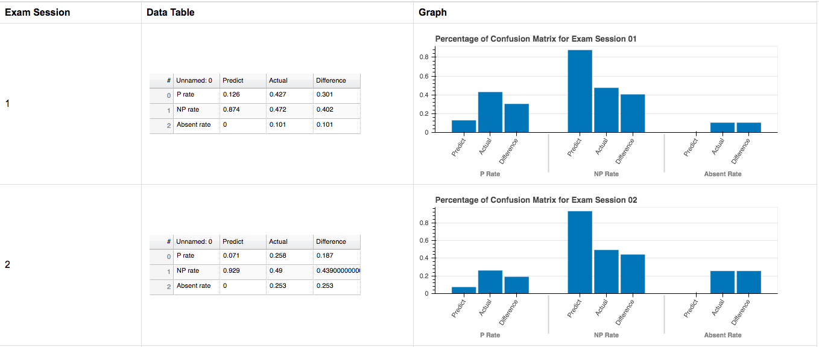

Part 4 of page

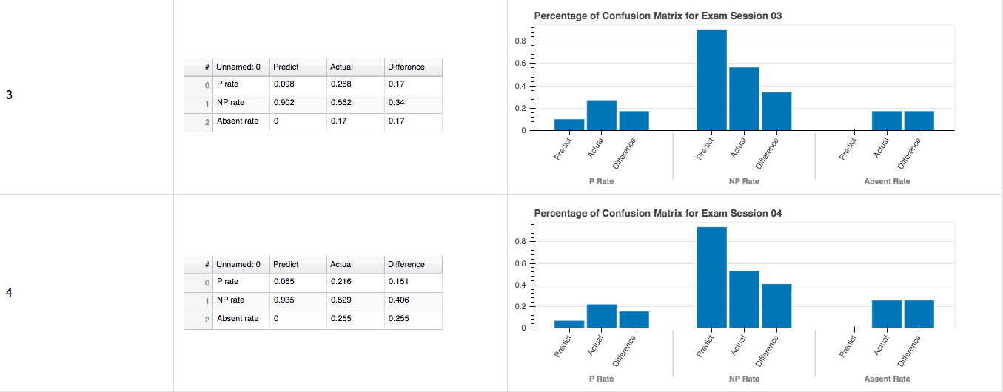

Part 5 of page

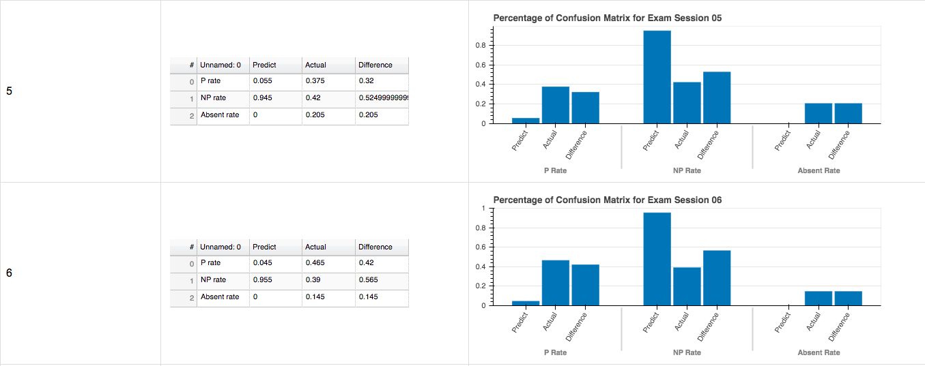

Part 6 of page

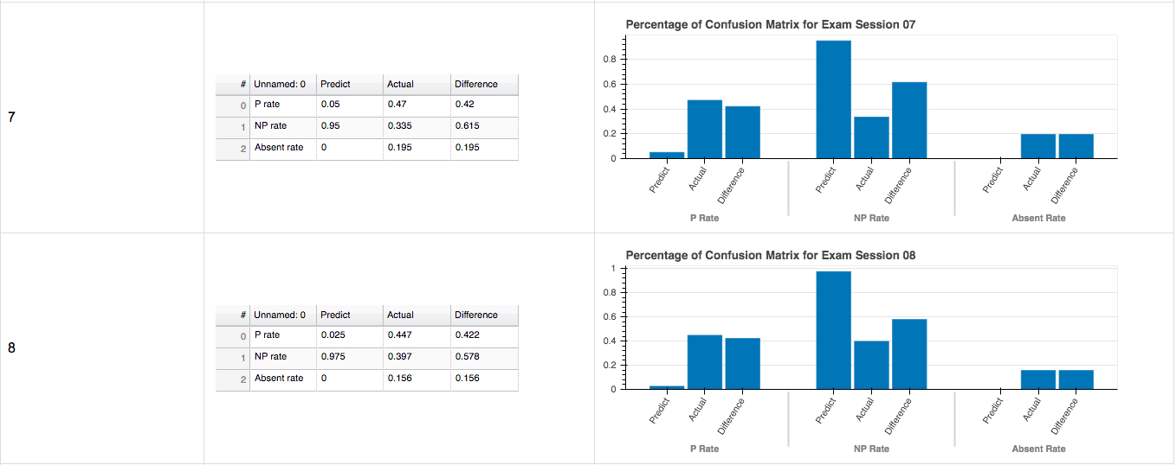

Part 7 of page

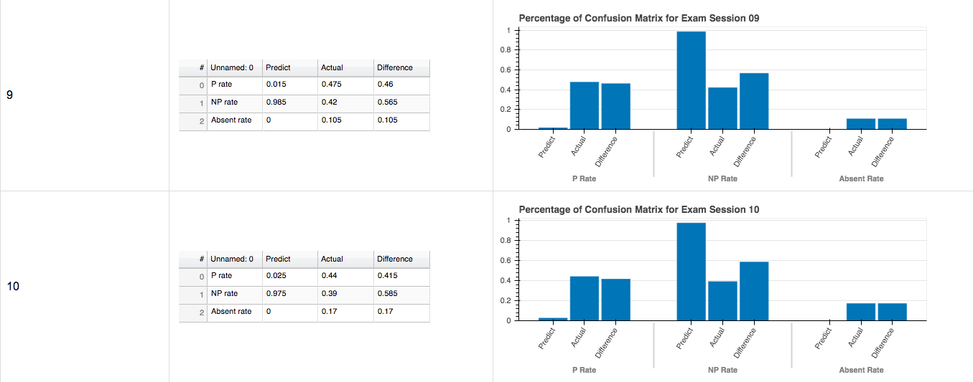

Part 8 of page

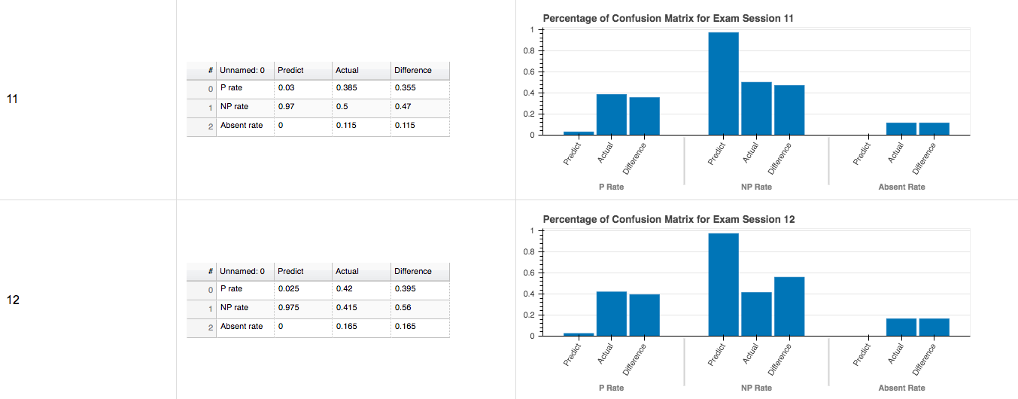

Part 9 of page

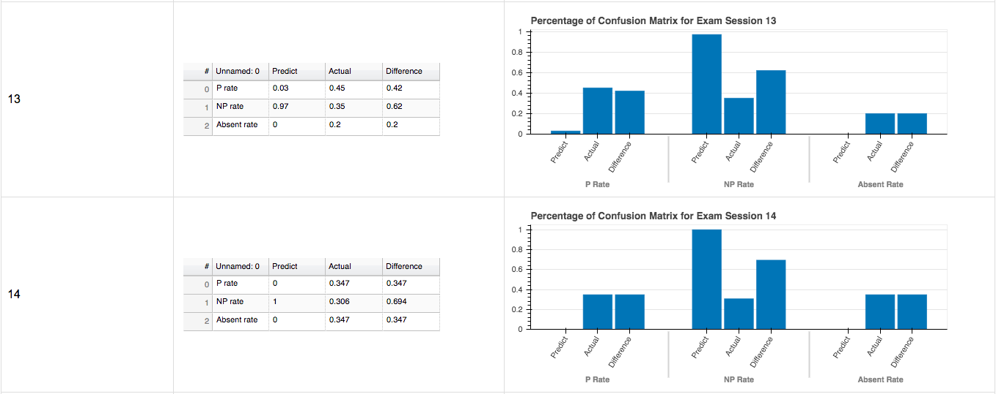

Part 10 of page

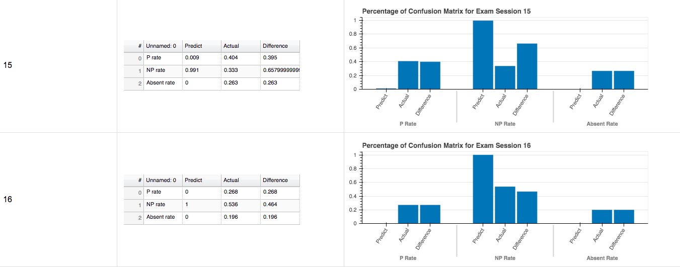

Part 11 of page

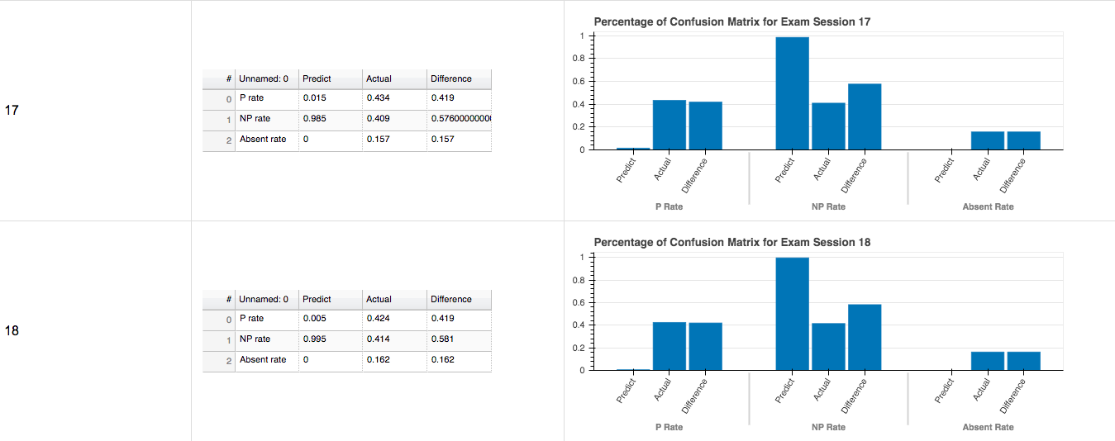

Part 12 of page

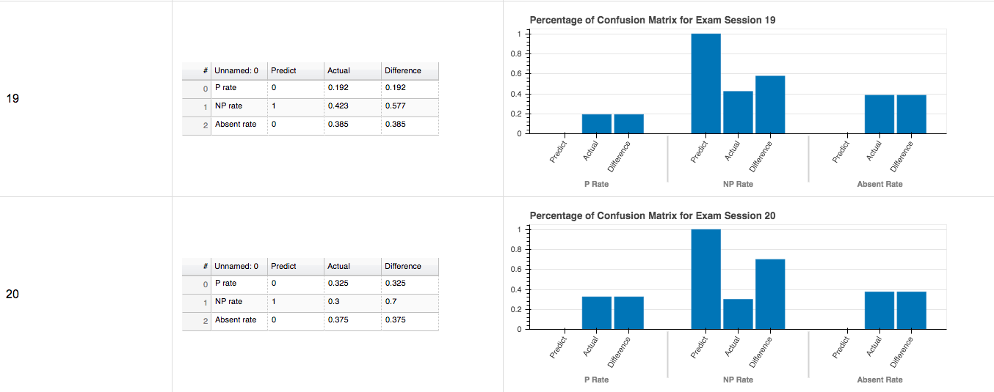

Part 13 of page

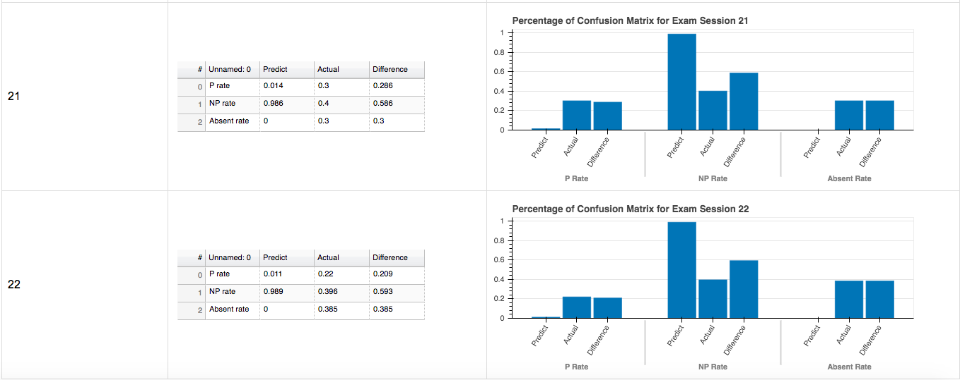

End of page

Page of summary of Exam session 01

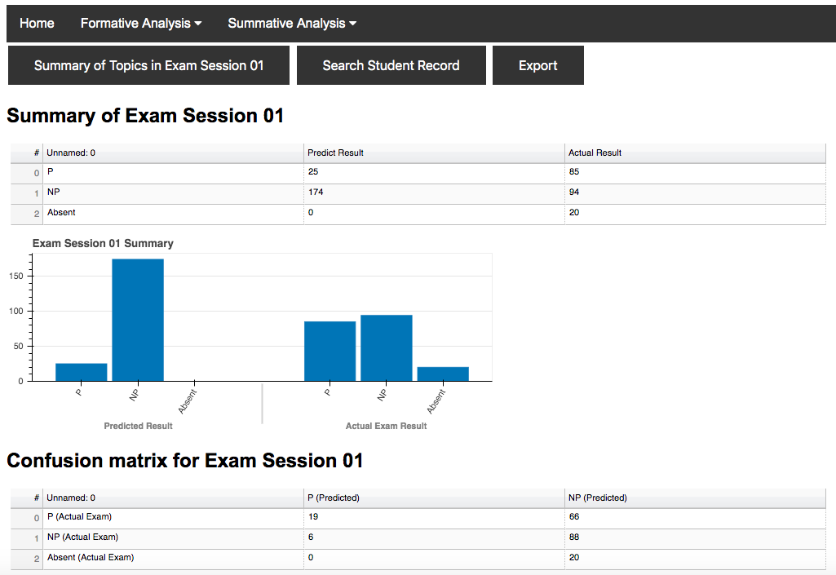

Part 2 of Page

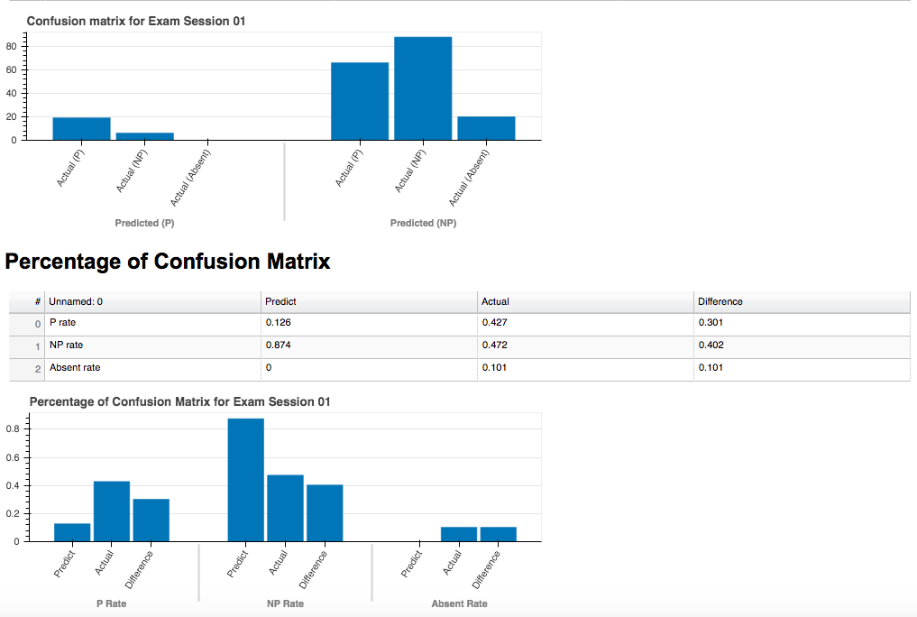

End of Page

Summary of Topics of Exam Session 01

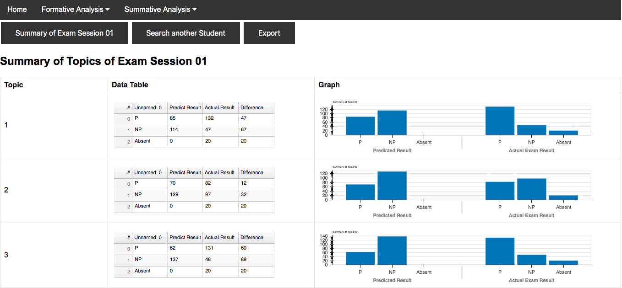

Part 2 of Page

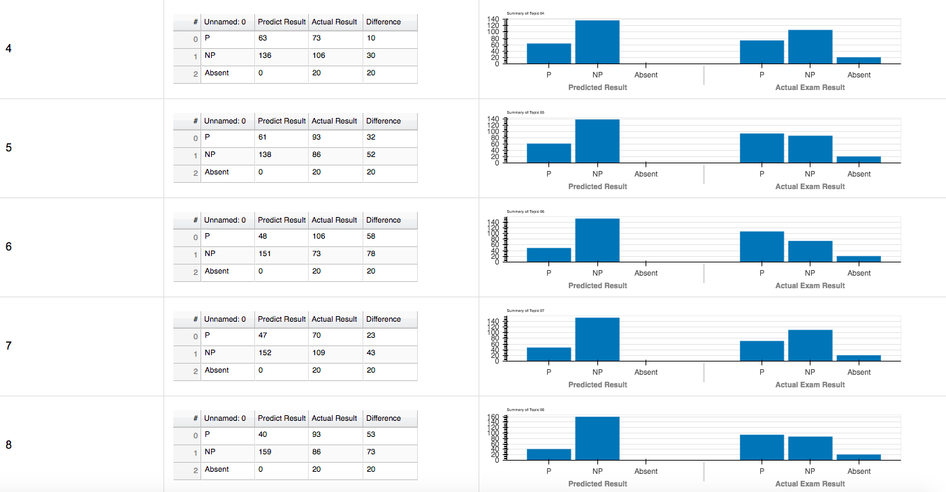

Part 3 of Page

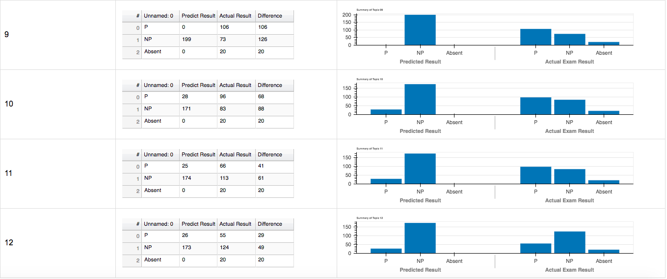

End of Page

Page of searching student

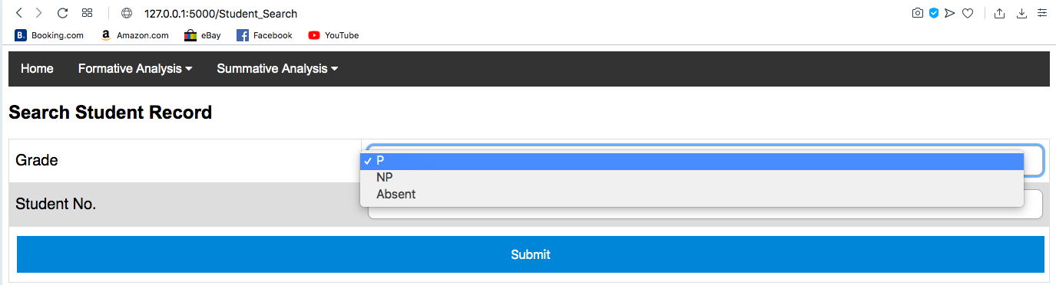

End of Page

Page of individual student from category P

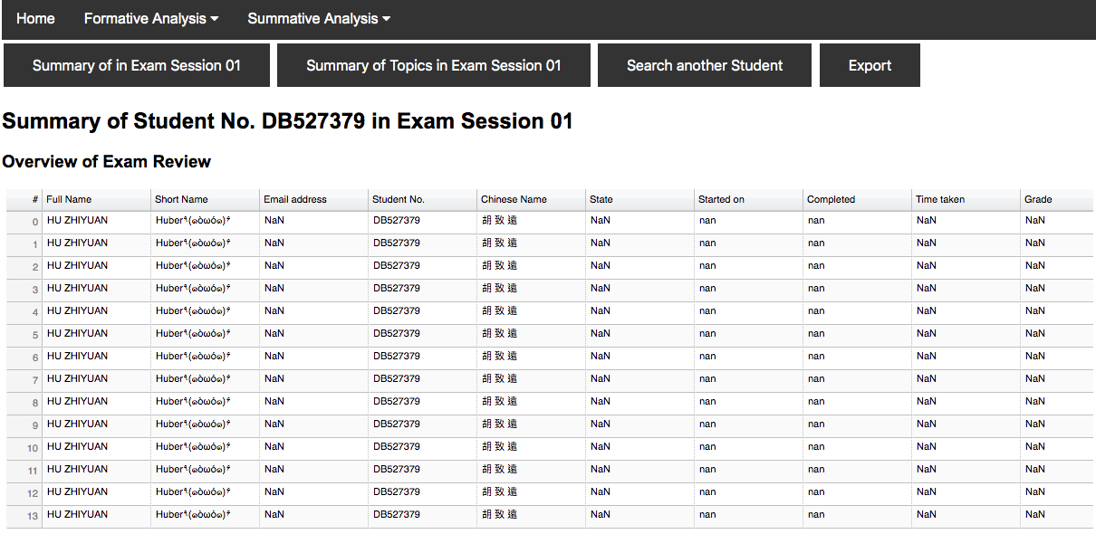

Part 2 of Page

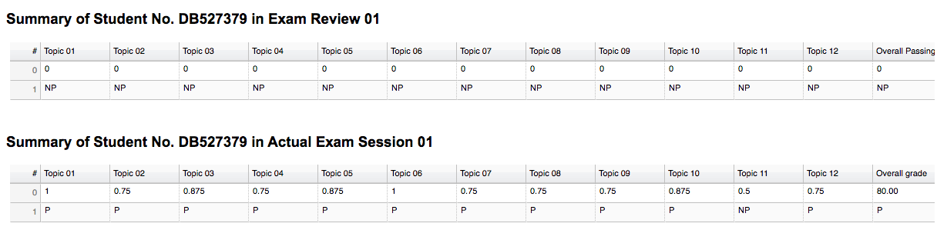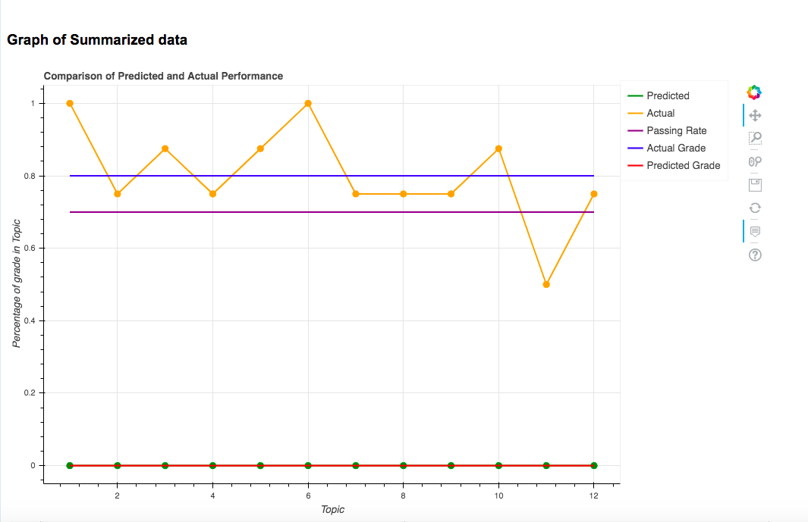

Page 3 of Page

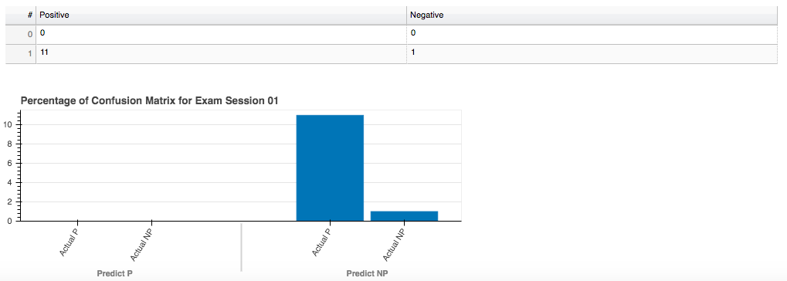

End of Page

Page of Prediction Machine – Before clicking submit button

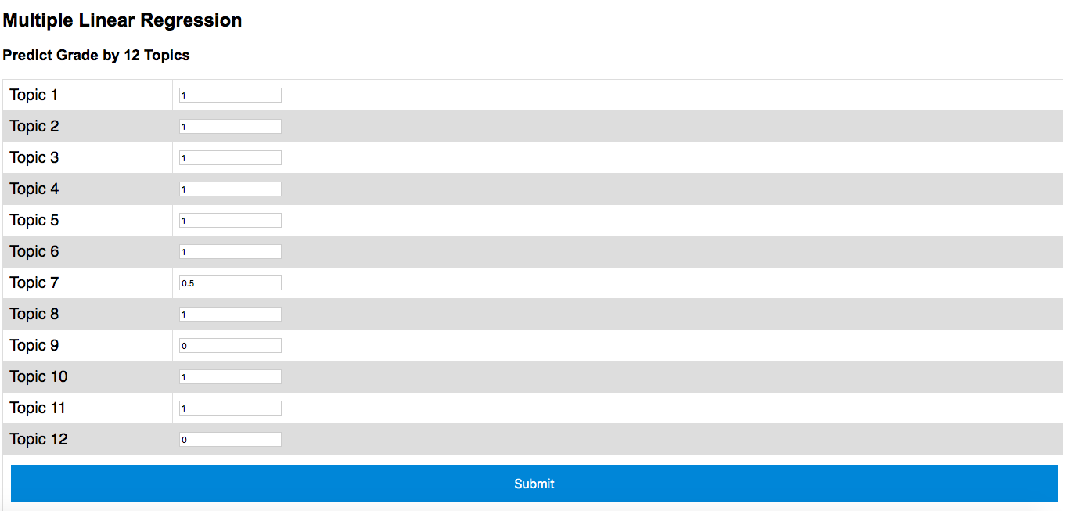

End of Page

Page of Prediction Machine – After clicking submit button

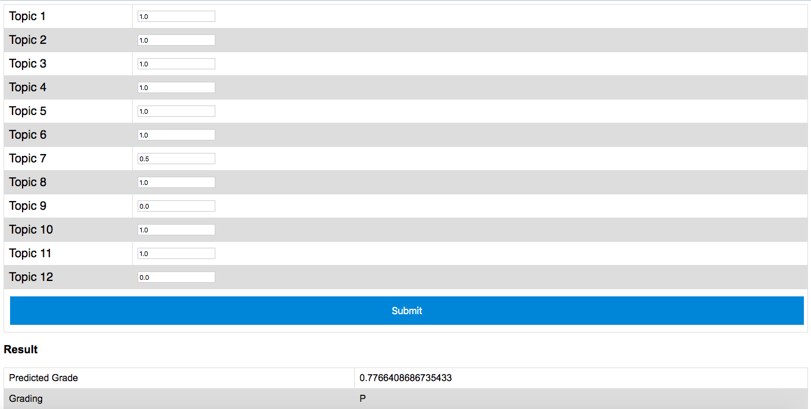

End of Page

Page of Prediction Machine – Correlation between topic and grade

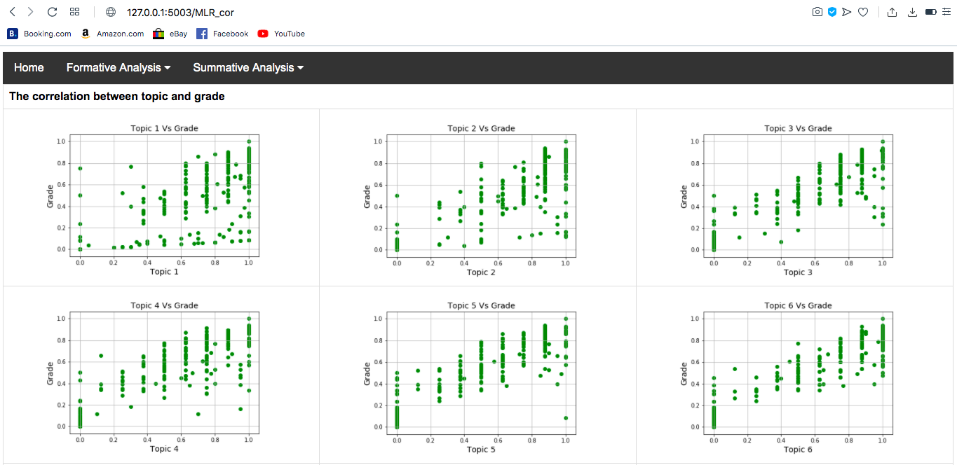

Part 2 of Page

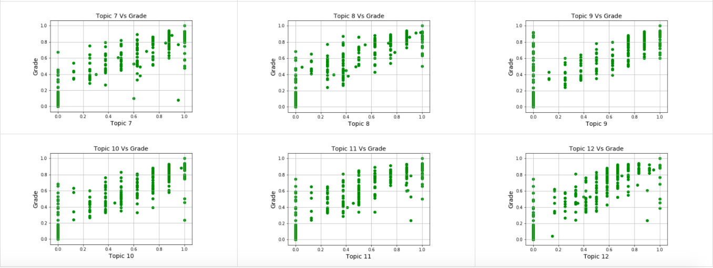

End of Page

Page of Summary of Mock Exam – Menu of Mock Exam result for one or multiple exam sessions

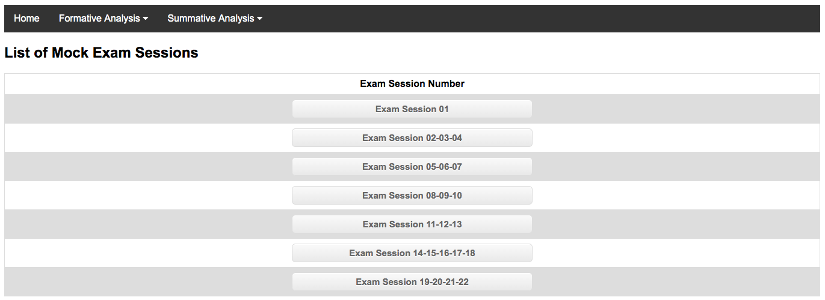

End of Page

Page of Summary of Mock Exam – Summary of Participation rate of RC in Mock-up exam for five exam sessions

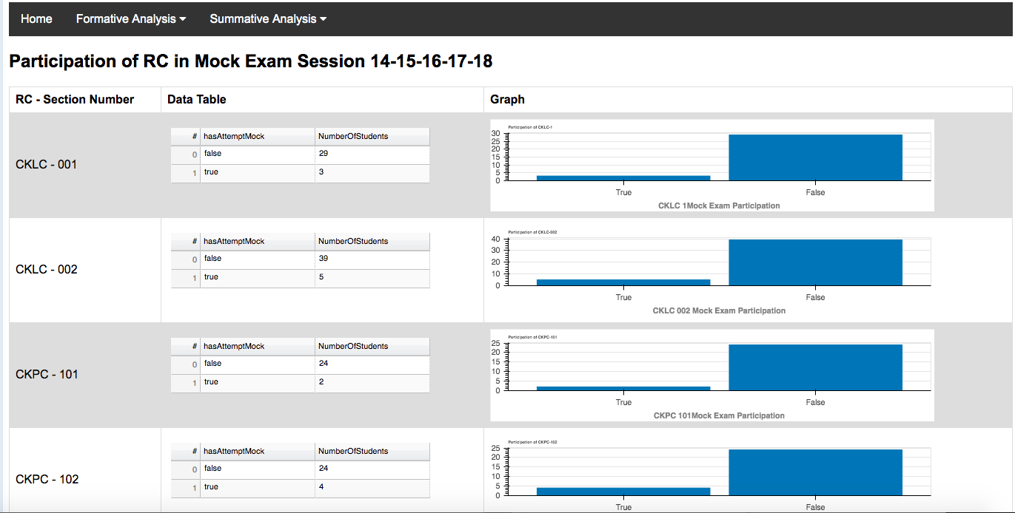

Page 2 of Page

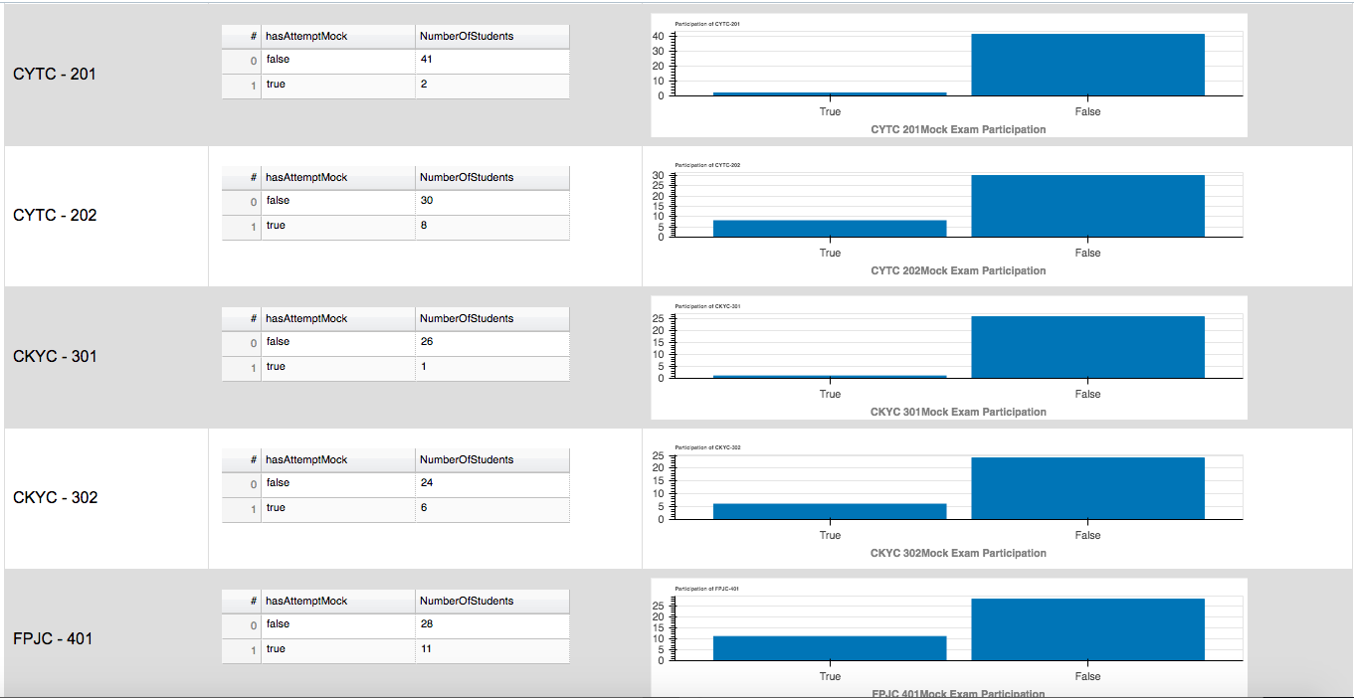

Part 3 of Page

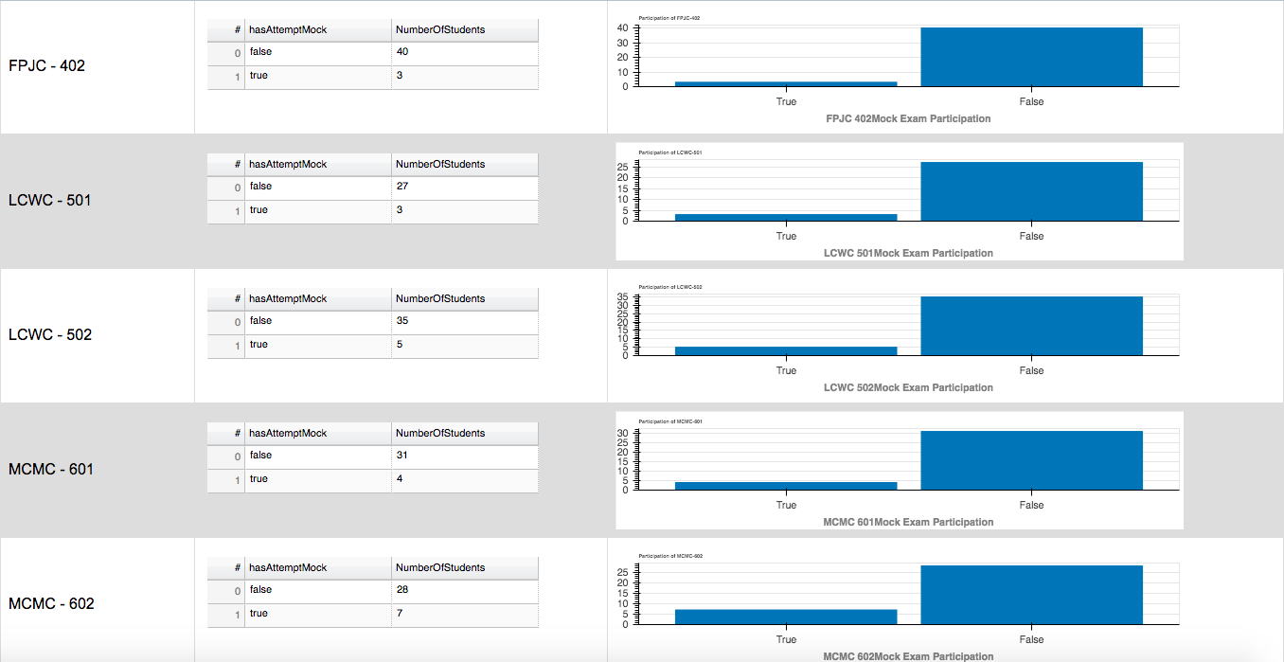

Part 4 of Page

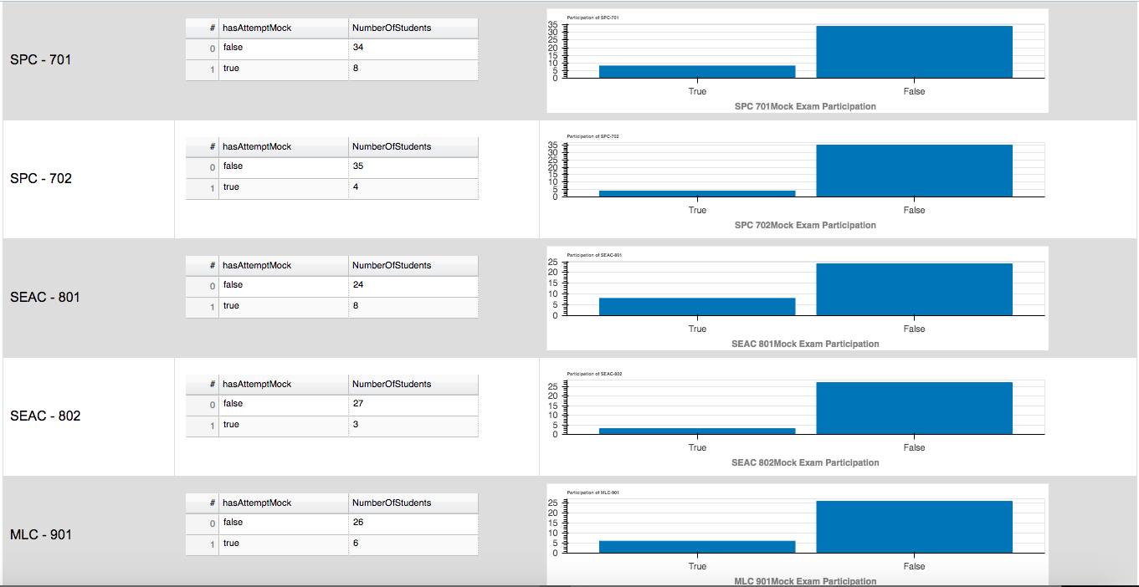

Part 5 of page

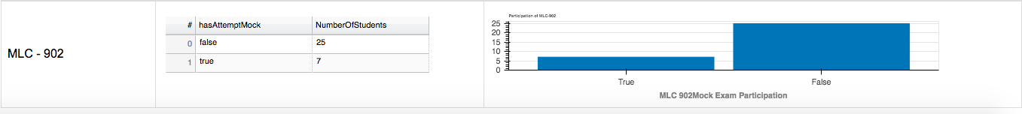

End of Page